Practice for Task 1 BL-BH

Quizlet Activity
Directions:
Go to this link to practice the vocabulary and flashcards for Emergency Signs. This is a public practice website.
- BL-BH Quizlet on Emergency Signs
- https://quizlet.com/614982009/emergency-signs-practice-flash-cards/?x=1qqt
- Click on Flashcards. On each flashcard click on it to reveal the sign on one side. The word for the sign will be on the other side.
- Click on Learn. Choose the matching term for each side.
- Click on Spell. Practice spelling the words for the signs.
- Click on Write. Practice writing out the words for the signs.
- Click on Test. Try to get 100% correct.
- Click on Match. This is hard because it is timed. Drag the sign to the name of the sign. How fast did you do it?

Emergency Words and Signs Practice
Directions:
- Study the signs and words. In pairs, Partner A says the word and Partner B describes or points to the sign.
- Your teacher may also say the word and you identify the sign.
- What do you do when you see the sign?
- Print out and cut up the signs separate from the names. In pairs work on matching up the signs with the words. Then, ask each other what to do when you see the signs.
Sign | Name
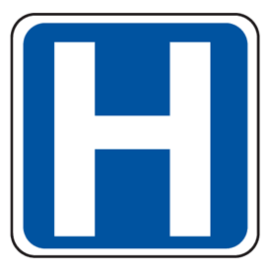 | Hospital Sign
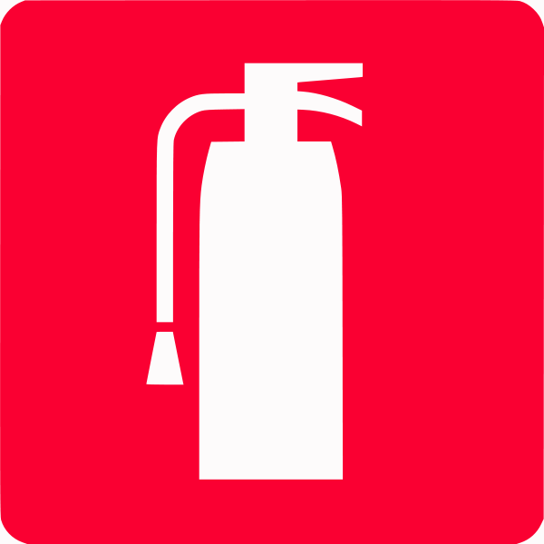 | Fire Extinguisher Sign
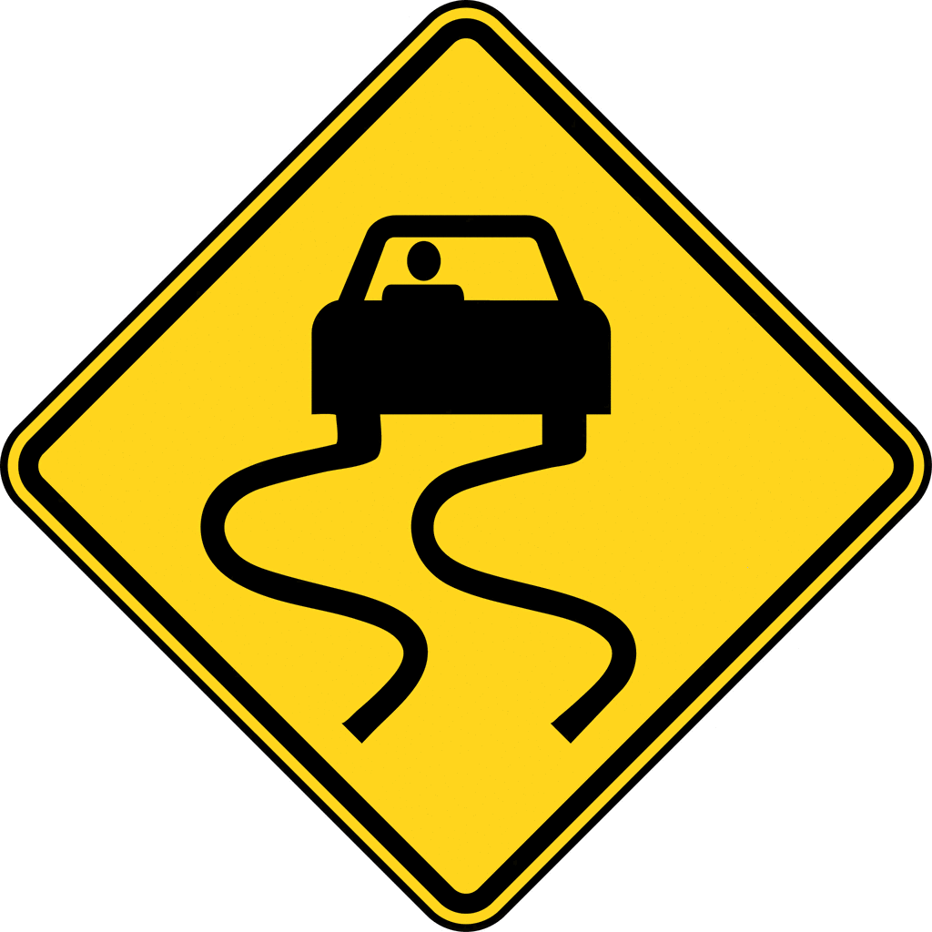 | Slippery Road Warning Sign
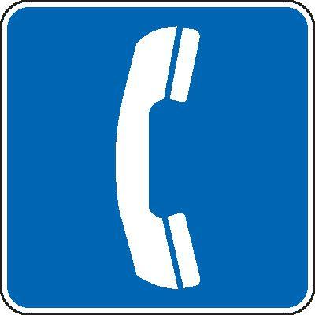 | Emergency Telephone Sign
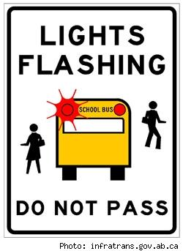 | School Bus Sign
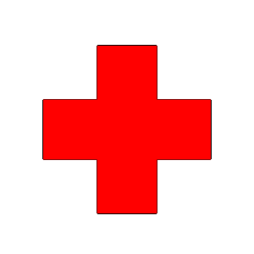 | First Aid Sign
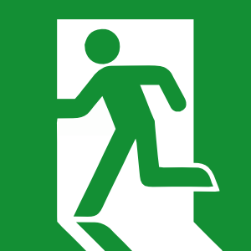 | Emergency Exit Sign
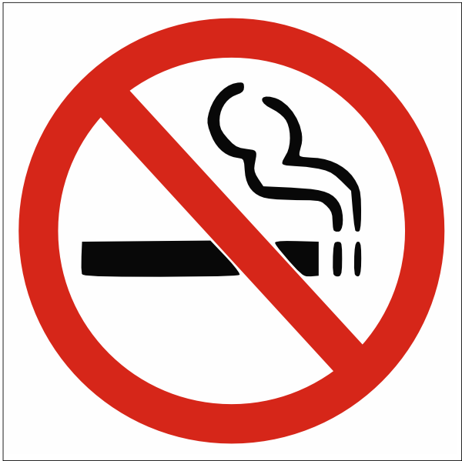 | No Smoking Sign
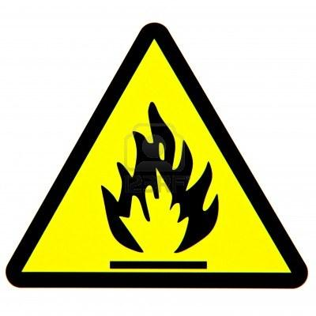 | (Flammable) Fire Danger Sign
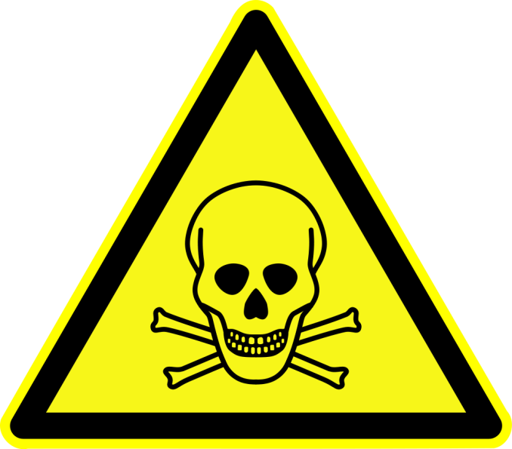 | Poison Sign
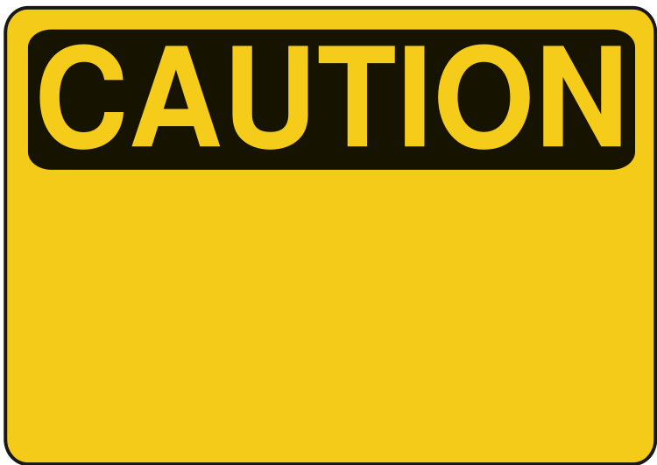 | Caution Sign
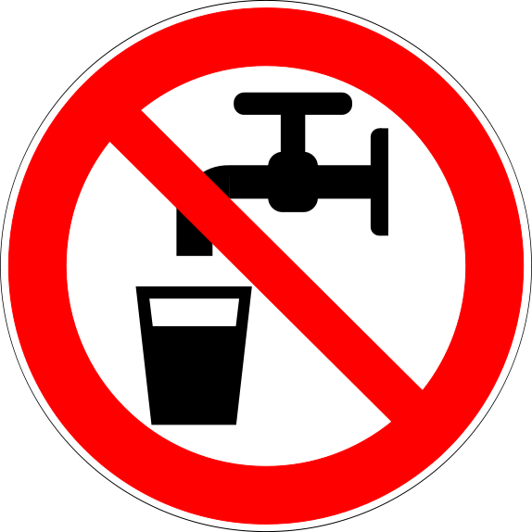 | Not Safe Drinking Water Sign
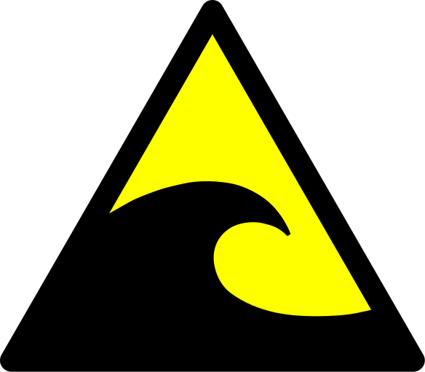 | Tsunami or High Waves Sign
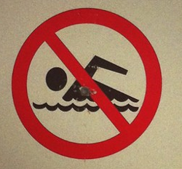 | Beach Closed Sign
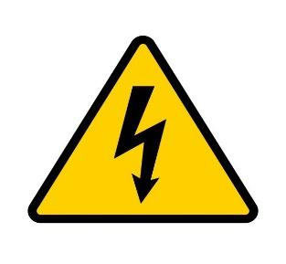 | High Voltage Sign
 | Masks Required Sign
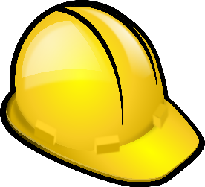 | Hard Hat Sign
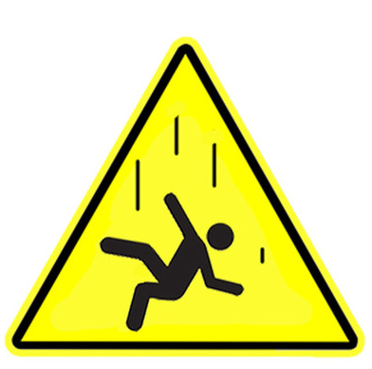 | Danger of Falling Sign
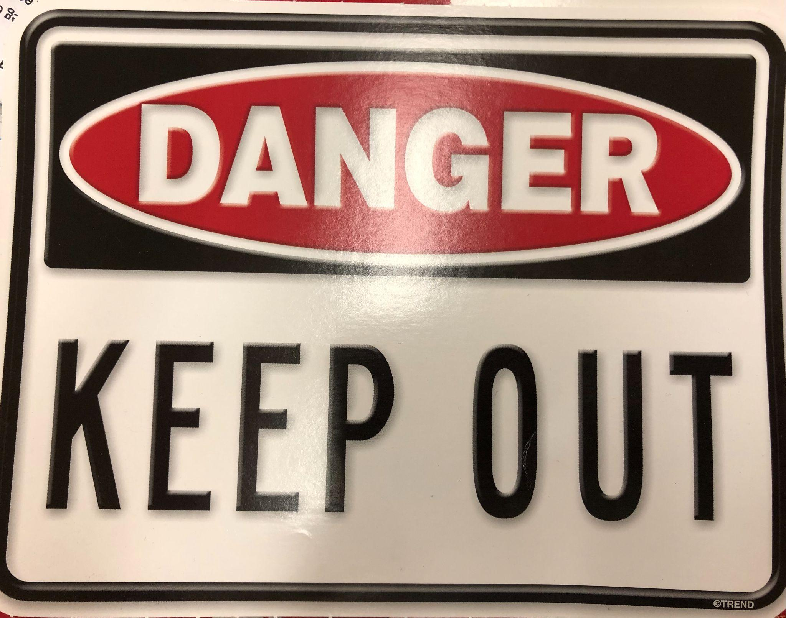 | Stay away from here
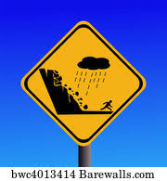 | Mudslide
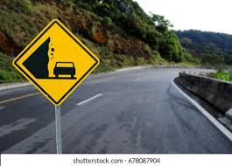 | Falling rocks

Spelling and Vocabulary Cloze Activity
Directions:
Fill in the missing letters for each emergency sign. Check with a partner.
1. h o s ___ i t ___l
2. p __ i s___n
3. e m ____ r ____ e n c ____ phone
4. ___ a ___ k s r___ q ___ i r e d
5. m__ ___ s l ____ d ____
6. ___ i r ___ t a___ d
7. f___ a ____ m a ___b l e
8. e ____ e____ g e n ___ y e___ i t
9. h ___ g h ___ a ____ e s
10. s____ a y a___a y

Emergency Sign Word Search
Directions:
Look for and circle all the words listed below in the word search. Some words are vertical. Others are backwards. Check your answers with a classmate.*
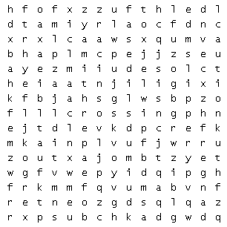

Words in the puzzle:
caution, flammable, closed, hazard,
danger, keep out, falling, slippery, hospital,
enter, exit, mudslide, walk, crossing

*Answer key is on the next page…but don’t look until you finish.
Answer Key:
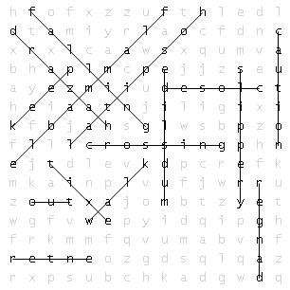

Practice for Task 2 BL-BH

Quizlet Activity
Directions:
Go to this link to practice the vocabulary and flashcards for Emergency Signs. This is a public practice website.
- Quizlet on Healthy and Unhealthy Practices
- https://quizlet.com/614994700/task-2-bl-bh-277-practice-flash-cards/?x=1qqt
- Click on Flashcards. On each flashcard click on it to reveal the sign on one side. The word for the sign will be on the other side.
- Click on Learn. Choose the matching term for each side.
- Click on Spell. Practice spelling the words for the signs.
- Click on Write. Practice writing out the words for the signs.
- Click on Test. Try to get 100% correct.
- Click on Match. This is hard because it is timed. Drag the sign to the name of the sign. How fast did you do it?

Healthy and Unhealthy Behaviors Practice 1
Directions:
- You teacher will show you Power Point slides.
- Your teacher will tell you the behavior and you will see a picture of the behavior.
- Is the behavior healthy or unhealthy?
- You and your class will practice with this Power Point many times.
- Maybe you can think of more healthy or unhealthy behaviors. Tell your class.

Healthy and Unhealthy Behaviors Practice 2
Directions:
- Study the phrases and pictures on the next pages. In pairs, Partner A says the “Why?” behavior and Partner B describes or points to the picture that matches.
- Your teacher may also say the behavior and you identify the picture.
- Is the behavior healthy or unhealthy?
- Print out and cut up the pictures separate from the behavior. In pairs, work on matching up the pictures with the behaviors. Then, ask each other if they are healthy or unhealthy.

Why? | Picture
Talk with your friends. | 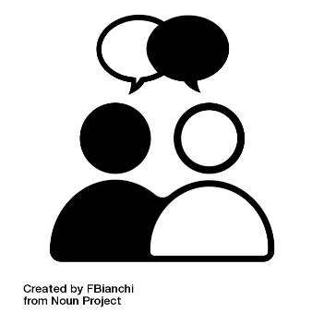
Drink water. Stay hydrated. | 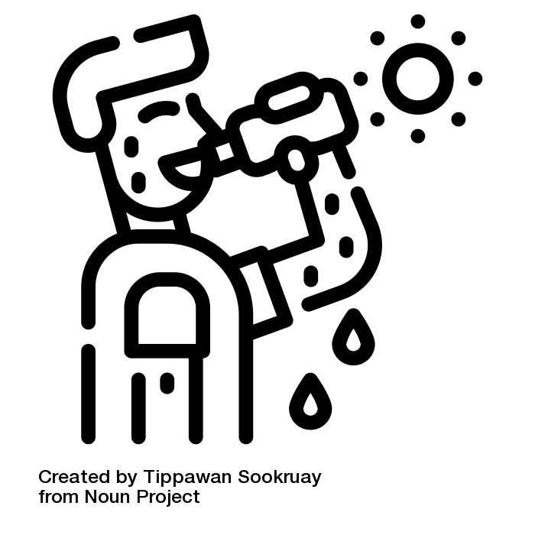
Walk in nature. | 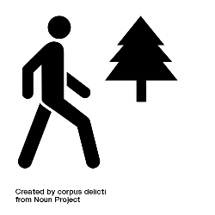
Don’t play too many violent video games. | 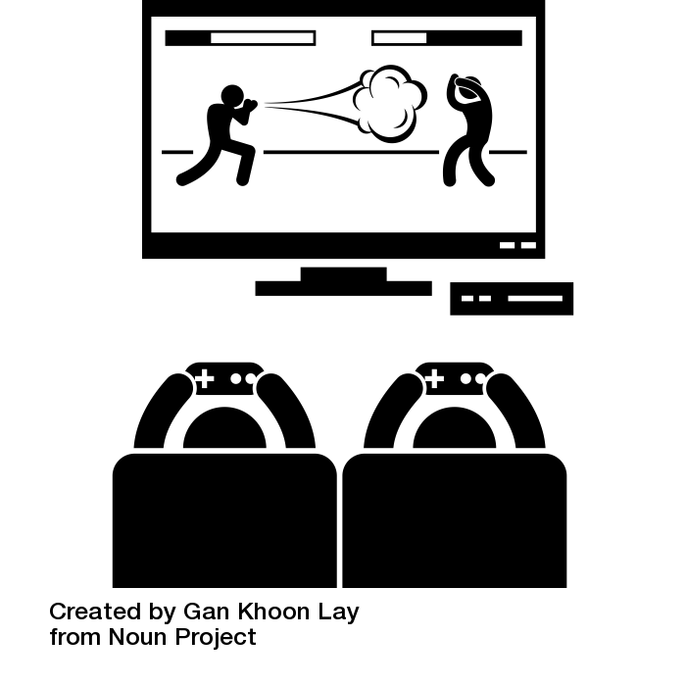
Wash your hands often. | 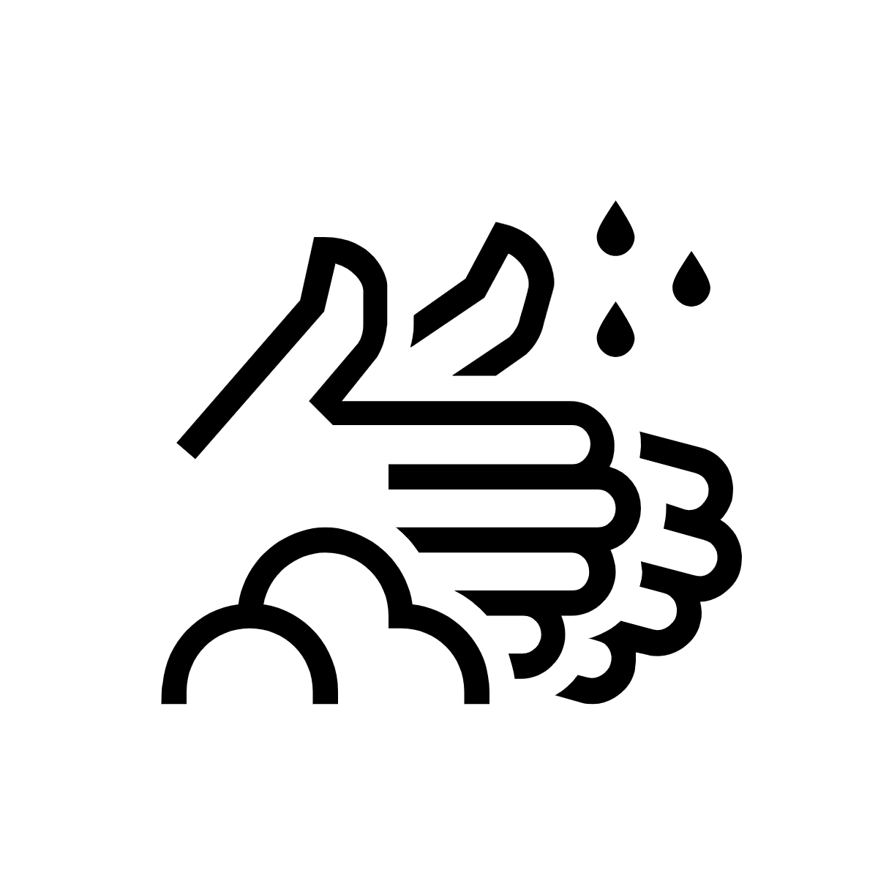
Don’t look at your phone with bad neck posture. | 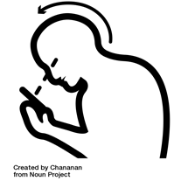
Don’t forget about good hygiene. | 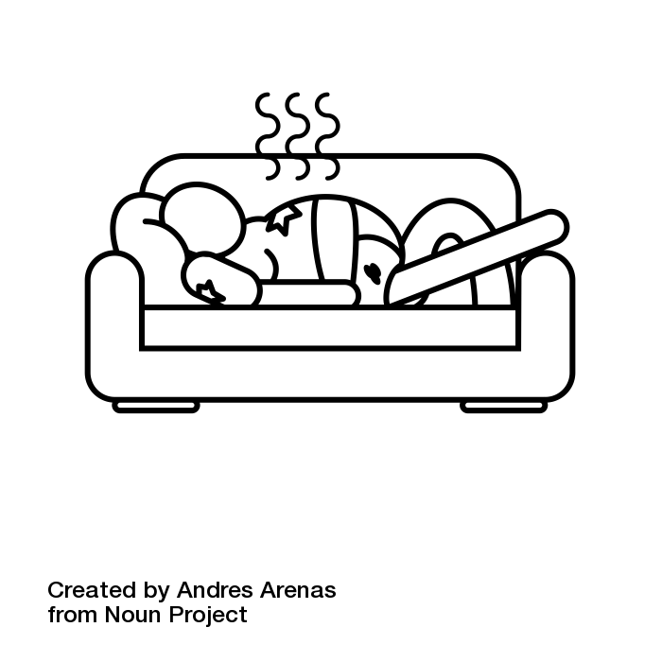
Why? | Picture
Wear a mask around other people. | 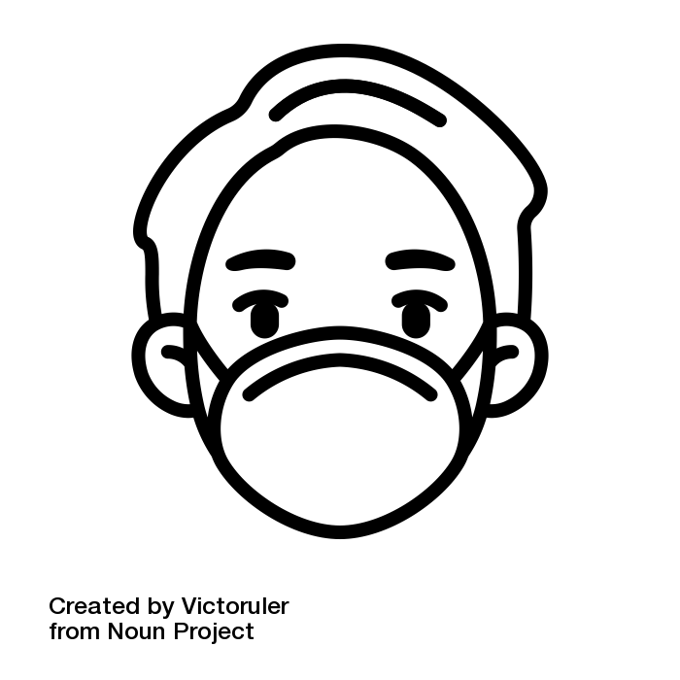
Don’t drink too much alcohol. | 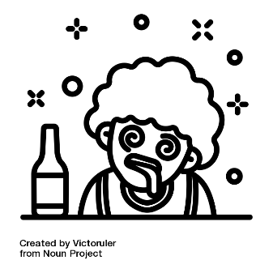
Don’t eat junk food or drink soda. Don’t become overweight. | 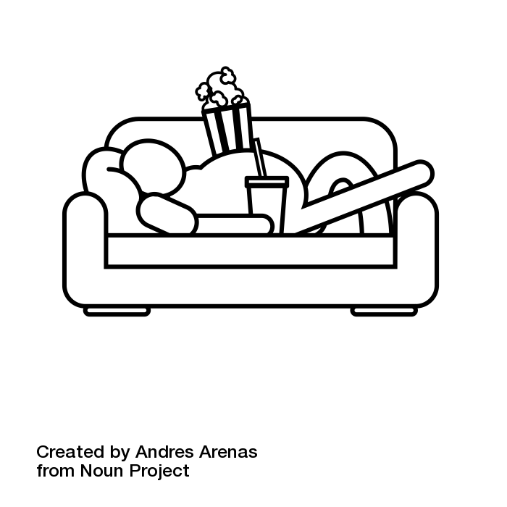
Use a seatbelt. | 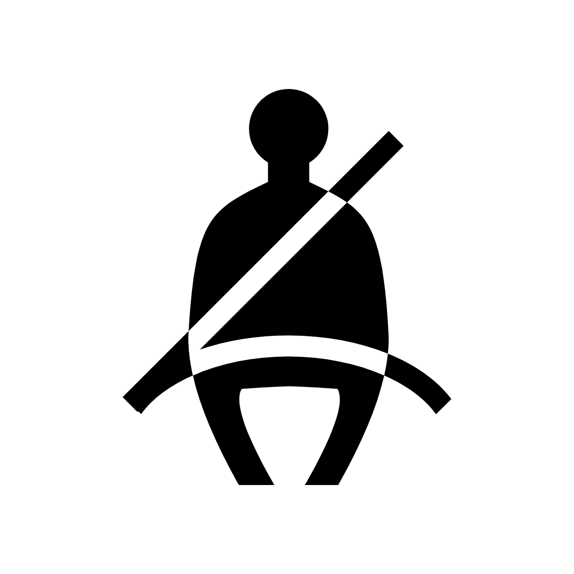
Don’t stay home sad, alone, or depressed. | 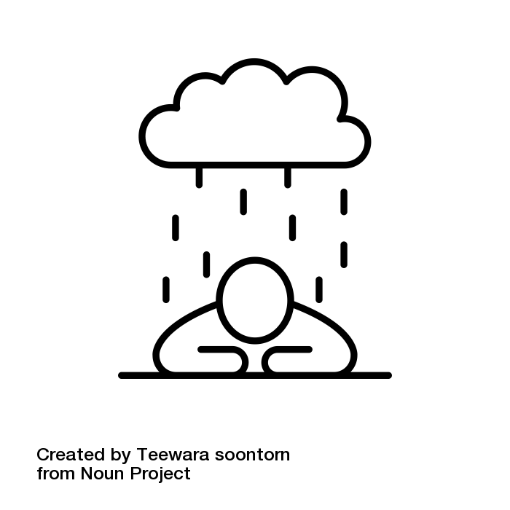
Eat vegetables. Have a healthy diet. | 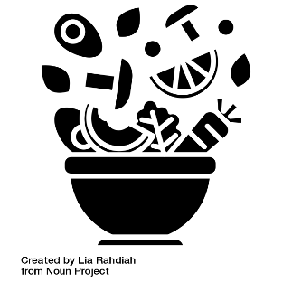
Clean and sanitize frequently. | 