COAAP 70.2 Task 1 – Childcare Environments

Observation and Discussion
Directions: Look at Photos 1 and 2 of a safe childcare environment. What do you notice? Talk about them with a partner and take notes below the picture.
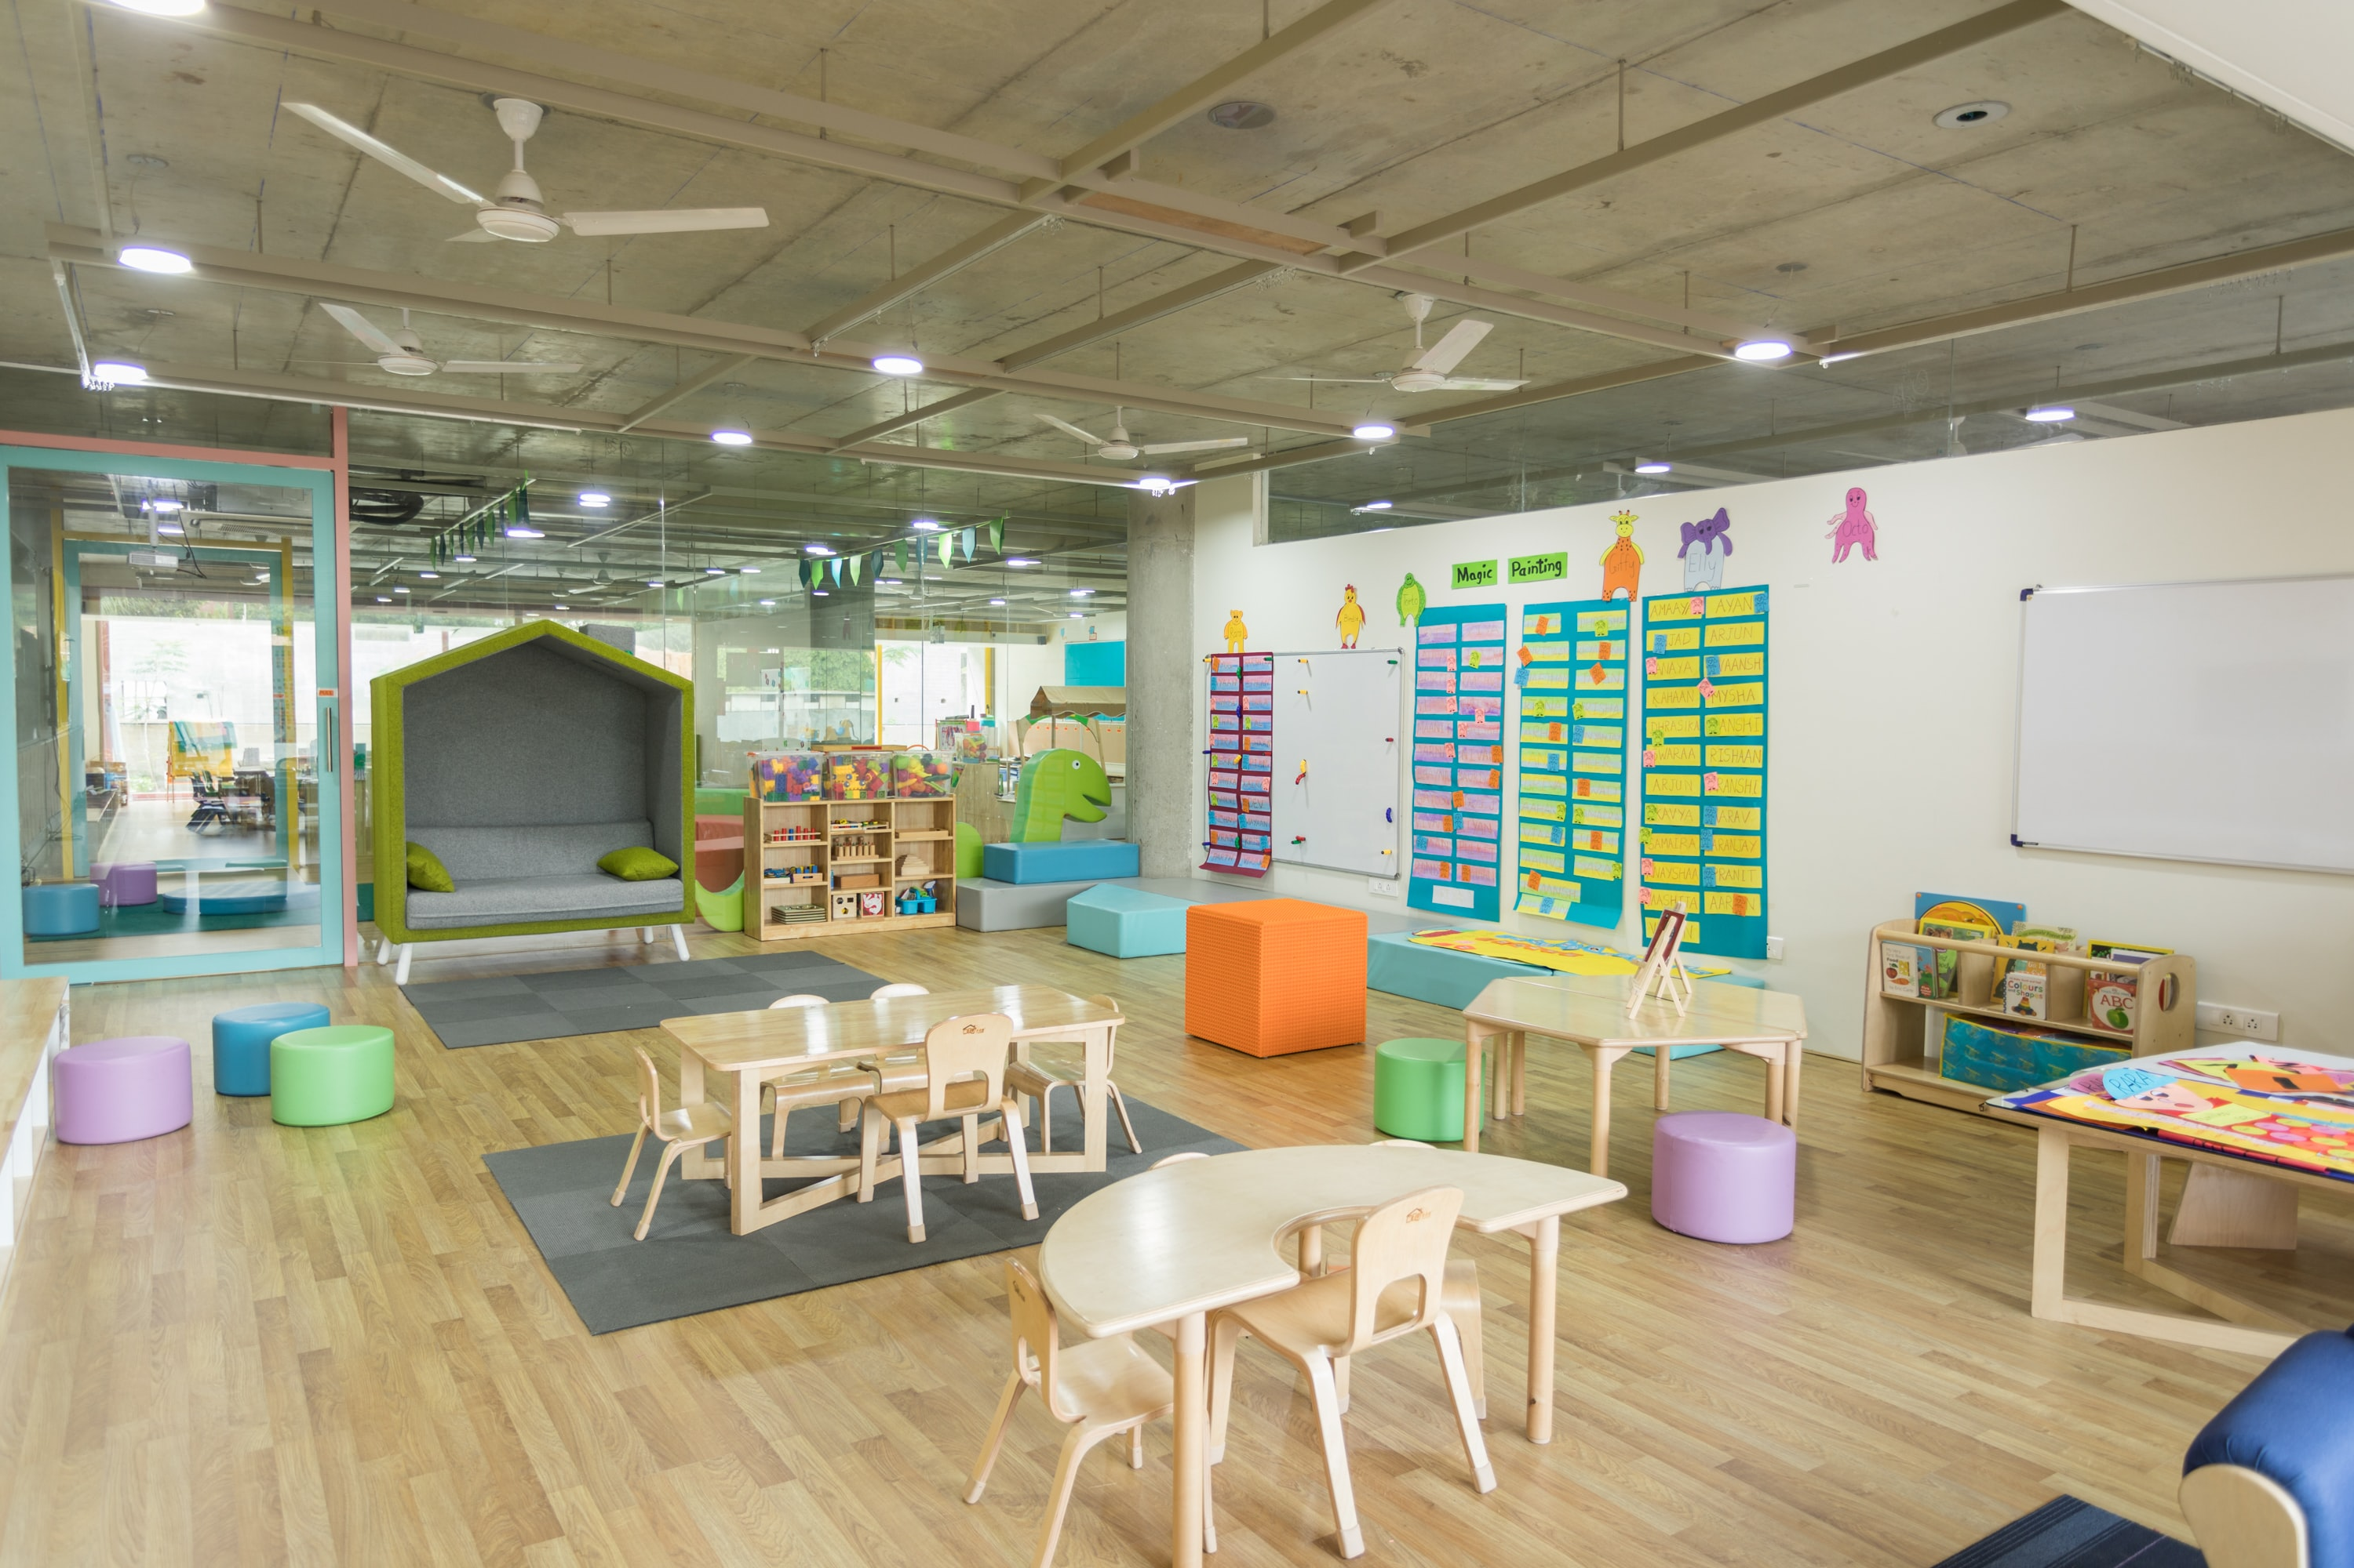
Photo 1 by Gautam Arora on Unsplash

My notes:
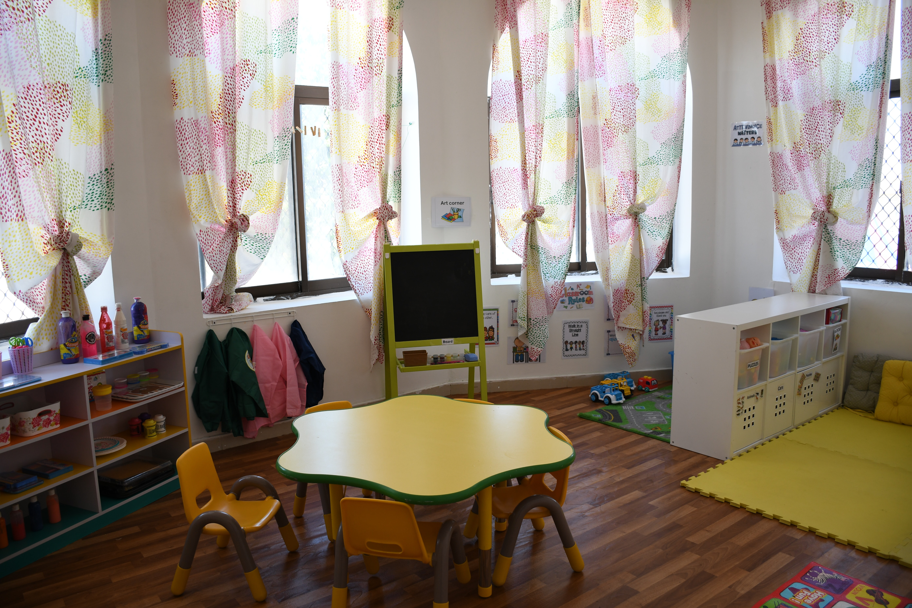
Photo 2 Photo by Atikah Akhtar on Unsplash
My notes:

Directions: Look at Photos 3 and 4 of an unsafe childcare environment. What do you notice? Talk about them with a partner and take notes below the picture.
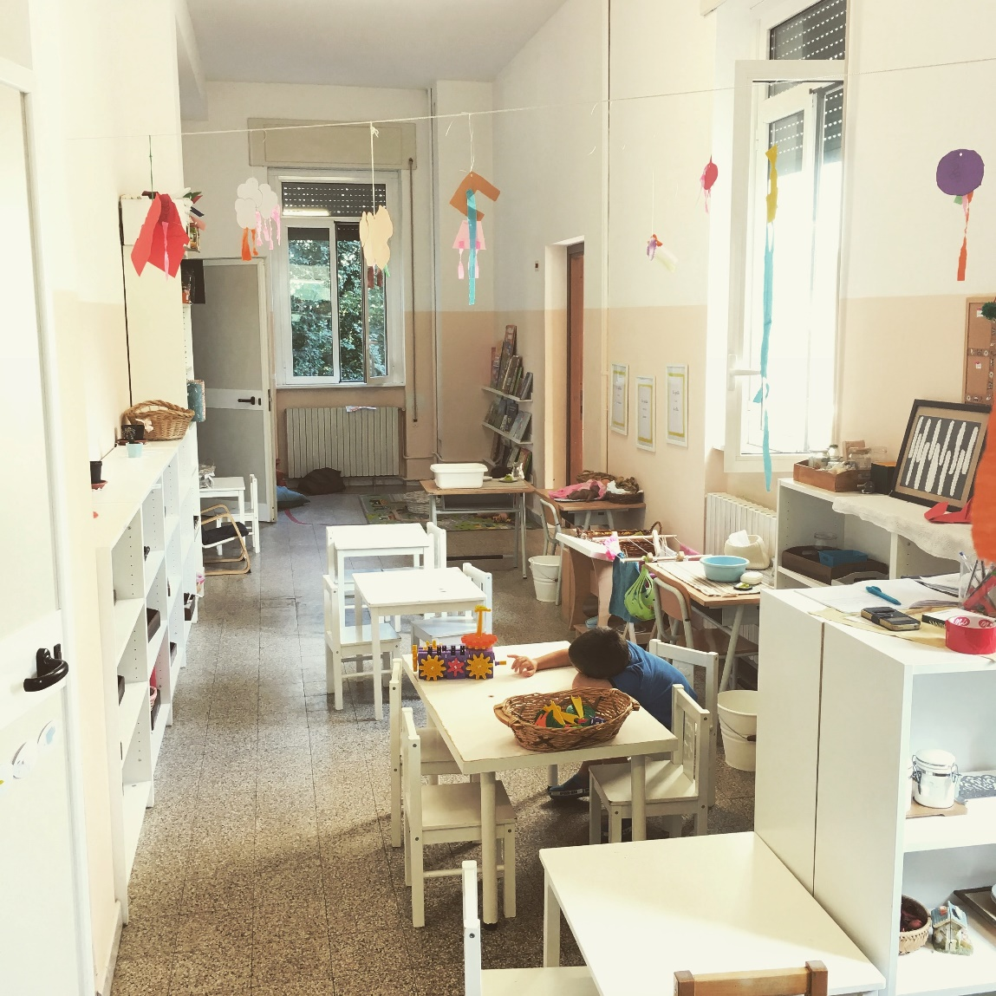
Photo 3 by Iwan Buetti on Unsplash
My Notes:
Photo 4 by krakenimages on Unsplash
My Notes:

Writing Practice
Directions: Look back at Photo 1. Write 5 clear and complete sentences about how this picture shows a safe, good quality childcare environment for children.

Directions: Look back at Photo 4. Write 5 clear and complete sentences about how this picture shows an unsafe, poor quality childcare environment for children.

