
EL CIVICS #19.7
IMMIGRANTS’ RIGHTS AND RESPONSIBILITIES
Name:
Student Guide

MESSAGE TO THE STUDENT
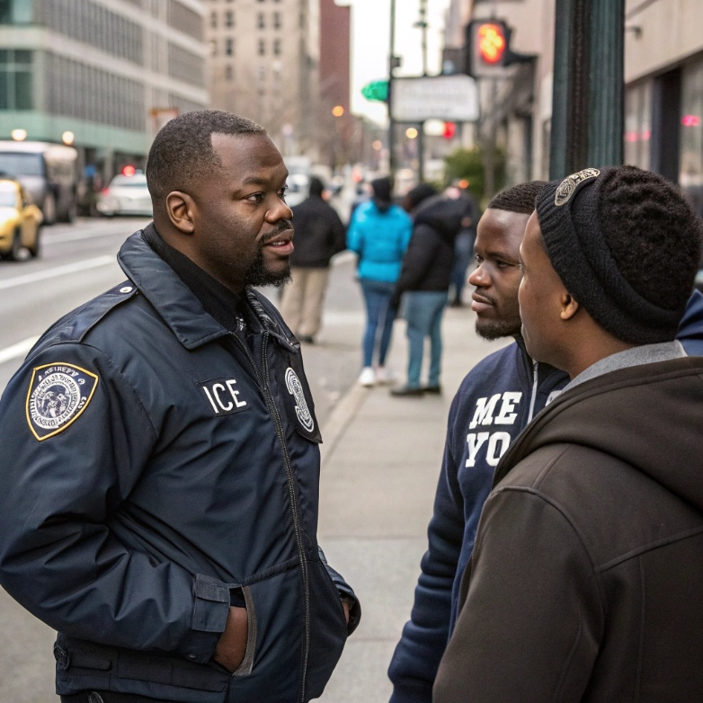
You are going to study some lessons about immigrants’ rights and responsibilities. After you complete the lessons, you will take a test. There are two parts to the test:
1. Speaking test: Look at pictures to determine an immigrant’s problem, state the immigrant’s rights and responsibilities and use a directory to identify a local agency that can help.

2. Writing test: Complete a chart. Use a directory to identify agencies and services which relate to various immigration problems.
Image generated by Recraft AI
EL Civics is a program that helps people who are new in the United States. The government gives money to our school for each student who passes the tests. You are helping your family, yourself, and the school. Thank you.
Use your phone to view the oral assessment:
 | 

INTRODUCTION

Immigrant’s Rights
Rights are freedoms or privileges that are guaranteed by law. For example, all children have the right to public education. Which of the freedoms below do you think are rights for all people living in the U.S.? Circle them. Share your ideas with your class.
K-12 public education practice your religion have a bank account
have a job get fair pay at work emergency medical care
say your opinion freely have a driver’s license own a house
1. Read the paragraph. Concentrate on the main ideas.
The United States is a country that depends on immigration. In fact, the Statue of Liberty, a world-famous U.S. landmark, is a welcome symbol to

newcomers. In contrast, many newcomers struggle to find answers
about living in the U.S. What rights do immigrants in the U.S. have?
What should a person do or say when interacting with authorities?
How can a newcomer get help with important immigration matters?
The following lessons will introduce you to some of the most
important laws in the U.S. You will also learn how those laws apply
to problems that many newcomers face. Finally, you will learn about local agencies that offer assistance to immigrants.
2. Listen to your teacher read the paragraph. Ask questions about any words you don’t understand.
3. In a small group, review the paragraph and find the answers to the questions.
- What message does the Statue of Liberty symbolize?
- What kinds of questions do newcomers to the U.S. often have?

- What will you learn in these lessons about immigrant rights?
Visit the Statue of Liberty

THE CONSTITUTION

Important Laws in the United States
What do you already know about the Constitution, the highest law in the U.S.? Cover the bottom half of this page. Answer the questions to your best ability. Then, in a small group, read the bottom half of the page to find out if you are right.
1. The Constitution is a document that explains…  - the form of government in the U.S.  - the rights of all people in the U.S.  - the responsibilities of the government.  - all of the above | 2. An amendment is a…  - change to a document.  - court appointment.  - kind of lawyer. | 3. The Bill of Rights are…  - the first ten amendments to the Constitution.  - how much you pay for your rights.  - the rights that only citizens of the U.S. have.

Discussion: In a small group, take turns reading about important U.S. laws. Decide together what the best answers are for the questions above.
  - What is the Constitution?
The Constitution is our plan of government. It explains the democratic form of our government and describes the government’s responsibilities. It also guarantees the rights of all people in the United States, citizens and non-citizens. The Constitution is the highest law in the land.
- What are amendments?
Amendments are changes to the Constitution. Amendments can be made by the people when a large majority of the citizens support the change. Since 1787, when the Constitution was originally written, 27 amendments have been added to the Constitution.
- What is the Bill of Rights?
A few years after the original Constitution was written, the authors wanted to add protections for individuals. Ten amendments, called the Bill of Rights, were added. Some of these amendments are famous. For example, the first amendment guarantees each of us freedom of speech and freedom of religion.

THE CONSTITUTION

Important Laws in the United States

  - Read the paragraphs about the Constitution.
The Constitution of the United States has been the highest law of the land since it was adopted in 1789. It describes the structure of A the American government and all its laws. The writers of the Constitution wanted to create a strong government that was under the control of the people.
The Constitution was written to allow for changes, or amendments. In 1791, ten famous amendments were added to the Constitution. These are known as the Bill of Rights. The Bill of Rights is a list of rights that people living in the U.S are guaranteed. For example, the first amendment guarantees freedom of speech and freedom of religion. Since 1791, seventeen other amendments have been added. Among these is the amendment that ended slavery. Another gave women the right to vote. It is our responsibility to follow the laws of the U.S. and to know about the protections the Constitution provides for all people living in the U.S.
- Circle T for true or F for false.
- T F The Constitution hasn’t changed since it was first written.
- T F The Constitution is the highest law in the U.S.
- T F The Bill of Rights describes the powers of the government.
- T F The Bill of Rights describes what people are free to do.
- T F We are responsible for knowing the law and following the law.
- T F The Constitution can be changed.
- T F The writers of the Constitution wanted to create a strong government that could control the people.

Use your phone to listen to the reading.

IMMIGRANTS’ RIGHTS

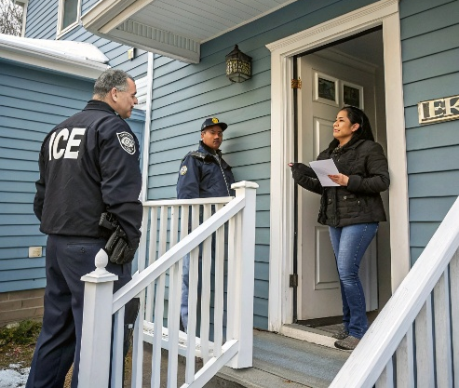
Blanca’s Problem
  - Talk about the picture.
What is happening in the picture? Who is the man knocking on the door? How do you think the people in the apartment feel? What do you think will happen next?
  - Read to find out what happened next.
Image generated by Recraft AI
Sometimes immigration officers go door-to-door looking for immigration fugitives. If they don’t find the person they are looking for, they will question neighbors, family members, and sometimes even people on the street.
Blanca Moran recently had this experience. Immigration officers came to her door and asked for a person who no longer lived there. The officers asked to come in, and Blanca opened her door. The officers did not have a search warrant. When the officers were inside, they questioned her and her family about their immigration status. Her family was undocumented. Blanca and her husband, David, answered all the officers’ questions truthfully. Because they are undocumented, David was arrested, but Blanca was allowed to stay because she was taking care of their young son.
- Circle T for true or F for false.
- T F Blanca asked for an immigration officer to come to the house.
- T F The immigration officer was looking for Blanca.
- T F The immigration officer was looking for someone else but found Blanca instead.
- T F Blanca and her husband told the truth.
- T F Blanca was not arrested, but her husband was.
- T F Blanca and her husband had a lawyer with them.

VOCABULARY
- Read the definitions and examples.
    - allow: let; permit; agree to
“Would you please allow us to go home early today?”
- door-to-door: going from one house to the next in an area
Sometimes people sell things door-to-door instead of selling them from a store.
- fugitive: a person who is escaping from the law enforcement officers.
The newspaper reported that a fugitive escaped from the state prison.
- immigration status: the type of permission for residence or legal position a person has with the U.S. government. Examples are: citizen, permanent resident, undocumented, etc.
Last year, her immigration status changed from permanent resident to citizen.
- search warrant: a paper from a court giving an officer permission to enter someone’s home to search for things or people.
The resident asked the officer at her door, “Do you have a search warrant?”
- Complete the sentences with one of the vocabulary words.
allow door-to-door fugitive immigration status search warrant

    - After the police showed us a , we let them come into the house.
    - My kids like to watch TV, but I only them to watch one program.
    - The citizen married a new immigrant. He petitioned the government to change his wife’s .
    - My daughter’s school needs money, so the kids are selling chocolate bars
.
    - The bank robber ran from the police. He is a .

RIGHTS
- Discussion
- Do you know anyone who has had a similar experience to Blanca?
- Do situations like this happen in your native country?
- Do you think Blanca did the right thing to allow the officer to come into her home?
- What could you do in this situation?
- Reading: What are the rights and responsibilities?
Our rights and responsibilities in the United States are written in the Constitution. It is the highest law in the land. The Constitution guarantees the rights of all people in the United States, citizens and non-citizens. Amendments are changes to the Constitution. The first ten amendments are called the Bill of Rights. So far, there are 27 amendments.
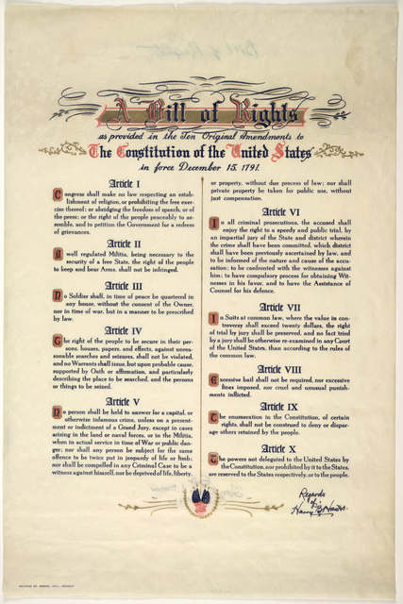
RIGHTS
- 4th amendment – You have the right to
- refuse* a government official to enter your home if the officer does not have a search warrant. An exception to this is if the officer suspects immediate danger or has good reason to believe that a crime is taking place.
- 5th amendment – You have the right to be silent. You do not have to answer questions. You can say, “I choose to be silent.”
- 6th amendment – You have the right to have help from a lawyer. You can say, “I want a lawyer.”
*refuse: say no; do not permit;
RESPONSIBILITIES
- You must tell the truth.
- You must say your correct name if asked.

IMMIGRATION LAW

How Does the Law Apply to You?
If the Immigration Service arrives at your house and knocks on your door, you do not always have to open the door. Usually, the Immigration Service needs a search warrant or arrest warrant with your name and address to enter your house. You do not have to allow them to enter if they don’t have a warrant. The exceptions are if they believe you are in danger, or if they believe that a crime is happening in your home. The Immigration Service can enter your home only if they have a warrant, or they think there is presently a crime happening in your home, or you give them permission to enter.
Even if the officers have a warrant and enter your home, you have the right to be silent. This means that you do not have to give any information to Immigration Service officials, except you must state your correct name. Other than saying your name, you can say, “I do not want to speak,” or “I want to talk to a lawyer before answering any questions.
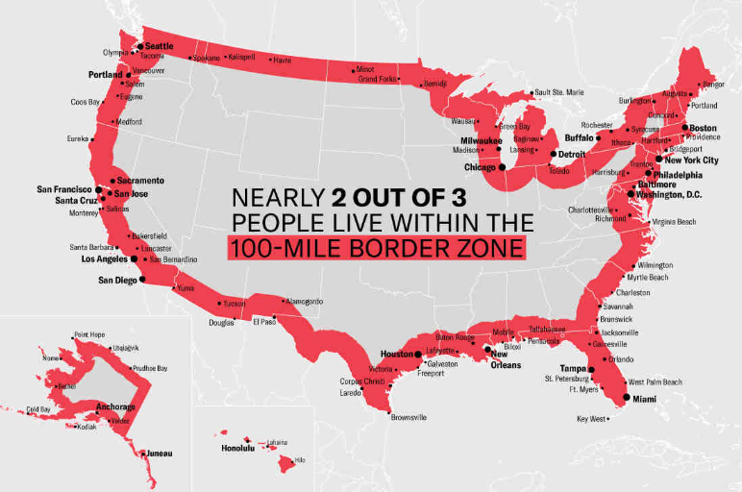
*Exception: Your rights at the border are different. The “border’” includes not only the line between the U.S. and Mexico or Canada, but also airports and areas that are within one hundred miles of the border, in international water, like the Pacific Ocean and areas close to the border, for example, the border checkpoint near San Clemente, California. In these border places, you have to prove that you have legal permission to be in the U.S. The Immigration Service can detain you to ask questions if you don’t. They can also search you or your bags without a search warrant. Remember that you always have the right to remain silent.
Copyright 2024, ACLU of New Mexico. Originally posted by the ACLU of New Mexico at https://www.aclu-nm.org/en/user-agreement. Automatically permitted distribution under the fair use clause.
Learn more:
- American Friends Service Committee: U.S. - Mexico Border Program
- San Diego Volunteer Lawyer Program
- Catholic Legal Immigration Network, Inc: Know Your Rights

IMMIGRANTS’ RIGHTS

Blanca’s Problem
Read about Blanca’s problem on page 6 again. Answer the questions.
Image generated by Recraft AI
- When the officer is standing outside Blanca’s door, what should Blanca do?  - She should pretend she isn’t at home; she should not open the door.  - She should ask to see a search warrant with her name on it.  - She should angrily tell the officer to go away. |  | - Does Blanca have to permit the officer to come into her house?  - Yes, because the officer represents the law.  - No, because he doesn’t have a search warrant with her name on it, and no crime is in progress.  - No, it’s her house, so she can refuse an officer in situations.
- What are Blanca’s rights?  - She has the right to get help from a lawyer.  - She has the right to be silent.  - She has the right to refuse to let a government officer enter her home unless he or she has a search warrant.  - All of the above |  | - Which amendments protect Blanca?  - 4th and 5th  - 4th and 6th  - 4th, 5th and 6th
- When the officer asks her questions, what should she say?
- She should say her true name only.
- She should lie and say a different name or give other false information.
- She should say that she wants to speak with a lawyer before answering any questions.
- She should say that she chooses to be silent.
- All of the above.
- Answers a, c, d, are correct.

IMMIGRANTS’ RIGHTS

Blanca’s Problem, Speaking Practice
A person is required by law to give his or her true name when asked by an officer of the law but no more. If a person is calm and respectful and knows the laws of the Constitution, he or she can feel safe when an officer comes to the door. The conversation below demonstrates how Blanca or other immigrants can speak to an immigration officer who comes to the door.
Practice the dialogue between Blanca and the immigration officer:
Officer: [Knocks on the door.]
Blanca: Who is it? [She does not open the door.]
Officer: This is Officer Green from U.S. Immigration and Customs Enforcement.
Blanca: May I see some ID, please?
Officer: [Officer Green holds up his picture ID to the peep hole in the door.]
Blanca: [Opens door a little bit.]
Officer: May I come in?
Blanca: [With calm voice:] I’m sorry, but, no, you may not come in. Who do you want to speak to?
Officer: Oscar Armenta.
Blanca: There is no Oscar Armenta here. You have the wrong apartment.
Officer: This is 22D. He lives at this address.
Blanca: This is 22D, but there is no Oscar Armenta. Maybe he lived here before I moved in.
Officer: What is your name? How long have you lived here? Who else lives here?
Blanca: My name is Blanca Moran. [She remains calm.] I do not want to answer any more questions.
Officer: Just a few questions, ma’am. [He moves toward the door.]
Blanca: [She continues to block the door.] I’m very sorry, but before you can come in, I need to see a search warrant with my name on it.
Officer: Is that really necessary? Do you have something to hide? Let me see your identification.
Blanca: [She does not move.] Because of my rights, I do not want to speak with you at this time, Sir. I want to speak to a lawyer before I answer any questions. Thank you and goodbye, Sir. [She closes the door.]

IMMIGRANTS’ RIGHTS

Blanca’s Problem, Speaking Practice
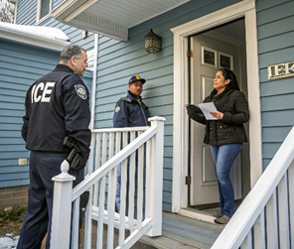
Image generated by Recraft AI
Practice the questions with a partner.
- What is happening in this picture?
- Does this person have to allow the officer to come in?
- Does this person have to say his or her name if the officer asks?
- Does this person have to answer all the officer’s questions?
- The officer asks to come into the house. What can this person do or say?
- The officer asks, “Do you have legal papers to be in the United States?” What can this person do or say?
- Which amendments or rights protect this person?
- Look at your Immigrants’ Resource Directory. Which agency can assist Blanca in this situation?
- How can Blanca contact this agency?
- Name one service this agency offers that matches Blanca’s needs.

IMMIGRANTS’ RIGHTS

David’s Problem
I worked 45 hours last week. I should have overtime.
- Talk about the pictures. What is the man looking at? Why is he upset?

Image generated by Recraft AI
- Read.
Many people immigrate to the U.S. because of employment opportunities. However, every worker needs to keep track of their work hours and read paycheck stubs carefully to be sure that they are compensated fairly.
David is a new immigrant who works for a construction company. He is looking at his pay stub. He wonders if he is being paid fairly. He is sure that he worked 45 hours, but he did not receive overtime pay for the extra hours. When employees work more than 40 hours in one week, employers must pay a higher wage for those extra hours. That’s the law.
David recently arrived in the U.S. and doesn’t have a green card yet, so he doesn’t know if his boss must follow employment laws or not. David wants to speak to someone about his pay, but he is worried. Could he lose his job? David works hard and wants to receive the pay he deserves.

- Comprehension Check Listen to the reading.
Circle T for true or F for false next to each statement.
- T F David worked 45 hours last week.
- T F David’s paycheck stub says he worked 40 hours.
- T F Overtime hours pay more than regular pay.
- T F David was paid a higher wage for his overtime hours.
- T F David thinks he might not be getting paid correctly.

IMMIGRANTS’ RIGHTS

Vocabulary
- Read the definitions and examples.
- fair /fairly: | reasonably and correctly according to the rules  “It’s not fair to pay her more than me if we are doing the same work. I want to be paid fairly.”
- keep track of: | to pay attention to the progress of something  “I’m on a diet, so I have to keep track of what I eat.”
- compensate: | to pay for work completed  “Volunteers are generous. They work hard but are not compensated for their time.”
- wonder: | to think about something; to ask yourself a question about something you want to know  “Asha speaks English very well. I wonder how she learned it.”
- deserve: | merit; to have earned something; to be worthy of something  “Trang has done good work all year. He deserves a raise.”

- Complete the sentences with one of the vocabulary words.
fairly | deserve | compensated | wonder | keep track of

- All children the opportunity to go to school.
- Look at those clouds! I if it is going to rain soon.
- I my hours to make sure that I am
for each hour I work.
- Employees expect to be for their time and effort.
- The law requires employers to pay workers .

IMMIGRANTS’ RIGHTS
Discussion
- Do you know anyone who has received an incorrect paycheck?
- Does this kind of problem happen in your country? What do the workers do when they do not receive fair pay?
- What might happen if David speaks to his employer about getting fair pay?
- What do you think David should do?
- What rights do you think David has?
Our rights and responsibilities in the United States are written in the Constitution. It is the highest law in the land. The Constitution guarantees the rights of all people in the United States, citizens and non-citizens. Amendments are changes to the Constitution. The first ten amendments are called the Bill of Rights. So far, there are 27 amendments.
RIGHTS
14th Amendment: We all have equal protection guaranteed under the law. Every person living in the United States has protection from being a victim of injustice. No one has a right to treat another person badly. This means that employers must treat all workers, both citizens and non-citizens, equally. Employers must follow the laws of the U.S, and all workers in the U.S. have the same right to fair compensation.
RESPONSIBILITIES
We must follow all the laws of the United States.
HOW DOES THE LAW APPLY TO YOU?

Employment rights are not related to immigration status. All employees in the U.S., including undocumented workers, have the same right to get fair pay. Documented and undocumented workers should receive at least the minimum wage. They should also get overtime pay for hours they work above 40 hours per week. Anyone can visit an Employee Rights Center to learn about his or her right to get fair pay.
Learn more on their website by clicking on this link: Employee Rights Center: Minimum Wage/Overtime Pay or use this QR code

IMMIGRANTS’ RIGHTS

David’s Problem
Bulk Buy Warehouse EARNINGS STATEMENT
EMPLOYEE NAME SOCIAL SEC NO. EMPLOYEE ID CHECK NO. PAY PERIOD PAY DATE
David Garcia 005-25-xxxx 1108 101 9/8 – 9/15 9/22
RATE HOURS CURRENT TOTAL DECUCTIONS CURRENT TOTAL
20.00 45.00 900.00 FEDERAL TAX 135.00
FICA TAX 40.20
FICA MEDICARE 9.60
Answer the following questions
- Which amendment protects David’s right to get fair pay?
- the 4th amendment
- the 14th amendment
- the 1st amendment
- Who is responsible for David knowing his rights about fair pay?
- David is.
- His employer is.
- David doesn’t have any rights.
- What are his rights?
- As an undocumented worker, he has no rights at work.
- He has the right to a minimum wage, but that is all.
- He has the right to fair pay according to the law, including overtime pay.
- What can David do?
- He can visit an Employee Rights Center to get advice.
- He can ask his employer to correct his paycheck.
- He can consult a lawyer.
- All of the above.

IMMIGRANTS’ RIGHTS

David’s Problem
I worked 45 hours last week. I should have overtime.
Image generated by Recraft AI
Practice the questions with a partner.
- What is happening in this picture?
- Who is responsible for knowing the number of hours a worker has worked, the worker or the boss?
- David is a new immigrant to the U.S. He doesn’t have a green card yet. Does the boss have to follow employment laws?
- Which amendment or right protects this person?
- What can this person do?
- Look at the Immigrants’ Resource Directory. Which agency can assist David in this situation?
- Name one service this agency offers that matches David’s needs.
- What is the procedure for making an appointment?

IMMIGRANTS’ RIGHTS


Zara’s Problem
1. Talk about the picture.
What is happening in the picture? How do the people feel? What do you think their relationship is to each other? What do you think will happen next?
2. Read about Zara’s problem.
Violence within a family, called domestic violence, is a widespread problem in the U.S. When the victim is an undocumented immigrant, she or he may feel especially helpless.
Image generated by Recraft AI
A few years ago Zara married Bob, a U.S. citizen. Zara doesn’t have any legal documents, but Bob said he would take care of the legal papers when they got married. Zara waited for Bob to file a petition for her, but he never did. He was kind when she married him, but he has changed. Now Bob abuses Zara physically and emotionally. She wants to leave him, but she doesn’t know if she can because she doesn’t have legal papers. Her son is also suffering from seeing the violence in their family. Bob tells Zara that if she tries to leave, he will report her to immigration. Zara has no family in the U.S. and no money of her own. She doesn’t know what to do.
3. Comprehension Check: Circle T for true or F for false next to each statement.
- T F Zara is a victim of violence in her home.
- T F Zara’s husband is a citizen.
- T F Zara was a citizen when she married Bob.
- T F Bob has filed an application for Zara to become a legal permanent resident.
- T F Bob says he will get her in trouble with immigration if she tries to leave him.
- T F Zara feels like she cannot change her life.

IMMIGRANTS’ RIGHTS

Vocabulary
4.Read the definitions and examples.
- domestic: relating to home and family
“It’s a domestic problem, not a public problem.”
- widespread: common, existing or happening in many places
“Cases of the flu were widespread this year.”
- file a petition: submit a request for something from a higher authority
“We filed a petition to the judge to ask for help.”
- abuse: treat someone badly (physically or psychologically)
“Domestic violence means that someone is abusing a family member.”
5. Complete the sentences with one of the vocabulary words.
domestic widespread file a petition abuse
- In the U.S., family members cannot hurt each other in a cruel way. We cannot
each other.
- The news was . Everyone heard about the accident.
- If you want to bring a family member from another country into the U.S., you must
.
- Cleaning the house, cooking and taking care of children are responsibilities.
6. Discuss the questions.
- Do you know anyone who has experienced domestic violence?
- What are the laws about a family member hitting another person in the family?
- What do you think Zara should do?
- What rights do you think Zara has?

IMMIGRANTS’ RIGHTS
Our rights and responsibilities in the United States are written in the Constitution. It is the highest law in the land. The Constitution guarantees the rights of all people in the United States, citizens and non-citizens. Amendments are changes to the Constitution. The first ten amendments are called the Bill of Rights. So far, there are 27 amendments.
RIGHTS
14th Amendment: This amendment says that every person living in the United States has equal protection under the law. In this case, the law gives Zara the right to protection from domestic violence.
RESPONSIBILITIES
You must follow all the laws of the U.S.
HOW DOES THE LAW APPLY TO YOU?
There are laws in the U.S. against abuse, even if the victim is without legal permission to be in the U.S. No one can be treated as a slave or victim. Zara’s husband may believe he has power over her because of her illegal status, but he does not. He must follow the laws of the U.S.
A legal aid agency can tell victims of domestic violence about VAWA, the Violence Against Women Act. This law protects immigrants from domestic violence. It was created in 1994 when Congress recognized that many women were not reporting domestic violence because their partners threatened not to help them apply for permanent residence or citizenship in the United States. In 2000, the law was changed to allow a greater number of immigrant victims of domestic violence to qualify for VAWA. Under this law, the victims are allowed to remain in the U.S. until a visa is available, and they are eligible to obtain work authorization. VAWA permits women like Zara to legally self-petition to stay in the U.S. They can start the process to become a permanent resident without their partner’s cooperation.
No one has to stay in an abusive situation.

Learn more by visiting the website through this
link: Casa Cornelia, or through this QR code

IMMIGRANTS’ RIGHTS

Zara’s Problem
Image generated by Recraft AI
Answer the following questions
- Does Bob have a legal right to hurt Zara emotionally or physically?
- No, because it’s against the law to treat anyone as a slave or victim.
- Yes, because he is Zara’s husband. The government cannot tell husbands how to treat their wives.
- Yes, because Zara gave up her rights when she entered the U.S. illegally.
- Which amendment protects Zara?
- The 4th amendment
- The 15th amendment
- The 14th amendment
- What are Zara’s rights?
- She has the right to be protected from domestic violence.
- She has the right to get transportation back to her native country.
- She doesn’t have any rights.
- What should Zara do?
- She should ignore her husband’s abuse.
- She should ask a legal aid agency to help her qualify for the benefits of VAWA.
- She should accept her husband’s decision not to help her with her legal papers.

IMMIGRANTS’ RIGHTS

Zara’s Problem
Image generated by Recraft AI
Practice the questions with a partner.
- What is happening in this picture?
- Does the victim have to stay in this situation?
- According to U.S. law, is it OK for the husband to hit his wife?
- Which amendment, right, or law protects this woman?
- What can this woman do?
- Which agency can assist Zara in this situation?
- How can Zara contact this agency?
- Name one service this agency offers that matches Zara’s needs.

IMMIGRANTS’ RIGHTS

Yonathan’s Problem

- Talk about the picture.
Who do you think the people are? What is happening? What do you think they are saying to each other? What do you think will happen next?
- Read.
Sometimes individuals are stopped on the street for questioning by immigration officers. This can be frightening for new immigrants.
Image generated by Recraft AI
Yonathan entered the U. S. illegally a few years ago to look for work. He found a good job in construction and has been working steadily without work authorization. He has also been taking English classes to improve his employment opportunities. One day, an immigration officer approached him on his way to school. Yonathan wanted to be polite, so he stopped walking. The officer asked him for his papers and Yonathan answered, “I don’t have any papers”. He felt like running away but decided not to run. Then the officer arrested him and sent him back to his country.
- Circle T for true or F for false next to each statement.
- T F Immigration officers sometimes ask people on the street to stop and answer questions.
- T F Yonathan is undocumented.
- T F Yonathan is a student and a construction worker.
- T F Yonathan continued walking after the immigration officer approached him.
- T F Yonathan was honest with the immigration officer.

IMMIGRANTS’ RIGHTS
- Read the definitions and examples.
- steadily: staying the same; continuously
“The students steadily improved as they practiced every day.”
- work authorization: permission to work legally
“I have applied for work authorization so that I can be legally employed.”
- approach(ed): move closer to somebody or something
“The students approached the teacher after class to ask a few more questions.”
- polite: showing good manners or courtesy
“Polite people say ‘please’ and ‘thank you’.”
- Complete the sentences with one of the vocabulary words.
steadily work authorization approached polite
- I wish the rain would stop. It has rained for two days.
- A stranger me to ask for directions to the airport.
- People who say, “Please,” and, “Thank you,” are .

- Without , it is difficult to get a good job. It’s easier to find work when you have legal papers.
Use your phone to practice the vocabulary with fun games on Quizlet
- Discussion
- Do you know anyone who has had experiences similar to Yonathan?
- Do you think Yonathan did the right thing to stop and answer the officer’s questions?
- What else could Yonathan have done?
- What rights do you think Yonathan has?

IMMIGRANTS’ RIGHTS
Our rights and responsibilities in the United States are written in the Constitution. It is the highest law in the land. The Constitution guarantees the rights of all people in the United States, citizens and non-citizens. Amendments are changes to the Constitution. The first ten amendments are called the Bill of Rights. So far, there are 27 amendments.
RIGHTS
5th amendment – You have the right to be silent. You do not have to answer questions. You can say, “I choose to be silent.”
6th amendment – You have the right to have help from a lawyer. You can say, “I want a lawyer.”
*Exception: Your rights at the border are different. The “border’” includes not only the line between the U.S. and Mexico or Canada, but also airports and areas close to the border, for example, the border checkpoint near San Clemente, California. In these border places, you have to prove that you have legal permission to be in the U.S. The Immigration Service can detain you to ask questions if you don’t. They can also search you or your bags without a search warrant. Remember that you always have the right to remain silent.
RESPONSIBILITIES
You must tell the truth.
You must say your correct name when asked.
HOW DOES THE LAW APPLY TO YOU?
If an Immigration Service official begins to ask you questions while you are walking down the street or in another public place such as a park, you can continue walking. The Immigration Service must allow you to keep walking if they do not have a good reason to stop you and ask you questions. They cannot stop you just because you look like you came from another country or because you speak with an accent. These are not good reasons. You don’t have to answer any questions. You have the right to remain silent. You can keep walking or say, “I choose to remain silent,” if they try to ask you questions.
An example of a good reason to stop you is if you are leaving a place where they have previously found many undocumented workers. That gives the officers reason to check for more undocumented workers. Also, do not run! If you run, you are giving them a good reason to arrest you because your actions indicate that you might have committed a crime. Remember that you have the right to remain silent.

IMMIGRANTS’ RIGHTS

Yonathan’s Problem
Review Questions
- Did Yonathan have to stop walking when the immigration officer approached him?
  - No, he had the right to keep walking.
  - Yes, he had to do whatever the officer asked him to do.
- Did Yonathan have to answer all of the officer’s questions?
Image generated by Recraft AI
  - Yes, he had to answer all the officer’s questions.
  - No, he only had to say his name.
- Which amendments protect Yonathan?
  - 14th
  - 4th and 5th
  - 5th and 6th
- What are Yonathan’s rights?
  - He has the right to remain silent and to have help from a lawyer.
  - He has no rights because he is undocumented.
  - He has the right to lie and make false statements.

IMMIGRANTS’ RIGHTS

Yonathan’s Problem
Image generated by Recraft AI
Practice the questions with a partner.
- What is happening in this picture?
- Does the man have to stop walking?
- Does the person have to say his name if the officer asks?
- Does the person have to answer all the officer’s questions?
- What can the person do or say?
- Name an amendment or right that protects this person.
- Which agency can assist Yonathan in this situation?
- How can Yonathan make an appointment with this agency?
- Name one service this agency offers that matches Yonathan’s needs.
View the oral assessment:

LAW ENFORCEMENT


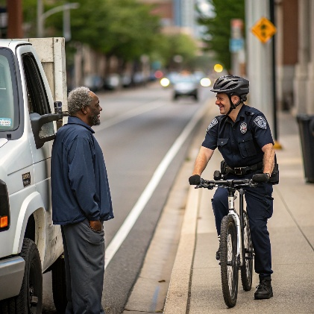
Understanding Different Types of Law Enforcement
Image generated by Recraft AI
Image generated by Recraft AI
Image generated by Recraft AI
- Talk about the picture.
What do you notice about these officers? How are their uniforms different or similar? Why do you think it's important to know the difference between these officers? Have you ever interacted with any of these types of officers?
- Read.
In the United States, there are many different types of law enforcement officers. Each type of officer has different responsibilities, different powers, and different goals. It is important for immigrants to understand the differences so they know their rights in each situation.
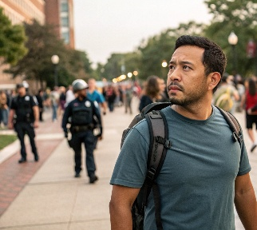
José is a student at the community college. One day, as he was walking to class, he saw three different types of officers on campus. He wasn't sure who they were or what they could ask him to do. He wondered, "Can all of these officers ask about my immigration status? Do I have to answer their questions? What are my rights with each type of officer?"
Image generated by Recraft AI
- Circle T for true or F for false next to each statement.
- T F All law enforcement officers in the United States have the same powers.
- T F José was concerned about what questions the officers could ask him.
- T F It's important for immigrants to know how types of officers differ.
- T F José knows exactly what his rights are with each type of officer.

LAW ENFORCEMENT

Vocabulary
- Read the definitions and examples.
- jurisdiction: | the official power to make legal decisions and judgments; the territory or area where an organization has authority  "The San Diego Police Department has jurisdiction within the city limits."
- authority: | the power or right to give orders, make decisions, and enforce obedience  "Each type of officer has different authority depending on their job."
- enforcement: | making sure someone follows a law, rule, or duty  "Immigration enforcement is the responsibility of federal agents, not local police."
- Complete the sentences with one of the vocabulary words.
- ICE officers have the to enforce federal immigration laws.
- Local police have within their city or county, but not in other areas.
- The of immigration laws is primarily a federal responsibility.

Different Types of Law Enforcement
- Immigration and Customs Enforcement (ICE)

Purpose: ICE is a federal agency responsible for enforcing immigration laws and investigating criminal activity involving immigrants.
Image generated by Recraft AI
Appearance:
- Dark blue uniforms with "POLICE ICE" or "HSI" on them
- Federal badges
- Sometimes wear plain clothes with badges on belts or around neck

LAW ENFORCEMENT
Immigration and Customs Enforcement (ICE) continued…
What they can do: | What they cannot do:
- Ask about your immigration status (You don’t have to answer.)  - Request to see your immigration documents (You don’t have to show them.)  - Arrest people for immigration violations  - Detain undocumented immigrants | - Enter your home without a warrant or your permission  - Stop you without good reason to believe you are breaking immigration law  - Arrest you for using your rights |   badge
- San Diego Police Department (SDPD)
      Image generated by Easy-Peasy.AI  patch  badge | Purpose: SDPD officers enforce local and state laws and protect public safety within the city of San Diego.  Appearance:  - Dark blue or black uniforms with “San Diego Police” patches on each arm  - San Diego Police Department badge on chest  - Dark blue or black pants    - Local police vehicles marked "San Diego Police" with “America’s Finest”
What they can do:  - Enforce traffic laws  - Respond to emergency calls  - Arrest people for criminal violations  - Ask for identification if they suspect a crime | What they cannot do:  - Enforce federal immigration laws  - Stop someone only to investigate immigration status  - Ask about immigration status during routine interactions

LAW ENFORCEMENT
- San Diego Community College District Police
      badge  patch  Image generated by Recraft AI | Purpose: Campus police maintain safety on college campuses and enforce laws within college property. They go through the same training as San Diego Police.  Appearance:  - Often wear the same uniform as SDPD    - SDCCD Campus Police badge on chest and patches on arms  - Sometimes wear lighter blue uniforms  Image generated by Recraft AI  - College district police vehicles  
What they can do:  - Enforce laws on campus property  - Respond to emergencies on campus  - Provide campus security  - Issue citations for campus violations | What they cannot do:  - Enforce immigration laws  - Stop someone only to investigate immigration status  - Share student information with ICE without a warrant

Our rights and responsibilities in the United States are written in the Constitution. It is the highest law in the land. The Constitution guarantees the rights of all people in the United States, citizens and non-citizens.

LAW ENFORCEMENT

Your Rights with Different Officers
RIGHTS IN THE U.S.
- With all officers, you have the right to remain silent (5th Amendment)
- With all officers, you have the right to speak to a lawyer (6th Amendment)
- With all officers, you have the right to refuse searches of your person, car, or home without a warrant (4th Amendment)
YOUR RIGHTS HERE IN CALIFORNIA
California has special laws that limit how local police and campus police can cooperate with immigration enforcement:
- The California Values Act (SB 54) prohibits local police from:
  - Asking about immigration status
  - Detaining someone based on ICE requests
  - Using resources to enforce immigration laws
- California AB 21 protects students by requiring college campuses to:
  - Refuse campus access to ICE without legal requirements
  - Not share student information with ICE
  - Provide legal services information to students
WHAT TO DO IN DIFFERENT SITUATIONS
If approached by ICE:  - Stay calm and don’t run or resist  - You can remain silent or ask, "Am I free to go?"  - If you are not being arrested, you can calmy walk away  - You do not have to show immigration papers or ID unless they have good reason to believe you are breaking an immigration law.  - If you are being arrested, you can say, "I want to speak to a lawyer" and remain silent until advised by a lawyer | If approached by SDPD:  - Stay calm and don’t run or resist  - You can remain silent or ask, "Am I free to go?"  - Give the information on your Driver’s License, Insurance Card, and Registration if stopped while driving  - They should not ask about immigration status  - You do not have to show immigration papers
If approached by Campus Police:
- Stay calm and don’t run or resist
- You can identify yourself as a student if you are one
- They should not ask about immigration status
- Campus police focus on campus safety, not immigration enforcement
- You can ask to speak with college legal services or a lawyer

IMMIGRANTS’ RIGHTS

Agencies that Help Immigrants
- Talk about these questions with your classmates in a small group.
- What kinds of legal problems do immigrants sometimes have in the U. S.?
- Where can you find information about the law and immigration?
- Have you ever received assistance from a lawyer or immigration service in the U.S.?

- Read the paragraphs below. Then listen to your teacher read the text out loud. Ask questions about words you don’t understand.
Living in the United States usually means an immigrant will enjoy an exciting new life as well as difficult challenges. For example, benefits of living in the U.S. might include safety, social freedoms or better economic opportunities. At the same time, life in the U.S. requires learning about new laws and new responsibilities. Knowing the law and how to take care of your legal paperwork will help you fully enjoy the safety, social freedoms and economic opportunities that new immigrants look forward to. Understanding how to do this can be an enormous challenge.
People in San Diego are fortunate because there are several agencies that offer affordable assistance to individuals who have a legal issue or problem. Services include: assistance to change your legal status, leave an abusive family situation, resolve a problem with an employer, or bring another family member into the United States. Many more services are offered by a variety of agencies.
The lessons that follow will introduce you to several of these agencies. You will collect information about the agencies and learn the services they offer. Please keep these lessons at home for future reference. You never know when you might need help through a difficult time.
Use your phone to listen to the reading:


IMMIGRANTS’ RIGHTS

Agencies that Help Immigrants
- Answer the questions with complete sentences.
- According to the text, what are some of the benefits of living in the U.S.?

- What does living in the United States require?

- Is there any inexpensive help available in San Diego to assist immigrants?

- Match the words on the left with the words on the right.
- an advantage, something helpful  - information  - a question, a concern  - a difficulty, a hardship  - inexpensive, you have ability to pay  - documents, official papers  - unfair, offensive, cruel, insulting  - expect, hope for, anticipate  - very big, huge  - position in society relating to the law  - related to the law | - a challenge  - paperwork  - look forward to  - enormous  - affordable  - legal  - legal status  - abusive  - reference  - an issue  - a benefit
Practice the vocabulary on Quizlet:


IMMIGRANTS’ RIGHTS

Agencies and Services
Read about each situation. Use your Immigrants’ Rights Resource Directory to answer the questions.
I should have overtime.
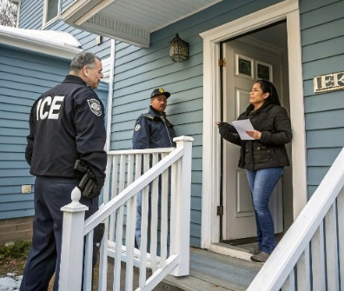
- An immigration officer knocked on Blanca’s door. He was looking for someone else but also wanted to question Blanca and her husband. Blanca allowed the officer to enter her home. She and her husband answered the officer’s questions truthfully. Since they were undocumented, her husband was arrested.
- Which agency can assist Blanca in this situation?
Image generated by Recraft AI
- How can Blanca contact this agency?
- Name one service this agency offers that matches Blanca’s needs.


- David works for a construction company. He recently arrived in the U.S. so he doesn’t have a green card. He received his pay check and thinks that he did not get paid correctly. He worked overtime but the overtime pay is missing from his check.
- Which agency can assist David in this situation?
- Name one service this agency offers that matches David’s needs.
- What is the procedure to make an appointment?
Image generated by Recraft AI

- Zara is a victim of domestic violence. She wants to get out of this abusive situation. Her husband is a U.S. citizen, and she is undocumented. Her husband says he will report her to immigration if she tries to leave him.
- Which agency can assist Zara in this situation?
- How can Zara contact this agency?
- Name one service this agency offers that matches Zara’s needs.
Image generated by Recraft AI

- Yonathan was walking to adult school one day when an immigration officer stopped him on the street to ask him some questions.
- Which agency can assist Yonathan in this situation?
- How can Yonathan make an appointment with this agency?
- Name one service this agency offers that matches Yonathan’s needs.
Image generated by Recraft AI

