Contents
Handout #1: Introduction – Work Problems (Task 1) 2
Handout #2: Introduction – Parts of an Email (Task 1) 4
Handout #3: Practice 1 – Parts of an Email (Task 1) 8
Handout #4: Practice 1 – Parts of an Email – Answer Key (Task 1) 9
Handout #5: Practice 2 – Write an Email (Task 1) 10
Handout #6: Practice 2 – Write an Email – Example Answer (Task 1) 11
Handout #7: Practice 3 – Write an Email (Task 1) 12
Handout #8: Practice 3 – Write an Email – Example Answer (Task 1) 13
Handout #9: Practice 4 – Write an Email (Task 1) 14
Handout #10: Practice 4 – Write an Email – Example Answer (Task 1) 15
Handout #11: Practice 5 – Write an Email (Task 1) 16
Handout #12: Practice 5 – Write an Email – Example Answer (Task 1) 17
Handout #13: Practice 6 – Write an Email (Task 1) 18
Handout #14: Practice 6 – Write an Email – Example Answer (Task 1) 19
Handout #15: Practice 7 – Write an Email (Taks 1) 20
Handout #16: Practice 7 – Write an Email – Example Answer (Taks 1) 21
Handout #17: Practice 8 – Write an Email (Task 1) 22
Handout #18: Practice 8 – Write an Email – Example Answer (Task 1) 23
Handout #19: Practice 9 – Write an Email (Task 1) 24
Handout #20: Practice 9 – Write an Email – Example Answer (Task 1) 25
Handout #21: Practice 10 – Write an Email (Task 1) 26
Handout #22: Practice 10 – Write an Email – Example Answer (Task 1) 27
Handout #23: Introduction – Reasons to be Late to Work (Task 2) 28
Handout #24: Practice 1 – Reasons to be Late to Work (Task 2) 29
Handout #25: Practice 1 – Reasons to be Late to Work – Answer Key (Task 2) 30
Handout #26: Practice 2 – Reasons to be Late to Work (Task 2) 31
Handout #27: Practice 2 – Reasons to be Late to Work – Answer Key (Task 2) 32
Handout #28: Practice 3 – Role Play (Task 2) 33
Handout #29: Practice 3 Role Play – Example Answers (Task 2) 34

Introduction – Work Problems (Task 1)
These are examples of work problems:
My computer is not working. It is broken. | 
The air conditioning (AC) in my office is broken. | 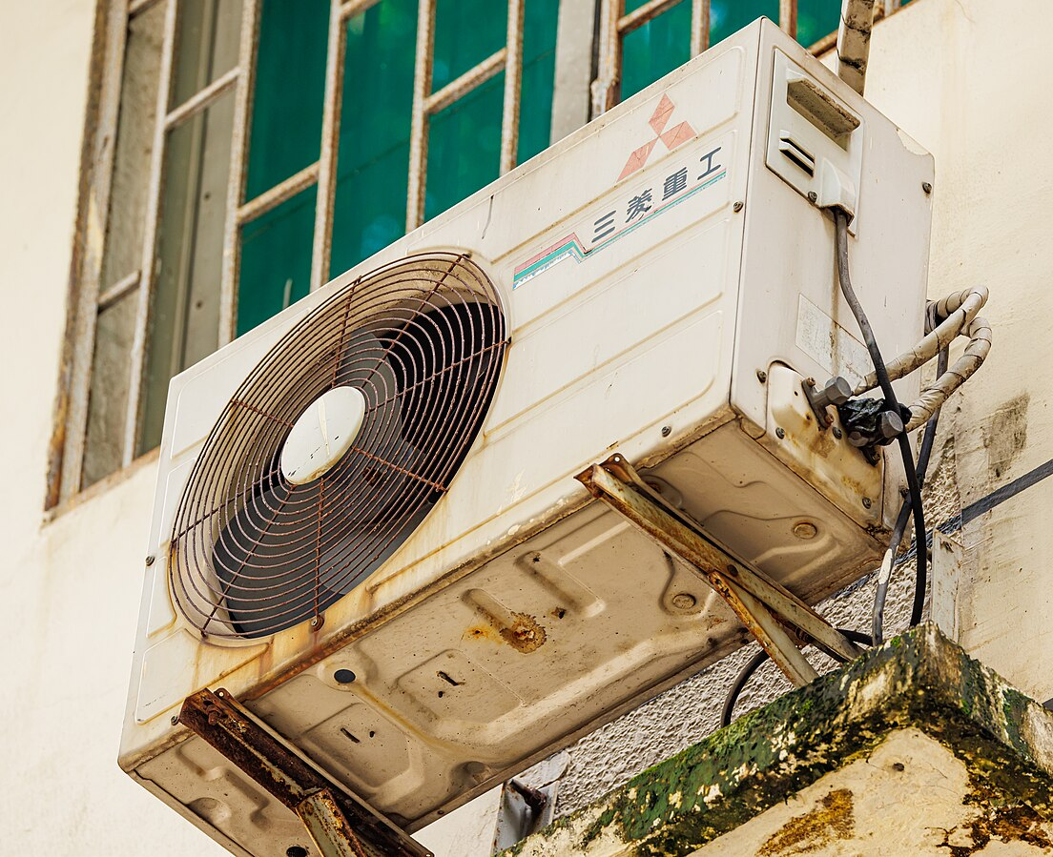
I am allergic to my co-worker’s body smell. | 
My co-worker is late every day. I have to do his work. | 
My co-worker’s breath has a strong smell after lunch. | 

Handout #1: Introduction – Work Problems, cont’d (Task 1)
My co-worker leaves garbage on our desk. | 
I am allergic to my co-worker’s perfume. | 
My co-worker talks on her phone during work hours. | 
My co-worker warms up fish in the microwave for lunch. The break room smells. | 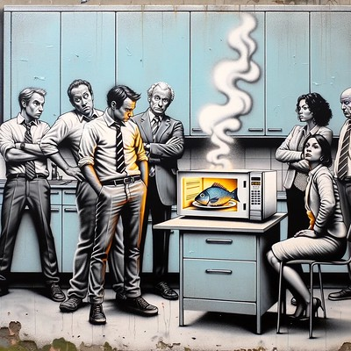

Introduction – Parts of an Email (Task 1)
There are SEVEN parts of an email.
Part 1 – To: who you are sending the email to (must be a correct email address)
To: | elcivicsemail@gmail.com
CC:
Subject:

GREETING
BODY
CLOSING
ELECTORNIC SIGNATURE
Part 2 – CC: carbon copy (you can email a copy to another person)
To:
CC: | yourteacher@mdusd.org
Subject:

GREETING
BODY
CLOSING
ELECTORNIC SIGNATURE
Part 3 – Subject: what the email is about: Work Problem
To:
CC:
Subject: | Work Problem

GREETING
BODY
CLOSING
ELECTORNIC SIGNATURE
Handout 2: Introduction – Parts of an Email, cont’d (Task 1)
Part 4 – Greeting: the first line of the email : Dear __________,
To:
CC:
Subject:

GREETING: Dear Mrs. Schieber,
BODY
CLOSING
ELECTORNIC SIGNATURE
Part 5 – Body: message of the email
To:
CC:
Subject:

GREETING
BODY: I have a problem with furniture in my classroom. I have 45 students and only 42 chairs. Today, one chair fell down and broke. The chair might cut a student. Could you please help me with my situation? I would like to have at least 4 more chairs for my students. I really appreciate your help.
CLOSING
ELECTORNIC SIGNATURE

Handout 2: Introduction – Parts of an Email, cont’d (Task 1)
Part 6 – Closing: the last line of the email: Sincerely, Yours, Best wishes, Thankfully, etc.
To: | elcivicsemail@gmail.com
CC:
Subject:

GREETING
BODY
CLOSING: Sincerely, / Yours, / Best wishes, / Thankfully,
ELECTORNIC SIGNATURE
Part 7 – Electronic Signature: your name and contact information (phone number)
To: | elcivicsemail@gmail.com
CC:
Subject:

GREETING
BODY
CLOSING
ELECTRONIC SIGNATURE: Terie Foglizzo
925-655-9251

Handout 2: Introduction – Parts of an Email, cont’d (Task 1)
Example Email with all SEVEN Parts:
To: | elcivicsemail@gmail.com
CC: | yourteacher@mdusd.org
Subject: | Work Problem

Dear Ms. Schieber,
I have a problem with the furniture in my classroom. I have 45 students and only 42 chairs. Today, one chair fell down and broke. The chair might cut a student. Could you please help me with my situation? I would like to have at least 4 more chairs for my students. I really appreciate your help.
Sincerely,
Terie Foglizzo
925-655-9251

Practice 1 – Parts of an Email (Task 1)
Directions: Label the SEVEN Parts of the email below.
To: | elcivicsemail@gmail.com
CC: | yourteacher@mdusd.org
Subject: | Work Problem

Dear Ms. Schieber,
I have a problem with the furniture in my classroom. I have 45 students and only 42 chairs. Today, one chair fell down and broke. The chair might cut a student. Could you please help me with my situation? I would like to have at least 4 more chairs for my students. I really appreciate your help.
Sincerely,
Terie Foglizzo
925-655-9251

Practice 1 – Parts of an Email – Answer Key (Task 1)
Directions: Label the SEVEN Parts of the email below.
To: | elcivicsemail@gmail.com  Part 1 – To
CC: | yourteacher@mdusd.org  Part 2 – CC
Subject: | Work Problem  Part 3 – Subject

Dear Ms. Schieber,
Part 4 – Greeting
I have a problem with the furniture in my classroom. I have 45 students and only 42 chairs. Today, one chair fell down and broke. The chair might cut a student. Could you please help me with my situation? I would like to have at least 4 more chairs for my students. I really appreciate your help.
Part 6 – Closing
Part 5 – Body
Sincerely,
Terie Foglizzo
Part 7 – Electronic Signature
925-655-9251

Practice 2 – Write an Email (Task 1)
Work Problem:
Directions: Use the information below to write an email to your boss, Mrs. White (janewhite@gmail.com) and cc her secretary, Jack (jackblack@gmail.com).
You have to finish your work by tomorrow. But your computer is broken. Tell your boss about the problem. Ask your boss to get your computer fixed today. Your phone number is (925) 123-5555.
To:
CC:
Subject:

Practice 2 – Write an Email – Example Answer (Task 1)
Work Problem:
Directions: Use the information below to write an email to your boss, Mrs. White (janewhite@gmail.com) and cc her secretary, Jack (jackblack@gmail.com).
You have to finish your work by tomorrow. But your computer is broken. Tell your boss about the problem. Ask your boss to get your computer fixed today. Your phone number is (925) 123-5555.
To: | janewhite@gmail.com
CC: | jackblack@gmail.com
Subject: | Work Problem

Dear Mrs. White,
I have a problem. I have to finish my work by tomorrow. But my computer is broken. Can you get it fixed today? Thank you.
Sincerely,
(Write your first and last name)
(925) 123-5555

Practice 3 – Write an Email (Task 1)
Work Problem:
Directions: Use the information below to write an email to your boss, Mrs. White (janewhite@gmail.com) and cc her secretary, Jack (jackblack@gmail.com).
It is 100 degrees outside. But your air conditioning is broken in the office where you work. Tell your boss about the problem. Ask your boss to please get the air conditioning fixed today. Your phone number is (925) 456-7878.
To:
CC:
Subject:

Practice 3 – Write an Email – Example Answer (Task 1)
Work Problem:
Directions: Use the information below to write an email to your boss, Mrs. White (janewhite@gmail.com) and cc her secretary, Jack (jackblack@gmail.com).
It is 100 degrees outside. But your air conditioning is broken in the office where you work. Tell your boss about the problem. Ask your boss to please get the air conditioning fixed today. Your phone number is (925) 456-7878.
To: | janewhite@gmail.com
CC: | jackblack@gmail.com
Subject: | Work Problem

Dear Mrs. White,
I have a problem. It is 100 degrees outside. But my air conditioning is broken in the office where I work. Can you please get it fixed today? Thank you.
Sincerely,
(Write your first and last name)
(925) 456-7878

Practice 4 – Write an Email (Task 1)
Work Problem:
Directions: Use the information below to write an email to your boss, Mrs. White (janewhite@gmail.com) and cc her secretary, Jack (jackblack@gmail.com).
You sit next to a co-worker who has a strong smell. The smell makes you feel sick. Tell your boss about the problem. Ask your boss to please talk to your co-worker about this. Your phone number is (925) 987-2222.
To:
CC:
Subject:

Practice 4 – Write an Email – Example Answer (Task 1)
Work Problem:
Directions: Use the information below to write an email to your boss, Mrs. White (janewhite@gmail.com) and cc her secretary, Jack (jackblack@gmail.com).
You sit next to a co-worker who has a strong smell. The smell makes you feel sick. Tell your boss about the problem. Ask your boss to please talk to your co-worker about this. Your phone number is (925) 987-2222.
To: | janewhite@gmail.com
CC: | jackblack@gmail.com
Subject: | Work Problem

Dear Mrs. White,
I have a problem. I sit next to a co-worker who has a strong smell. The smell makes me feel sick. Can you please talk to her about this? Thank you.
Sincerely,
(Write your first and last name)
(925) 987-2222

Practice 5 – Write an Email (Task 1)
Work Problem:
Directions: Use the information below to write an email to your boss, Mrs. White (janewhite@gmail.com) and cc her secretary, Jack (jackblack@gmail.com).
You come to work on time. But your co-worker is always late. You have to do his work for him. Tell your boss about the problem. Ask your boss to tell him to come on time. Your phone number is (925) 444-5678.
To:
CC:
Subject:

Practice 5 – Write an Email – Example Answer (Task 1)
Work Problem:
Directions: Use the information below to write an email to your boss, Mrs. White (janewhite@gmail.com) and cc her secretary, Jack (jackblack@gmail.com).
You come to work on time. But your co-worker is always late. You have to do his work for him. Tell your boss about the problem. Ask your boss to tell him to come on time. Your phone number is (925) 444-5678.
To: | janewhite@gmail.com
CC: | jackblack@gmail.com
Subject: | Work Problem

Dear Mrs. White,
I have a problem. I come to work on time. But my co-worker is always late. I have to do his work for him. Can you tell him to come on time? Thank you.
Sincerely,
(Write your first and last name)
(925) 444-5678

Practice 6 – Write an Email (Task 1)
Work Problem:
Directions: Use the information below to write an email to your boss, Mrs. White (janewhite@gmail.com) and cc her secretary, Jack (jackblack@gmail.com).
You can smell your co-worker’s breath after lunch. The smell makes you feel sick. Tell your boss about the problem. Ask your boss to talk to your co-worker about brushing her teeth after lunch. Your phone number is (925) 789-1111.
To:
CC:
Subject:

Practice 6 – Write an Email – Example Answer (Task 1)
Work Problem:
Directions: Use the information below to write an email to your boss, Mrs. White (janewhite@gmail.com) and cc her secretary, Jack (jackblack@gmail.com).
You can smell your co-worker’s breath after lunch. The smell makes you feel sick. Tell your boss about the problem. Ask your boss to talk to your co-worker about brushing her teeth after lunch. Your phone number is (925) 789-1111.
To: | janewhite@gmail.com
CC: | jackblack@gmail.com
Subject: | Work Problem

Dear Mrs. White,
I have a problem. I can smell my co-worker’s breath after lunch. The smell makes me feel sick. Can you talk to her about brushing her teeth after lunch? Thank you.
Sincerely,
(Write your first and last name)
(925) 789-1111

Practice 7 – Write an Email (Taks 1)
Work Problem:
Directions: Use the information below to write an email to your boss, Mrs. White (janewhite@gmail.com) and cc her secretary, Jack (jackblack@gmail.com).
There is old food and garbage on your co-worker’s desk. You sit next to your co-worker. Your papers get dirty. Tell your boss about the problem. Ask your boss to tell him to clean up his desk. Your phone number is (925) 321-7777.
To:
CC:
Subject:

Practice 7 – Write an Email – Example Answer (Taks 1)
Work Problem:
Directions: Use the information below to write an email to your boss, Mrs. White (janewhite@gmail.com) and cc her secretary, Jack (jackblack@gmail.com).
There is old food and garbage on your co-worker’s desk. You sit next to your co-worker. Your papers get dirty. Tell your boss about the problem. Ask your boss to tell him to clean up his desk. Your phone number is (925) 321-7777.
To: | janewhite@gmail.com
CC: | jackblack@gmail.com
Subject: | Work Problem

Dear Mrs. White,
I have a problem. There is old food and garbage on my co-worker’s desk. I sit next to my co-worker. My papers get dirty. Can you tell him to clean up his desk? Thank you.
Sincerely,
(Write your first and last name)
(925) 321-7777

Practice 8 – Write an Email (Task 1)
Work Problem:
Directions: Use the information below to write an email to your boss, Mrs. White (janewhite@gmail.com) and cc her secretary, Jack (jackblack@gmail.com).
Your co-worker wears a lot of perfume. You are allergic to the smell. It makes you sneeze. Tell your boss about the problem. Ask your boss to tell her not to wear perfume to work. Your phone number is (925) 555-6789.
To:
CC:
Subject:

Practice 8 – Write an Email – Example Answer (Task 1)
Work Problem:
Directions: Use the information below to write an email to your boss, Mrs. White (janewhite@gmail.com) and cc her secretary, Jack (jackblack@gmail.com).
Your co-worker wears a lot of perfume. You are allergic to the smell. It makes you sneeze. Tell your boss about the problem. Ask your boss to tell her not to wear perfume to work. Your phone number is (925) 555-6789.
To: | janewhite@gmail.com
CC: | jackblack@gmail.com
Subject: | Work Problem

Dear Mrs. White,
I have a problem. My co-worker wears a lot of perfume. I am allergic to the smell. It makes me sneeze. Can you please tell her not to wear perfume to work? Thank you.
Sincerely,
(Write your first and last name)
(925) 555-6789

Practice 9 – Write an Email (Task 1)
Work Problem:
Directions: Use the information below to write an email to your boss, Mrs. White (janewhite@gmail.com) and cc her secretary, Jack (jackblack@gmail.com).
Your co-worker talks on her cell phone during work. She is very loud. You can’t think. Tell your boss about the problem. Ask your boss to tell her not to talk on her cell phone in the office. Your phone number is (925) 654-3232.
To:
CC:
Subject:

Practice 9 – Write an Email – Example Answer (Task 1)
Work Problem:
Directions: Use the information below to write an email to your boss, Mrs. White (janewhite@gmail.com) and cc her secretary, Jack (jackblack@gmail.com).
Your co-worker talks on her cell phone during work. She is very loud. You can’t think. Tell your boss about the problem. Ask your boss to tell her not to talk on her cell phone in the office. Your phone number is (925) 654-3232.
To: | janewhite@gmail.com
CC: | jackblack@gmail.com
Subject: | Work Problem

Dear Mrs. White,
I have a problem. My co-worker talks on her cell phone during work. She is very loud. I can’t think. Can you please tell her not to talk on her cell phone in the office? Thank you.
Sincerely,
(Write your first and last name)
(925) 654-3232

Practice 10 – Write an Email (Task 1)
Work Problem:
Directions: Use the information below to write an email to your boss, Mrs. White (janewhite@gmail.com) and cc her secretary, Jack (jackblack@gmail.com).
Your co-worker warms up fish in the microwave for lunch. The break room smells very bad. Tell your boss about the problem. Ask your boss to tell him not to warm up fish in the break room. Your phone number is (925) 222-6789.
To:
CC:
Subject:

Practice 10 – Write an Email – Example Answer (Task 1)
Work Problem:
Directions: Use the information below to write an email to your boss, Mrs. White (janewhite@gmail.com) and cc her secretary, Jack (jackblack@gmail.com).
Your co-worker warms up fish in the microwave for lunch. The break room smells very bad. Tell your boss about the problem. Ask your boss to tell him not to warm up fish in the break room. Your phone number is (925) 222-6789.
To: | janewhite@gmail.com
CC: | jackblack@gmail.com
Subject: | Work Problem

Dear Mrs. White,
I have a problem. My co-worker warms up fish in the microwave for lunch. The break room smells very bad. Can you tell him not to warm up fish in the break room? Thank you.
Sincerely,
(Write your first and last name)
(925) 222-6789

Introduction – Reasons to be Late to Work (Task 2)
Examples of acceptable (ok) reasons to be late to work:
  Car accident |   Car problems |   House fire
  House problems | 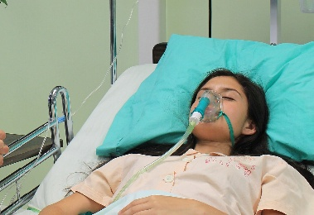  Medical emergency |   Traffic jam
Examples of unacceptable (not ok) reasons to be late to work:
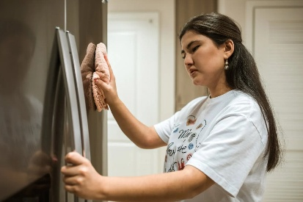  Cleaning the house |   Drinking with friends |   Going grocery shopping
  Going to a party |   Waking up late |   Watching a soccer game

Practice 1 – Reasons to be Late to Work (Task 2)
Directions: Write the correct words for each picture. Then circle “acceptable” (ok) or “unacceptable” (not ok).
House problems | Cleaning the house | Going to a party
Watching a soccer game | Car accident | Medical emergency

Acceptable / Unacceptable | Acceptable / Unacceptable
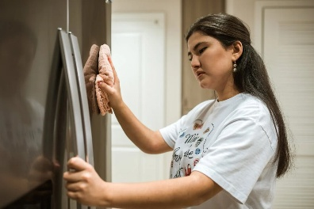  Acceptable / Unacceptable | Acceptable / Unacceptable
  Acceptable / Unacceptable | Acceptable / Unacceptable

Practice 1 – Reasons to be Late to Work – Answer Key (Task 2)
Directions: Write the correct words for each picture. Then circle “acceptable” (ok) or “unacceptable” (not ok).
House problems | Cleaning the house | Going to a party
Watching a soccer game | Car accident | Medical emergency

Medical emergency  Acceptable / Unacceptable | Going to a party  Acceptable / Unacceptable
Cleaning the house  Acceptable / Unacceptable | House problems  Acceptable / Unacceptable
Car accident  Acceptable / Unacceptable | Watching a soccer game  Acceptable / Unacceptable

Practice 2 – Reasons to be Late to Work (Task 2)
Directions: Write the correct words for each picture. Then mark “acceptable” (ok) or “unacceptable” (not ok).
Waking up late | Traffic jam | Going grocery shopping
House fire | Car problems | Drinking with friends

Acceptable / Unacceptable | Acceptable / Unacceptable
Acceptable / Unacceptable | Acceptable / Unacceptable
Acceptable / Unacceptable | Acceptable / Unacceptable

Practice 2 – Reasons to be Late to Work – Answer Key (Task 2)
Directions: Write the correct words for each picture. Then mark “acceptable” (ok) or “unacceptable” (not ok).
Waking up late | Traffic jam | Going grocery shopping
House fire | Car problems | Drinking with friends

- House fire  Acceptable / Unacceptable | - Drinking with friends  Acceptable / Unacceptable
- Going grocery shopping  Acceptable / Unacceptable | - Car problems  Acceptable / Unacceptable
- Waking up late  Acceptable / Unacceptable | - Traffic jam  Acceptable / Unacceptable

Practice 3 – Role Play (Task 2)
Directions: Practice this role play between a worker and the boss. On test day, you will be the worker. Tell your boss, Mrs. Plant, that you need the day off today. Tell her an acceptable (ok) reason why you need the day off. Tell her you will be back tomorrow.
Secretary: Hello. This is the secretary. Who do you want to talk to?
Worker: (1. Ask to speak to Mrs. Plant.)
Boss: This is Mrs. Plant. What is your name?
Worker: (2. Tell her your name.)
Boss: Hello (say the student’s name), How can I help you?
Worker: (3. Tell her you need the day off today.)
Boss: Why do you need the day off today?
Worker: (4. Tell her the reason.)
Boss: Oh, I’m sorry to hear that. Will you be back at work tomorrow?
Worker: (5. Answer her question.)
Boss: Ok, I hope everything will be ok soon. See you tomorrow.
Worker: (6. Thank Mrs. Plant and say goodbye.)



Practice 3 Role Play – Example Answers (Task 2)
Directions: Practice this role play between a worker and the boss. On test day, you will be the worker. Tell your boss, Mrs. Plant, that you need the day off today. Tell her an acceptable (ok) reason why you need the day off. Tell her you will be back tomorrow.
Secretary: Hello. This is the secretary. Who do you want to talk to?
Worker: (1) Hello. I want to talk to Mrs. Plant.
Boss: This is Mrs. Plant. What is your name?
Worker: (2) My name is (say your name).
Boss: Hello (say the student’s name), How can I help you?
Worker: (3) I need the day off today.
Boss: Why do you need the day off today?
Worker: (4) (Say one acceptable reason. For example:)
I had a car accident.
I have car problems.
I had a house fire.
I have house problems.
I have a medical emergency.
There is a traffic jam.
Boss: Oh, I’m sorry to hear that. Will you be back tomorrow?
Worker: (5) Yes, I will be back tomorrow.
Boss: Ok, I hope everything will be ok soon. See you tomorrow.
Worker: (6) Thank you. Goodbye.

