Contents
Handout #1: Introduction – Work Problems (Task 1) 2
Handout #2: Practice 1 – Write an Email (Task 1) 4
Handout #3: Practice 1 – Write an Email – Example Answer (Task 1) 5
Handout #4: Practice 2 – Write an Email (Task 1) 6
Handout #5: Practice 2 – Write an Email – Example Answer (Task 1) 7
Handout #6: Practice 3 – Write an Email (Task 1) 8
Handout #7: Practice 3 – Write an Email – Example Answer (Task 1) 9
Handout #8: Practice 4 – Write an Email (Task 1) 10
Handout #9: Practice 4 – Write an Email – Example Answer (Task 1) 11
Handout #10: Practice 5 – Write an Email (Task 1) 12
Handout #11: Practice 5 – Write an Email – Example Answer (Task 1) 13
Handout #12: Practice 6 – Write an Email (Taks 1) 14
Handout #13: Practice 6 – Write an Email – Example Answer (Taks 1) 15
Handout #14: Practice 7 – Write an Email (Task 1) 16
Handout #15: Practice 7 – Write an Email – Example Answer (Task 1) 17
Handout #16: Practice 8 – Write an Email (Task 1) 18
Handout #17: Practice 8 – Write an Email – Example Answer (Task 1) 19
Handout #18: Practice 9 – Write an Email (Task 1) 20
Handout #19: Practice 9 – Write an Email – Example Answer (Task 1) 21
Handout #20: Introduction – Reasons to be Late to Work (Task 2) 22
Handout #21: Practice 1 – Reasons to be Late to Work (Task 2) 23
Handout #22: Practice 1 – Reasons to be Late to Work – Answer Key (Task 2) 24
Handout #23: Practice 2 – Reasons to be Late to Work (Task 2) 25
Handout #24: Practice 2 – Reasons to be Late to Work – Answer Key (Task 2) 26
Handout #25: Practice 3 – Role Play (Task 2) 27
Handout #26: Practice 3 Role Play – Example Answers (Task 2) 28

Introduction – Work Problems (Task 1)
These are examples of work problems:
My computer is not working. It is broken. | 
The air conditioning (AC) in my office is broken. | 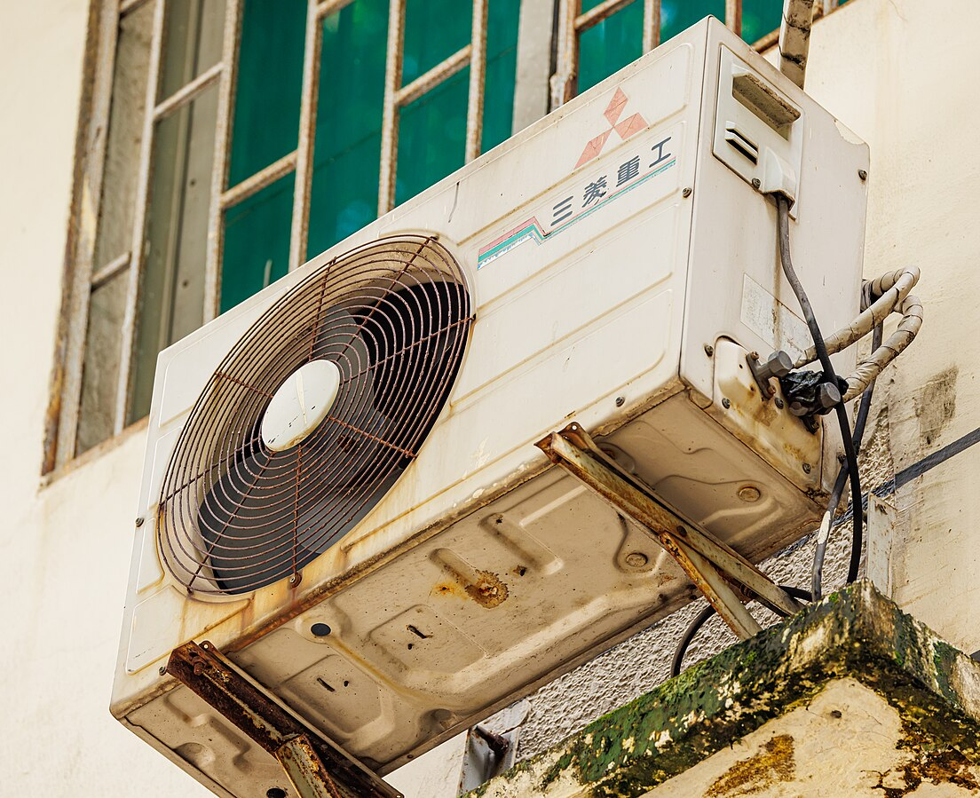
I am allergic to my co-worker’s body smell. | 
My co-worker is late every day. I have to do his work. | 
My co-worker’s breath has a strong smell after lunch. | 

Handout #1: Introduction – Work Problems, cont’d (Task 1)
My co-worker leaves garbage on our desk. | 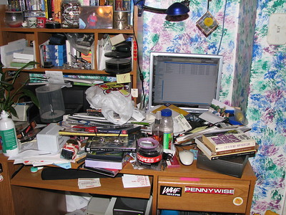
I am allergic to my co-worker’s perfume. | 
My co-worker talks on her phone during work hours. | 
My co-worker warms up fish in the microwave for lunch. The break room smells. | 

Practice 1 – Write an Email (Task 1)
Work Problem:
Directions: Use the information below to write an email.
The computer is broken. You can’t work. Someone needs to fix it.
Your phone number is (925) 123-5555.
Write to your boss Mr. Brown about the problem.
Dear , (name of your boss)
I have a problem with my

Please help me with this problem.
Thank you,
(first name) (last name)
Here is my contact information.
(your phone number)

Practice 1 – Write an Email – Example Answer (Task 1)
Work Problem:
Directions: Use the information below to write an email.
The computer is broken. You can’t work. Someone needs to fix it.
Your phone number is (925) 123-5555.
Write to your boss Mr. Brown about the problem.
Dear Mr. Brown,
I have a problem with my computer. It is broken. I can’t work. Someone needs to fix it.
Please help me with this problem.
Thank you,
(Write your first and last name)
Here is my contact information.
(925) 123-5555

Practice 2 – Write an Email (Task 1)
Work Problem:
Directions: Use the information below to write an email.
The air conditioning (AC) in your office is broken. It is too hot. Someone needs to fix it. Your phone number is (925) 456-7878.
Write to your boss Mrs. Jones about the problem.
Dear , (name of your boss)
I have a problem with my

Please help me with this problem.
Thank you,
(first name) (last name)
Here is my contact information.
(your phone number)

Practice 2 – Write an Email – Example Answer (Task 1)
Work Problem:
Directions: Use the information below to write an email.
The air conditioning (AC) in your office is broken. It is too hot. Someone needs to fix it. Your phone number is (925) 456-7878.
Write to your boss Mrs. Jones about the problem.
Dear Mrs. Jones,
I have a problem with my AC. It is broken. It is too hot. Someone needs to fix it.
Please help me with this problem.
Thank you,
(Write your first and last name)
Here is my contact information.
(925) 456-7878

Practice 3 – Write an Email (Task 1)
Work Problem:
Directions: Use the information below to write an email.
Your co-worker has a strong smell. The smell makes you feel sick.
Your phone number is (925) 987-2222.
Write to your boss Mrs. Endo about the problem.
Dear , (name of your boss)
I have a problem with my

Please help me with this problem.
Thank you,
(first name) (last name)
Here is my contact information.
(your phone number)

Practice 3 – Write an Email – Example Answer (Task 1)
Work Problem:
Directions: Use the information below to write an email.
Your co-worker has a strong smell. The smell makes you feel sick.
Your phone number is (925) 987-2222.
Write to your boss Mrs. Endo about the problem.
Dear Mrs. Endo,
I have a problem with my co-worker. She has a strong smell. The smell makes me feel sick.
Please help me with this problem.
Thank you,
(Write your first and last name)
Here is my contact information.
(925) 987-2222

Practice 4 – Write an Email (Task 1)
Work Problem:
Directions: Use the information below to write an email.
Your co-worker is one hour late to work every day. You have to do his work and your work. You want your co-worker to come on time.
Your phone number is (925) 444-5678.
Write to your boss Mr. Sadat about the problem.
Dear , (name of your boss)
I have a problem with my

Please help me with this problem.
Thank you,
(first name) (last name)
Here is my contact information.
(your phone number)

Practice 4 – Write an Email – Example Answer (Task 1)
Work Problem:
Directions: Use the information below to write an email.
Your co-worker is one hour late to work every day. You have to do his work and your work. You want your co-worker to come on time.
Your phone number is (925) 444-5678.
Write to your boss Mr. Sadat about the problem.
Dear Mr. Sadat,
I have a problem with my co-worker. He is one hour late to work every day. I have to do his work and my work. I want my co-worker to come on time.
Please help me with this problem.
Thank you,
(Write your first and last name)
Here is my contact information.
(925) 444-5678

Practice 5 – Write an Email (Task 1)
Work Problem:
Directions: Use the information below to write an email.
You can smell your co-worker’s breath after lunch. The smell makes you feel sick. You want her to brush her teeth after lunch.
Your phone number is (925) 789-1111.
Write to your boss Mrs. Garcia about the problem.
Dear , (name of your boss)
I have a problem with my

Please help me with this problem.
Thank you,
(first name) (last name)
Here is my contact information.
(your phone number)

Practice 5 – Write an Email – Example Answer (Task 1)
Work Problem:
Directions: Use the information below to write an email.
You can smell your co-worker’s breath after lunch. The smell makes you feel sick. You want her to brush her teeth after lunch.
Your phone number is (925) 789-1111.
Write to your boss Mrs. Garcia about the problem.
Dear Mrs. Garcia,
I have a problem with my co-worker. I can smell her breath after lunch. The smell makes me feel sick. I want her to brush her teeth after lunch.
Please help me with this problem.
Thank you,
(Write your first and last name)
Here is my contact information.
(925) 789-1111

Practice 6 – Write an Email (Taks 1)
Work Problem:
Directions: Use the information below to write an email.
Your co-worker does not have a clean desk. There is garbage on her desk. You sit next to your co-worker. Your papers get dirty. You want her to clean up.
Your phone number is (925) 321-7777.
Write to your boss Mrs. White about the problem.
Dear , (name of your boss)
I have a problem with my

Please help me with this problem.
Thank you,
(first name) (last name)
Here is my contact information.
(your phone number)

Practice 6 – Write an Email – Example Answer (Taks 1)
Work Problem:
Directions: Use the information below to write an email.
Your co-worker does not have a clean desk. There is garbage on her desk. You sit next to your co-worker. Your papers get dirty. You want her to clean up.
Your phone number is (925) 321-7777.
Write to your boss Mrs. White about the problem.
Dear Mrs. White,
I have a problem with my co-worker. She does not have a clean desk. There is garbage on her desk. I sit next to her. My papers get dirty. I want her to clean up.
Please help me with this problem.
Thank you,
(Write your first and last name)
Here is my contact information.
(925) 321-7777

Practice 7 – Write an Email (Task 1)
Work Problem:
Directions: Use the information below to write an email.
Your co-worker wears a lot of perfume. You are allergic to the smell. It makes you sneeze. Your phone number is (925) 555-6789.
Write to your boss Mrs. Flowers about the problem.
Dear , (name of your boss)
I have a problem with my

Please help me with this problem.
Thank you,
(first name) (last name)
Here is my contact information.
(your phone number)

Practice 7 – Write an Email – Example Answer (Task 1)
Work Problem:
Directions: Use the information below to write an email.
Your co-worker wears a lot of perfume. You are allergic to the smell. It makes you sneeze. Your phone number is (925) 555-6789.
Write to your boss Mrs. Flowers about the problem.
Dear Mrs. Flowers,
I have a problem with my co-worker. She wears a lot of perfume. I am allergic to the smell. It makes me sneeze.
Please help me with this problem.
Thank you,
(Write your first and last name)
Here is my contact information.
(925) 555-6789

Practice 8 – Write an Email (Task 1)
Work Problem:
Directions: Use the information below to write an email.
Your co-worker talks on her phone a lot. She is loud. You can’t do your work.
Your phone number is (925) 654-3232.
Write to your boss Mr. Chen about the problem.
Dear , (name of your boss)
I have a problem with my

Please help me with this problem.
Thank you,
(first name) (last name)
Here is my contact information.
(your phone number)

Practice 8 – Write an Email – Example Answer (Task 1)
Work Problem:
Directions: Use the information below to write an email.
Your co-worker talks on her phone a lot. She is loud. You can’t do your work.
Your phone number is (925) 654-3232.
Write to your boss Mr. Chen about the problem.
Dear Mr. Chen,
I have a problem with my co-worker. She talks on her phone a lot. She is loud. I can’t do my work.
Please help me with this problem.
Thank you,
(Write your first and last name)
Here is my contact information.
(925) 654-3232

Practice 9 – Write an Email (Task 1)
Work Problem:
Directions: Use the information below to write an email.
Your co-worker warms up fish in the microwave for lunch. The break room smells. Your phone number is (925) 222-6789.
Write to your boss Mr. Gupta about the problem.
Dear , (name of your boss)
I have a problem with my

Please help me with this problem.
Thank you,
(first name) (last name)
Here is my contact information.
(your phone number)

Practice 9 – Write an Email – Example Answer (Task 1)
Work Problem:
Directions: Use the information below to write an email.
Your co-worker warms up fish in the microwave for lunch. The break room smells. Your phone number is (925) 222-6789.
Write to your boss Mr. Gupta about the problem.
Dear Mr. Gupta,
I have a problem with my co-worker. She warms up fish in the microwave for lunch. The break room smells.
Please help me with this problem.
Thank you,
(Write your first and last name)
Here is my contact information.
(925) 222-6789

Introduction – Reasons to be Late to Work (Task 2)
Examples of acceptable (ok) reasons to be late to work:
  Car accident |   Car problems |   House fire
  House problems | 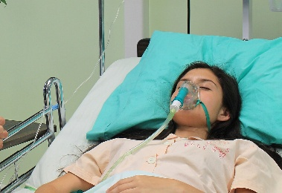  Medical emergency |   Traffic jam
Examples of unacceptable (not ok) reasons to be late to work:
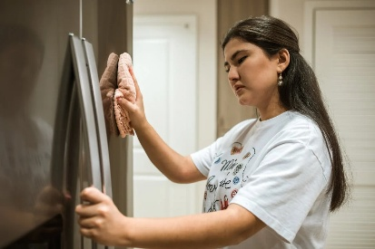  Cleaning the house |   Drinking with friends |   Going grocery shopping
  Going to a party |   Waking up late |   Watching a soccer game

Practice 1 – Reasons to be Late to Work (Task 2)
Directions: Write the correct words for each picture. Then circle “acceptable” (ok) or “unacceptable” (not ok).
House problems | Cleaning the house | Going to a party
Watching a soccer game | Car accident | Medical emergency

Acceptable / Unacceptable | Acceptable / Unacceptable
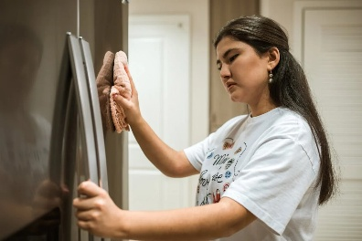  Acceptable / Unacceptable | Acceptable / Unacceptable
  Acceptable / Unacceptable | Acceptable / Unacceptable

Practice 1 – Reasons to be Late to Work – Answer Key (Task 2)
Directions: Write the correct words for each picture. Then circle “acceptable” (ok) or “unacceptable” (not ok).
House problems | Cleaning the house | Going to a party
Watching a soccer game | Car accident | Medical emergency

Medical emergency  Acceptable / Unacceptable | Going to a party  Acceptable / Unacceptable
Cleaning the house  Acceptable / Unacceptable | House problems  Acceptable / Unacceptable
Car accident  Acceptable / Unacceptable | Watching a soccer game  Acceptable / Unacceptable

Practice 2 – Reasons to be Late to Work (Task 2)
Directions: Write the correct words for each picture. Then mark “acceptable” (ok) or “unacceptable” (not ok).
Waking up late | Traffic jam | Going grocery shopping
House fire | Car problems | Drinking with friends

Acceptable / Unacceptable | Acceptable / Unacceptable
Acceptable / Unacceptable | Acceptable / Unacceptable
Acceptable / Unacceptable | Acceptable / Unacceptable

Practice 2 – Reasons to be Late to Work – Answer Key (Task 2)
Directions: Write the correct words for each picture. Then mark “acceptable” (ok) or “unacceptable” (not ok).
Waking up late | Traffic jam | Going grocery shopping
House fire | Car problems | Drinking with friends

- House fire  Acceptable / Unacceptable | - Drinking with friends  Acceptable / Unacceptable
- Going grocery shopping  Acceptable / Unacceptable | - Car problems  Acceptable / Unacceptable
- Waking up late  Acceptable / Unacceptable | - Traffic jam  Acceptable / Unacceptable

Practice 3 – Role Play (Task 2)
Directions: Practice this role play between a worker and the boss. On test day, you will be the worker. Tell your boss, Mrs. Plant, you will be late to work today. Tell her an acceptable (ok) reason why you will be late.
Secretary: Hello. This is the secretary. Who do you want to talk to?
Worker: (1. Ask to speak to Mrs. Plant.)
Boss: This is Mrs. Plant. What is your name?
Worker: (2. Tell her your name.)
Boss: Hello (say the student’s name), How can I help you?
Worker: (3. Tell her you will be late to work today.)
Boss: Why are you going to be late today?
Worker: (4. Tell her the reason.)
Boss: Oh, I’m sorry to hear that, but thank you for calling to tell me.
Worker: (5. Thank Mrs. Plant and say goodbye.)



Practice 3 Role Play – Example Answers (Task 2)
Directions: Practice this role play between a worker and the boss. On test day, you will be the worker. Tell your boss, Mrs. Plant, you will be late to work today. Tell her an acceptable (ok) reason why you will be late.
Secretary: Hello. This is the secretary. Who do you want to talk to?
Worker: (1) Hello. I want to talk to Mrs. Plant.
Boss: This is Mrs. Plant. What is your name?
Worker: (2) My name is (say your name).
Boss: Hello (say the student’s name), How can I help you?
Worker: (3) I will be late to work today.
Boss: Why are you going to be late today?
Worker: (4) (Say one acceptable reason. For example:)
I had a car accident.
I have car problems.
I had a house fire.
I have house problems.
I have a medical emergency.
There is a traffic jam.
Boss: Oh, I’m sorry to hear that, but thank you for calling to tell me.
Worker: (5) Thank you. Goodbye.

