Contents
Handout #1: Introduction to Entrepreneurship (Task 2) 2
Handout #2: Example of Entrepreneurship Mindset (Task 2) 3
Handout #3: Practice 1 – Entrepreneurship Mindset (Task 2) 4
Handout #4: Practice 2 – Describe a Business Plan (Task 2) 5
Handout #5: Introduction – Business Vocabulary (Task 3) 6
Handout #6: Practice – Business Vocabulary (Task 3) 7
Handout #7: Answer Key – Business Vocabulary (Task 3) 8
Handout #8: Introduction – Cost Estimate #1 (Task 3) 9
Handout #9: Practice – Cost Estimate #1 (Task 3) 10
Handout #10: Answer Key – Cost Estimate #`1 (Task 3) 11
Handout #11: Introduction – Cost Estimate #2 (Task 3) 12
Handout #12: Practice – Cost Estimate #2 (Task 3) 13
Handout #13: Answer Key – Cost Estimate #2 (Task 3) 14

Introduction to Entrepreneurship (Task 2)
Who is an Entrepreneur? You are!
Entrepreneurs have ideas about starting a business, improving their workplace, or helping their community. Entrepreneurs are passionate about their business, workplace, or community.
Entrepreneurs sell a product or a service to the public.   | Entrepreneurs think of ways to make their workplace better.  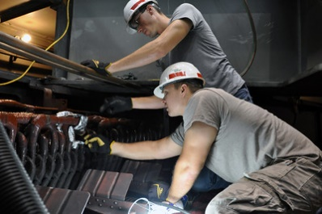 | Entrepreneurs think of ways to volunteer to help their communities.  
Everyone can have an entrepreneurship mindset!
Thinking like an entrepreneur means…
- Think about a problem.
- Create a solution.
- Or, think of something you are passionate about! What do you love to do?


Example of Entrepreneurship Mindset (Task 2)
How to have an Entrepreneurship Mindset:
- Identify a current problem.
I have a hard time with making my kids’ school lunches every morning. They don’t like to eat sandwiches. They can’t bring leftovers to school because there is no microwave for students. What can I do?
- Create a solution to overcome it.
Maybe you can start a business that makes fresh bento box lunches for children delivered to your door every week, like Japanese bento boxes!

Read about some problems. A business idea often comes from an area in your life that frustrates you or causes problems.
- I get hungry at work at Loma Vista Adult Center. I don’t have time to leave work to drive to buy lunch. I also don’t have time to make my lunch in the morning. I wish there was food I could buy at my workplace.
- My son has soccer practice three times a week, but both my husband and I work. I don’t know how he can get to his soccer practice.

Practice 1 – Entrepreneurship Mindset (Task 2)
Now ask yourself and a partner!
- What is the problem that needs to be solved? This can be a personal problem or a problem in the marketplace, at your workplace, or in your community.
- How is the problem currently handled?
- What is a better way to solve the problem?


Practice 2 – Describe a Business Plan (Task 2)
You will be creating a PowerPoint Slideshow to describe a business plan. Use the template (3.3_IL_Task 2_PowerPoint Template). Answer the following questions on the slides with bullet points and pictures. Then orally present your Business Plan to the class using the PowerPoint Slides.
- Introduction – Your business name, your name and your teacher’s name
- Summary: What is the business? Describe what the business does or makes (landscaping, restaurant, etc.) and how much you will charge for your service or product.
- Marketing Analysis, Plan and Sale Strategies: Why did you choose this business? Why do you think this business will be successful? How will you advertise your business?
- Resources Needed: How many employees are needed (if any)? What are their responsibilities/ roles/ positions or job titles, hours, and wages? Or How much money do you think you need to start this business? Equipment, permits?
- What is your contact Information? (Business email, phone number, days and hours of operation, & business address)


Introduction – Business Vocabulary (Task 3)

- Total cost: add everything together that needs to be paid for
- Estimate: a guess of how much something will cost or how long it will take to do
- Labor: work (work hours)
- Client: the person who pays for a professional product or service from a business
- Customers: the people who pay for a product or service
- Materials: things or items that someone needs to prepare or make something
- Completion date: the day when the job will be finished
- Contract: a promise between the customer and the business owner that the job costs a certain amount of money and will be finished on a certain day
- Wet Signature: official first and last name written in your own handwriting with a pen
- Electronic Signature: your full name written using an electronic device
- Charge: how much money a customer will need to pay the business

Practice – Business Vocabulary (Task 3)
Directions: Write the correct vocabulary word in the example sentences.
1. It will take him 5 hours of to remove the weeds, rocks, and grass.
2. Jerry tells his new that he will finish her yard before the wedding.
3. Jerry needs to his customers $45 an hour for his labor.
4. Jerry promised his client that the would be on July 4th.
5. Customers want to know the before the job starts so they have enough money to pay for it.
6. Every business needs many to be successful.
7. Most legal paperwork needs your in blue pen to be official.
8. Before Jerry starts the job, he needs to buy many
9. Jerry had to give his client an of how much he thought the job might cost.
10. Many businesses want their customers to sign a before they start the job.
11. Some legal documents can be signed with an using a computer.

Answer Key – Business Vocabulary (Task 3)
Directions: Write the correct vocabulary word in the example sentences.
1. It will take him 5 hours of labor to remove the weeds, rocks, and grass.
2. Jerry tells his new client that he will finish her yard before the wedding.
3. Jerry needs to charge his customers $45 an hour for his labor.
4. Jerry promised his client that the completion date would be on July 4th.
5. Customers want to know the total cost before the job starts so they have enough money to pay for it.
6. Every business needs many customers to be successful.
7. Most legal paperwork needs your wet signature in blue pen to be official.
8. Before Jerry starts the job, he needs to buy many materials.
9. Jerry had to give his client an estimate of how much he thought the job might cost.
10. Many businesses want their customers to sign a contract before they start the job.
11. Some legal documents can be signed with an electronic signature using a computer.

Introduction – Cost Estimate #1 (Task 3)
Business: Landscaping
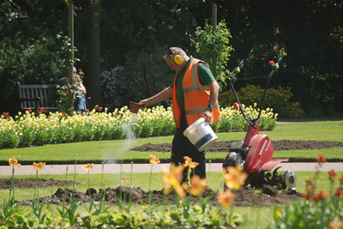
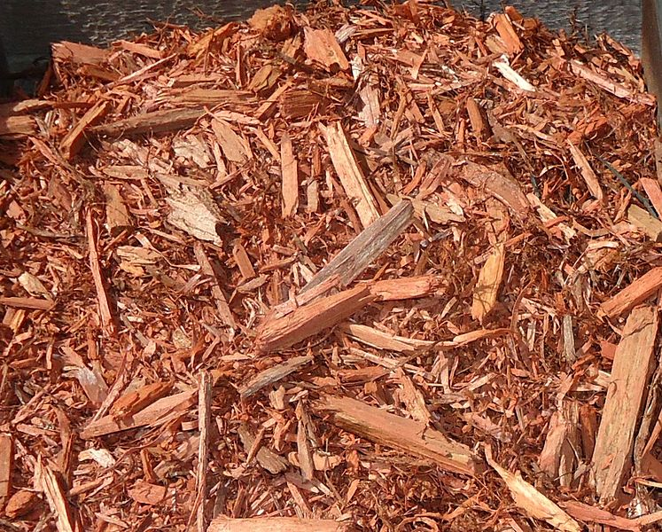
Vocabulary
- Mulch: small pieces of wood used to cover the ground
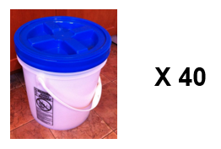
- Cubic yard: a measurement equal to 40 five-gallon buckets
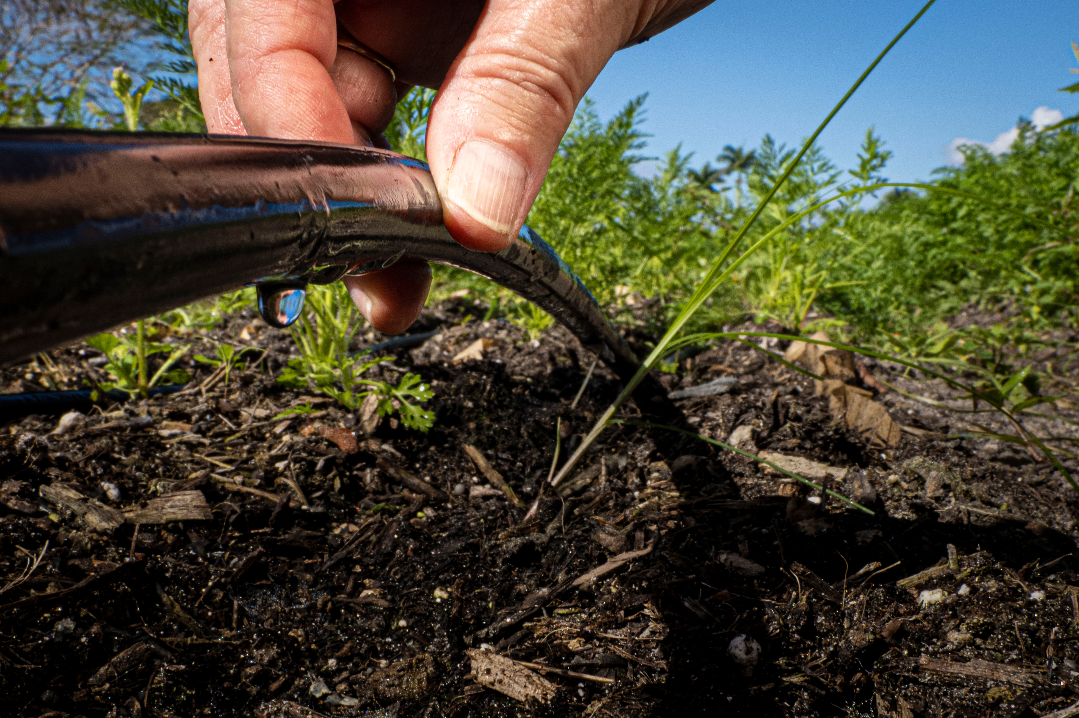

- Drip System: automatic water system for plants that uses less water than sprinklers
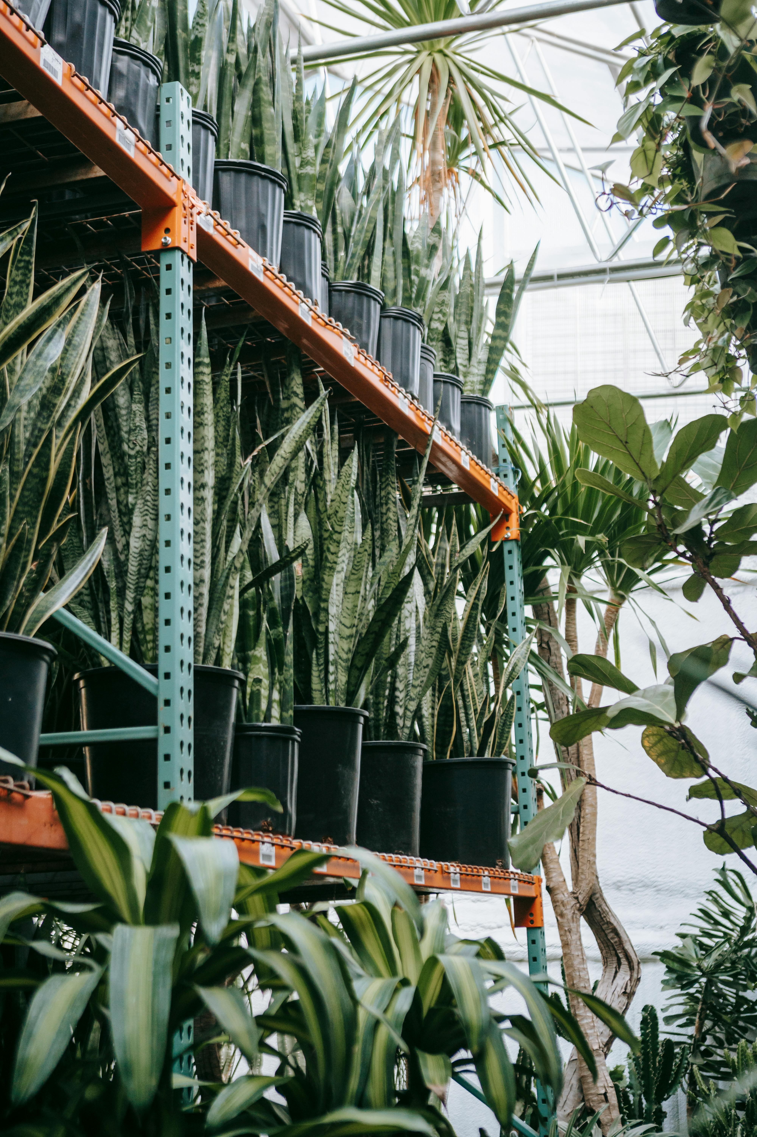
- One-gallon plants: plants that are grown to a larger size
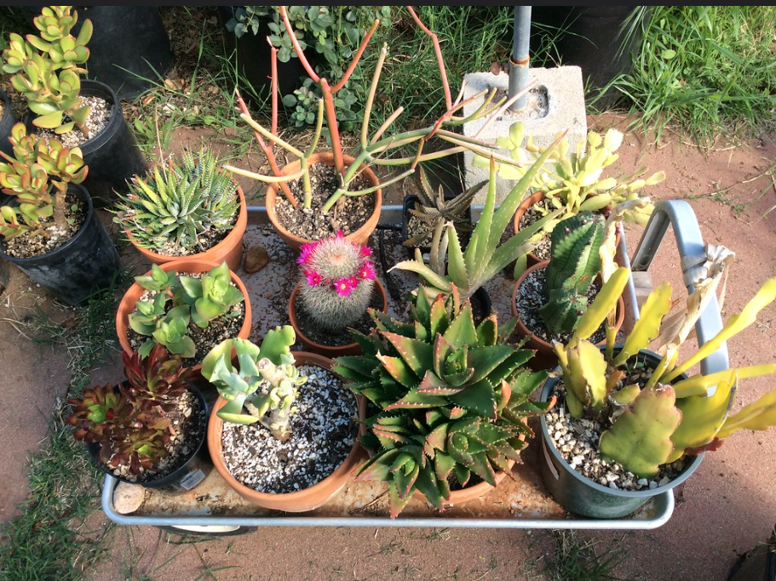
- Succulents and cactus: plants that don’t need much water
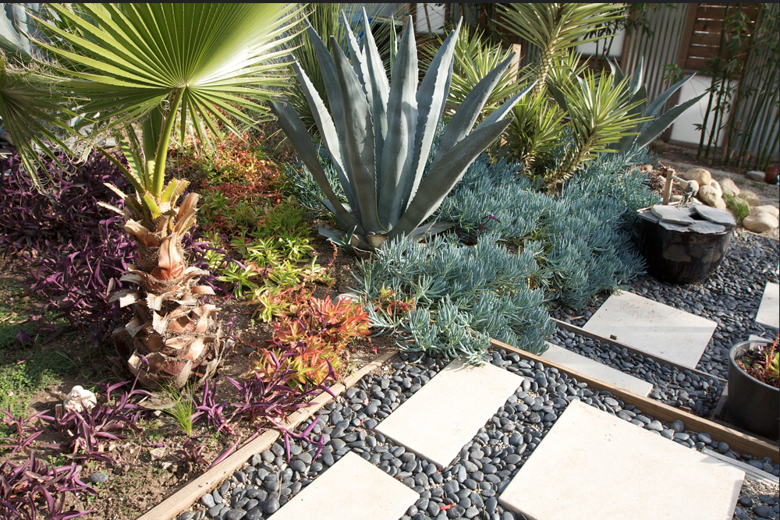
- Drought resistant plant: desert plant, can survive without much water

Practice – Cost Estimate #1 (Task 3)

Please read about Jerry Chase’s landscaping business called Jerry’s Gardening. Complete the estimate that he will give to his client.
Jerry has a new client, Maria Rodolff. Maria wants a new drip system installed in her front yard. Maria wants Jerry to plant drought-resistant cactus and succulents. She also wants Jerry to remove the grass and replace it with mulch. Maria wants a beautiful desert theme for her new front yard.
Jerry looked at prices of mulch, cactus, and succulents. He has to buy 1 cubic yard of mulch. It costs $50 for one cubic yard of mulch. He needs 20 one-gallon plants which cost $10 dollars each and 10 half-gallon plants which cost $5 dollars each. It will take him 5 hours of labor to remove the weeds, rocks, and grass. It will take 5 hours of labor to finish planting the new plants and laying out the mulch. He charges $30 an hour. He will start work on August 1st and finish on August 25th.
Contract and Estimate for Jerry’s Gardening
1. Customer Name:
2. Prepared by:
3. Date:
4. Estimate for (job name):
5. Materials Needed and Cost:
  - = $
  - = $
  - = $
6. Total Cost of Materials: $
7. Hours of Labor:
8. Cost of Labor: $
9. Total Estimate: $
10. Estimated completion date:
11. Customer Signature: Date:
12. Business Owner Signature: Date:

Answer Key – Cost Estimate #`1 (Task 3)
Please read about Jerry Chase’s landscaping business called Jerry’s Gardening. Complete the estimate that he will give to his client.
Jerry has a new client, Maria Rodolff. Maria wants a new drip system installed in her front yard. Maria wants Jerry to plant drought-resistant cactus and succulents. She also wants Jerry to remove the grass and replace it with mulch. Maria wants a beautiful desert theme for her new front yard.
Jerry looked at prices of mulch, cactus, and succulents. He has to buy 1 cubic yard of mulch. It costs $50 for one cubic yard of mulch. He needs 20 one-gallon plants which cost $10 dollars each and 10 half-gallon plants which cost $5 dollars each. It will take him 5 hours of labor to remove the weeds, rocks, and grass. It will take 5 hours of labor to finish planting the new plants and laying out the mulch. He charges $30 an hour. He will start work on August 1st and finish on August 25th.
Contract and Estimate for Jerry’s Gardening
1. Customer Name: Maria Rodolff
2. Prepared by: Jerry Chase
3. Date: (today’s date)
4. Estimate for (job name): New Front Yard
5. Materials Needed and Cost:
- 1 cubic yard of mulch = $ 50
- 20 one-gallon plants = $ 200
- 10 half-gallon plants = $ 50
6. Total Cost of Materials: $ 300
7. Hours of Labor: 10
8. Cost of Labor: $ 300
9. Total Estimate: $ 600
10. Estimated completion date: August 25, (current year)
11. Customer Signature: Maria Rodolff Date: (today’s date)
12. Business Owner Signature: Jerry Chase Date: (today’s date)

Introduction – Cost Estimate #2 (Task 3)
Business: Pool Cleaning
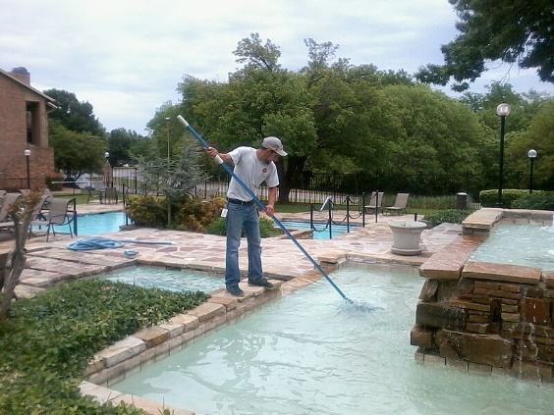

Vocabulary
- Clean pool: a pool with clear, blue water
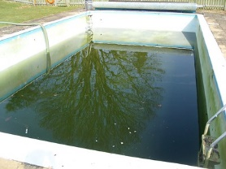
- Dirty pool: a pool with mirky (not clear) water because there are things like dirt, leaves, or bugs in the water
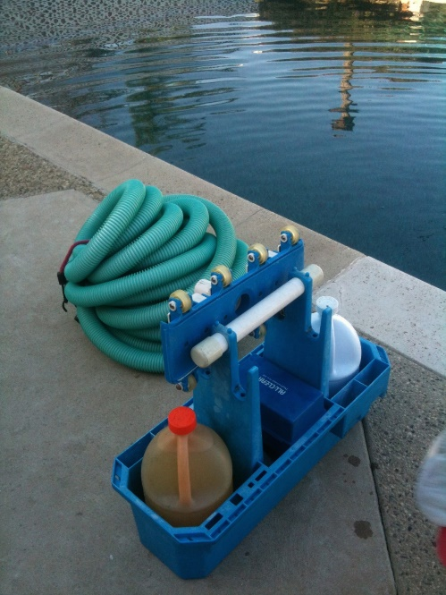
- Chemicals: liquids like Chlorine that keeps water clean
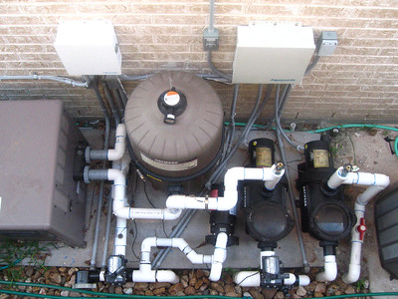
- Pool pump: machine that moves water through a filter to keep the water clean
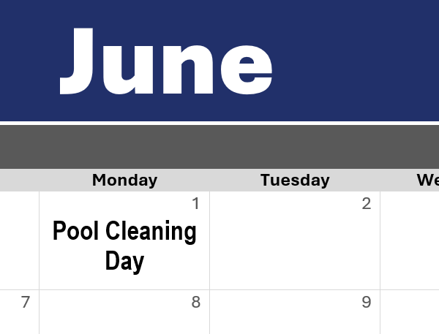
- Maintenance plan: regularly scheduled service to keep the water clean

Practice – Cost Estimate #2 (Task 3)

Please read about Walter Anton’s pool service, Walter the Pool Guy. Complete the estimate that he will give to his new client.
Shirley Simmons is a new client who has a large pool in Danville, CA. Shirley did not clean her pool for one year. It is really dirty. She asked Walter to make her pool beautiful before her son’s wedding. The wedding will be on July 4th.
First, Walter will test the pool’s chemical levels. Then, he’ll treat the water with basic chemicals. The chemicals cost about $200. Next, he will clean the top and bottom surfaces of the pool and remove the leaves. After that, he’ll inspect the equipment to make sure it is working well. Finally, he’ll replace the broken pool pump. The pool pump costs $50. It will take him 10 hours of work to finish this job. He charges $30 an hour.
In addition, Walter’s company has a maintenance plan. He told Shirley that he could clean her pool once a month. He charges $150 per month for maintenance. Shirley liked the idea of a maintenance plan and agreed to sign the contract.
Contract and Estimate for Walter the Pool Guy
1. Customer Name:
2. Prepared by:
3. Date:
4. Estimate for (job name):
5. Materials Needed and Cost:
- = $
- = $
6. Total Cost of Materials: $
7. Hours of Labor:
8. Cost of Labor: $
9. Total Estimate: $
10. Estimated completion date:
11. Maintenance Plan: $ /month
12. Customer Signature: Date:
13. Business Owner Signature: Date:

Answer Key – Cost Estimate #2 (Task 3)
Please read about Walter Anton’s pool service, Walter the Pool Guy. Complete the estimate that he will give to his new client.
Shirley Simmons is a new client who has a large pool in Danville, CA. Shirley did not clean her pool for one year. It is really dirty. She asked Walter to make her pool beautiful before her son’s wedding. The wedding will be on July 4th.
First, Walter will test the pool’s chemical levels. Then, he’ll treat the water with basic chemicals. The chemicals cost about $200. Next, he will clean the top and bottom surfaces of the pool and remove the leaves. After that, he’ll inspect the equipment to make sure it is working well. Finally, he’ll replace the broken pool pump. The pool pump costs $50. It will take him 10 hours of work to finish this job. He charges $30 an hour.
In addition, Walter’s company has a maintenance plan. He told Shirley that he could clean her pool once a month. He charges $150 per month for maintenance. Shirley liked the idea of a maintenance plan and agreed to sign the contract.
Contract and Estimate for Walter the Pool Guy
1. Customer Name: Shirley Simmons
2. Prepared by: Walter Anton
3. Date: (today’s date)
4. Estimate for (job name): Pool Cleaning
5. Materials Needed and Cost:
- chemicals = $ 200
- pool pump = $ 50
6. Total Cost of Materials: $ 250
7. Hours of Labor: 10
8. Cost of Labor: $ 300
9. Total Estimate: $ 550
10. Estimated completion date: July 4, (current year)
11. Maintenance Plan: $ 150 /month
12. Customer Signature: Shirley Simmons Date: (today’s date)
13. Business Owner Signature: Walter Anton Date: (today’s date)

