Contents
Handout #1: Introduction – Business Vocabulary (Task 1) 2
Handout #2: Practice – Business #1 (Task 1) 3
Handout #3: Answer Key – Business #1 (Task 1) 4
Handout #4: Practice – Business #2 (Task 1) 5
Handout #5: Answer Key – Business #2 (Task 1) 6
Handout #6: Reading / Answer Key – Problem & Business Solution (Task 1) 7
Handout #7: Practice – Problem & Business Solution Part A (Task 1) 9
Handout #8: Practice – Problem & Business Solution Part B (Task 1) 11
Handout #9: Practice – Matching Business Examples (Task 1) 13
Handout #10: Practice – Product Business Sentences (Task 1) 16
Handout #11: Practice – Service Business Sentences (Task 1) 18
Handout #12: Introduction – Business Vocabulary (Task 3) 20
Handout #13: Practice – Business Vocabulary (Task 3) 21
Handout #14: Answer Key – Business Vocabulary (Task 3) 22
Handout #15: Introduction – Cost Estimate #1 (Task 3) 23
Handout #16: Practice – Cost Estimate #1 (Task 3) 24
Handout #17: Answer Key – Cost Estimate #1 (Task 3) 25
Handout #18: Introduction – Cost Estimate #2 (Task 3) 26
Handout #19: Practice – Cost Estimate #2 (Task 3) 27
Handout #20: Answer Key – Cost Estimate #2 (Task 3) 28

Introduction – Business Vocabulary (Task 1)

- What is a business?
A business sells a product or service. For example, McDonalds is a business. It sells hamburgers, french fries, and soda.
- Who is a business owner?


A business owner is someone who started a business. For example, in this picture this business owner sells food from his food truck.
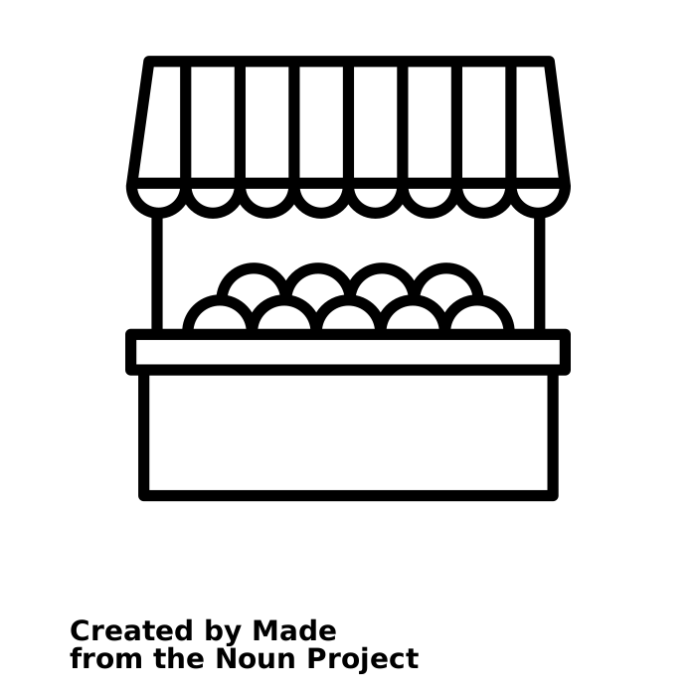
- What is a product?
A product is something you can buy. For example, you can buy fruit. This business is a fruit and vegetable market.
- What is a service?
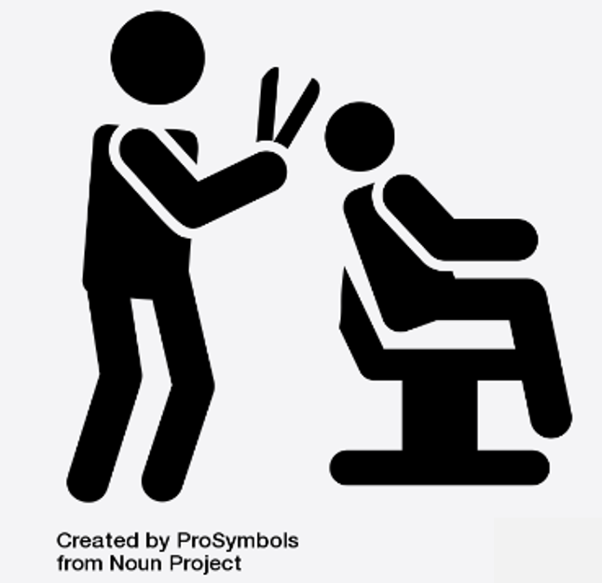
A service is help that you pay for. For example, you pay for someone to cut your hair. This business is a hair salon.
- What is the cost or price?
The cost or price is how much money someone will pay you. For example:
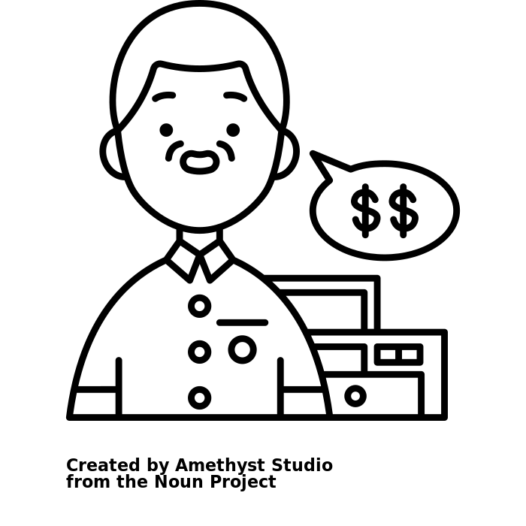
Question: How much do your apples cost?
Answer: They cost $3 a bag.
Question: How much does a haircut cost?
Answer: It costs $35.

- What is an idea or plan?
An idea or plan is what you want to do in the future.

- What is a customer?
A customer is someone who wants to buy a product or service from a business.
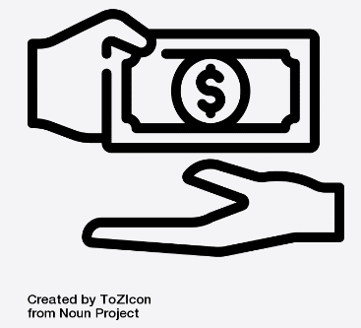
- What does “sell” mean?
Sell means to give someone a product or a service and get some money for it.

Practice – Business #1 (Task 1)
Directions: Please read with a partner. Then answer the questions.
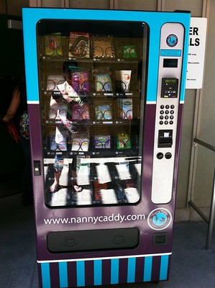

A: I want to be a business owner.
B: What is the business?
A: I want to have a baby supplies vending machine.
B: What do you do or make?
A: I can sell diapers and baby food to parents who need it.
B: Why do you like this business?
A: I like to help parents and babies.
- What is the business?
- What can the person do or make?
- Why does the person like this business?
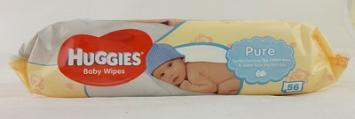

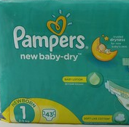

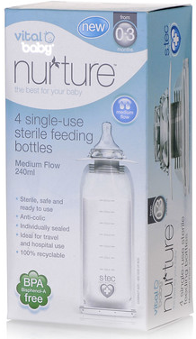

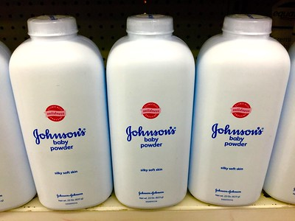

Answer Key – Business #1 (Task 1)
Directions: Please read with a partner. Then answer the questions.

A: I want to be a business owner.
B: What is the business?
A: I want to have a baby supplies vending machine.
B: What do you do or make?
A: I can sell diapers and baby food to parents who need it.
B: Why do you like this business?
A: I like to help parents and babies.
- What is the business? A baby supplies vending machine.
- What can the person do or make? Sell diapers and baby food.
- Why does the person like this business? They like to help parents and babies.

Practice – Business #2 (Task 1)
Directions: Please read with a partner. Then answer the questions.
A: My son wants to be a business owner.
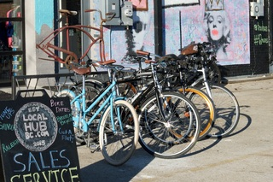

B: What is the business?
A: He wants to have a bicycle repair store.
B: What does he do or make?
A: He fixes broken bicycles.
B: Why does he like this business?
A: He likes to fix bicycles. He can fix bicycles very well.
- What is the business?
- What can the owner do or make?
- Why does her son like this business?
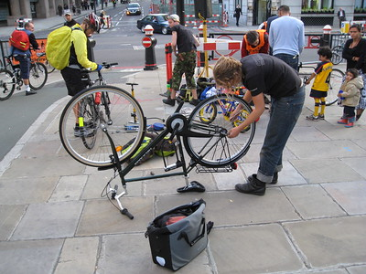

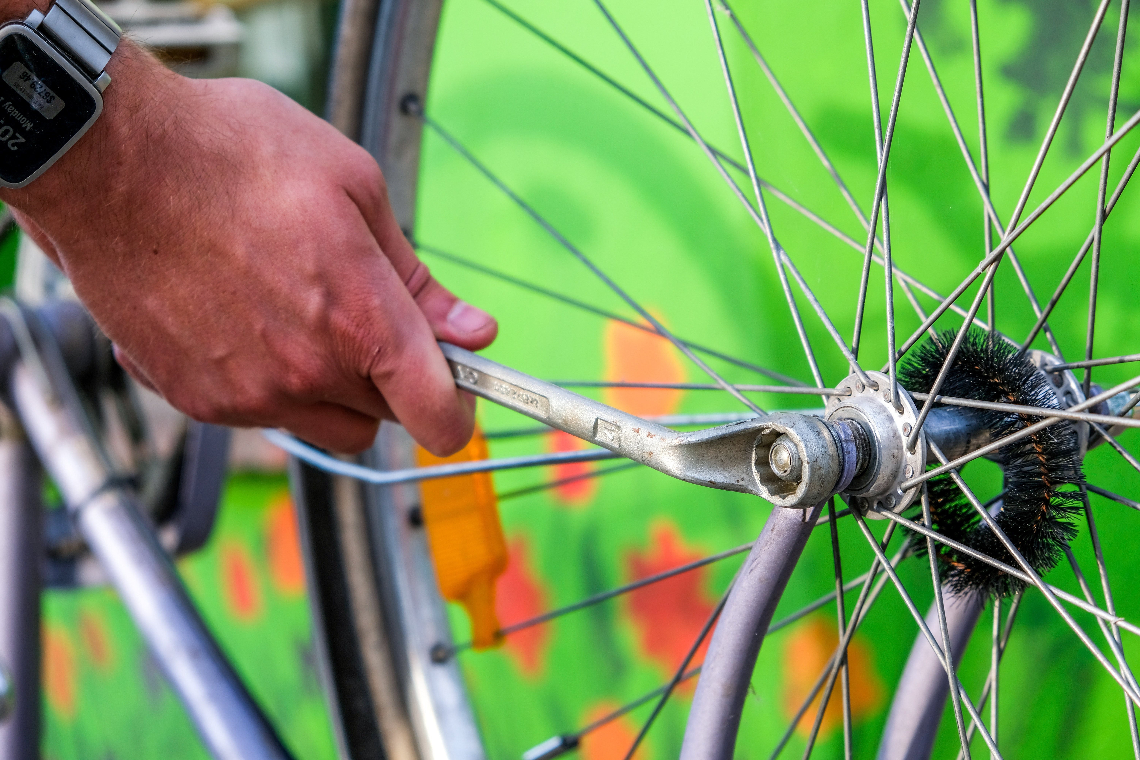

Answer Key – Business #2 (Task 1)
Directions: Please read with a partner. Then answer the questions.
A: My son wants to be a business owner.
B: What is the business?
A: He wants to have a bicycle repair store.
B: What does he do or make?
A: He fixes broken bicycles.
B: Why does he like this business?
A: He likes to fix bicycles. He can fix bicycles very well.
- What is the business? A bicycle repair store.
- What can the owner do or make? Fix broken bicycles.
- Why does her son like this business? He likes to fix bicycles. He can fix bicycles very well.

Reading / Answer Key – Problem & Business Solution (Task 1)
Directions: Use this handout to cut out and paste pictures to the Problem and Business Solution Handouts Part A and Part B.
Problem | Business Solution
  The grass is too tall. | 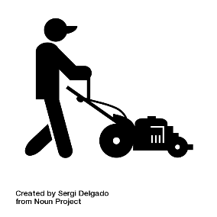  The gardener cuts the grass.
  He goes on a trip. He has a dog. | 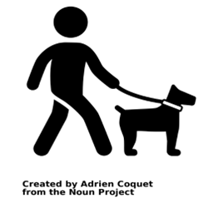  A dog walker walks the dog.
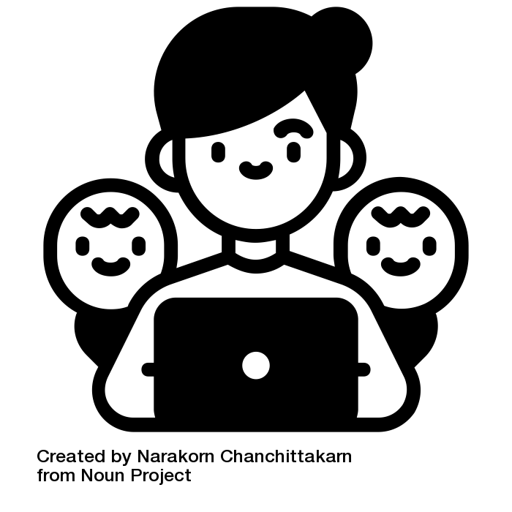  The mom has to work. | 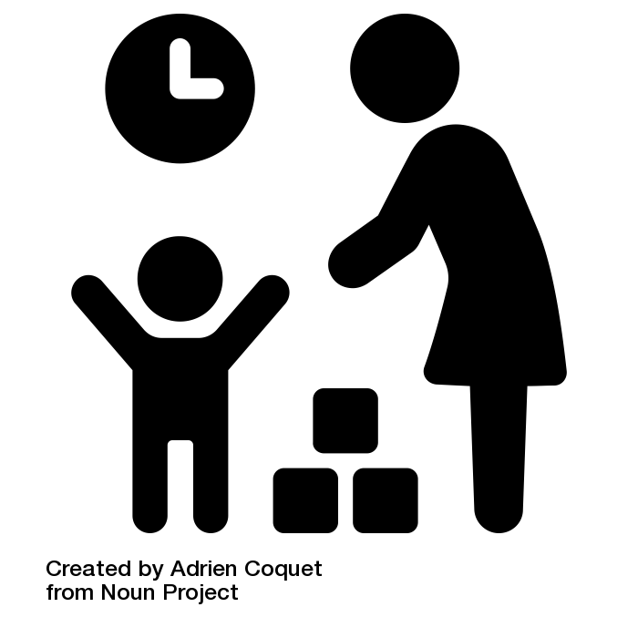  The daycare owner watches her children.
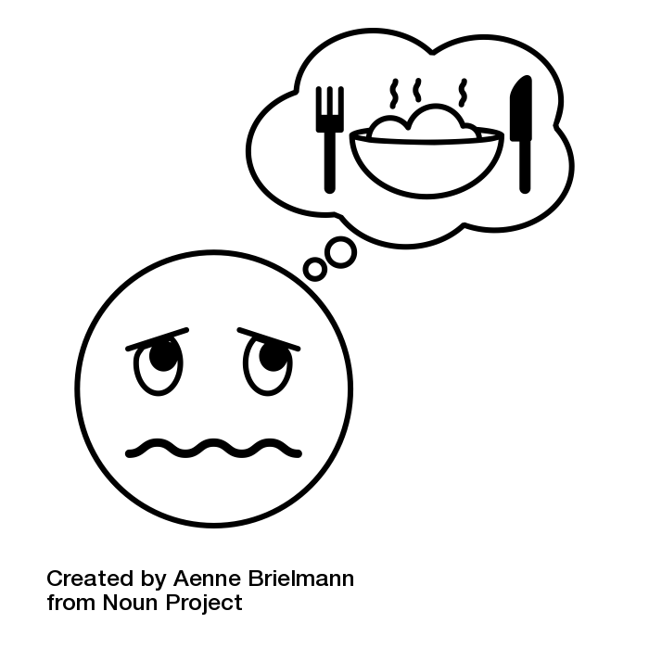  The student is hungry. | 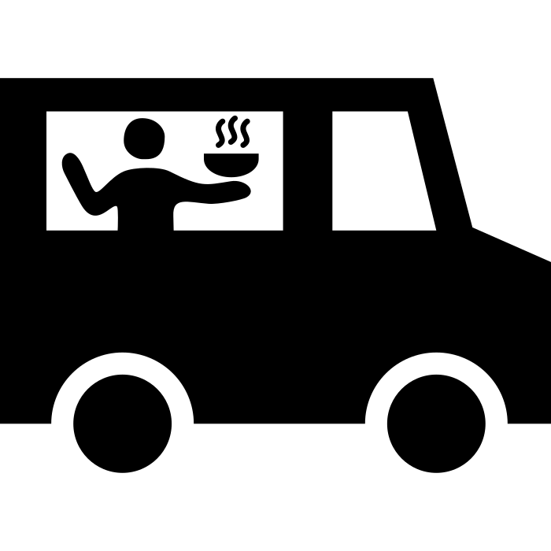  The food truck owner sells food at school.

Handout #6: Reading / Answer Key – Problem & Business Solution (Task 1) cont.
Problem | Business Solution
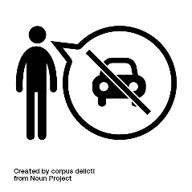  He can’t drive. He needs groceries. | 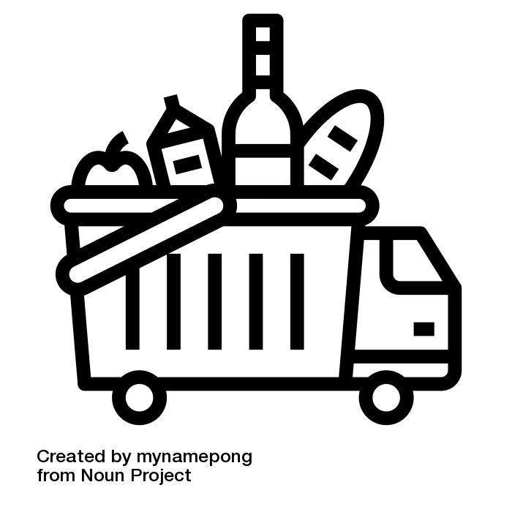  The food delivery owner brings groceries.
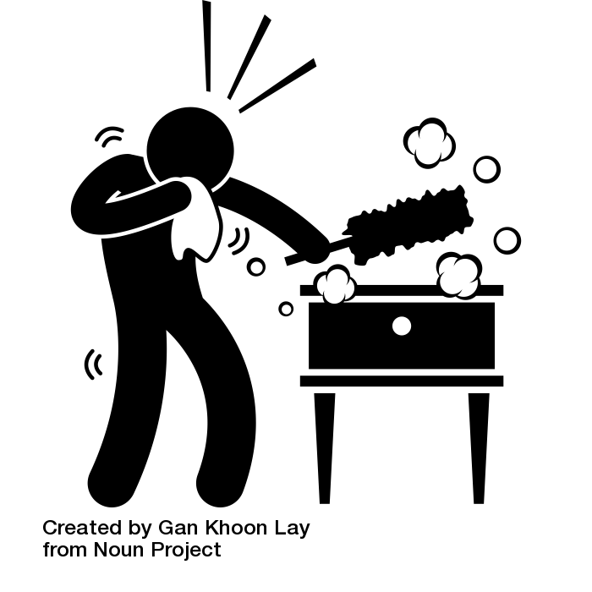  The house is dirty. | 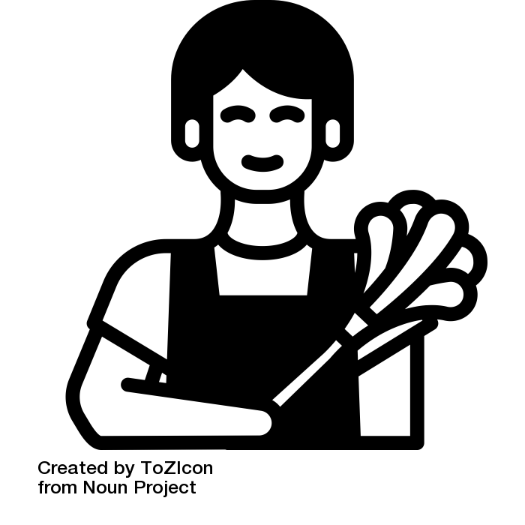  The house cleaner cleans it.
  The window is broken. |   The construction worker fixes it.
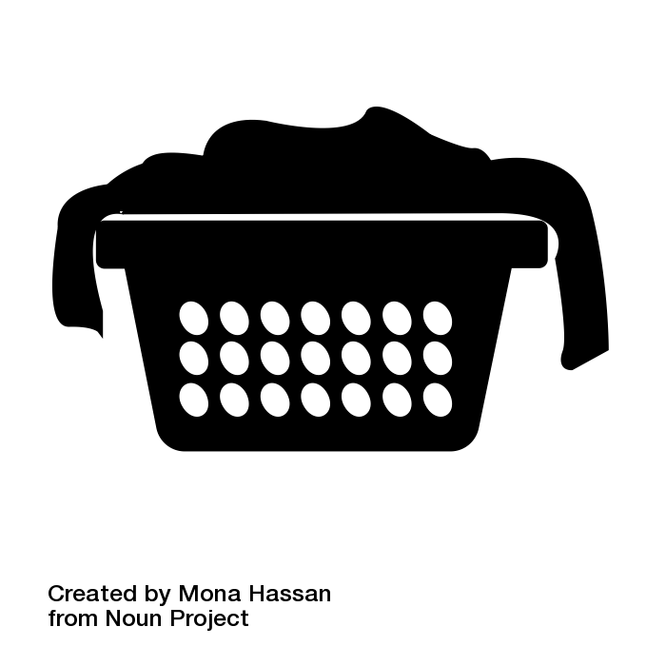  The laundry is dirty. | 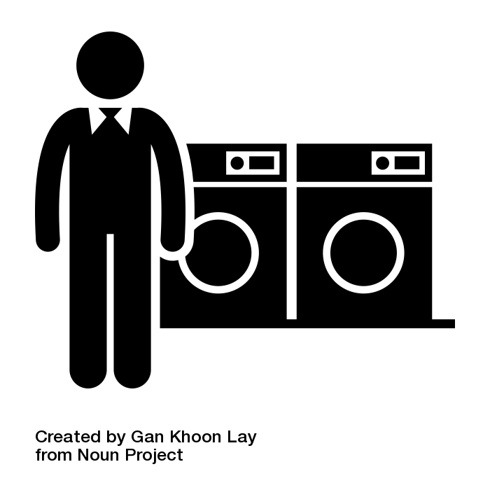  The laundromat owner washes it.

Practice – Problem & Business Solution Part A (Task 1)
Directions: Cut and paste the picture that is a solution to a problem. Write the solution.
Problem | Business Solution

The grass is too tall.

He goes on a trip. He has a dog.

The mom has to work.

The student is hungry.

Handout #7: Practice – Problem & Business Solution Part A (Task 1) cont.
Problem | Business Solution

He can’t drive. He needs groceries.

The house is dirty.
The window is broken. | .
The laundry is dirty. | .

Practice – Problem & Business Solution Part B (Task 1)
Directions: Cut and paste the picture that is a solution to a problem. Write the problem.
Problem | Business Solution
 | The gardener cuts the grass.
 | A dog walker walks the dog.
 | The daycare owner watches her children.
 | The food truck owner sells food at school.

Handout #8: Practice – Problem & Business Solution Part B (Task 1) cont.
Problem | Business Solution
. | The food delivery owner brings groceries.
 | The house cleaner cleans it.
 | The construction worker fixes it.
 | The laundromat owner washes it.

Practice – Matching Business Examples (Task 1)
Directions: Find the name of the business. Then write: I have a business. For example, I have a house cleaning business.
leaf blowing | grocery delivery | home daycare
laundromat | lawn mowing | jewelry
dog walking | florist | food truck
house cleaning | meal preparation | construction
After you finish writing, you can practice speaking with a partner.
Question: What is your business? Answer: I have a business.


Handout #9: Practice – Matching Business Examples (Task 1) cont.
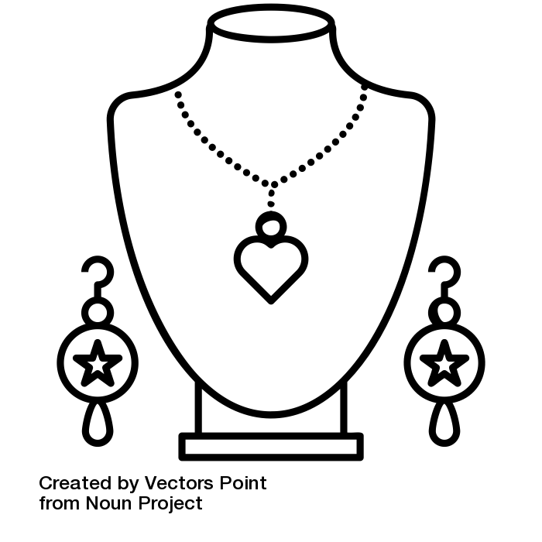


Handout #9: Practice – Matching Business Examples (Task 1) cont.
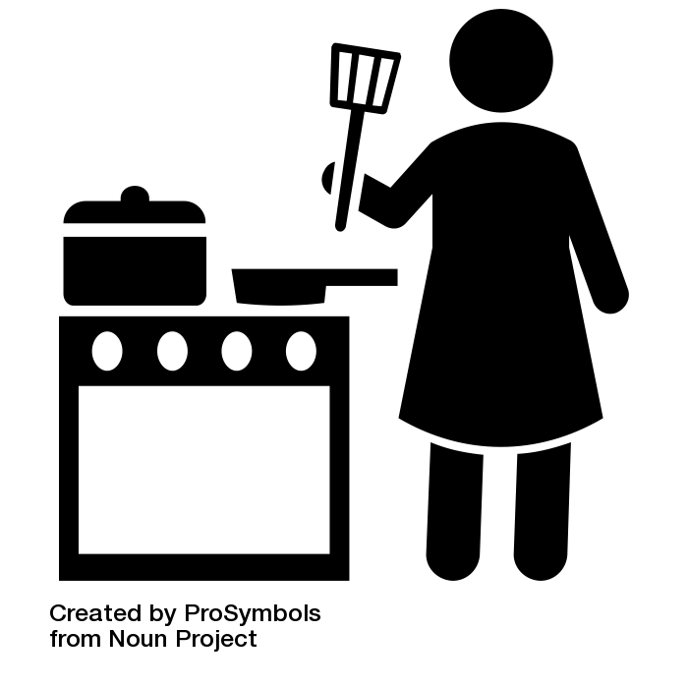

Practice – Product Business Sentences (Task 1)
Directions: Learn about businesses that sell a product. Read and pronounce. Ask your partner two questions:
- What is your business?
- What do you make?
Then copy the answers below in each box.
 | What is your business? | What do you make?
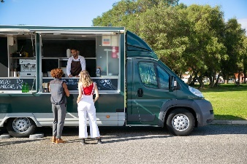  Food Truck | I have a food truck. | I make and sell food from a truck.
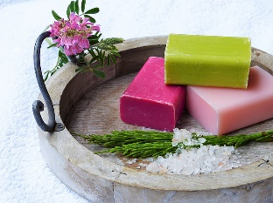  Soap | I have a soap business. | I make soap.
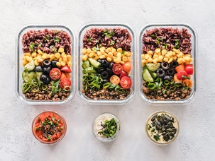  Meal Preparation | I have a meal preparation business. | I make meals for the week.
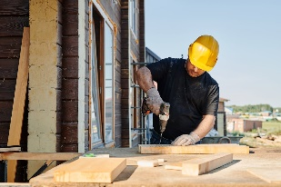  Construction | I have a construction business. | I make buildings.

Handout #10: Practice – Product Business Sentences (Task 1) cont.
 | What is your business? | What do you make?
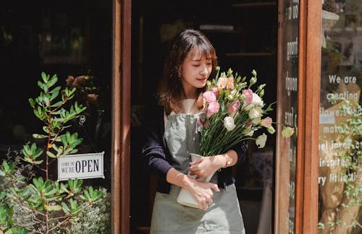  Florist | I have a flower business. | I make flower arrangements.
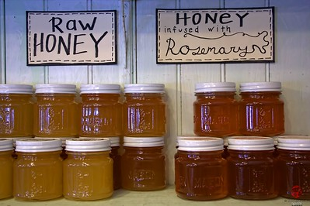  Honey | I have a honey business. | I make jars of honey.
  Jewelry | I have a jewelry business. | I make jewelry.
Now, let’s have some conversation practice. Choose a business and interview your partner with these questions:
1.What is your business?
2. What do you make?
3. Why do you like this business?

Practice – Service Business Sentences (Task 1)
Directions: Learn about businesses that sell a service. Read and pronounce. Ask your partner two questions:
- What is your business?
- What do you do?
Then copy the answers below in each box.
 | What is your business? | What do you do?
House cleaning | I have a house cleaning business | I clean houses.
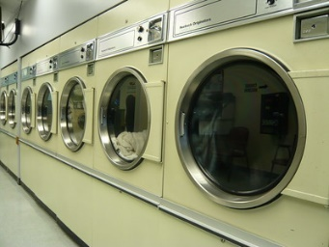  Laundromat | I have a laundromat business. | I have machines that clean clothes.
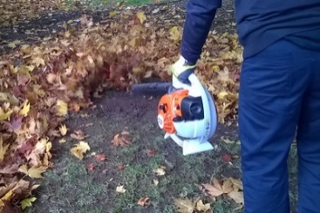  Leaf blowing | I have a leaf blowing business. | I clean the leaves.
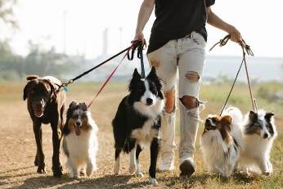  Dog walking | I have a dog walking business. | I walk other people’s dogs.

Handout #11: Practice – Service Business Sentences (Task 1) cont.
 | What is your business? | What do you do?
Grocery delivery | I have a grocery delivery business. | I bring food to people’s homes.
  Home daycare | I have a daycare business. | I take care of other people’s children in my home.
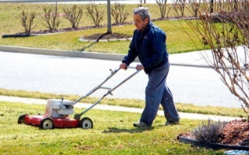  Lawn mowing | I have a lawn mowing business. | I cut people’s grass.
Now, let’s have some conversation practice. Choose a business and interview your partner with these questions:
1.What is your business?
2. What do you do?
3. Why do you like this business?

Introduction – Business Vocabulary (Task 3)
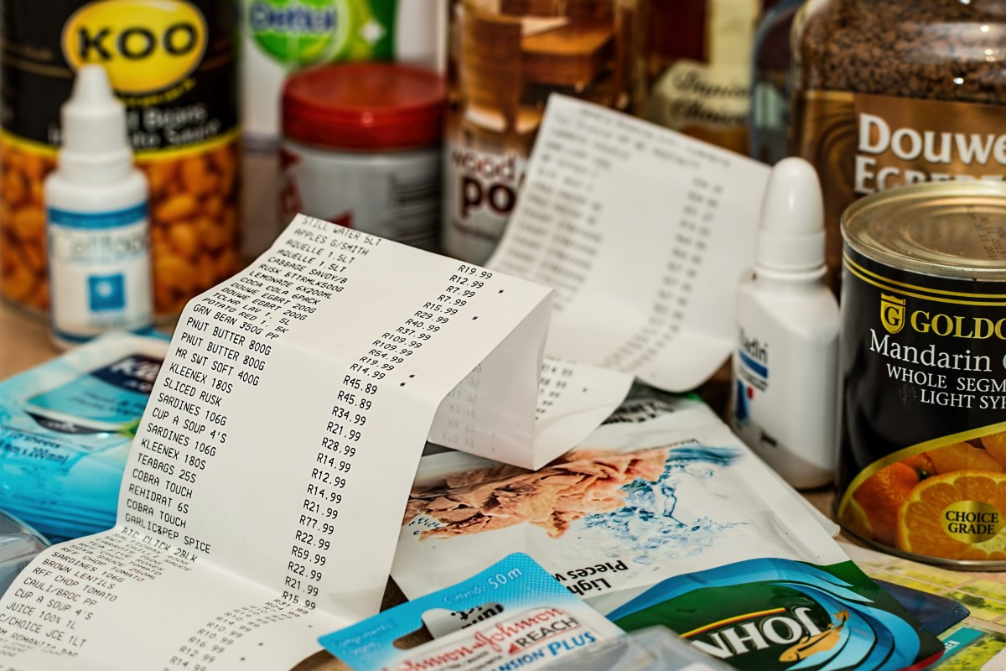
- Total cost: Add together everything that you buy.
Example: I want to buy a bag of oranges for $10 and a can of soup for $3. The total cost is $13.
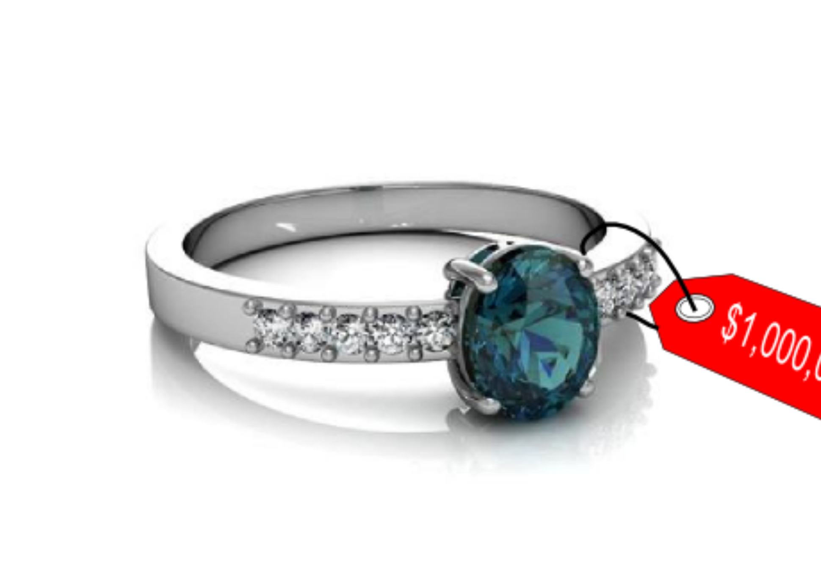
- Cost: money you need to pay (price).
Example: The ring costs $100.
$
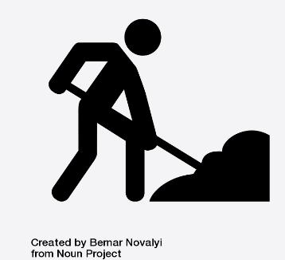
- Labor: work (how many hours someone works)
Example: She gets paid $40 for each hour of labor.
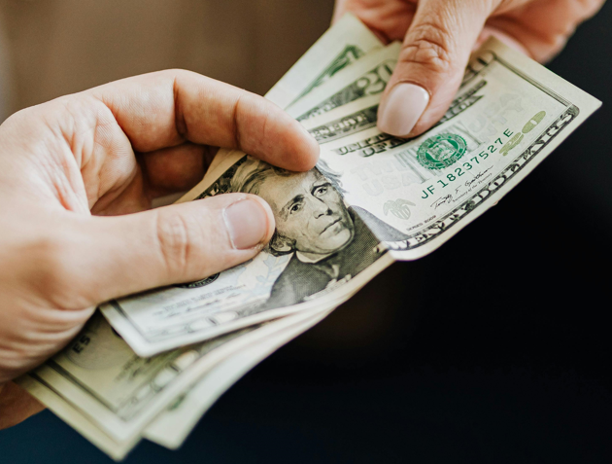
- Earns: money from your job (salary)
Example: He earns $300 every day.
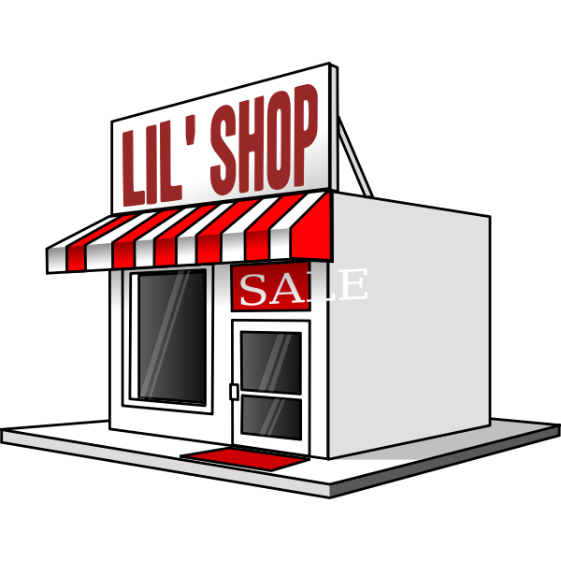http://www.publicdomainfiles.com/show_file.php?id=13534053624854
- Business: a place or people who make or sell something
Example: A hair salon is a business where you can get a haircut.
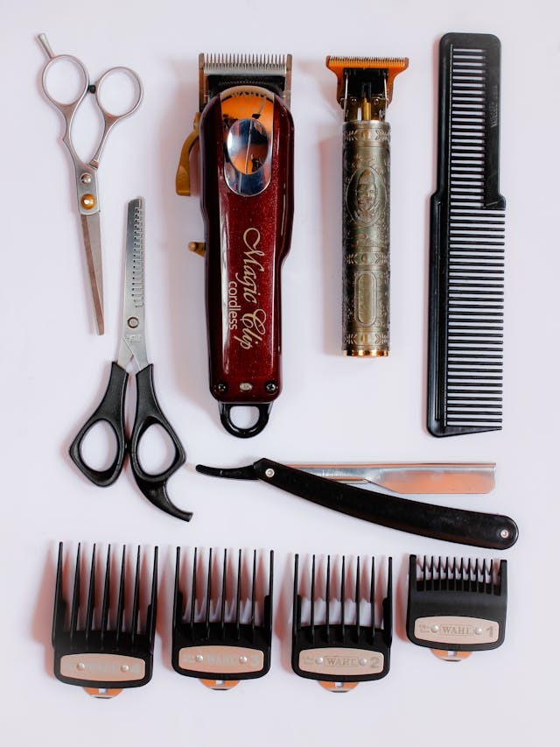

- Materials: things someone needs to prepare or make something
Example: You need materials like scissors, a comb, and a razor to cut someone’s hair.
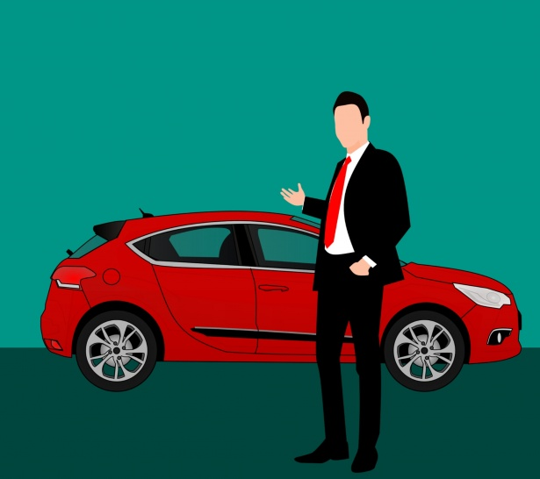
- Own: something that belongs to you (you buy it or make it)
Example: I want to buy a car. I want to own a car.

Practice – Business Vocabulary (Task 3)
Directions: Write the correct word in the sentence next to the picture.
total | total cost | labor | business
own | earns | materials | costs

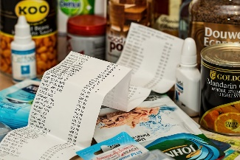 | - I want to buy a bag of oranges for $10 and a can of soup for $3.  The is $13.
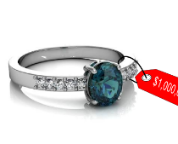 | - The ring $100.
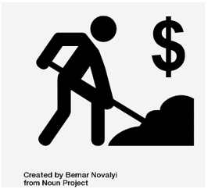 | - She gets $40 for each hour of .
 | - She $300 every day.
 | - A hair salon is a where you can get a haircut.
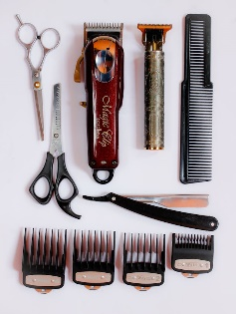 | - You need like scissors, a comb, and a razor to cut someone’s hair.
 | - I want to buy a car. I want to a car.

Answer Key – Business Vocabulary (Task 3)
Directions: Write the correct word in the sentence next to the picture.
total | total cost | labor | business
own | earns | materials | costs

- I want to buy a bag of oranges for $10 and a can of soup for $3.
The total or total cost is $13.
- The ring costs $100.
- She gets $40 for each hour of labor.
- She earns $300 every day.
- A hair salon is a earns where you can get a haircut.
- You need materials like scissors, a comb, and a razor to cut someone’s hair.
- I want to buy a car. I want to own a car.

Introduction – Cost Estimate #1 (Task 3)
Business: Landscaping
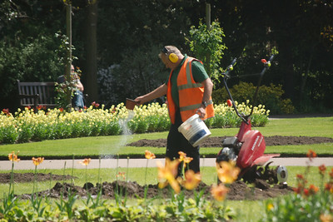
Vocabulary
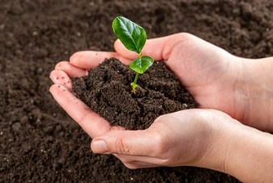  Soil | 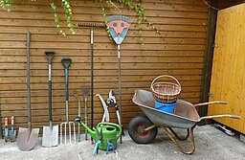  Materials | 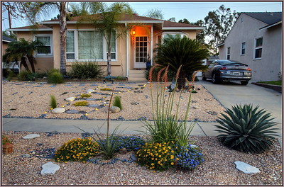  Front yard
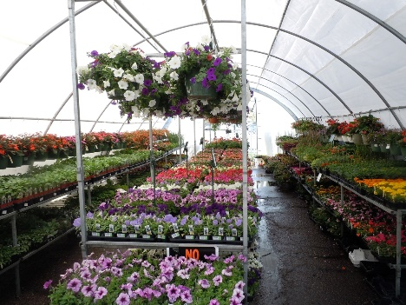  Plants | 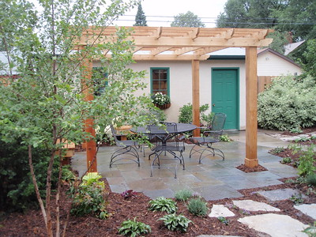  Backyard | Labor

Practice – Cost Estimate #1 (Task 3)
Please read and answer the questions below.
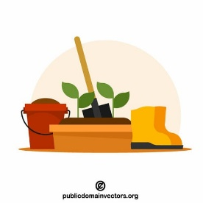
Jerry owns a landscaping business. Today, Jerry needs to buy materials to make a new yard for a customer. He will need to buy soil and plants. He has to buy soil. It costs $50 for soil. He needs 10 plants. Each plant costs $5. The job will take 10 hours of labor. He earns $30 an hour.
Landscaping Estimate
- What does Jerry need to buy? | Cost:
- What does Jerry need to buy? | Cost:
- How much is the total cost for materials?
- How much is the total cost for labor?
- How much total cost for the job?

Answer Key – Cost Estimate #1 (Task 3)
Please read and answer the questions below.
Jerry owns a landscaping business. Today, Jerry needs to buy materials to make a new yard for a customer. He will need to buy soil and plants. He has to buy soil. It costs $50 for soil. He needs 10 plants. Each plant costs $5. The job will take 10 hours of labor. He earns $30 an hour.
Landscaping Estimate
- What does Jerry need to buy? Soil | Cost: $50
- What does Jerry need to buy? 10 plants | Cost: $50
- How much is the total cost for materials? | $100
- How much is the total cost for labor? | $300
- How much total cosy for the job? | $400

Introduction – Cost Estimate #2 (Task 3)
Business: Pool Cleaning
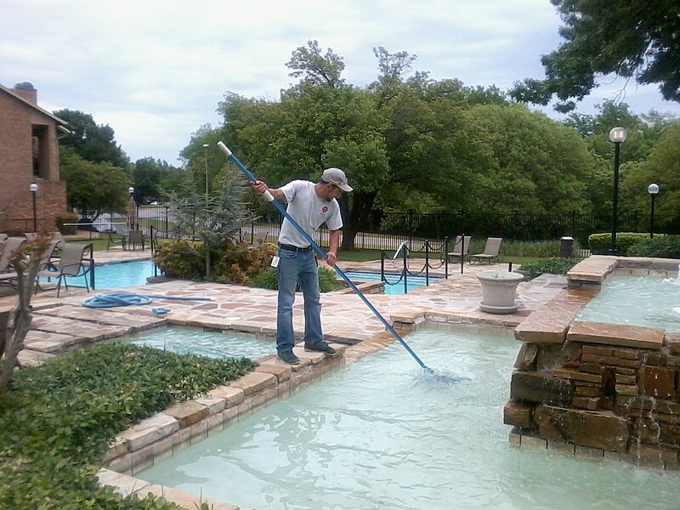
Vocabulary
  Clean pool | 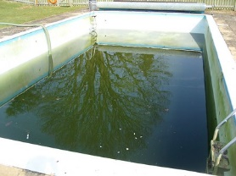  Dirty pool
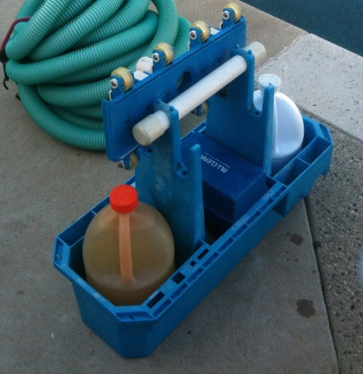  Chemicals | 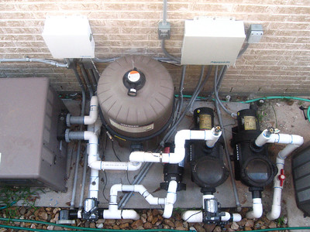  Pool pump

Practice – Cost Estimate #2 (Task 3)
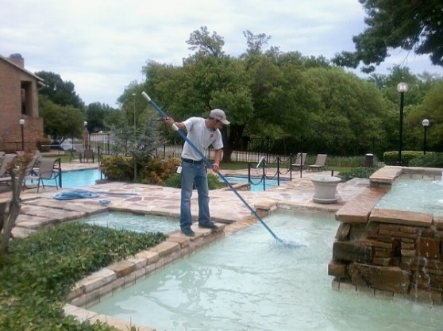
Please read about Walter Anton’s pool service. Then answer the questions in the chart.
Shirley Simmons has a large pool in Danville, CA. Her pool is really dirty. She asked the owner Walter Anton to make her pool beautiful by July 4th. Walter looked at Shirley’s pool. It needs a lot of work. He will treat the water with basic chemicals. The chemicals cost about $200. He will clean the top and bottom of the pool and remove all dirt and leaves. He will buy a new pool pump to replace the broken pool pump. The pool pump costs $50. It will take him 10 hours of work to finish this job. He charges $30 an hour.
Estimate and Contract
- What will he buy? | Cost:
- What will he buy? | Cost:
- How much is the total cost for materials?
- How much is the total cost for labor?
- How much is the total cost for the job?

Answer Key – Cost Estimate #2 (Task 3)
Please read about Walter Anton’s pool service. Then answer the questions in the chart.
Shirley Simmons has a large pool in Danville, CA. Her pool is really dirty. She asked the owner Walter Anton to make her pool beautiful by July 4th. Walter looked at Shirley’s pool. It needs a lot of work. He will treat the water with basic chemicals. The chemicals cost about $200. He will clean the top and bottom of the pool and remove all dirt and leaves. He will buy a new pool pump to replace the broken pool pump. The pool pump costs $50. It will take him 10 hours of work to finish this job. He charges $30 an hour.
Estimate and Contract
- What will he buy? Chemicals | Cost: $200
- What will he buy? Pool pump | Cost: $50
- How much is the total cost for materials? | $250
- How much is the total cost for labor? | $300
- How much is the total cost for the job? | $550

