Contents
Handout #1: Introduction – Employee vs. Business Owners (Task 1) 2
Handout #2: Practice – Business #1 (Task 1) 4
Handout #3: Answer Key – Business #1 (Task 1) 5
Handout #4: Practice – Business #2 (Task 1) 6
Handout #5: Answer Key – Business #2 (Task 1) 7
Handout #6: Reading / Answer Key – Problem & Business Solution (Task 1) 8
Handout #7: Practice – Problem & Business Solution Part A (Task 1) 10
Handout #8: Practice – Problem & Business Solution Part B (Task 1) 12
Handout #9: Practice – Matching Business Examples (Task 1) 14
Handout #10: Practice – Product Business Sentences (Task 1) 17
Handout #11: Practice – Service Business Sentences (Task 1) 19
Handout #12: Introduction – Business Vocabulary (Task 3) 21
Handout #13: Practice – Business Vocabulary (Task 3) 22
Handout #14: Answer Key – Business Vocabulary (Task 3) 23
Handout #15: Introduction – Cost Estimate #1 (Task 3) 24
Handout #16: Practice – Cost Estimate #1 (Task 3) 25
Handout #17: Answer Key – Cost Estimate #1 (Task 3) 26
Handout #18: Introduction – Cost Estimate #2 (Task 3) 27
Handout #19: Practice – Cost Estimate #2 (Task 3) 28
Handout #20: Answer Key – Cost Estimate #2 (Task 3) 29

Introduction – Employee vs. Business Owners (Task 1)
- What is she? She is an employee. She has a job in a supermarket. She is a cashier.
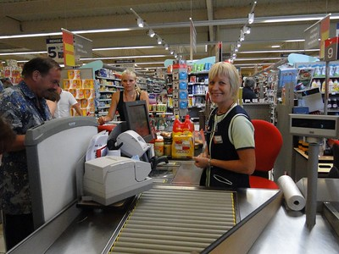
- What is he? He is an employee. He works at Walmart. He puts things on the shelves.
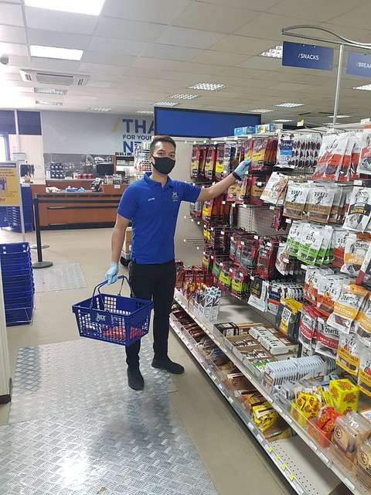
- What is she? She is an employee. She works at McDonalds. She is a cook.
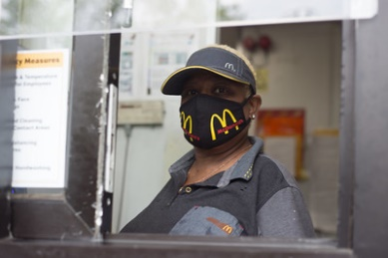
- What is he? He is an employee. He works at the gas station. He pumps the gas.
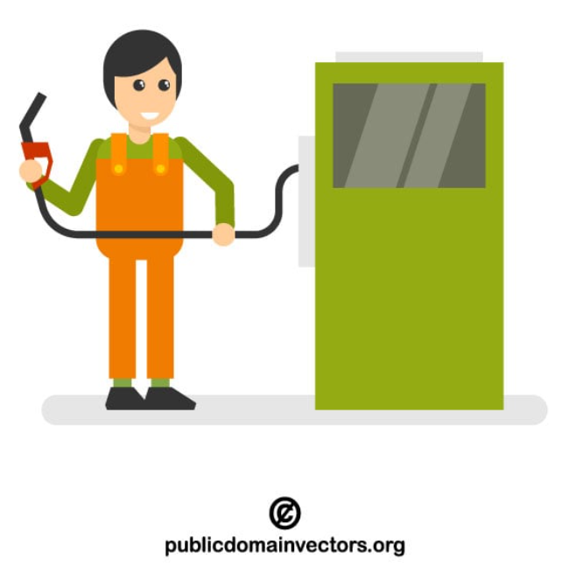

Handout #2: Introduction – Employee vs. Business Owners (Task 1) cont.
- What is she? She is a business owner. She owns a soap store. She makes and sells soap and perfume.

- What is he? He is a business owner. He owns a jewelry store. He makes and sells jewelry.
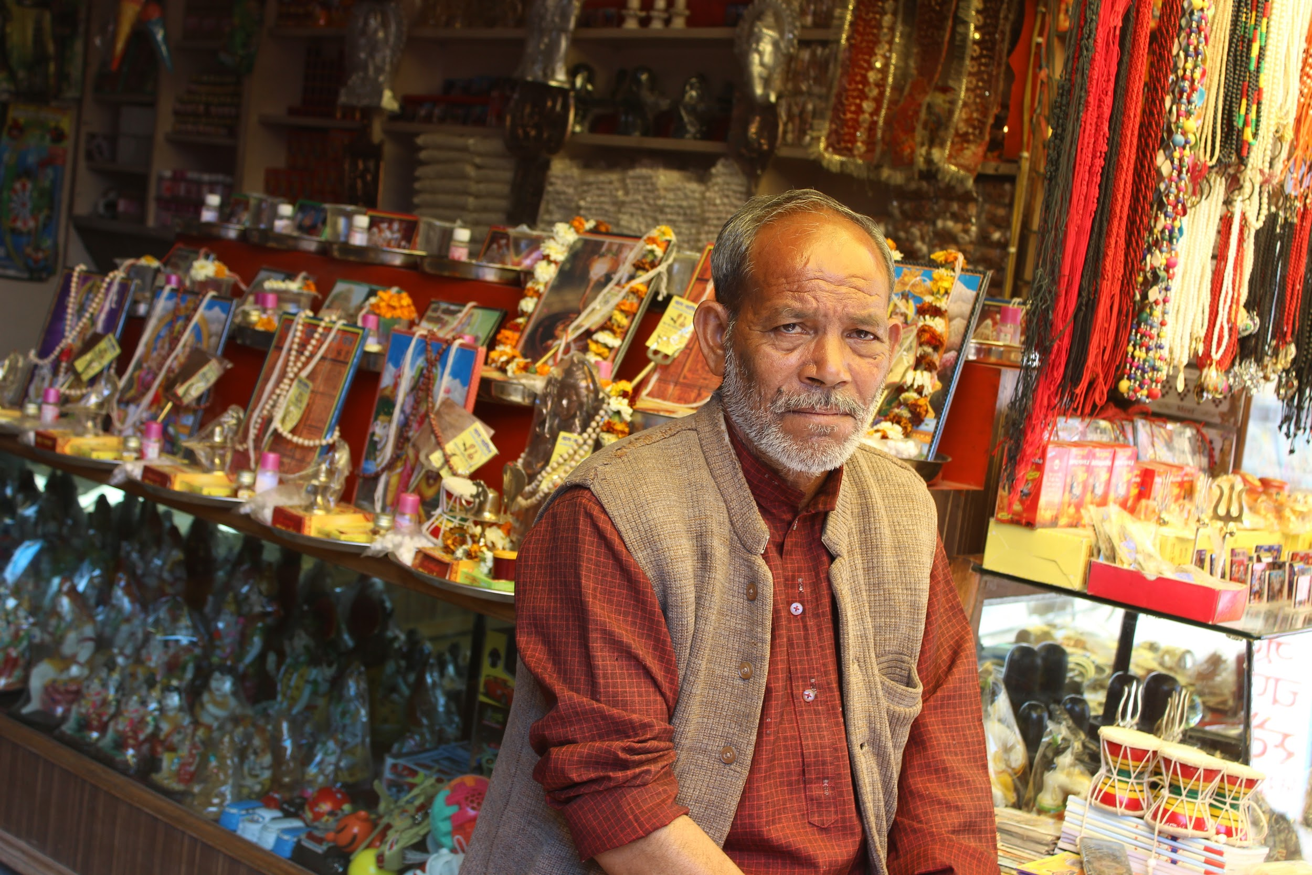
- What are they? They are business owners. They own a market. They sell food.
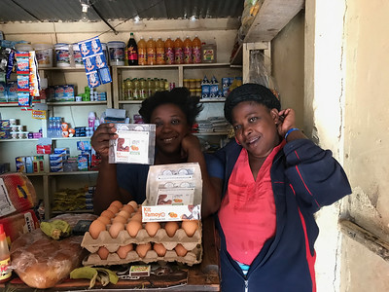
- What is she? She is a business owner. She has a daycare in her house. She watches other people’s children.


Practice – Business #1 (Task 1)
Directions: Please read with a partner. Then answer the questions.
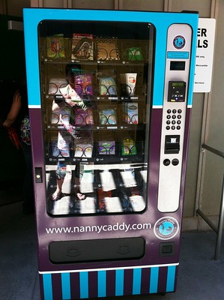

A: I want to be a business owner.
B: What is the business?
A: I want to have a baby supplies vending machine.
B: What do you do or make?
A: I can sell diapers and baby food to parents who need it.
B: Why do you like this business?
A: I like to help parents and babies.
- What is the business?
- What can the person do or make?
- Why does the person like this business?
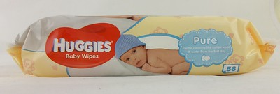

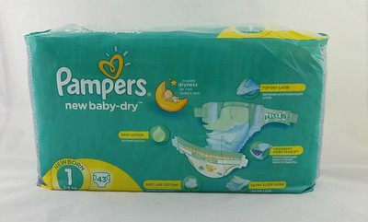

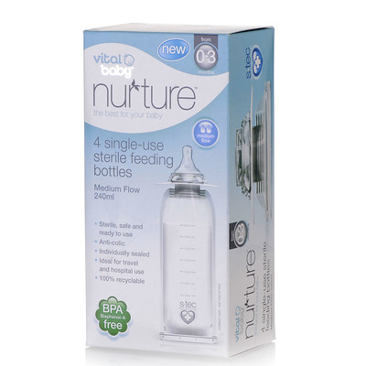

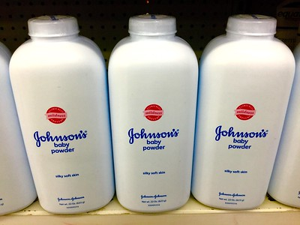

Answer Key – Business #1 (Task 1)
Directions: Please read with a partner. Then answer the questions.

A: I want to be a business owner.
B: What is the business?
A: I want to have a baby supplies vending machine.
B: What do you do or make?
A: I can sell diapers and baby food to parents who need it.
B: Why do you like this business?
A: I like to help parents and babies.
- What is the business? A baby supplies vending machine.
- What can the person do or make? Sell diapers and baby food.
- Why does the person like this business? They like to help parents and babies.

Practice – Business #2 (Task 1)
Directions: Please read with a partner. Then answer the questions.
A: My son wants to be a business owner.
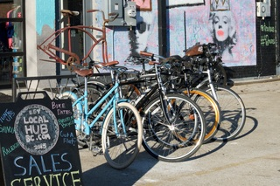

B: What is the business?
A: He wants to have a bicycle repair store.
B: What does he do or make?
A: He fixes broken bicycles.
B: Why does he like this business?
A: He likes to fix bicycles. He can fix bicycles very well.
- What is the business?
- What can the owner do or make?
- Why does her son like this business?
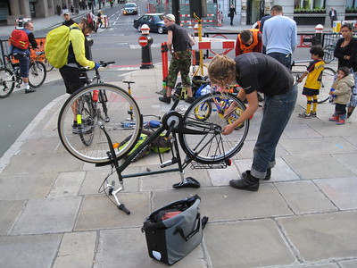

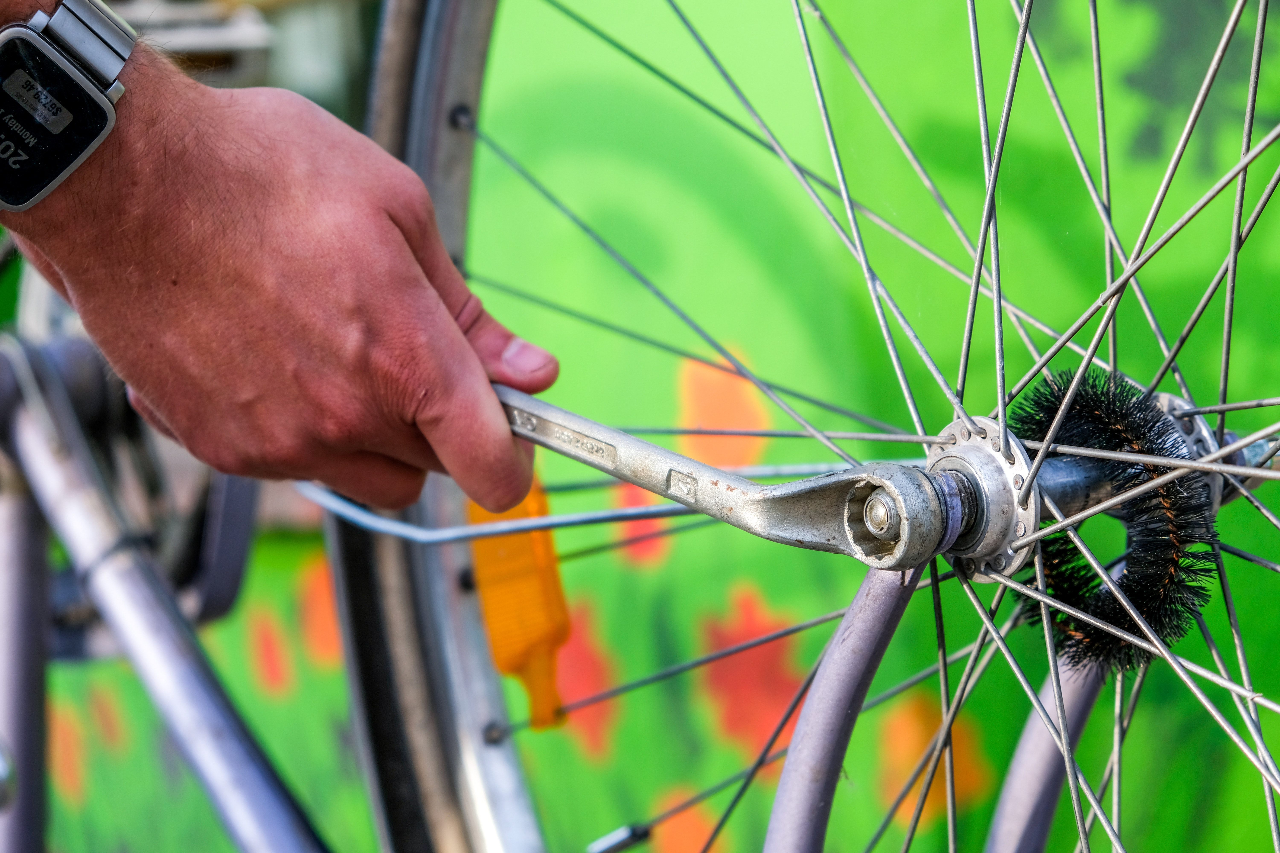

Answer Key – Business #2 (Task 1)
Directions: Please read with a partner. Then answer the questions.
A: My son wants to be a business owner.
B: What is the business?
A: He wants to have a bicycle repair store.
B: What does he do or make?
A: He fixes broken bicycles.
B: Why does he like this business?
A: He likes to fix bicycles. He can fix bicycles very well.
- What is the business? A bicycle repair store.
- What can the owner do or make? Fix broken bicycles.
- Why does her son like this business? He likes to fix bicycles. He can fix bicycles very well.

Reading / Answer Key – Problem & Business Solution (Task 1)
Directions: Use this handout to cut out and paste pictures to the Problem and Business Solution Handouts Part A and Part B.
Problem | Business Solution
  The grass is too tall. | 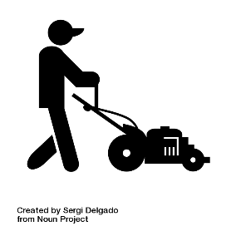  The gardener cuts the grass.
  He goes on a trip. He has a dog. | 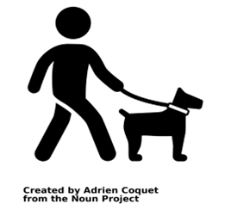  A dog walker walks the dog.
  The mom has to work. | 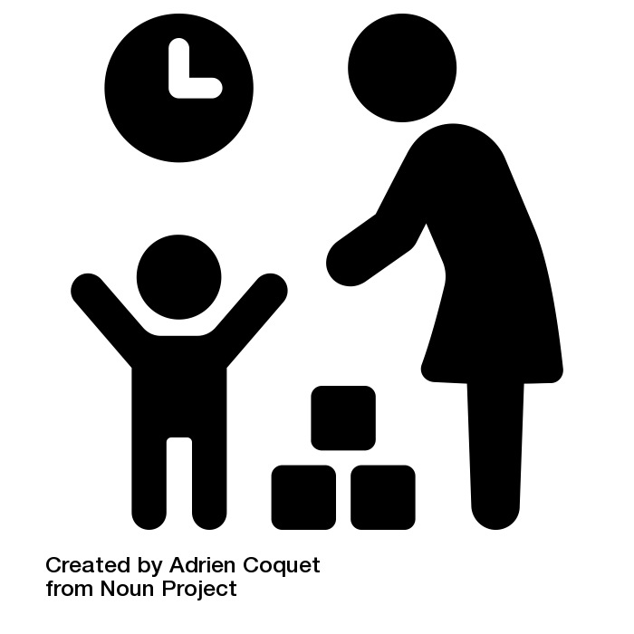  The daycare owner watches her children.
  The student is hungry. | 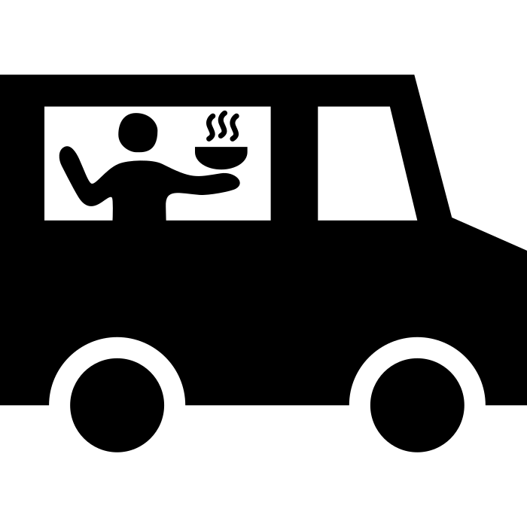  The food truck owner sells food at school.

Handout #6: Reading / Answer Key – Problem & Business Solution (Task 1) cont.
Problem | Business Solution
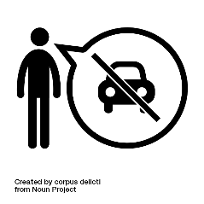  He can’t drive. He needs groceries. | 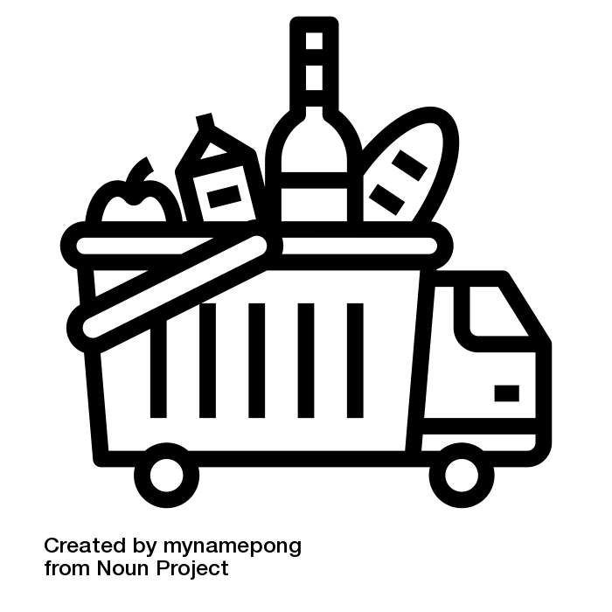  The food delivery owner brings groceries.
  The house is dirty. |   The house cleaner cleans it.
  The window is broken. |   The construction worker fixes it.
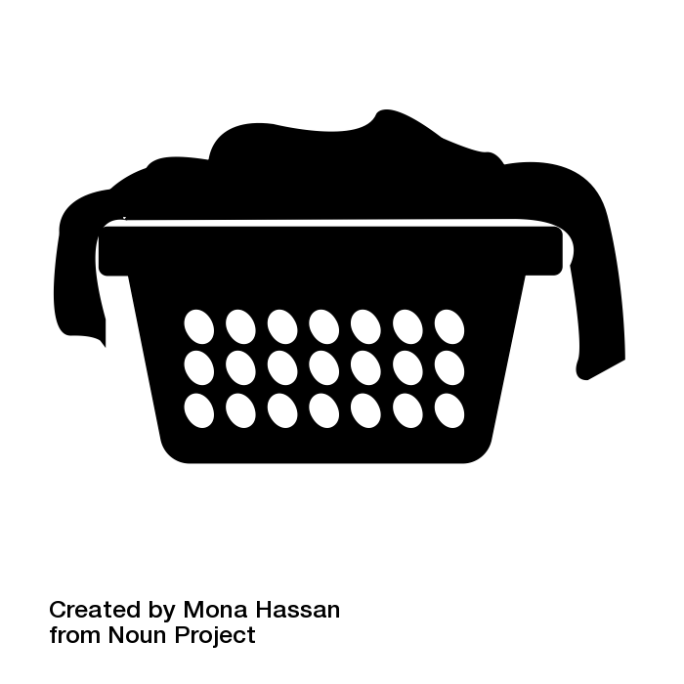  The laundry is dirty. | 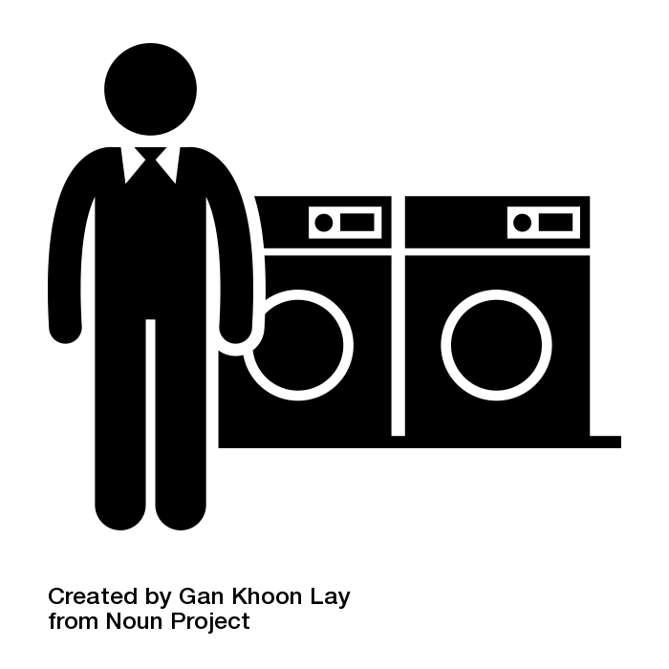  The laundromat owner washes it.

Practice – Problem & Business Solution Part A (Task 1)
Directions: Cut and paste the picture that is a solution to a problem. Write the solution.
Problem | Business Solution

The grass is too tall.

He goes on a trip. He has a dog.

The mom has to work.

The student is hungry.

Handout #7: Practice – Problem & Business Solution Part A (Task 1) cont.
Problem | Business Solution

He can’t drive. He needs groceries.

The house is dirty.
The window is broken. | .
The laundry is dirty. | .

Practice – Problem & Business Solution Part B (Task 1)
Directions: Cut and paste the picture that is a solution to a problem. Write the problem.
Problem | Business Solution
 | The gardener cuts the grass.
 | A dog walker walks the dog.
 | The daycare owner watches her children.
 | The food truck owner sells food at school.

Handout #8: Practice – Problem & Business Solution Part B (Task 1) cont.
Problem | Business Solution
. | The food delivery owner brings groceries.
 | The house cleaner cleans it.
 | The construction worker fixes it.
 | The laundromat owner washes it.

Practice – Matching Business Examples (Task 1)
Directions: Find the name of the business. Then write: I have a business. For example, I have a house cleaning business.
leaf blowing | grocery delivery | home daycare
laundromat | lawn mowing | jewelry
dog walking | florist | food truck
house cleaning | meal preparation | construction
After you finish writing, you can practice speaking with a partner.
Question: What is your business? Answer: I have a business.


Handout #9: Practice – Matching Business Examples (Task 1) cont.



Handout #9: Practice – Matching Business Examples (Task 1) cont.
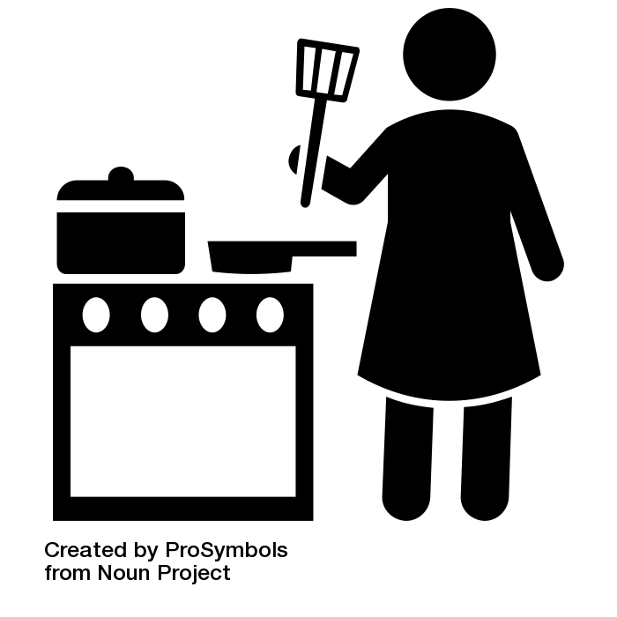

Practice – Product Business Sentences (Task 1)
Directions: Learn about businesses that sell a product. Read and pronounce. Ask your partner two questions:
- What is your business?
- What do you make?
Then copy the answers below in each box.
 | What is your business? | What do you make?
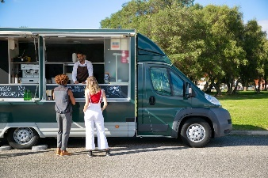  Food Truck | I have a food truck. | I make and sell food from a truck.
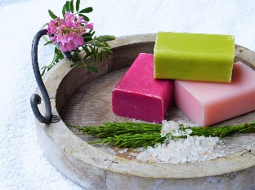  Soap | I have a soap business. | I make soap.
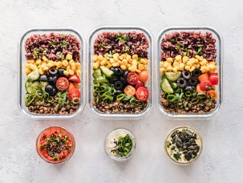  Meal Preparation | I have a meal preparation business. | I make meals for the week.
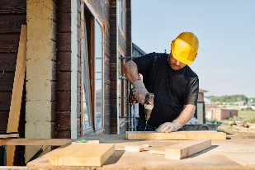  Construction | I have a construction business. | I make buildings.

Handout #10: Practice – Product Business Sentences (Task 1) cont.
 | What is your business? | What do you make?
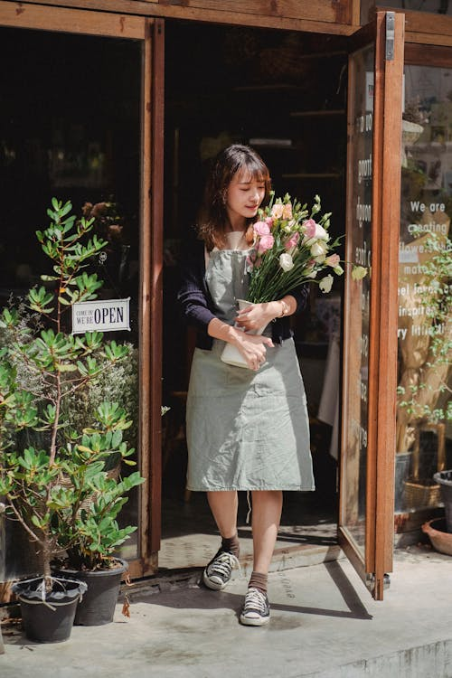  Florist | I have a flower business. | I make flower arrangements.
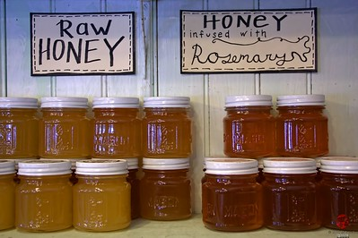  Honey | I have a honey business. | I make jars of honey.
  Jewelry | I have a jewelry business. | I make jewelry.
Now, let’s have some conversation practice. Choose a business and interview your partner with these questions:
1.What is your business?
2. What do you make?
3. Why do you like this business?

Practice – Service Business Sentences (Task 1)
Directions: Learn about businesses that sell a service. Read and pronounce. Ask your partner two questions:
- What is your business?
- What do you do?
Then copy the answers below in each box.
 | What is your business? | What do you do?
House cleaning | I have a house cleaning business | I clean houses.
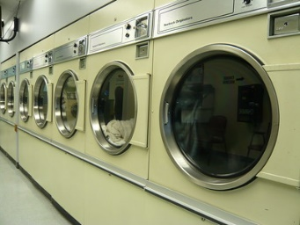  Laundromat | I have a laundromat business. | I have machines that clean clothes.
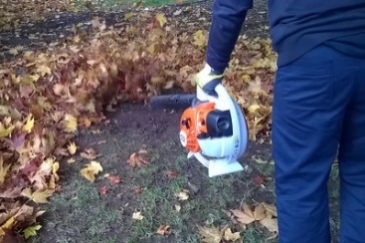  Leaf blowing | I have a leaf blowing business. | I clean the leaves.
  Dog walking | I have a dog walking business. | I walk other people’s dogs.

Handout #11: Practice – Service Business Sentences (Task 1) cont.
 | What is your business? | What do you do?
Grocery delivery | I have a grocery delivery business. | I bring food to people’s homes.
  Home daycare | I have a daycare business. | I take care of other people’s children in my home.
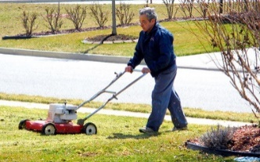  Lawn mowing | I have a lawn mowing business. | I cut people’s grass.
Now, let’s have some conversation practice. Choose a business and interview your partner with these questions:
1.What is your business?
2. What do you do?
3. Why do you like this business?

Introduction – Business Vocabulary (Task 3)
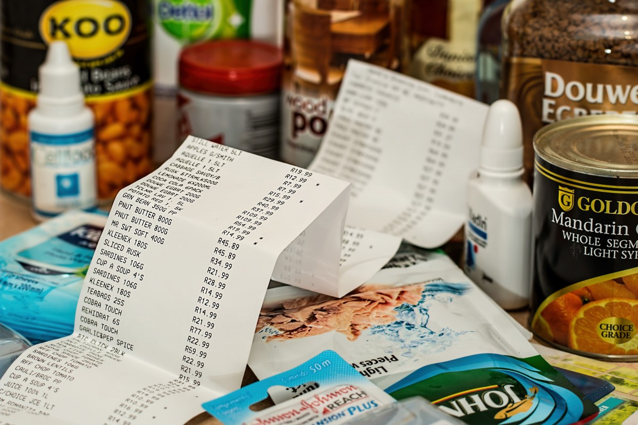
- Total cost: Add together everything that you buy.
Example: I want to buy a bag of oranges for $10 and a can of soup for $3. The total cost is $13.
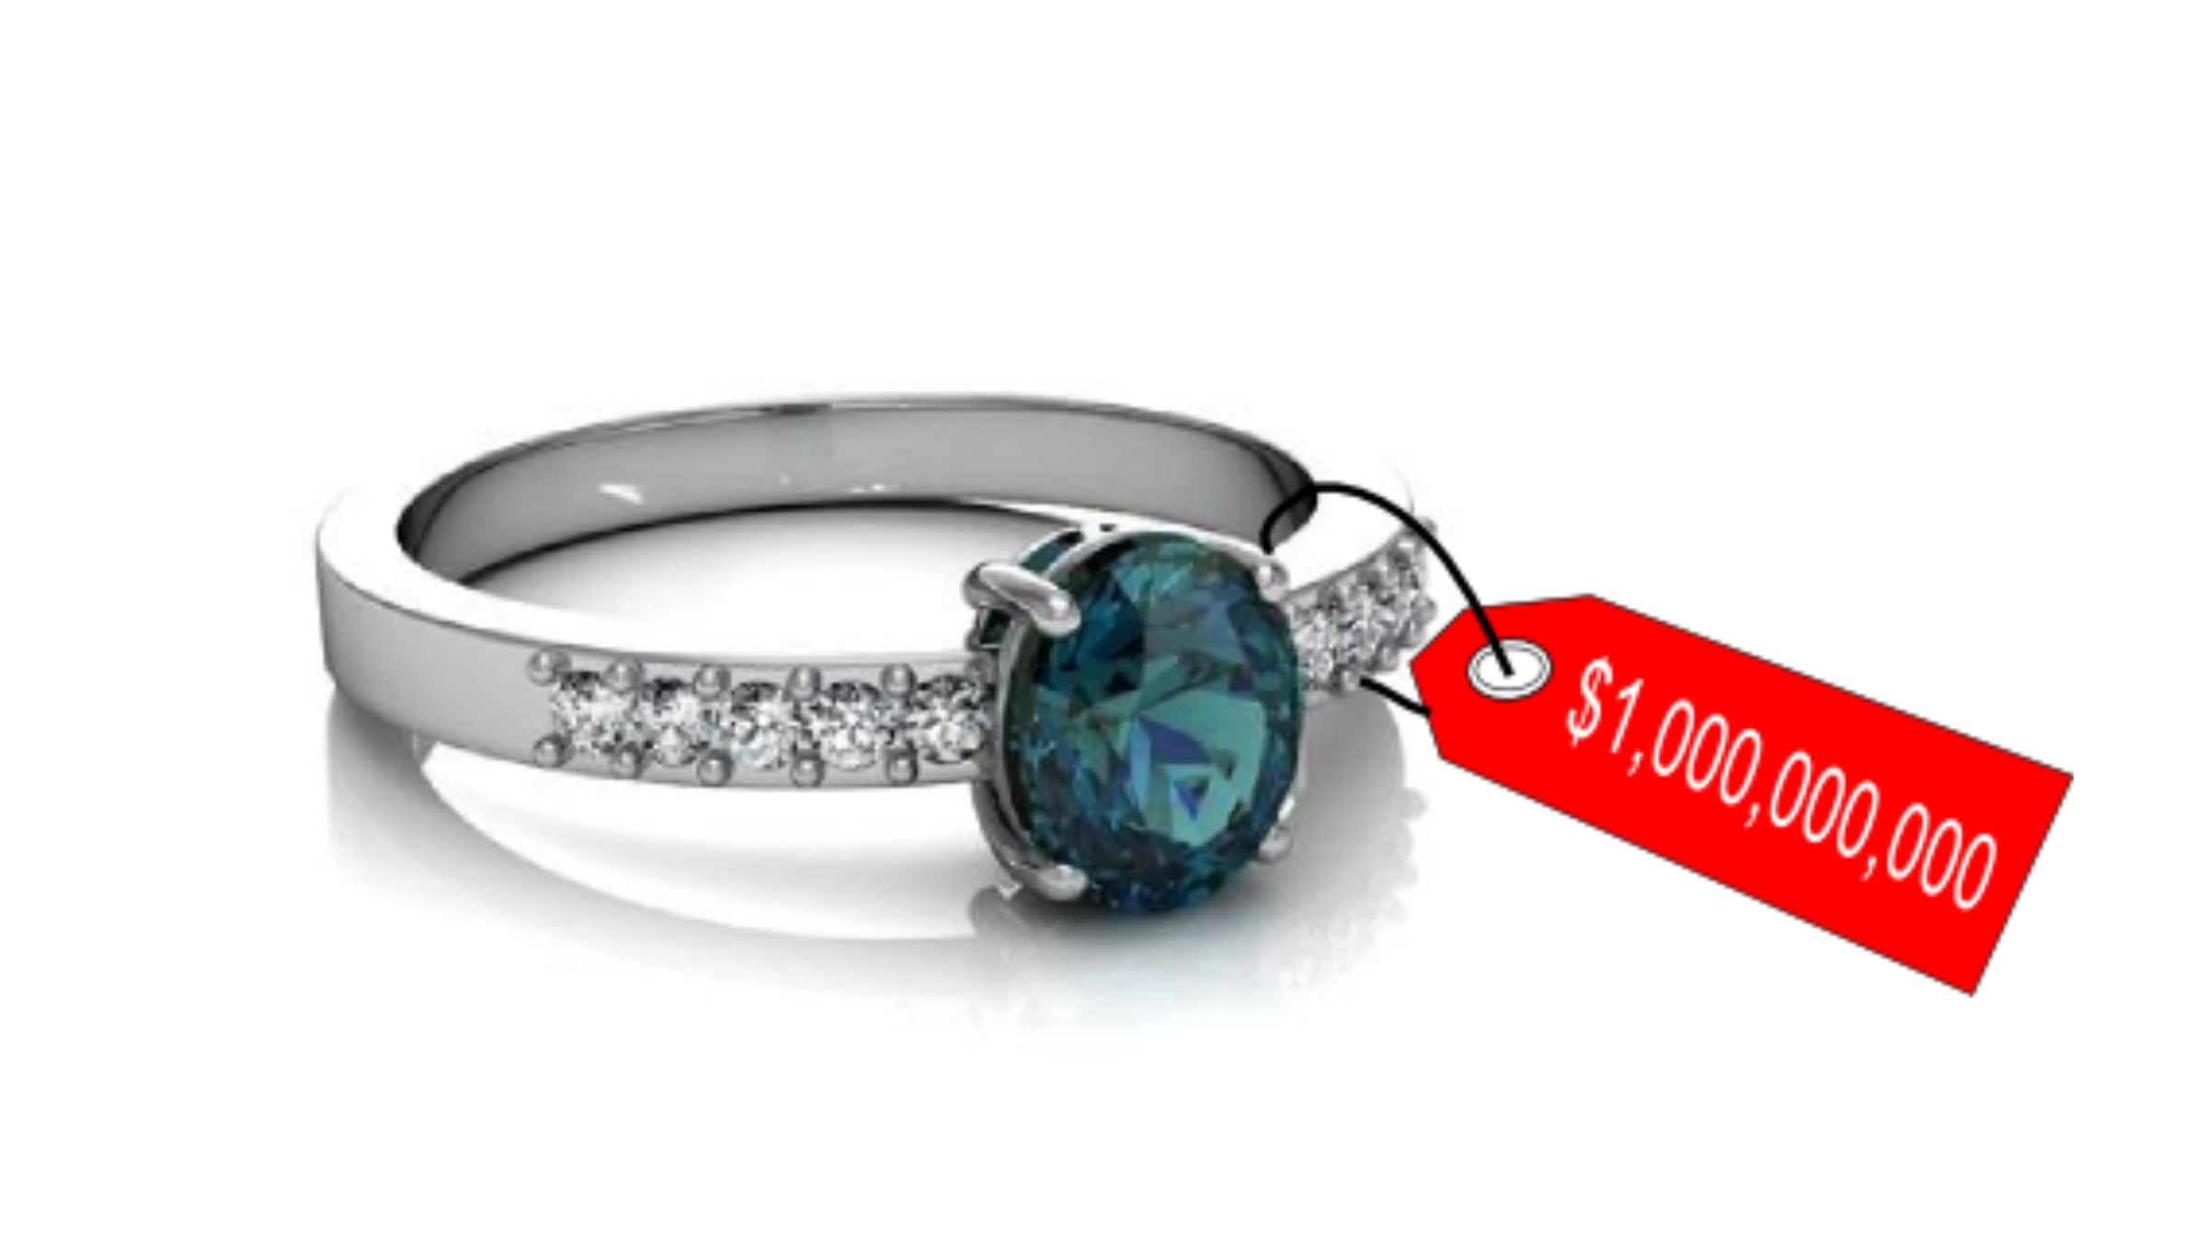
- Cost: money you need to pay (price).
Example: The ring costs $100.
$
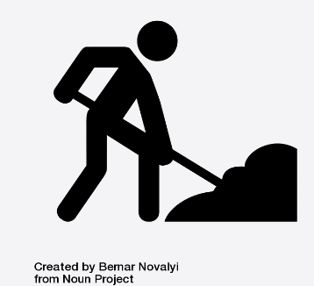
- Labor: work (how many hours someone works)
Example: She gets paid $40 for each hour of labor.

- Earns: money from your job (salary)
Example: He earns $300 every day.
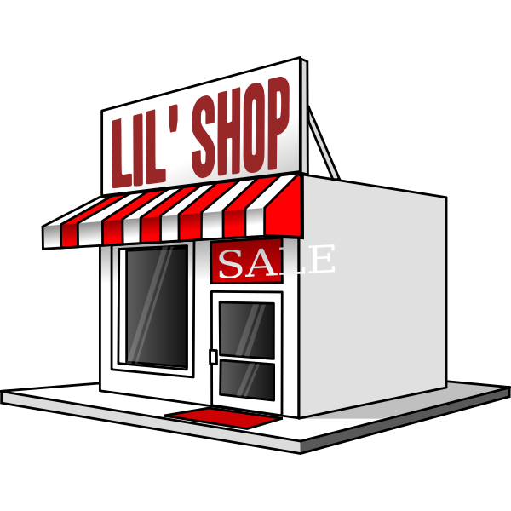http://www.publicdomainfiles.com/show_file.php?id=13534053624854
- Business: a place or people who make or sell something
Example: A hair salon is a business where you can get a haircut.
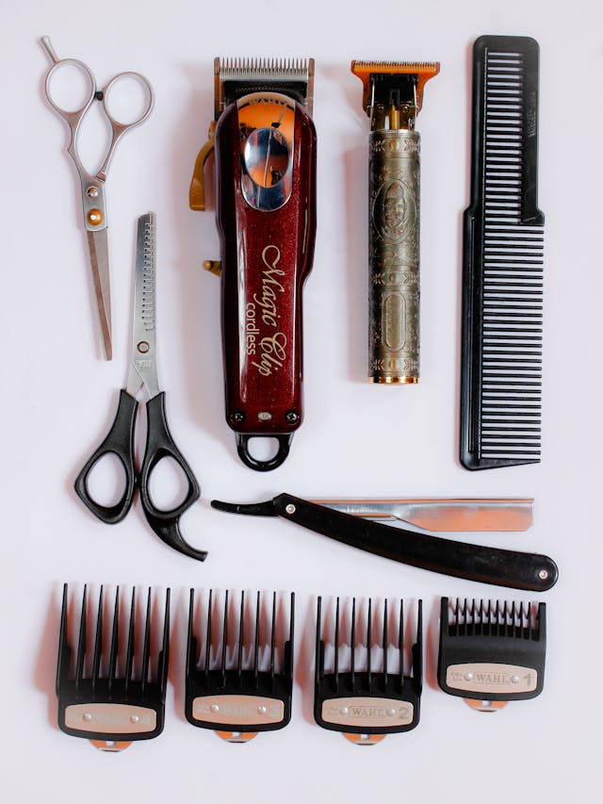

- Materials: things someone needs to prepare or make something
Example: You need materials like scissors, a comb, and a razor to cut someone’s hair.

- Own: something that belongs to you (you buy it or make it)
Example: I want to buy a car. I want to own a car.

Practice – Business Vocabulary (Task 3)
Directions: Write the correct word in the sentence next to the picture.
total | total cost | labor | business
own | earns | materials | costs

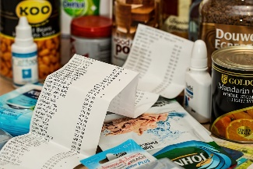 | - I want to buy a bag of oranges for $10 and a can of soup for $3.  The is $13.
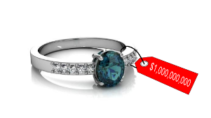 | - The ring $100.
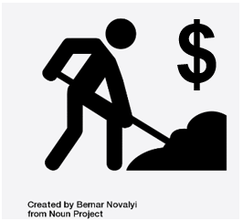 | - She gets $40 for each hour of .
 | - She $300 every day.
 | - A hair salon is a where you can get a haircut.
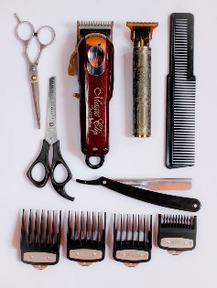 | - You need like scissors, a comb, and a razor to cut someone’s hair.
 | - I want to buy a car. I want to a car.

Answer Key – Business Vocabulary (Task 3)
Directions: Write the correct word in the sentence next to the picture.
total | total cost | labor | business
own | earns | materials | costs

- I want to buy a bag of oranges for $10 and a can of soup for $3.
The total or total cost is $13.
- The ring costs $100.
- She gets $40 for each hour of labor.
- She earns $300 every day.
- A hair salon is a earns where you can get a haircut.
- You need materials like scissors, a comb, and a razor to cut someone’s hair.
- I want to buy a car. I want to own a car.

Introduction – Cost Estimate #1 (Task 3)
Business: Landscaping
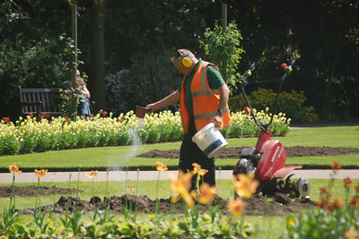
Vocabulary
  Soil | 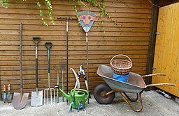  Materials | 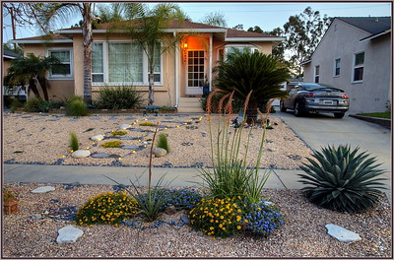  Front yard
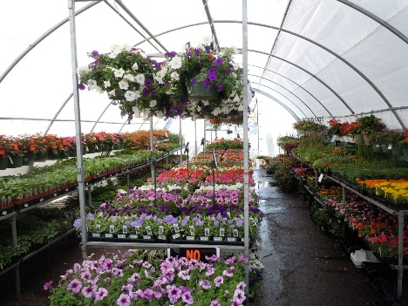  Plants | 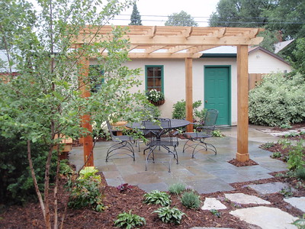  Backyard | Labor

Practice – Cost Estimate #1 (Task 3)
Please read and answer the questions below.
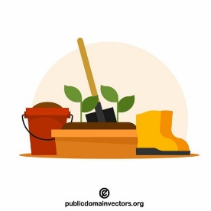
Jerry owns a landscaping business. He wants to make a new front yard.
He buys plants. He needs 10 plants. Each plant costs $5.
He works for 5 hours. His pay is $30 an hour.
Landscaping Estimate
- How many plants does Jerry need?
- How much do the plants cost each?
- What is the total cost of the plants?
- How many hours does he work?
- How much is he paid each hour?
- How much money will Jerry get for his work?
- Total cost of the job? (add the cost of #3 and #6)

Answer Key – Cost Estimate #1 (Task 3)
Please read and answer the questions below.
Jerry owns a landscaping business. He wants to make a new front yard.
He buys plants. He needs 10 plants. Each plant costs $5.
He works for 5 hours. His pay is $30 an hour.
Landscaping Estimate
- How many plants does Jerry need? | 10
- How much do the plants cost each? | $5
- What is the total cost of the plants? | $50
- How many hours does he work? | 5
- How much is he paid each hour? | $30
- How much money will Jerry get for his work? | $150
- Total cost of the job? (add the cost of #3 and #6) | $200

Introduction – Cost Estimate #2 (Task 3)
Business: Pool Cleaning
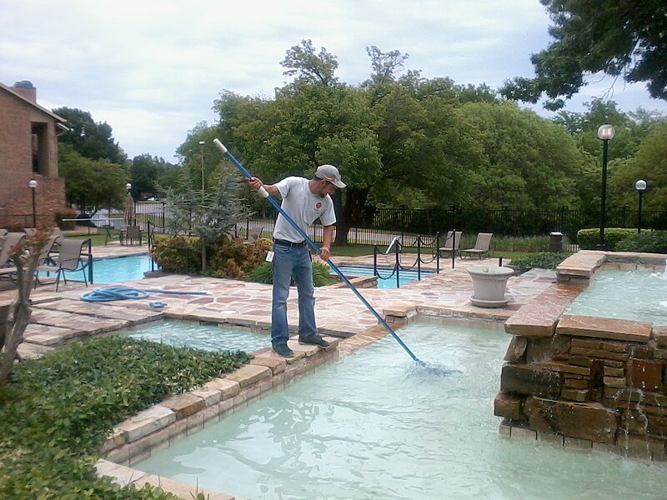
Vocabulary
  Clean pool | 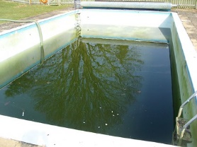  Dirty pool
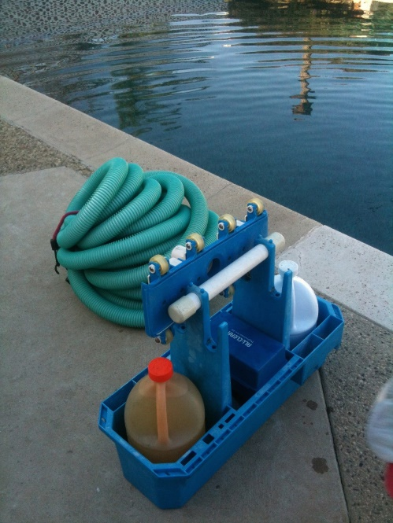  Chemicals | 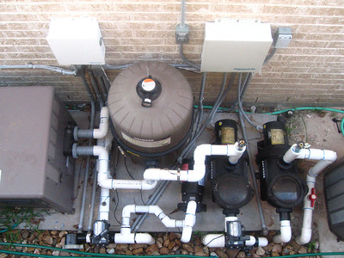  Pool pump

Practice – Cost Estimate #2 (Task 3)
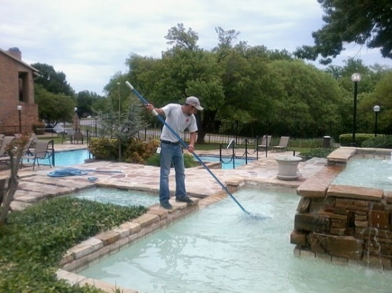
Please read about Walter Anton’s pool service. Then answer the questions in the chart.
Shirley Simmons has a large pool. It is very dirty. Walter buys chemicals to clean the pool. The chemicals cost about $200. He buys a new pool pump. The pool pump costs $50. He cleans the top and bottom of the pool. He works for 10 hours. He charges $30 an hour.
Estimate and Contract
- What he bought: | Cost:
- What he bought: | Cost:
- How much for the total cost for materials?
- How many hours of work?
- How much is he paid each hour?
- How much for the total work hours?
- Total cost for the job?

Answer Key – Cost Estimate #2 (Task 3)
Please read about Walter Anton’s pool service. Then answer the questions in the chart.
Shirley Simmons has a large pool. It is very dirty. Walter buys chemicals to clean the pool. The chemicals cost about $200. He buys a new pool pump. The pool pump costs $50. He cleans the top and bottom of the pool. He works for 10 hours. He charges $30 an hour.
Estimate and Contract
- What he bought: Chemicals | Cost: $200
- What he bought: Pool Pump | Cost: $50
- How much for the total cost for materials? | $250
- How many hours of work? | 10
- How much is he paid each hour? | $30
- How much for the total work hours? | $300
- Total cost for the job? | $250

