Contents

Handout #1: Overview of Tasks 2

Handout #2: Introduction – Phone Etiquette (Task 1) 3

Handout #3: Vocabulary (Task 1) 4

Handout #4: Directions – Responding to a Phone Call (Task 1A) 5

Handout #5: Example – Phone Call (Task 1A) 6

Handout #6: Example – Relaying a Message (Task 1B) 7

Handout #7: Example – Complete a Phone Message (Task 2) 8

Handout #8: Practice 1 – Phone Call (Task 1A, 1B and Task 2) 9

Handout #9: Practice 1 Answer Key – Phone Call (Task 1A, 1B and Task 2) 11

Handout #10: Practice 2 – Phone Call (Task 1A, 1B and Task 2) 13

Handout #11: Practice 2 Answer Key – Phone Call (Task 1A, 1B and Task 2) 15

Handout #12: Introduction – Business Writing (Task 3) 17

Handout #13: Example – Business Writing (Task 3) 18

Handout #14: Practice 1 – Business Writing (Task 3) 19

Handout #15: Practice 1 Example Answer – Business Writing (Task 3) 20

Handout #16: Practice 2 – Business Writing (Task 3) 21

Handout #17: Practice 2 Example Answer – Business Writing (Task 3) 22

# Overview of Tasks

**Soft Skills**

**Level: Advanced**

|  |  |  |
| --- | --- | --- |
| **Task 1**  **Respond to a Business Phone Call**  **[Business man talking on the phone. Creative Commons Photo by Mart Production on Pexels.](https://www.pexels.com/photo/a-bearded-man-on-a-phone-call-8872415/)** | **Task 2**  **Complete a Phone Message**  **[Woman at work writing down a phone message. Creative Commons Photo by Yan Krukau on Pexels.](https://www.pexels.com/photo/a-woman-taking-notes-while-in-a-phone-call-7793187/)** | **Task 3**  **Write a Business Communication**  **[Side view of a person at work typing on a laptop. Public Domain Photo from Rawpixel.](https://www.rawpixel.com/image/5928257/photo-image-background-public-domain-hands)** |

# Introduction – Phone Etiquette (Task 1)

Phone etiquette is important because it helps us communicate effectively and respectfully in a professional setting. It involves using the telephone in a polite and considerate manner. It includes the following:

**Clear Communication**: Proper phone etiquette ensures that our messages are understood. When we speak clearly, greet others politely, and give information in an organized way, it helps avoid confusion.

**Professionalism**: Using good phone manners shows that we are professional and take our work seriously. It creates a positive impression on colleagues, clients, and others we interact with on the phone.

**Building Relationships**: Politeness on the phone helps in building positive relationships. People appreciate when we treat them with respect, and this contributes to a friendly and cooperative work environment.

**Customer Satisfaction**: In jobs where we interact with customers over the phone, good etiquette is crucial. It makes customers feel valued and satisfied, enhancing the reputation of the business.

**Efficient Communication**: Proper phone etiquette promotes efficient communication. When we listen carefully, ask questions, and respond appropriately, it saves time and helps us get things done more effectively.

**Avoiding Misunderstandings**: Clear communication through good phone etiquette reduces the chances of misunderstandings. This is especially important in the workplace, where misunderstandings can lead to mistakes or confusion.

In conclusion, learning and practicing proper phone etiquette is essential for effective and respectful communication in a professional setting. It not only helps us convey our messages clearly but also contributes to a positive and cooperative work environment.

# Vocabulary (Task 1)

|  |  |
| --- | --- |
| **business phone etiquette** | The polite and appropriate way of using the telephone in a business or professional setting. This includes answering calls professionally, taking messages, and communicating clearly. |
| **apologize** | To express regret or say sorry for a mistake, inconvenience, or any action that may have caused harm or offense to someone else. |
| **paraphrase** | To express the meaning of something written or spoken using different words, often to ensure understanding or to clarify information. |
| **concentrate** | To focus all one's attention and effort on a specific task or activity, without being easily distracted. |
| **body language** | The non-verbal communication expressed through facial expressions, gestures, posture, and other physical behaviors. |
| **customer service** | The assistance and support provided by a business to its customers before, during, and after a purchase or transaction. |
| **receptionist** | A person who works in an office or other professional environment and is responsible for greeting visitors, answering phones, and performing administrative tasks. |
| **miscommunication** | The failure to convey a message accurately or the misunderstanding of a message between two or more people. |
| **keywords** | Words that are significant or essential in a context, often used in searches or to highlight important information. |
| **active listening** | A communication skill that involves fully focusing, understanding, and responding to a speaker with the goal of ensuring accurate comprehension. |
| **administrative assistant** | A person who provides support and assistance in administrative tasks, such as organizing schedules, managing correspondence, and handling office paperwork. |
| **clarification strategies** | Ways to find out more information or understand better. Examples are repeating important information, summarizing what you heard, or asking for something to be repeated more slowly. |

# Directions – Responding to a Phone Call (Task 1A)

You will have a telephone conversation. Practice proper phone etiquette in your dialog. Make sure these 10 things are included, as demonstrated on Handout #5: Example – Phone Call (Task 1A).

1. Greeting (answer the telephone).
2. Apologize that the person they need to talk to is not available at the moment.
3. Offer to take a message.
4. Ask a question to get an important detail.
5. Ask another question to get more important details.
6. Use a clarification strategy to confirm understanding.
7. Use another clarification strategy to confirm understanding.
8. Paraphrase the caller’s problem using the caller’s name.
9. Inform the caller of the next steps regarding the message.
10. Include an appropriate closing.

# Example – Phone Call (Task 1A)

**Scenario**

Lisa works at The Keller Company as a receptionist. Dean Thomas, a customer, is calling regarding a problem with his online account. He is unable to log in and needs assistance. Mrs. Hansen handles Dean's account, but she is not available at the moment. Lisa will need to take a phone message. She must be sure to ask important questions as necessary and use clarification strategies accordingly.

**Lisa** Good morning! Thank you for calling The Keller Company. This is Lisa. How can I help you? (1)

**Dean** I have a question regarding my online account. I can’t log in.

**Lisa** Okay. I can look into that for you. May I please have your name? (4)

**Dean** Yes. My name is Dean Thomas.

**Lisa** Thank you, Dean. Can you spell your last name, please? (6)

**Dean** Yes, it’s T-H-O-M-A-S.

**Lisa** Thank you. I found your account. It looks like Mrs. Hansen handles your account. I’m sorry, but she is out of the office right now. (2) I’ll be happy to give her a message for you. (3)

**Dean** Great! Thank you. Can she please call me back?

**Lisa** Of course. Dean, what is the best number to reach you? (5)

**Dean** (714) 555-6324.

**Lisa** Just to confirm, your number is (714) 555-6324, correct? (7)

**Dean** Yes, that is correct.

**Lisa** Okay, Dean. I’ll give Mrs. Hansen the message regarding your login trouble. (8) She will return your call this afternoon. (9)

**Dean** Thank you.

**Lisa** You’re welcome. Good-bye. (10)

# Example – Relaying a Message (Task 1B)

**Scenario**

Mrs. Hansen has returned to the office. Lisa, the receptionist, verbally gives her Dean’s message.

**Mrs. Hansen** Hi, Lisa. My meeting is over now. Do I have any messages?

**Lisa** Yes. Dean Thomas called because he can’t log in to his online account. He wants you to call him back.

**Mrs. Hansen** Okay. That was Dean Thomas?

**Lisa** Yes.

**Mrs. Hansen** Alright, thanks.

**Lisa** You’re welcome.

# Example – Complete a Phone Message (Task 2)

**Phone Message**

|  |  |
| --- | --- |
| **While You Were Out** |  |
| **Call For:** *Mrs. Hansen* | **Date:** *11/27/23* |
| **From:** *Dean Thomas* | **Time:** *9:17 a.m.* |
| **Message taken by:** *Lisa* | **Phone:** (*714*) *555-3123* |

|  |
| --- |
| **Message:** *He can’t log in to his account. Please call back.* |

# Practice 1 – Phone Call (Task 1A, 1B and Task 2)

**Task 1, Content A – Phone Call**

**Scenario**

You work at The Madison Company as an Administrative Assistant. Jenny Nguyen, a customer, is calling regarding a problem with her credit account. It seems that she was double charged on her statement. Mr. Chen oversees Jenny's account, but he is in a meeting right now. You will need to take a phone message. Be sure to ask important questions as necessary and use clarification strategies accordingly.

**Admin. Asst**. *(1: Greeting – answer the telephone)*

**Jenny** I have a question regarding my account. I think I was charged twice.

**Admin. Asst.** *(4: Ask a question to get an important detail – name & account number)*

**Jenny** Yes. My name is Jenny Nguyen. My account number is 2309.

**Admin. Asst.** *(6: Use a clarification strategy to confirm understanding of account number)*

**Jenny** Yes.

**Admin. Asst.** *(2: Apologize that the person they need to talk to is not available at the moment) (3: Offer to take a message)*

**Jenny** Okay, thank you. Would you please ask him to call me back?

**Admin. Asst.** *(5: Ask another question to get more important details – phone number)*

**Jenny** (949) 555-7489.

**Admin. Asst.** *(7: Use another clarification strategy to confirm understanding of phone number)*

**Jenny** Yes, that’s it.

**Admin. Asst.** *(8: Paraphrase the caller’s problem using the caller’s name) (9: Inform the caller of the next steps regarding the message, that you will give Mr. Chen her message and he will call her back after his meeting)*

**Jenny** Thank you.

**Admin. Asst.** *(10: Include an appropriate closing)*

**Handout #8: Practice 1 – Phone Call (Task 1A, 1B and Task 2) cont.**

**Task 2 – Complete a Phone Message**

**Phone Message**

|  |  |
| --- | --- |
| **While You Were Out** |  |
| **Call For:** | **Date:** |
| **From:** | **Time:** |
| **Message taken by:** | **Phone: ( )** |

|  |
| --- |
| **Message:** |

**Task 1, Content B – Relaying a Phone Message**

**Scenario**

Mr. Chen has returned to the office. As the Administrative Assistant, verbally give him Jenny’s message.

**Mr. Chen** Hi, . I’m back now. Are there any messages for me?

**Admin. Asst.**

**Mr. Chen** Okay. That was Jenny Nguyen?

**Admin. Asst.**

**Mr. Chen** Alright, thanks.

**Admin. Asst.**

# Practice 1 Answer Key – Phone Call (Task 1A, 1B and Task 2)

**Task 1, Content A – Phone Call**

**Scenario**

You work at The Madison Company as an Administrative Assistant. Jenny Nguyen, a customer, is calling regarding a problem with her credit account. It seems that she was double charged on her statement. Mr. Chen oversees Jenny's account, but he is in a meeting right now. You will need to take a phone message. Be sure to ask important questions as necessary and use clarification strategies accordingly.

**Admin. Asst.** *Good morning! Thank you for calling The Madison Company. This**is . How can I help you?* (1)

**Jenny** I have a question regarding my account. I think I was charged twice.

**Admin. Asst.** *Okay. I can check on that for you. May I please have your name and account number? (4)*

**Jenny** Yes. My name is Jenny Nguyen. My account number is 2309.

**Admin. Asst.** *Thank you, Jenny. That was account number 2309, right? (6)*

**Jenny** Yes.

**Admin. Asst.** *Thank you. I found your account.**It looks like Mr. Chen takes care of your account.**I’m sorry, but he is in a meeting right now. I can take a message for him. (2,3)*

**Jenny** Okay, thank you. Would you please ask him to call me back?

**Admin. Asst.** *Sure. Jenny, what is the best number for him to reach you? (5)*

**Jenny** (949) 555-7489.

**Admin. Asst.** *Just to confirm, your number is (949) 555-7489. (7)*

**Jenny** Yes, that’s it.

**Admin. Asst.** *Okay, Jenny. I’ll give Mr. Chen the message regarding your account. (8)**He will return your call after his meeting. (9)*

**Jenny** Thank you.

**Admin. Asst.** *You’re welcome. Good-bye. (10)*

**Handout #9: Practice 1 Answer Key – Phone Call (Task 1A, 1B and Task 2) cont.**

**Task 2 – Complete a Phone Message**

**Phone Message**

|  |  |
| --- | --- |
| **While You Were Out** |  |
| **Call For**: *Mr. Chen* | **Date:** *(Use real date)* |
| **From:** *Jenny Nguyen* | **Time:** *(Use real time)* |
| **Message taken by:** *(Use your name)* | **Phone: (***949***)** *555-7489* |

|  |
| --- |
| **Message:** *She thinks she was charged twice on her account.*  *Please call her back.* |

**Task 1, Content B – Relaying a Phone Message**

**Scenario**

Mr. Chen has returned to the office. As the Administrative Assistant, verbally give him Jenny’s message.

**Mr. Chen** Hi, I’m back now. Are there any messages for me?

**Admin. Asst.** *Yes. Jenny Nguyen called. She thinks she was charged twice on her account. She wants you to call her back.*

**Mr. Chen** Okay. That was Jenny Nguyen?

**Admin. Asst.** *Yes.*

**Mr. Chen** Alright, thanks.

**Admin. Asst.** *You’re welcome.*

# Practice 2 – Phone Call (Task 1A, 1B and Task 2)

**Task 1, Content A – Phone Call**

**Scenario**

You work for Victorian Apartments as a receptionist. John Smith, a tenant, is calling because there is a leak in his apartment. The maintenance office is closed for lunch and is not available to take the call. You will need to take a phone message. Be sure to ask important questions as necessary and use clarification strategies accordingly.

**Receptionist** *(1: Greeting – answer the telephone)*

**John** Hello. I have a leak under the sink in my apartment. Can I please have someone stop by to fix it?

**Receptionist** *(4: Ask a question to get an important detail – name & apartment number)*

**John** Yes. My name is John Smith. My apartment number is 205.

**Receptionist** *(6: Use clarification strategy to confirm understanding)*

**John** Yes

**Receptionist** *(2: Apologize that the person they need to talk to is not available at the moment) (3: Offer to take a message)*

**John** Great! Thank you.

**Receptionist** *(5:* *Ask another question to get more important details – phone number)*

**John** (714) 555-6324.

**Receptionist** *(7: Use another clarification strategy to confirm understanding of phone number)*

**John** Yes, that is correct.

**Receptionist** *(8: Paraphrase the caller’s problem using the caller’s name)**(9:* *Inform the caller of the next steps regarding the message, that you will give the maintenance person the message, and they will come by when they get back from lunch)*

**John** Thank you.

**Receptionist** *(10:* *Include an appropriate closing)*

**Handout #10 Practice 2 – Phone Call (Task 1A, 1B and Task 2) cont.**

**Task 2 – Complete a Phone Message**

**Phone Message**

|  |  |
| --- | --- |
| **While You Were Out** |  |
| **Call For:** | **Date:** |
| **From:** | **Time:** |
| **Message taken by:** | **Phone: ( )** |

|  |
| --- |
| **Message:** |

**Task 1, Content B – Relaying a Phone Message**

**Scenario**

The maintenance person has returned from lunch. As the receptionist, verbally give him John’s message.

**Maintenance** Hi, . I’m back now. Are there any messages for me?

**Receptionist**

**Maintenance** Okay. That was 205?

**Receptionist**

**Maintenance** Alright, thanks.

**Receptionist**

# Practice 2 Answer Key – Phone Call (Task 1A, 1B and Task 2)

**Task 1, Content A – Phone Call**

**Scenario**

You work for Victorian Apartments as a receptionist. John Smith, a tenant, is calling because there is a leak in his apartment. The maintenance office is closed for lunch and is not available to take the call. You will need to take a phone message. Be sure to ask important questions as necessary and use clarification strategies accordingly.

**Receptionist** *Good morning! Thank you for calling Victorian Apartments. This is . How can I help you? (1)*

**John** Hello. I have a leak under the sink in my apartment. Can I please have someone stop by to fix it?

**Receptionist** *Okay. May I please have your name and apartment number? (4)*

**John** Yes. My name is John Smith. My apartment number is 205.

**Receptionist** *Thank you, John. That was apartment number 205, correct? (6)*

**John** Yes.

**Receptionist** *Thank you. No one from the maintenance office is available right now. I’ll be happy to leave them a message for you. (2,3)*

**John** Great! Thank you.

**Receptionist** *You’re welcome. John, what is the best number to reach you? (5)*

**John** (714) 555-6324.

**Receptionist** *Just to confirm, your number is (714) 555-6324. (7)*

**John** Yes, that is correct.

**Receptionist** *Okay, John. I’ll give the maintenance person the message regarding your leak. (8)**They will come by this afternoon. (9)*

**John** Thank you.

**Receptionist** *You’re welcome. Good-bye. (10)*

**Handout #11 Practice 2 Answer Key – Phone Call (Task 1A, 1B and Task 2) cont.**

**Task 2 – Complete a Phone Message**

**Phone Message**

|  |  |
| --- | --- |
| **While You Were Out** |  |
| **Call For:** *Maintenance* | **Date:** *(Use real date)* |
| **From:** *John Smith in Apartment 205* | **Time:** *(Use real time)* |
| **Message taken by:** *(Use your name)* | **Phone: (***714***)** 555-6324 |

|  |
| --- |
| **Message:** *He has a leak under the sink. He needs you to go and check on it.* |

**Task 1, Content B – Relaying a Phone Message**

**Scenario**

The maintenance person has returned from lunch. As the receptionist, verbally give him John’s message.

**Maintenance** Hi, . I’m back now. Are there any messages for me?

**Receptionist** *Yes. Mr. Smith in 205 called. He has a leak.**He needs you to go and check on it.*

**Maintenance** Okay. That was 205?

**Receptionist** *Yes.*

**Maintenance** Alright, thanks.

**Receptionist** *You’re welcome.*

# Introduction – Business Writing (Task 3)

Business writing is different from academic writing. For academic writing, students are expected to add transitional words, and use more advanced vocabulary. However, with business writing, it is the opposite. Most employers and customers want communication to be brief and to the point. No one wants to read an email that has too many extra words. However, word choice is very important when writing for work. Only use words that you are comfortable using and words that you normally use. Remember, an email or memo can be forwarded to many different people, so make sure that the information can be understood by everyone, not just a few people.

Regarding business communication, there are many forms. For example, a business letter can be formal for professional purposes, or it can be informal. We will be focusing on a letter for the purpose of selling a product. Even the informal letter still needs to have some of the components of the standard business letter. In a letter like this you should introduce yourself and your product, provide details of the product, and give some persuasive comments to encourage buying your product. It also needs to include a greeting and a closing.

# Example – Business Writing (Task 3)

Study this example of a letter to sell a minivan.

[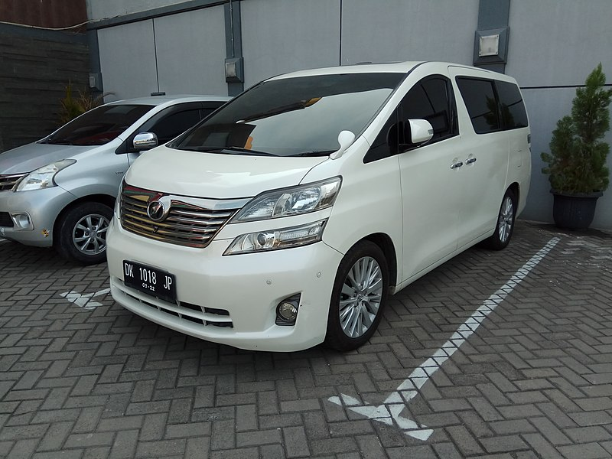](https://commons.wikimedia.org/wiki/File:Toyota_Vellfire_(AH20_pre-facelift,_Bali_registered),_East_Surabaya.jpg)

***Minivan***

Hi Mai,

This is Joe from Adventure Motors. I hope you're well! I've got some exciting news about a new minivan that is available now. It is the perfect ride for your family's everyday adventures.

This new minivan is spacious, easy to drive, and has a sleek design. You need a comfortable and roomy vehicle to get around, and this minivan is the perfect choice. Plus, it's fuel-efficient!

Why choose our new minivan? It's affordable, provides plenty of cargo space for family trips, and it is reliable. It is your ticket for stress-free rides. Let me know if you have any questions!

Best,

Joe

# Practice 1 – Business Writing (Task 3)

**Directions:** You own a company that sells tote bags. Write a letter to sell your product. Be sure to include all the necessary elements in your letter, with at least 3 paragraphs.

[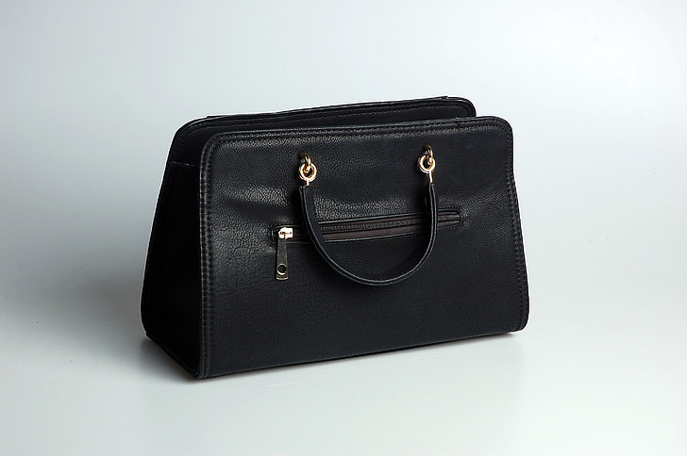](https://www.pickpik.com/handbag-black-simplicity-studio-leather-tote-156580)

# Practice 1 Example Answer – Business Writing (Task 3)

**Directions:** You own a company that sells tote bags. Write a letter to sell your product. Be sure to include all the necessary elements in your letter, with at least 3 paragraphs.

[](https://www.pickpik.com/handbag-black-simplicity-studio-leather-tote-156580)

Hi Jane,

This is Maria from Hernandez Boutique. I hope you’re well. I’ve got some exciting news about a new tote bag that is available now. It is the perfect size to fit all of your essential everyday items.

This new tote bag is handmade with the finest full-grain leather. You need a stylish tote bag to complete your look, and this is the perfect choice. Plus, the leather will only get softer with use.

Why choose our new tote bag? It’s priced well at under $50, it’s stylish, and the zipper closure at the top will keep all your personal items safe. Our tote bags are handcrafted just for you! Let me know if you have any questions.

Best,

Maria

# Practice 2 – Business Writing (Task 3)

**Directions:** You own a company that sells a blender/food processor. Write a letter to sell your product. Be sure to include all the necessary elements in your letter, with at least 3 paragraphs.

[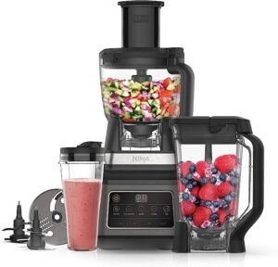](https://www.trustedreviews.com/deals/best-prime-day-ninja-deals-heavy-discounts-on-air-fryers-blenders-knives-and-more-4347424)

# Practice 2 Example Answer – Business Writing (Task 3)

**Directions:** You own a company that sells a blender/food processor. Write a letter to sell your product. Be sure to include all the necessary elements in your letter, with at least 3 paragraphs.

[](https://www.trustedreviews.com/deals/best-prime-day-ninja-deals-heavy-discounts-on-air-fryers-blenders-knives-and-more-4347424)

Dear Kyung,

This is Sam from Sam’s Kitchen Gadgets. I hope you’re well! I’ve got some exciting news about a new blender/food processor that is available now. It is the perfect all-in-one tool for your kitchen.

The new blender/food processor is powerful, quiet, and easy to use. You need one machine that can do it all, and this is the perfect choice. Plus, it is energy-efficient!

Why choose our new blender/food processor? It’s affordable, comes with six different attachments, and it is reliable. It is your ticket to fast, easy smoothies and vegetable blends. Let me know if you have any questions.

Best,

Sam