Contents

Handout #1: Overview of Tasks 2

Handout #2: Introduction – Phone Etiquette (Task 1) 3

Handout #3: Directions – Responding to a Phone Call (Task 1) 4

Handout #4: Example – Phone Call (Task 1) 5

Handout #5: Example – Complete a Phone Message (Task 2) 6

Handout #6: Practice 1 – Phone Call (Task 1 & 2) 7

Handout #7: Practice 1 Answer Key – Phone Call (Task 1 & 2) 9

Handout #8: Practice 2 – Phone Call (Task 1 & 2) 11

Handout #9: Practice 2 Answer Key – Phone Call (Task 1 & 2) 13

Handout #10: Introduction – Business Writing (Task 3) 15

Handout #11: Example – Business Writing (Task 3) 16

Handout #12: Practice 1 – Business Writing (Task 3) 17

Handout #13: Practice 1 Example Answer – Business Writing (Task 3) 18

Handout #14: Practice 2 – Business Writing (Task 3) 19

Handout #15: Practice 2 Example Answer – Business Writing (Task 3) 20

# Overview of Tasks

**Soft Skills**

**Level: Intermediate Low**

|  |  |  |
| --- | --- | --- |
| **Task 1**  **Respond to a Business Phone Call**  **[Business man talking on the phone. Creative Commons Photo by Mart Production on Pexels.](https://www.pexels.com/photo/a-bearded-man-on-a-phone-call-8872415/)** | **Task 2**  **Complete a Phone Message**  **[Woman at work writing down a phone message. Creative Commons Photo by Yan Krukau on Pexels.](https://www.pexels.com/photo/a-woman-taking-notes-while-in-a-phone-call-7793187/)** | **Task 3**  **Write a Business Communication**  **[Side view of a person at work typing on a laptop. Public Domain Photo from Rawpixel.](https://www.rawpixel.com/image/5928257/photo-image-background-public-domain-hands)** |

# Introduction – Phone Etiquette (Task 1)

Good phone etiquette is important at work. It means using the telephone in a polite way. Here are ways to show good phone etiquette:

**Clear Communication**: When you speak clearly, talk politely, and give information in an organized way, it helps people understand your messages.

**Professionalism**: Using good phone etiquette shows you are professional (that you are serious about your work). It creates (makes) a positive feeling with the people you talk to on the phone.

**Building Relationships**: Being polite on the phone helps to make good relationships and this helps make a friendly, comfortable workplace.

**Customer Satisfaction**: Good phone etiquette is very important when talking with customers. It makes customers feel important and satisfied (happy). When customers are satisfied, it makes the reputation of the business better.

**Efficient Communication**: Good phone etiquette helps to make communication efficient (fast and correct). When we listen carefully, ask questions, and answer appropriately, it saves time and helps us do things well (good).

**Avoiding (Not Making) Misunderstandings**: “Misunderstandings” mean you or another person doesn’t understand something correctly. Good phone etiquette reduces (makes less) misunderstandings. This is very important in the workplace because misunderstandings can end in mistakes or confusion.

Learning and practicing good phone etiquette is very important for good, respectful communication at work. We can give clear messages, and we can feel positive and comfortable at work when we use good phone etiquette.

# Directions – Responding to a Phone Call (Task 1)

You will have a telephone conversation. Use good phone etiquette in your conversation. Make sure to do these 8 things:

1. Answer the telephone and end the telephone conversation politely.
2. Apologize (say sorry) that the person they need to talk to is busy right now.
3. Say that you can give the person a message.
4. Ask a question to get an important detail.
5. Ask another question to get more important details.
6. Ask a question or say the information again to make sure you understand correctly (Use a clarification strategy).
7. Paraphrase the caller’s problem (say the caller’s message again using different words). Make sure to use the caller’s name.
8. Tell the caller what will happen next.

# Example – Phone Call (Task 1)

**Scenario**

Lisa works at The Keller Company. Dean Thomas, a customer, is calling about a problem with his online account. He is not able to log in and needs help. Mrs. Hansen takes care of Dean's account, but she is busy right now. Lisa needs to take a phone message.

**Lisa** Good morning! Thank you for calling The Keller Company. This is Lisa. How can I help you? (1)

**Dean** I have a question regarding my online account. I can’t log in.

**Lisa** Okay. I can look into that for you. Can you tell me your name please? (4)

**Dean** Yes. My name is Dean Thomas.

**Lisa** Thank you, Dean. I found your account. It looks like Mrs. Hansen takes care of your account. I’m sorry, but she is out of the office right now. (2) I’ll be happy to give her a message for you. (3)

**Dean** Great! Thank you. Can she please call me back?

**Lisa** Of course. Dean*, can you tell me your phone number please?* (5)

**Dean** (714) 555-6324.

**Lisa** Just to make sure, your number is (714) 555-6324, correct? (6)

**Dean** Yes, that is correct.

**Lisa** Okay, Dean. I’ll give Mrs. Hansen the message about your login trouble. (7) She will call you back this afternoon. (8)

**Dean** Thank you.

**Lisa** You’re welcome. Good-bye. (1)

# Example – Complete a Phone Message (Task 2)

**Phone Message**

|  |  |
| --- | --- |
| **While You Were Out** |  |
| **Call For:** *Mrs. Hansen* | **Date:** *11/27/23* |
| **From:** *Dean Thomas* | **Time:** *9:17 a.m.* |
| **Message taken by:** *Lisa* | **Phone:** (*714*) *555-3123* |

|  |
| --- |
| **Message:** *He can’t log in to his account. Please call back.* |

# Practice 1 – Phone Call (Task 1 & 2)

**Task 1 – Phone Call**

**Scenario**

You work at The Madison Company. Jenny Nguyen, a customer, is calling about a problem with her credit card account. She thinks she was charged twice for something. Mr. Chen takes care of Jenny's account, but he is in a meeting right now. You need to take a phone message.

**Admin. Asst**. *(1: Answer the telephone* *politely)*

**Jenny** I have a question about my account. I think I was charged twice.

**Admin. Asst.** *(4: Ask a question to get an important detail – name & account number)*

**Jenny** Yes. My name is Jenny Nguyen. My account number is 2309.

**Admin. Asst.** *(2: Apologize that the person they need to talk to is busy right now) (3: Say that you can give the person a message)*

**Jenny** Okay, thank you. Would you please ask him to call me back?

**Admin. Asst.** *(5: Ask another question to get more important details – phone number)*

**Jenny** (949) 555-7489.

**Admin. Asst.** *(6: Use a clarification strategy to make sure you understand the phone number correctly)*

**Jenny** Yes, that’s it.

**Admin. Asst.** *(7: Paraphrase the caller’s problem using the caller’s name) (8: Tell the caller what will happen next, that you will give Mr. Chen her message and he will call her back after his meeting)*

**Jenny** Thank you.

**Admin. Asst.** *(1: End the telephone conversation politely)*

**Handout #7: Practice 1 – Phone Call (Task 1 & 2) cont.**

**Task 2 – Complete a Phone Message**

**Phone Message**

|  |  |
| --- | --- |
| **While You Were Out** |  |
| **Call For:** | **Date:** |
| **From:** | **Time:** |
| **Message taken by:** | **Phone: ( )** |

|  |
| --- |
| **Message:** |

# Practice 1 Answer Key – Phone Call (Task 1 & 2)

**Task 1 – Phone Call**

**Scenario**

You work at The Madison Company. Jenny Nguyen, a customer, is calling about a problem with her credit card account. She thinks she was charged twice for something. Mr. Chen takes care of Jenny's account, but he is in a meeting right now. You need to take a phone message.

**Admin. Asst.** *Good morning! Thank you for calling The Madison Company. This**is . How can I help you?* (1)

**Jenny** I have a question about my account. I think I was charged twice.

**Admin. Asst.** *Okay. I can check on that for you. Can you tell me your name and account number please? (4)*

**Jenny** Yes. My name is Jenny Nguyen. My account number is 2309.

**Admin. Asst.** *Thank you, Jenny. I found your account.**It looks like Mr. Chen takes care of your account.**I’m sorry, but he is in a meeting right now. I’ll be happy to give him a message for you. (2,3)*

**Jenny** Okay, thank you. Would you please ask him to call me back?

**Admin. Asst.** *Of course. Jenny, can you tell me your phone number please? (5)*

**Jenny** (949) 555-7489.

**Admin. Asst.** *Just to make sure, your number is (949) 555-7489, correct? (6)*

**Jenny** Yes, that’s correct.

**Admin. Asst.** *Okay, Jenny. I’ll give Mr. Chen the message about your account. (7)**He will call you back after his meeting. (8)*

**Jenny** Thank you.

**Admin. Asst.** *You’re welcome. Good-bye. (1)*

**Handout #8: Practice 1 Answer Key – Phone Call (Task 1 & 2) cont.**

**Task 2 – Complete a Phone Message**

**Phone Message**

|  |  |
| --- | --- |
| **While You Were Out** |  |
| **Call For**: *Mr. Chen* | **Date:** *(Use real date)* |
| **From:** *Jenny Nguyen* | **Time:** *(Use real time)* |
| **Message taken by:** *(Use your name)* | **Phone: (***949***)** *555-7489* |

|  |
| --- |
| **Message:** *She thinks she was charged twice on her account.*  *Please call her back.* |

# Practice 2 – Phone Call (Task 1 & 2)

**Task 1 – Phone Call**

**Scenario**

You work for Victorian Apartments. John Smith, a tenant, is calling because there is a leak in his apartment. The maintenance office is closed for lunch and is not available to take the call. You need to take a phone message.

**Receptionist** *(1: Answer the telephone politely)*

**John** Hello. I have a leak under the sink in my apartment. Can I please have someone stop by to fix it?

**Receptionist** *(4: Ask a question to get an important detail – name & apartment number)*

**John** Yes. My name is John Smith. My apartment number is 205.

**Receptionist** *(2: Apologize that the person they need to talk to is busy right now) (3: Say that you can give the person a message)*

**John** Great! Thank you.

**Receptionist** *(5:* *Ask another question to get more important details – phone number)*

**John** (714) 555-6324.

**Receptionist** *(6: Use a clarification strategy to make sure you understand the phone number correctly)*

**John** Yes, that is correct.

**Receptionist** *(7: Paraphrase the caller’s problem using the caller’s name)**(8:* *Tell the caller what will happen next, that you will give the maintenance person the message, and they will come by when they get back from lunch)*

**John** Thank you.

**Receptionist** *(1:* *End the telephone conversation politely)*

**Handout #9 Practice 2 – Phone Call (Task 1 & 2) cont.**

**Task 2 – Complete a Phone Message**

**Phone Message**

|  |  |
| --- | --- |
| **While You Were Out** |  |
| **Call For:** | **Date:** |
| **From:** | **Time:** |
| **Message taken by:** | **Phone: ( )** |

|  |
| --- |
| **Message:** |

# Practice 2 Answer Key – Phone Call (Task 1 & 2)

**Task 1 – Phone Call**

**Scenario**

You work for Victorian Apartments. John Smith, a tenant, is calling because there is a leak in his apartment. The maintenance office is closed for lunch and is not available to take the call. You need to take a phone message.

**Receptionist** *Good morning! Thank you for calling Victorian Apartments. This is . How can I help you? (1)*

**John** Hello. I have a leak under the sink in my apartment. Can I please have someone stop by to fix it?

**Receptionist** *Okay. Can you tell me your name and apartment number please? (4)*

**John** Yes. My name is John Smith. My apartment number is 205.

**Receptionist** *Thank you, John. No one from the maintenance office is available right now. I’ll be happy to give them a message for you. (2,3)*

**John** Great! Thank you.

**Receptionist** *You’re welcome. John, can you tell me your phone number please? (5)*

**John** (714) 555-6324.

**Receptionist** *Just to make sure, your number is (714) 555-6324, correct? (6)*

**John** Yes, that is correct.

**Receptionist** *Okay, John. I’ll give the maintenance person the message about your leak. (7)**They will come by this afternoon. (8)*

**John** Thank you.

**Receptionist** *You’re welcome. Good-bye. (1)*

**Handout #10 Practice 2 Answer Key – Phone Call (Task 1 & 2) cont.**

**Task 2 – Complete a Phone Message**

**Phone Message**

|  |  |
| --- | --- |
| **While You Were Out** |  |
| **Call For:** *Maintenance* | **Date:** *(Use real date)* |
| **From:** *John Smith in Apartment 205* | **Time:** *(Use real time)* |
| **Message taken by:** *(Use your name)* | **Phone: (***714***)** 555-6324 |

|  |
| --- |
| **Message:** *He has a leak under the sink. He needs you to go and check on it.* |

# Introduction – Business Writing (Task 3)

Business writing is different from academic writing. For academic writing, students use transitional words and more advanced vocabulary. However, with business writing, it is the opposite. Most employers and customers want communication to be short and direct. No one wants to read an email that has too many extra words. However, word choice is very important when writing for work. Only use words that you are comfortable using and words that you normally use. Remember, an email or memo can be forwarded (sent) to many different people, so make sure that the information can be understood by everyone, not just a few people.

With business communication, there are many forms. For example, a business letter can be formal for communicating with an important customer, or it can be informal. We will be writing a letter to sell a product. In a letter like this, you should introduce yourself and your product, provide details of the product, and give some reasons why your customer should buy your product. It also needs to have a greeting and a closing.

# Example – Business Writing (Task 3)

Study this example of a letter to sell a minivan.

[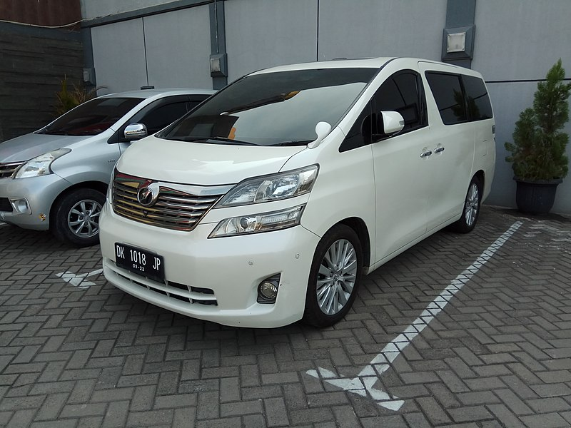](https://commons.wikimedia.org/wiki/File:Toyota_Vellfire_(AH20_pre-facelift,_Bali_registered),_East_Surabaya.jpg)

***Minivan***

Hi Mai,

This is Joe from Adventure Motors. I hope you're well! I've got some exciting news about a new minivan that is available now. This new minivan has a lot of space inside, is easy to drive, and has a stylish design. You need a comfortable and roomy vehicle to get around, and this minivan is the perfect choice. Plus, it's fuel-efficient! Let me know if you any have questions.

Best,

Joe

# Practice 1 – Business Writing (Task 3)

**Directions:** You own a company that sells tote bags. Write a letter to sell your product. Be sure to include all the necessary elements in your letter, with at least 1 paragraph.

[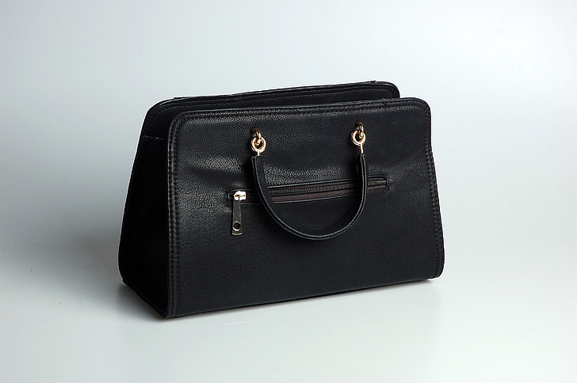](https://www.pickpik.com/handbag-black-simplicity-studio-leather-tote-156580)

# Practice 1 Example Answer – Business Writing (Task 3)

**Directions:** You own a company that sells tote bags. Write a letter to sell your product. Be sure to include all the necessary elements in your letter, with at least 1 paragraph.

[](https://www.pickpik.com/handbag-black-simplicity-studio-leather-tote-156580)

Hi Jane,

This is Maria from Hernandez Boutique. I hope you’re well. I’ve got some exciting news about a new tote bag that is available now. This new tote bag is handmade with the finest full-grain leather. You need a stylish tote bag to complete your look, and this is the perfect choice. Plus, the leather will only get softer with use. Let me know if you have any questions.

Best,

Maria

# Practice 2 – Business Writing (Task 3)

**Directions:** You own a company that sells a blender/food processor. Write a letter to sell your product. Be sure to include all the necessary elements in your letter, with at least 1 paragraph.

[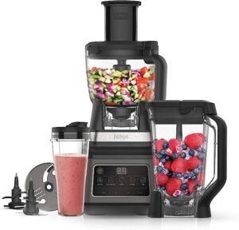](https://www.trustedreviews.com/deals/best-prime-day-ninja-deals-heavy-discounts-on-air-fryers-blenders-knives-and-more-4347424)

# Practice 2 Example Answer – Business Writing (Task 3)

**Directions:** You own a company that sells a blender/food processor. Write a letter to sell your product. Be sure to include all the necessary elements in your letter, with at least 1 paragraph.

[](https://www.trustedreviews.com/deals/best-prime-day-ninja-deals-heavy-discounts-on-air-fryers-blenders-knives-and-more-4347424)

Dear Kyung,

This is Sam from Sam’s Kitchen Gadgets. I hope you’re well! I’ve got some exciting news about a new blender/food processor that is available now. The new blender/food processor is powerful, quiet, and easy to use. You need one machine that can do it all, and this is the perfect choice. Plus, it is energy-efficient! Let me know if you have any questions.

Best,

Sam