EL Civics: Health Care (Obj 28.2) • BH
Task 2: Read and Interpret Medicine Labels
Language & Literacy Objectives:
10. Explain medicine labels and medical warning labels.
INTRODUCTION
In this lesson, students will learn how to read and interpret medicine labels.
ASSESSMENT TASK – 14 points possible
Part 1: Given pictures of six medicine labels, students will identify whether the labels are for prescription or non-prescription medication.
Part 2: Answer level-appropriate questions about a prescription label.
SUGGESTED ACTIVITIES
- Teacher and/or students bring in actual medicine packaging, including drug warnings. Have students work in small groups to identify all information on the label, then sort into categories, e.g. prescription/over-the-counter, brand name/generic, take with food/take on empty stomach, etc. Use document reader to project objects to whole class.
- Students find advertisements in magazines, newspapers or on TV for three prescription or over-the counter medicines. Call 800# or view website to identify uses, possible side effects, warnings, etc. Make a medicine label (poster-size) and explain each drug, its use, its side effects, etc. to the class.
- Students visit a local pharmacy and complete the enclosed handout (#7). Bring back to class and share experiences.

HANDOUTS PROVIDED
- Related Vocabulary
- Discussion Questions
- Introduction: How to Read Medicine Labels
- Talk to Your Doctor: Seven Questions to Ask About Your Medicines
- Practice: Prescription or OTC? (with Answer Key)
- Practice: Reading a Prescription Label (with Answer Key)
- Community Activity—Visit a Local Pharmacy
COMPUTER LAB IDEAS
- Create a medication/allergy log for yourself or a family member. List all current medications, including both prescription and over-the-counter. Be sure to include name, strength (dosage), instructions for use, etc. Keep a copy with you at all times.
- Find information about a medication, and then create a medicine label. Provide a template.
- Use the Drug Interaction Checker to look up drug and food interactions for medications the students take or are thinking about taking.
- Review medicine-related health vocabulary using software programs (e.g. Oxford Picture Dictionary) or online resources (see Related Websites).

Related Vocabulary
adapted from Dictionary.com & Longman Dictionary Online
prescription medication: medicine you can get only with a doctor’s note. Examples:
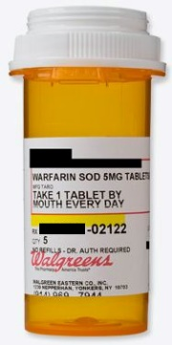
over-the-counter medication (OTC): medicine you can buy at any store, like CVS, Walgreens, or Target. Also called non-prescription medication. Examples:
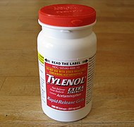
pharmacy: drugstore where you can get prescription medication, like CVS or Walgreens.
Rx # (prescription number): number used by the pharmacy to identify your medication.
patient: person who takes the medication.
refill: getting another bottle of prescription medication without a new doctor’s note.
medication name: name of the medicine.
strength: how many MG (milligrams) of a medicine is in one capsule.
instructions for use: how much, when, and how to take medicine. For example, “Take one capsule every 12 hours with food.”
exp. date (expiration date): last date that the medicine is ok to take.

Discussion Questions: Reading Medicine Labels
- What prescription drugs are most common in your native country?
- Which non-western medicines or home remedies are commonly used in your native country?
- How expensive are prescription drugs in your native country?
- How expensive are over-the-counter (OTC) drugs in your native country?
- How are pharmacies in your country similar to those in the U.S.? How are they different?
- What other items do pharmacies sell in your native country?

Introduction: How to Read Medicine Labels
adapted from Pharmacy Association of Nova Scotia
SAMPLE PRESCRIPTION LABEL
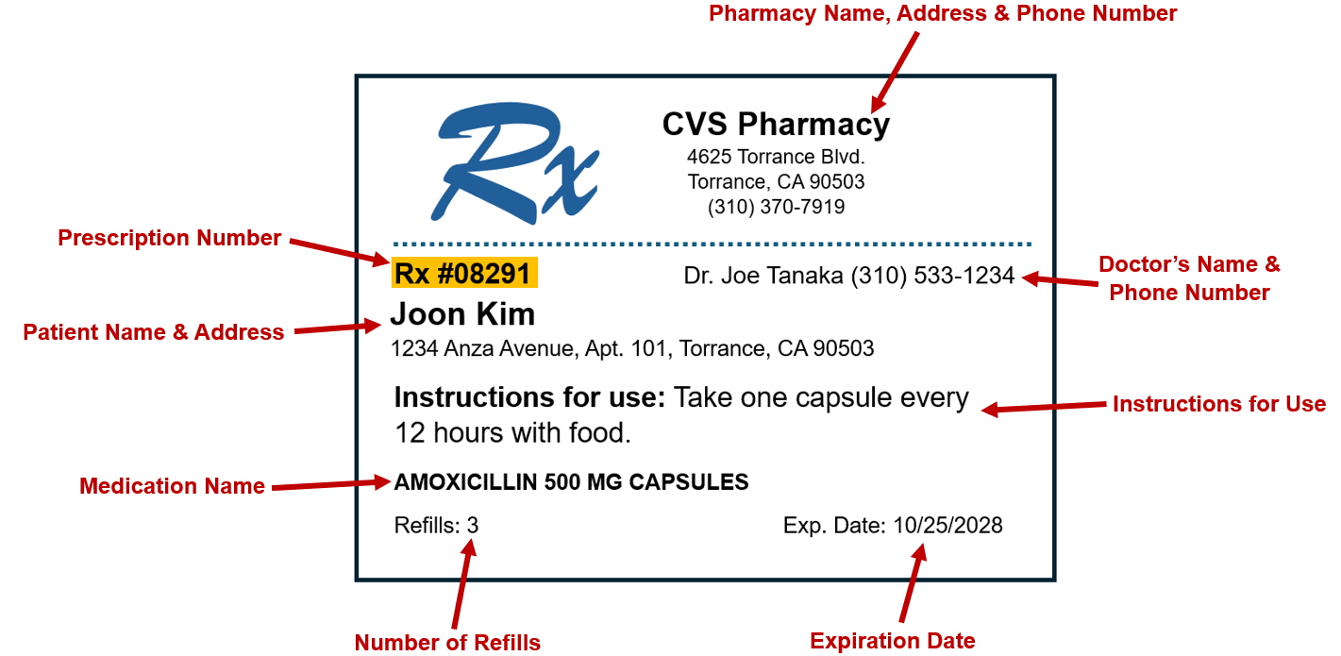
It is very important to read the drug label for instructions. Mistakes can affect your health. If you read the label and still have questions, call your doctor for help.

Talk to Your Doctor—Seven Questions to Ask About Your Medicines
adapted from The National Institute on Aging
“I talk to my doctor each time she prescribes a new medicine. I write down my questions so I don’t forget.”
Seven questions to ask your doctor or pharmacist:
- What is the name of the medicine, and why am I taking it?
- What medical condition does this medicine treat?
- How many times a day and how much medicine should I take? For how long?
- How long will it take to work?
- What should I do if I miss a dose?
- Are there any side effects I should know about? When should I call you if I am having side effects?
- Can I safely mix this medicine with the remedies, vitamins, and OTC drugs I am taking?
Each time you visit your doctor …
Ask if you still need to be on all your medicines

PRACTICE: PRESCRIPTION OR OTC?
Directions: Look at the pictures below. Write “prescription” or “OTC” under each picture.
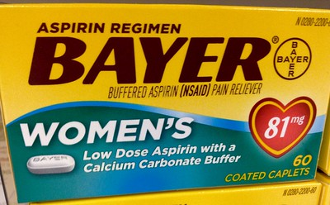 | 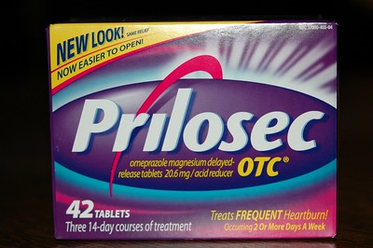
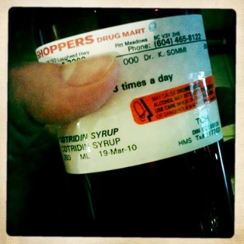

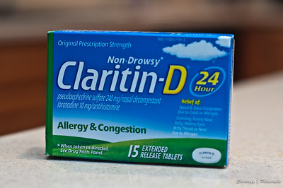

ANSWER KEY: PRESCRIPTION OR OTC?
Directions: Look at the pictures below. Write “prescription” or “OTC” under each picture.
- OTC | - OTC | - prescription
- prescription | - prescription | - OTC
- OTC | - prescription | - OTC

PRACTICE: READING A PRESCRIPTION LABEL
Directions: Answer the questions below about this prescription label:
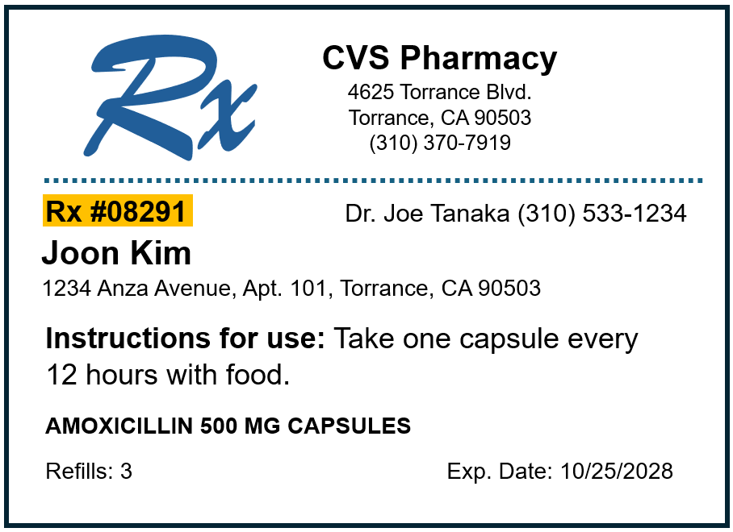
- What is the name and strength of the drug?
- What is the prescription number?
- What is the patient’s name?
- How many refills are left?

ANSWER KEY: READING A PRESCRIPTION LABEL
Directions: Answer the questions below about this prescription label:
- What are the name and strength of the drug? Amoxicillin, 500 MG
- What is the prescription number? 08291
- What is the patient’s name? Joon Kim
- How many refills are left? 3

COMMUNITY ACTIVITY—VISIT A LOCAL PHARMACY
Directions: Visit a local pharmacy. Research this information and report your findings to the class:
- What is the name of the pharmacy?
- Where is the prescription counter?
- Write the names of three over-the-counter (OTC) medications. List one instruction and one warning for each.
Over-the-Counter (OTC) Medicine #1:
Name:
Instruction:
Warning:
Over-the-Counter (OTC) Medicine #2:
Name:
Instruction:
Warning:
Over-the-Counter (OTC) Medicine #3:
Name:
Instruction:
Warning:
- List three other items can you buy in this pharmacy:

