EL Civics: Health Care (Obj 28.2) • BL
Task 2: Read and Interpret Medicine Labels
Language & Literacy Objectives:
10. Explain medicine labels and medical warning labels.
INTRODUCTION
In this lesson, students will learn how to read and interpret medicine labels.
ASSESSMENT TASK – 12 points possible
Part 1: Given pictures of six medicine labels, students will identify whether the labels are for prescription or non-prescription medication.
Part 2: Answer level-appropriate questions about a prescription label.
SUGGESTED ACTIVITIES
- Teacher and/or students bring in actual medicine packaging, including drug warnings. [Class set available for checkout from Resource Office.] Have students work in small groups to identify information on the label, then sort into categories, e.g. prescription/over-the-counter, brand name/generic, take with food/take on empty stomach, etc. Use document reader to project objects to whole class.
- Students bring in advertisements from magazines, newspapers or the Internet for prescription or over-the counter medicines. Work in groups to determine potential uses, warnings, etc.

HANDOUTS PROVIDED
- Related Vocabulary
- Discussion Questions
- Introduction: How to Read Medicine Labels
- Practice: Prescription or OTC? (with Answer Key)
- Practice: Reading a Prescription Label (with Answer Key)
COMPUTER LAB IDEAS
- Create a medication/allergy log for yourself or a family member. List all current medications, including both prescription and over-the-counter. Be sure to include name, strength (dosage), instructions for use, etc. Encourage students to keep a copy with them at all times, or at least make it available to a family member in case of emergency.
- Use the Drug Interaction Checker from drugs.com (see Related Websites) to look up drug and food interactions for medications the students take or are thinking about taking.
- Review health-related vocabulary using software (e.g. Oxford Picture Dictionary) and online resources (see Related Websites).

Related Vocabulary
adapted from Dictionary.com & Longman Dictionary Online
prescription medication: medicine you can get only with a doctor’s note. Examples:
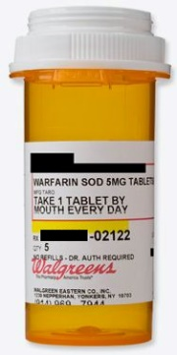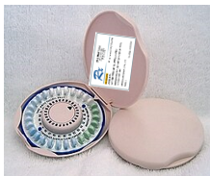
over-the-counter medication (OTC): medicine you can buy at any store, like CVS, Walgreens, or Target. Also called non-prescription medication. Examples:
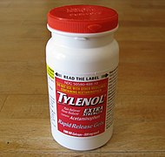
pharmacy: drugstore where you can get prescription medication, like CVS or Walgreens.
Rx # (prescription number): number used by the pharmacy to identify your medication.
patient: person who takes the medication.
refill: getting another bottle of prescription medication without a new doctor’s note.
medication name: name of the medicine.
instructions for use: how much, when, and how to take medicine. For example, “Take one capsule every 12 hours with food.”
exp. date (expiration date): last date that the medicine is ok to take.

Discussion Questions: Reading Medicine Labels
- What prescription drugs are most common in your native country?
- How expensive are prescription drugs in your native country?
- How expensive are over-the-counter (OTC) drugs in your native country?
- What other items do pharmacies sell in your native country?

Introduction: How to Read Medicine Labels
adapted from Pharmacy Association of Nova Scotia
SAMPLE PRESCRIPTION LABEL
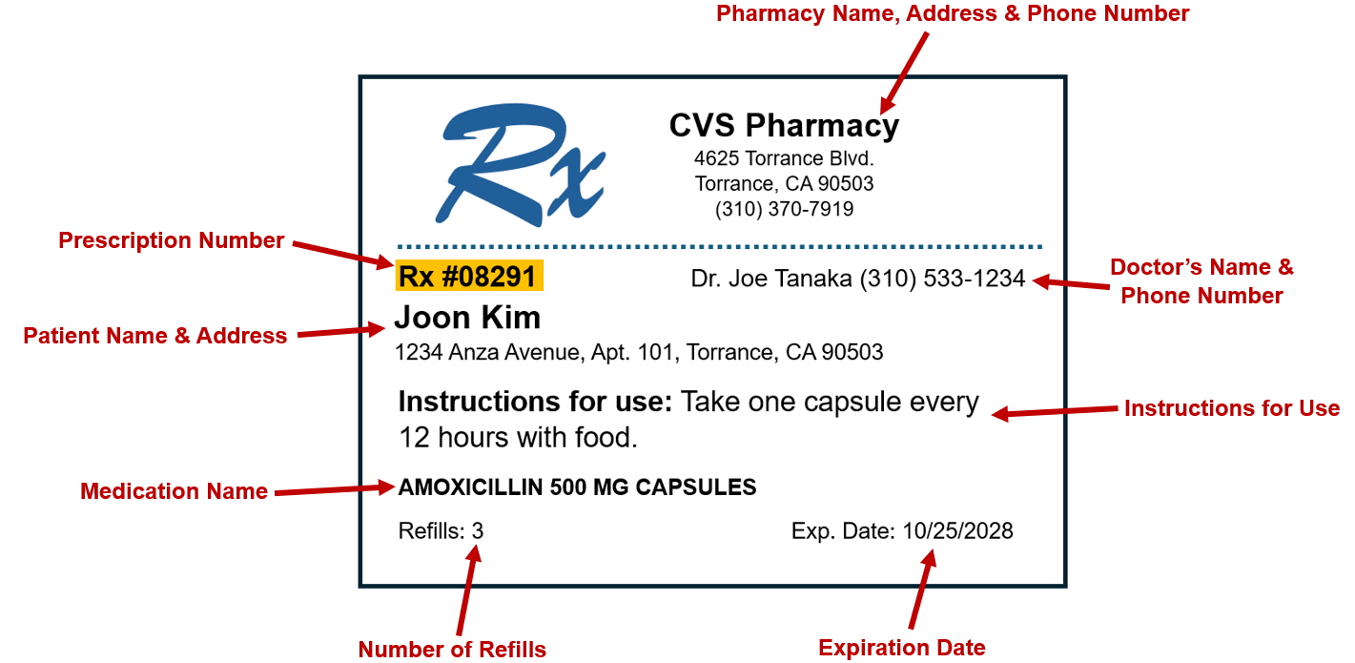

PRACTICE: PRESCRIPTION OR OTC?
Directions: Look at the pictures below. Write “prescription” or “OTC” under each picture.
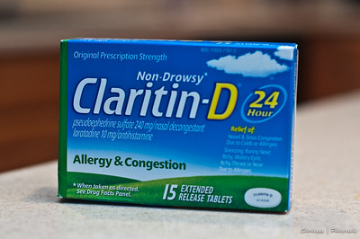

ANSWER KEY: PRESCRIPTION OR OTC?
Directions: Look at the pictures below. Write “prescription” or “OTC” under each picture.
- OTC | - OTC | - prescription
- prescription | - OTC | - prescription

PRACTICE: READING A PRESCRIPTION LABEL
Directions: Look at the prescription label. Fill in the information below.
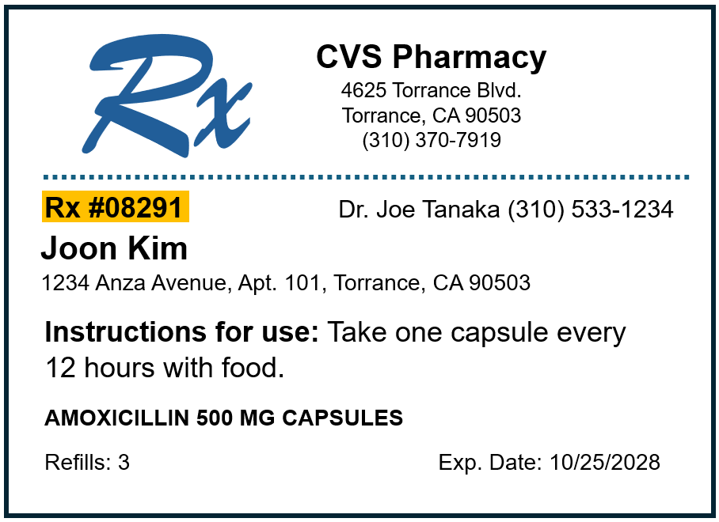
adapted from Pharmacy Association of Nova Scotia
- Prescription number:
- Name of drug:
- Number of refills left:

ANSWER KEY: READING A PRESCRIPTION LABEL
Directions: Look at the prescription label. Fill in the information below.
adapted from Pharmacy Association of Nova Scotia
- Prescription number: 08291
- Name of drug: Amoxicillin
- Number of refills left: 3

