EL Civics Objective 28 (Health Care) –IH5/ADV6
Task 1: Complete a Medical History Form
Language & Literacy Objectives:
Complete a medical health history form.
Describe symptoms of an illness.

INTRODUCTION
Students will learn the information they are expected to provide when visiting a doctor’s office, urgent care or hospital. In addition, students will learn how to describe their past health history, as well as current symptoms, in order to complete an authentic (adapted) medical health form.

ASSESSMENT TASK (18 points possible)
The related task on the assessment requires students to use a provided personal history to fill out an authentic medical history form. The number and complexity of items is adapted for each language level.

SUGGESTED ACTIVITIES
- Review parts of the body and common ailments, illnesses & diseases.
- Review the completed sample medical history form provided (Handout 4). Project it or give students print copies and ask questions about the patient. “When was Michael’s last medical exam?” “Has he ever had cancer? If so, what kind?” “Is his mother living? If so, does she have any health problems?”
- After reviewing the “Michael Simpson” sample, have the students practice filling out their own medical history forms. Encourage them to create a “master” form to take to their doctor’s office, the hospital, etc.

over …
HANDOUTS PROVIDED
- Related Vocabulary
- Discussion Questions
- Introduction: Medical Health History
- Comprehension: Read a Medical History Form
- Practice: Fill in a Medical Healthy History Form
- Additional Resources: Blank Medical History Forms
COMPUTER LAB ACTIVITIES
- Use web-based activities to review parts of the body, ailments, illnesses and diseases.
- Create refrigerator magnet with list of local healthcare providers
- Create a detailed “master” form to take to doctor’s office, etc. Type so that anyone else can clearly read if necessary.
- Use the following website to create a family medical history:
Surgeon General’s My Family Health Portrait

Related Vocabulary

form: document with blank spaces to write or type information

fill out: to complete (a form, for example) by providing required information.

medical/health history: summary of your symptoms, past illnesses & treatments, surgeries, ongoing diseases, & diseases that run in your family. Guide for your doctor.

medications: prescription and over-the-counter drugs taken to relieve symptoms or treat a disease or illness

surgery: operation or procedure, especially involving removal or replacement of a diseased organ or tissue

hospitalization: period of stay in a hospital

reason for visit: why you need to see the doctor now

symptoms: a subjective indication of a disorder or disease, such as pain, nausea or weakness. May be accompanied by objective signs of disease such as abnormal lab test results or findings during a physical examination.

- headaches: pain in the head (over the eyes, at the temples, or at the base of the skull)
- chest pain: pain in the chest
- shortness of breath: difficulty in drawing sufficient breath; labored breathing
- insomnia: chronic inability to fall asleep or remain asleep for an adequate length of time
- nausea/vomiting: sickness in the stomach/ejecting the stomach’s contents through the mouth
- vision problems: eye disturbances, including blurred vision, halos and blind spots
- sore throat: painful or sensitive condition of the throat exaggerated by swallowing or talking
- fatigue/weakness: weariness or exhaustion from labor, exertion, or stress; lacking strength
- weight loss: reduction of body weight to improve health; takes place when you use more calories to exist than you take in. Calories necessary for each person based on age, height, weight, genetics and lifestyle (e.g. amount of exercise).

health insurance: insurance that compensates the insured for expenses or loss incurred for medical reasons, as through illness or hospitalization.

name of insured: person who is covered by an insurance policy.

employer name: person or business that provides your insurance policy.

insurance carrier: insurance company; insurer

group number (no.): reference number for large number of people covered under the same insurance policy
This page intentionally blank

Discussion Questions: Medical Health History

- What are the most common health problems in your native country?

- Where do people get treated for these problems?

- What are the main differences in how health problems are treated in the U.S. and in your home country?

- Do you go to an English-speaking doctor or medical clinic now? Do you visit the doctor alone, or do you take someone who knows more English?

- Describe a time when you or a family member had a serious medical problem and needed emergency care.

- Have you ever had problems explaining a medical problem to a doctor or nurse?
Were you able to explain your symptoms? What vocabulary was most difficult for you?

- Have you ever had problems understanding what a doctor or nurse has told you? What did you do to get the information you needed?

- Have you ever filled out a medical history form? Were you able to complete it yourself, or did you need help from someone else (e.g. a family member)?

This page intentionally blank

Introduction: Medical Health History

A doctor wants to know about the illnesses and operations you have had, about any existing conditions (such as allergies), and about the symptoms you have now. Usually, you will be asked to fill out forms giving your health history. To avoid language difficulties at a time when you don’t feel well and need medical help, it is a good idea to prepare/update your medical history at a time when you feel fine.

Common questions may include:

- When was your last medical exam?
- What medications are you taking?
- What illnesses have you had?
- What permanent conditions (like diabetes) do you have?
- What are your habits, i.e.,
- Do you drink? How much? How often?
- Do you smoke? How many packs a day?
- How often do you exercise?
- What surgeries have you had?
- Have you had a child? How many?
- What health problems run in your family?
This page intentionally blank

Comprehension: Reading a Medical History Form

Read the completed medical history form on the next page and answer the following questions:

- Has this patient had any surgeries? If so, which ones? When? Where?

- What is the patient’s reason for the current visit?

- What medications does this patient take regularly?
- Is he allergic to anything?

- Is this patient covered by health insurance?
- Does the patient have any unhealthy habits?
- Is there anything in the patient’s family history that might impact the patient’s health?

This page intentionally blank

Comprehension: Reading a Medical History Form (cont.)
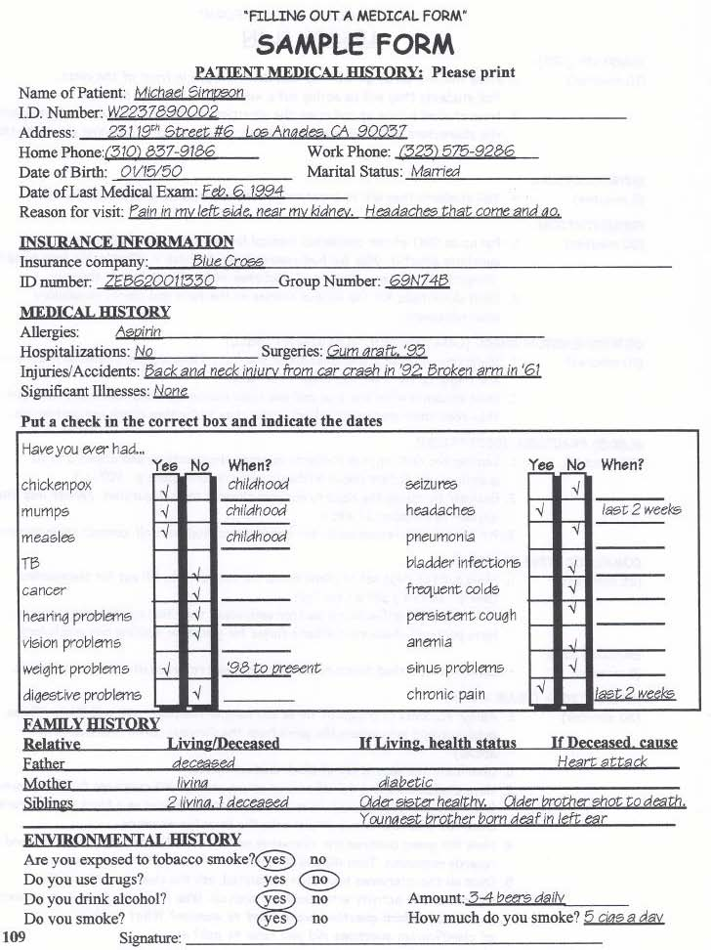

This page intentionally blank

Practice: Fill Out a Medical History Form

DIRECTIONS: Sandy needs your help to fill out her medical history form at the doctor’s office. Please use the information below:

Sandra Michelle Jones lives at 22230 Anza Avenue, Torrance, CA 90502.
Her home phone number is 310-555-2529 and her cell phone is 562-555-4891. Lately, she has been having frequent headaches, some blurred vision and is tired much of the time. She currently takes 20mg of Lipitor daily to help lower her cholesterol, and 50mg twice each day of Zoloft, a mild anti-depressant. Sandra is 5’9” tall and weighs 150 lbs, and was born on August 31, 1970. Her only hospitalizations have been for a Cesarean Section (C-Section) on August 4, 2005 at Torrance Memorial, and a tonsillectomy at Little Company of Mary on February 23, 1999. She is insured through her employer, Toyota. Her insurance carrier is Blue Cross, group ID #336894.

MEDICAL HISTORY FORM
1. Name (Last, First, M.I.): |  |  |  |  |  |  |  | 2. M F |  |  |  |  | 3. Date of Birth:  (MM/DD/YYYY)
4. Height: |  |  |  |  |  | 5. Weight:
6. Street Address: |  |  |  |  |  | 7. City, State, Zip:
8. Home Phone: |  |  |  |  |  | 9. Cell Phone:

PERSONAL HEALTH HISTORY

List medications (prescription and over-the-counter)
Name the Drug |  |  |  |  |  |  | Strength |  |  | Frequency Taken
10.
11.

List surgeries/hospitalizations
Reason |  |  |  |  |  |  | Year |  |  | Hospital
12.
13.

REASON FOR TODAY’S VISIT
14. Check your symptoms:
 | Headaches |  |  |  | Insomnia |  |  |  |  |  |  |  |  | Sore throat
 | Chest pain |  |  |  | Nausea/vomiting |  |  |  |  |  |  |  |  | Fatigue/weakness
 | Shortness of breath |  |  |  | Vision problems |  |  |  |  |  |  |  |  | Weight loss

HEALTH INSURANCE
15. Name of Insured: |  |  |  |  |  |  |  |  | 16. Employer Name:
17. Insurance Carrier: |  |  |  |  |  |  |  |  | 18. Group No.

This page intentionally blank

Answer Key: Fill Out a Medical History Form

DIRECTIONS: Sandy needs your help to fill out her medical history form at the doctor’s office. Please use the information below:

Sandra Michelle Jones lives at 22230 Anza Avenue, Torrance, CA 90502.
Her home phone number is 310-555-2529 and her cell phone is 562-555-4891. Lately, she has been having frequent headaches, some blurred vision and is tired a lot. She currently takes 20mg of Lipitor daily to help lower her cholesterol, and 50mg twice each day of Zoloft, a mild anti-depressant. Sandra is 5’9” tall and weighs 150 lbs, and was born on August 31, 1970. Her only hospitalizations have been for a Cesarean Section (C-Section) on August 4, 2005 at Torrance Memorial, and a tonsillectomy at Little Company of Mary on February 23, 1999. She is insured through her employer, Toyota. Her insurance carrier is Blue Cross, group ID #336894.

MEDICAL HISTORY FORM
1. Name (Last, First, M.I.): |  | Jones, Sandra M. |  |  |  |  |  | 2. M F |  |  |  | 3. Date of Birth:  (MM/DD/YYYY) |  |  | 08/31/1970
4. Height: |  | 5’9” (5 feet, 9 inches) |  |  |  |  |  | 5. Weight: |  |  |  |  | 150 lbs (pounds)
6. Street Address: |  | 22230 Anza Avenue |  |  |  |  |  | 7. City, State, Zip: |  |  |  |  | Torrance, CA 90502
8. Home Phone: |  | 310-555-2529 |  |  |  |  |  | 9. Cell Phone: |  |  |  |  | 562-555-4891

PERSONAL HEALTH HISTORY

List medications (prescription and over-the-counter)
Name the Drug |  |  |  |  | Strength |  |  |  |  |  |  |  |  | Frequency Taken
10. Lipitor |  |  |  |  | 20mg |  |  |  |  |  |  |  |  | Daily
11. Zoloft |  |  |  |  | 50mg |  |  |  |  |  |  |  |  | Twice each day

List surgeries/hospitalizations
Reason |  |  |  |  |  |  | Year |  |  |  | Hospital
12. Cesarean Section (C-Section) |  |  |  |  |  |  | 2005 |  |  |  | Torrance Memorial
13. Tonsillectomy |  |  |  |  |  |  | 1999 |  |  |  | Little Company of Mary

REASON FOR TODAY’S VISIT
14. Check your symptoms:
 | Headaches |  |  |  |  | Insomnia |  |  |  |  |  |  | Sore throat
 | Chest pain |  |  |  |  | Nausea/vomiting |  |  |  |  |  |  | Fatigue/weakness
 | Shortness of breath |  |  |  |  | Vision problems |  |  |  |  |  |  | Weight loss

HEALTH INSURANCE
15. Name of Insured: |  |  | Sandra Jones |  |  |  |  |  | 16. Employer Name: |  |  |  |  | Toyota
17. Insurance Carrier: |  |  | Blue Cross |  |  |  |  |  | 18. Group No. |  |  |  |  | 336894

This page intentionally blank

ADDITIONAL RESOURCES: MEDICAL HISTORY FORM 1

Patient Name: ____________________________________________________________

Address: ________________________________________________________________
________________________________________________________________
________________________________________________________________

Date of Birth: ___________________ Telephone Number _____________________

Past Medical History: Circle any of the following that you have had.

Allergies or Asthma | Congestive Heart Failure | Hemorrhoids | Migraines
Alcoholism | Depression | Hepatitis (Jaundice) | Phlebitis
Anemia | Diabetes | High Blood Pressure | Psoriasis
Arthritis | Drug Abuse | Heart Blockage | Hernia
Breast lumps/cysts | Eczema-Hives | Kidney Stones | Stroke
Cancer (Tumors) | Epilepsy or Seizures | Liver Disease | Suicide Attempt
Cataracts | Heart Attack | Lung Disease | Thyroid Disease

Other: __________________________________________________________________

Medications: [List all you are taking, the dosage (strength), and how often you take it.]
- ____________________________ 4 __________________________
- ____________________________ 5 __________________________
- ____________________________ 6 __________________________

Drug Allergies: _____________________________________________________

Review of Systems:
Within the last 6 months have you had problems with | Yes | No | Describe
General fatigue, weight loss, etc.)
Eyes (blurriness, burning, vision, etc.)
Ears, Nose, Throat
(drainage, bleeding, hard to swallow, etc.)
Lungs or Breathing
(shortness of breath, cough, wheeze, etc.)
Heart (chest pains, murmur, skipping, etc.)
Bones/Joints (swelling, stiffness, pain, etc.)
Skin (rashes, ulcers, etc.)
Depression, feeling uptight, sleep problems
Glands (problems with heat/cold, urine, eating, dry skin, hair change)

This page intentionally blank

ADDITIONAL RESOURCES: MEDICAL HISTORY FORM 2

HEALTH HISTORY QUESTIONNAIRE

All questions contained in this questionnaire are strictly confidential
and will become part of your medical record.
Name (Last, First, M.I.): |  |  |  |  |  |  |  | M F |  | DOB:
Marital status: |  | Single Partnered Married Separated Divorced Widowed
Previous or referring doctor: |  |  |  |  |  |  | Date of last physical exam:

PERSONAL HEALTH HISTORY
Childhood illness: |  |  | Measles Mumps Rubella Chickenpox Rheumatic Fever Polio
Immunizations and dates: |  |  |  | Tetanus |  |  | Pneumonia
 |  |  |  | Hepatitis |  |  | Chickenpox
 |  |  |  | Influenza |  |  | MMR Measles, Mumps, Rubella

List any medical problems that other doctors have diagnosed

Surgeries
Year | Reason |  |  |  |  |  |  |  | Hospital

Other hospitalizations
Year | Reason |  |  |  |  |  |  |  | Hospital
Have you ever had a blood transfusion? |  |  |  |  |  |  |  |  |  |  |  |  |  |  |  | Yes |  | No
Please turn to next page

