EL Civics: Health Care (Obj 28) • IL4
Task 3: Communicating With Your Doctor
Language & Literacy Objectives:
2. Develop a list of questions to ask community health care providers.
4. Describe symptoms of an illness.
INTRODUCTION
In this lesson, students will learn how to describe symptoms they are having, and the length of time they have been experiencing those symptoms. They will also learn strategies for asking their doctor for help and/or advice.
ASSESSMENT TASK – 12 points possible
Request Health Assistance: Given an agency-created prompt of an illness, student will write a draft of an email to the student’s doctor. Student will (1) describe the symptoms, (2) describe the duration of the illness, and (3) request assistance from the doctor.
SUGGESTED ACTIVITIES
- Students work together in pairs of groups to come up with lists of questions to ask healthcare providers, and questions to expect from healthcare providers
- Use PowerPoint presentation on “Describing Symptoms” to jumpstart class discussion
- Role plays between patients and doctors, patients and nurses; calling a doctor’s office to make an appointment
- Compare and contrast writing email and writing a formal letter

HANDOUTS PROVIDED
- Related Vocabulary
- Discussion Questions
- Describing Symptoms (Teacher’s Notes, plus 5 student handouts)
- Introduction: Talking With Your Doctor
- Communicating With Your Doctor Through Email
- Writing Effective Email Messages
- Examples: Email Messages to Doctors
- Practice: Emailing Your Doctor
COMPUTER LAB IDEAS
- Students type up lists of real questions for healthcare provider
- Student sends actual email (for an authentic purpose) to healthcare provider
- Listening practice – Doctor’s Office (Randall’s ESL Cyber Listening Lab)
- Prepare students with the type of information they need to bring to a doctor’s visit, and the types of questions they should be prepared to answer:
Questions Your Doctor Will Ask During a Primary Care Visit
- Videos on YouTube, e.g.:
Speaking With Patients, Medical Student Scenarios
- Use Picture Stories for Adult ESL Health Literacy as starting points for class discussions about health-related topics.

Task 3 – Handout #1

Related Vocabulary
adapted from Dictionary.com & Longman Dictionary Online

appointment: scheduled time to meet with your doctor or healthcare professional

medical examination: a set of medical tests in a clinic, doctor’s office or hospital

symptom: something wrong with your body or mind which shows that you have a particular illness

ailment: an illness that is mild or not very serious

illness: an unhealthy condition of the body or mind

disease: a particular kind of illness, especially one that can spread to another person, or that affects a particular part of the body

acute: when an illness or disease becomes serious very quickly

chronic: illness or disease that lasts for a long time and cannot be cured (e.g. asthma, arthritis)

hypochondriac: someone who always worries about their health and thinks they may be ill, even when they are really not ill

pain: the feeling you have when part of your body hurts
dull: not severe, but lasts for a long time
sharp: short, but severe

ache: continuous pain that is not sharp or very strong

side effects: an effect that a drug has on your body in addition to curing pain or illness (may be harmful)
This page intentionally blank.
Task 3 – Handout #2

Discussion Questions: Communicating With Your Doctor

- What is health care like in your country?
- What do you think of health care in this country?
- When was the last time you were sick?
- When was the last time you went to a doctor?
- Have you visited a doctor in the U.S.? Did you understand the doctor’s advice or instructions?
This page intentionally blank
TASK 3 - Handout #3A

Describing Symptoms—Teacher’s Notes
adapted from: Hopelink Adult Education

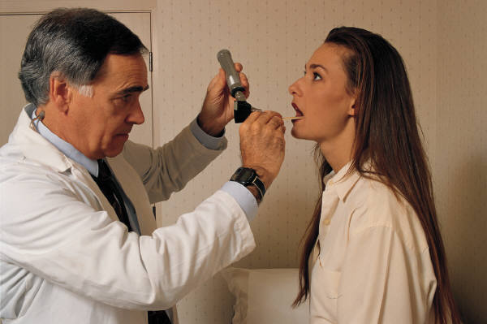

Using the Describing Symptoms handouts (#3B-3F), ask students the following questions:
“What’s the matter?”
“Has this ever happened to you?”
“What did you do?”
“What other words do you know when you are not feeling well?”

Project the sample conversation below or write it on the board. Students will practice the conversation in pairs. Use the pictures of symptoms to practice each one.
A: “What’s the matter?"
B: “I have a headache.”
A: “I’m sorry to hear that. I hope you feel better soon.”
B: “Thanks.”

For more practice, have students practice dialogues that might occur in the doctor’s office or emergency room, asking and answering questions such as:
"Where does it hurt?"
"How long have you felt like this?"
"Are you taking any medication?"
"What kind of medical insurance do you have?"

With more advanced students, have students practice writing down the symptoms and/or questions in a letter to take to the doctors’ office. Explain that this will help them to remember everything important and to be better understood.
This page intentionally blank
TASK 3 - Handout #3B

Describing Symptoms—Student Handout 1

adapted from: bogglesworldesl.com

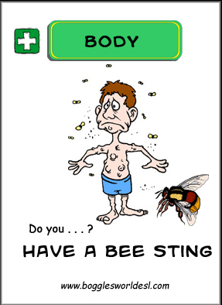 | 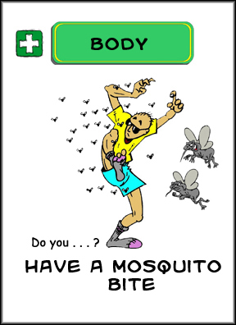
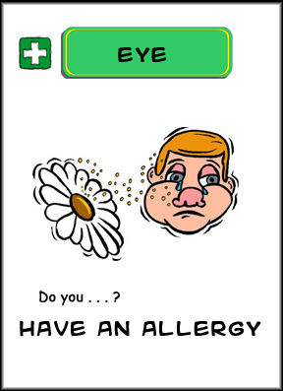
This page intentionally blank
TASK 3 - Handout #3C

Describing Symptoms—Student Handout 2

adapted from: bogglesworldesl.com

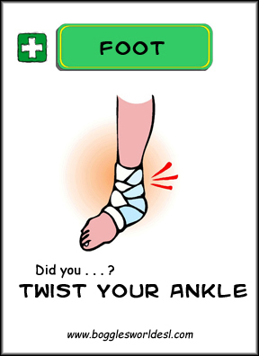 | 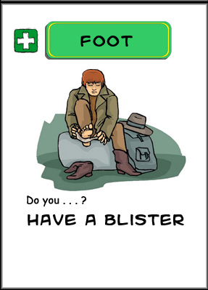
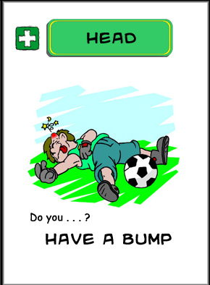 | 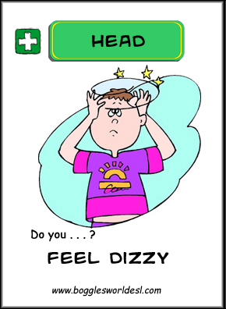
This page intentionally blank
TASK 3 - Handout #3D

Describing Symptoms—Student Handout 3

adapted from: bogglesworldesl.com

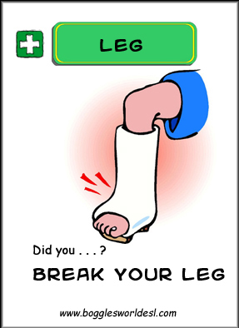 | 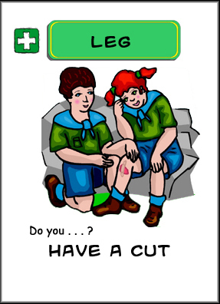
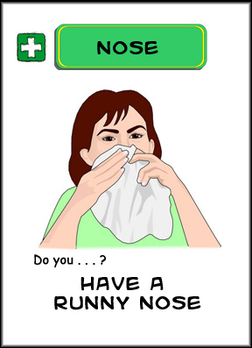 | 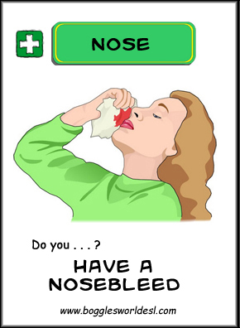
This page intentionally blank
TASK 3 - Handout #3E

Describing Symptoms—Student Handout 4

adapted from: bogglesworldesl.com
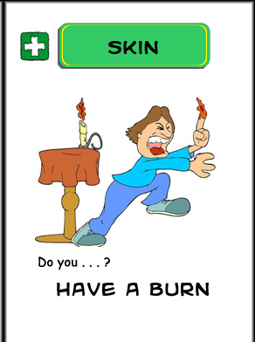 | 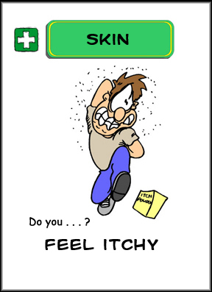
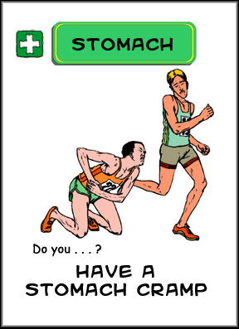 | 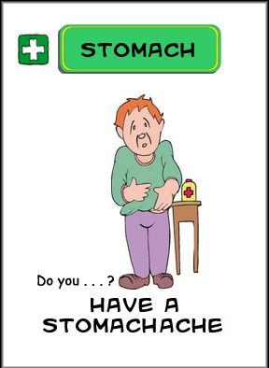
This page intentionally blank
TASK 3 - Handout #3F

Describing Symptoms—Student Handout 5

adapted from: bogglesworldesl.com
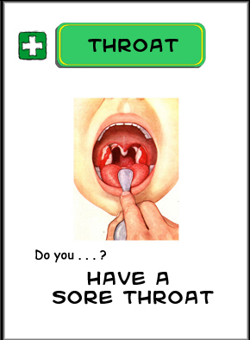 | 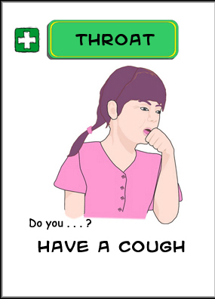
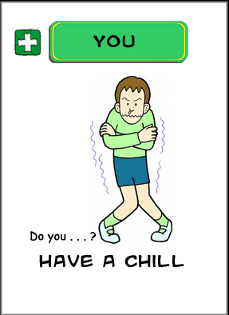 | 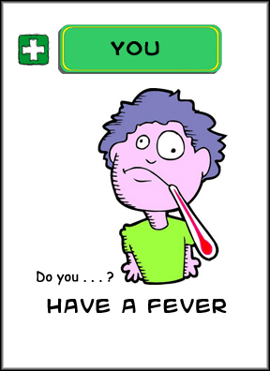
This page intentionally blank
TASK 3 - Handout #4

Introduction: Talking With Your Doctor
adapted from National Institutes of Health

When talking with your doctor …

Be honest — It is tempting to say what you think the doctor wants to hear: for example, that you smoke less or eat a more balanced diet than you really do. While this is natural, it’s not in your best interest. Your doctor can suggest the best treatment only if you say what is really going on. For instance, you might say: “I have been trying to quit smoking, as you recommended, but I am not having much success.”

Decide what questions are most important — Make a list of your questions or concerns in order of importance and give it to the doctor at the beginning of your appointment.

Stick to the point — Remember that each patient is given a limited amount of time. To make the best use of your time, stay focused. For instance, give the doctor a brief description of the symptom, when it started, how often it happens, and if it is getting worse or better.

Share your point of view about the visit — Tell the doctor if you feel rushed, worried, or uncomfortable. Try to voice your feelings in a positive way. For example, you could say something like: “I know you have many patients to see, but I’m really worried about this. I’d feel much better if we could talk about it a little more. I could come back for another visit.”

Remember, even the best doctor may not be able to answer all your questions.In that case, they can help you find the information you need or refer you to a specialist. If a doctor regularly brushes off your questions or symptoms, or tries to convince you they are “in your head,” look for another doctor.
This page intentionally blank
Task 3 – Handout #5
Communicating With Your Doctor Through Email

When should you email your doctor?
Email is a good way to communicate with your doctor when you don’t need an instant response (most replies typically expected within 48 hours). Many doctors prefer to use email with their patients for routine inquiries between appointments, such as:
- lab reports and test results
- updates on medication and treatment
- follow-up questions after a checkup
- prescription refills
- referrals to specialists

When should you call or visit in person?
When you have and emergency or acute health problem requiring immediate attention (e.g. sudden, sharp chest pain), you should call or visit. Also, many doctors prefer to see you in person if you have a new medical problem that hasn’t been treated before.

Tips for emailing your doctor:
- Include your real name (full name), patient’s name and ID number, and a contact phone number
- Be specific and focused
- If you need a response within 48 hours, call instead

This page intentionally blank
Task 3 – Handout #6

Writing Effective Email Messages

adapted from Wheaton College and Michigan State University writing resources
When writing an email message, you need to consider the following:
Format: rules for greetings, closings & punctuation | Rules for email are less formal than letters.Often, greetings and closings are not necessary.
Tone: feeling of the message (professional? angry? friendly?) | Send me information.  Could you please send me information?  I would appreciate it if you could send me information.  Thanks!  Thank you for your help.
Level of Formality: related to tone; depends on your relationship with the reader | Let me know, OK?  I would appreciate it if you could let me know what you think.
Functional Language: requests, suggestions, apologies, complaints | When communicating with your doctor, you will most likely write requests.

Writing a Routine Request to Your Doctor
A routine request is when you are not asking for a special favor, and you expect the request to be fulfilled.
- State your main idea in the first or second sentence. This will save your reader (the doctor) time. Include any necessary information the doctor will need to fulfill your request (e.g. name and current strength of medication).
- Use polite language.
- Be specific. State exactly what you want.
- Close with a friendly tone in your last paragraph.

This page intentionally blank
Task 3 – Handout #7

Examples: Email Requests to Doctors

From: Julie Brown
Date Sent: January 2, 2019
To: Dr. Bob Jones, Kaiser Permanente
Subject: Shortness of Breath

Hi Dr. Jones,

Hope you are doing well.

I’m writing because I have been having some shortness of breath for the past two weeks. It happens when I am sitting and when I am up moving around. It comes and goes--I will have it for a few days, then it goes away, and then comes on spontaneously. I do not have any chest pain or pain when I take a deep breath, but it feels like I cannot get enough air in. I’m a non-smoker and live in a smoke-free home.

I would appreciate your advice about how to improve my breathing.

Thank you,

Julie Brown
Patient #650893
310-972-5543

From: Hideko Sato
Date Sent: January 8, 2019
To: Dr. Sally Johnson
Subject: Change in Medication Strength

Dear Dr. Johnson,

How are you? I’m writing because I think my medication needs to be adjusted. As you prescribed at my last visit three months ago, I have been taking 75mcg of Levothroid for my thyroid problem. However, I am still feeling very sluggish. Could you please increase my dosage to 100mcg?

I look forward to hearing back from you.

Thanks,

Hideko Sato
Medical Record #: 008124849
562-555-4491

This page intentionally blank
TASK 3 - Handout #8

Practice: Emailing Your Doctor
Directions: Choose one of the scenarios below. Use the info provided to write an email to your doctor. Describe the symptoms & duration of your illness, and request the doctor’s help. Add any details that would be helpful to the doctor in understanding the problem.
Scenario 1:  Two months ago, your doctor gave you a prescription for Xanax for your nervousness. Now, you are feeling dizzy and having trouble sleeping. Ask Dr. Jones about changing the amount of the medication you take. | Scenario 2:  For three days, you have had a sore throat and cough. You feel better each day, but the cough is keeping you awake at night. Ask Dr. Jones to prescribe medication to reduce your cough and help you sleep.

From: Mary Smith
Sent: January 7, 2019 @ 10:15 a.m.
To: Dr. Jones
Subject: Question from your patient

