|  |
| --- |
| **EL Civics: Health Care (Obj 28) • IL4 Task 2: Read and Interpret Medicine Labels** |
| **Language & Literacy Objectives:**  10. Explain medicine labels and medical warning labels. |
| **INTRODUCTION** |
| In this lesson, students will learn how to read and interpret medicine labels. |
| **ASSESSMENT TASK – 16 points possible** |
| Part 1: Given pictures of six medicine labels, students will identify whether the labels are for prescription or non-prescription medication.  Part 2: Answer level-appropriate questions about a prescription label. |
| **SUGGESTED ACTIVITIES** |
| * Teacher and/or students bring in actual medicine packaging, including drug warnings. *[Class set available for checkout from Resource Office.]* Have students work in small groups to identify all information on the label, then sort into categories, e.g. prescription/over-the-counter, brand name/generic, take with food/take on empty stomach, etc. Use document reader to project objects to whole class. * Students find advertisements in magazines, newspapers or on TV for three prescription or over-the counter medicines. Call 800# or view website to identify uses, possible side effects, warnings, etc. Make a medicine label (poster-size) and explain each drug, its use, its side effects, etc. to the class. * Students visit a local pharmacy and complete the enclosed handout (#8). Bring back to class and share experiences. * Invite a pharmacist to speak to your class. Students prepare questions in advance to ask the guest speaker. |

|  |
| --- |
| **HANDOUTS PROVIDED** |
| Handout 1: Related Vocabulary  Handout 2: Discussion Questions  Handout 3: Introduction: How to Read Medicine Labels  Handout 4: Medications: The Importance of Reading the Label  Handout 5: Talk to Your Doctor: Seven Questions to Ask About Your Medicines  Handout 6: Practice: Prescription or OTC? (with Answer Key)  Handout 7: Practice: Reading Prescription Labels (with Answer Key)  Handout 8: Community Activity—Visit a Local Pharmacy |
| **COMPUTER LAB IDEAS** |
| * Conduct research on the medications available to treat different illnesses and diseases. Do the medications actually treat the problem or just alleviate the symptoms? Are there alternative (non-Western) treatments you recommend? Create and deliver a presentation to the class. * Create a medication/allergy log for yourself or a family member. List all current medications, including both prescription and over-the-counter. Be sure to include name, strength (dosage), instructions for use, etc. Keep a copy with you at all times. *(Templates in EL Civics teacher folder on classroom & lab desktops.)* * Have students research a medication, then create a medicine label based on the information they find. Provide a template. * Use the Drug Interaction Checker from drugs.com (see Related Websites) to research drug, food, lifestyle and disease interactions for medications the students take or are thinking about taking. * Research the effects of supplements, herbs and other non-Western treatments for diseases and ailments. |

Task 2 – Handout #1

**Related Vocabulary**

*adapted from* [*Dictionary.com*](http://www.dictionary.com/) *&* [*Wikipedia*](http://www.wikipedia.com/)

**medicine label**: provides important usage and safety information for consumers.

**prescription**: written order, especially by a physician, for the preparation and administration of a medicine or other treatment.

**non-prescription**: legally available for purchase without a doctor's prescription (also: “over-the-counter”).

**pharmacist**: one who is licensed to prepare and dispense drugs; a druggist.

**patient:** one who receives medical attention, care, or treatment.

**name of medication**:

***brand name*** *= name given when medicine created*

***generic name*** *= name(s) given after patent expires*

Brand name medicines typically cost more because the drug companies have exclusive right to distribute (no competition). They also build in the cost of research, manufacturing, advertising, etc. When patents expire, multiple drug manufacturers can develop the medication, which brings the cost to the consumer down substantially.

**dose/dosage**: amount of medication to be given. A **dose** is a quantity taken at one time; a **dosage** is any amount prescribed for a given period of time.

**pharmacy**: place where medical drugs are sold; a drugstore.

**refills**: filling a prescription another time without a new order from the physician.

**warnings**: notices about the possible dangers of taking medication, potential side effects and drug interaction precautions.

**expiration date**: The date past which a medicine must be removed from availability because it is no longer expected to be effective.

**instructions for use**: sequence of directions to follow when taking medication; includes how often and when to take.

*This page intentionally blank.*Task 2 – Handout #2

**Discussion Questions: Reading Medicine Labels**

**Whole Class Brainstorm:** What items do most people get in a pharmacy?

**Questions for Small Group Discussion:**

What do you say and do in each of these situations:

* *The pharmacist gives you a prescription, but you don’t understand the directions.*
* *You need to refill your prescription.*
* *When you open a new aspirin bottle, you see that the bottle has been opened before.*
* *You don’t know if the heart medicine you are taking is safe to take with your new prescription.*

1. What prescription drugs are most common in your native country?
2. How expensive are prescription drugs there?
3. How expensive are over-the-counter drugs there?
4. How are pharmacies in your country similar to those in the U.S.? How are they different?
5. In your country, what else do pharmacies sell in addition to drugs?

*This page intentionally blank*

TASK 2 - Handout #3

##### Introduction: How to Read Medicine Labels *adapted from* [*Office on Women's Health*](https://www.womenshealth.gov/)

Medicines, or drugs, come as either prescription or over the counter (OTC). **Prescription** drugs are used under a doctor’s care. **OTC** drugs can be bought and used without a doctor’s prescription, and you buy them at a drugstore or grocery store.

* **Prescription drugs** – These are the ones your doctor prescribes for you.
* **Over-the-counter medications** – These are drugs like aspirin, allergy medicine, and antacids. You can buy them at the drug or grocery store without a prescription.
* **Supplements** – These include vitamins, fish oil, and herbal products like St. John's Wort or Echinacea.

When using any kind of drug, it is really important to read the drug label for instructions. If you read the label and still have questions, call your doctor, nurse or pharmacist for help.

SAMPLE PRESCRIPTION LABEL

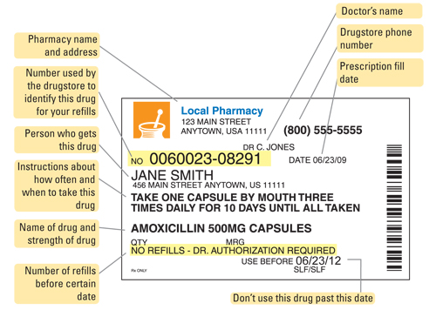

© March 2009, [womenshealth.org](http://www.womenshealth.org/)

*This page intentionally blank*

TASK 2 - Handout #3 (cont.)

##### Introduction: How to Read Medicine Labels (cont.) *adapted from* [*Office on Women's Health*](https://www.womenshealth.gov/)

SAMPLE OVER-THE-COUNTER (OTC)/NON-PRESCRIPTION LABEL

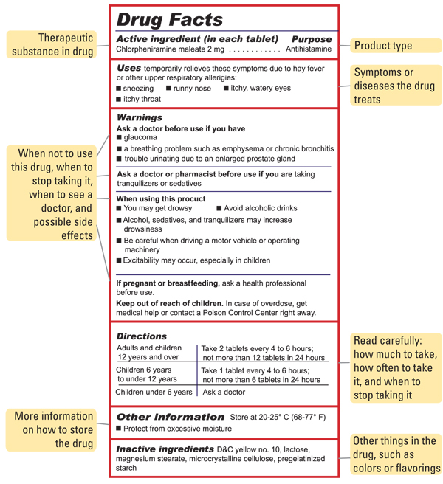

© March 2009, www.womenshealth.org

*This page intentionally blank*

Task 2 – Handout #4

**Medications: The Importance of Reading the Label**

*Labels have a lot of important information that you need to know. The illustration below shows the different parts of a prescription label and what they mean.*

MEDCO HEALTH PHONE: 800-841-3398 DEA#: BM5243629

6225 Annie Oakley Drive Las Vegas, NV 89120 DATE: 06/03/09

NAME: Michael Jones DR. LAGRELIUS RX: 0403302996

TAKE 1 TABLET EACH WEEK

FOSAMAX TABS 4’S 70MG 7 REFILLS

MFG: MERCK & CO., INC. DISCARD AFTER 09/30/10

CAUTION: DO NOT USE WITH ALCOHOL OR NON-PRESCRIBED DRUGS QTY: 1

WITHOUT CONSULTING THE PRESCRIBING PRACTITIONER

a

b

c

d

e

f

g

h

i

j

1. **Prescription number**. Needed when calling the pharmacy for a refill or for insurance forms.
2. **Doctor’s name**
3. **Date** prescription is filled
4. **Patient’s name**. This medication is for the patient only. Do not give medications to another person even if the symptoms are the same.
5. **Name of the medication and the strength of the medication**. Be sure the name on the label is the same as the doctor told you.
6. **Pharmacy name and phone number**
7. **Refills**. The label will show the number of refills permitted. It may also say “no refills” If you need more, call your doctor.
8. The package may also have **warning labels** with additional instructions, such as:

* Safe storage instructions, such as “keep refrigerated”
* Instructions for use, such as “shake well before using”
* Possible side effects, such as “may cause drowsiness”

i. **Expiration Date**. Do not use the medication after the expiration date. Do not save unused prescriptions.

j. **Instructions for use**. This is information about how often and when to take the medication. These instructions can be confusing. Examples:

* ***Take full course****—Take the entire bottle even if you feel better. With antibiotics, especially, the infection may return if you stop too soon.*
* ***Take with food****—Take the medication after you have eaten a meal. Some medications work better when the stomach is full.*
* ***Take 4 times a day****—Take the medication 4 times throughout the day (for example, at breakfast, lunch, dinner, and bedtime). This is different from “take every 4 hours,” which adds up to 6 times in a 24-hour period. Be sure to ask your doctor which is best.*

*This page intentionally blank.* Task 2 – Handout #5

**Talk to Your Doctor—Seven Questions to Ask About Your Medicines**

adapted from [National Institute on Aging](https://www.nia.nih.gov/health/medicines-and-medication-management/taking-medicines-safely-you-age)

Talk to your doctor & pharmacist. Get the facts about your medicine

Ask these questions before you leave your doctor's office. Take this list with you each time you visit your doctor. Be sure to write your answers and keep them where you will see them.

Ask your doctor:

1. What is the name of the medicine, and why am I taking it?
2. What medical condition does this medicine treat?
3. How many times a day and how much medicine should I take? For how long?
4. How long will it take to work?
5. What should I do if I miss a dose?
6. Are there any side effects I should know about? When should I call you if I am having side effects?
7. Can I safely mix this medicine with the remedies, vitamins, and OTC drugs I am taking?

|  |
| --- |
| Each time you visit:  Be sure to ask your doctor if you still need to be on all your medicines. |

*This page intentionally blank*TASK 2 - Handout #6

### PRACTICE: PRESCRIPTION OR OTC?

***Directions****: Look at each medicine label below. Write “****prescription****” or   
“****non-prescription****” under each picture.*

|  |  |  |
| --- | --- | --- |
| 1. ________________________ | 2. _____________________ | Amoxicillin 500mg medicine bottle  3. ________________________ |
| 4. ________________________ | 5. _____________________ | 6. ________________________ |
| 7. ________________________ | 8. _____________________ | 9. ________________________ |

*This page intentionally blank. This page intentionally blank*TASK 2 - Handout #6

### ANSWER KEY: PRESCRIPTION OR OTC?

***Directions****: Look at each medicine label below. Write “****prescription****” or   
“****non-prescription****” under each picture.*

|  |  |  |
| --- | --- | --- |
| 1. **non-prescription** | **2. non-prescription** | amoxicillin 500 mg  **3. prescription** |
| **4. prescription** | **5. prescription** | **6. non-prescription** |
| **7. non-prescription** | **8. prescription** | **9. non-prescription** |

*This page intentionally blank*TASK 2 - Handout #7

### PRACTICE: READING PRESCRIPTION LABELS

***Directions***: Read the prescription label and answer the questions.

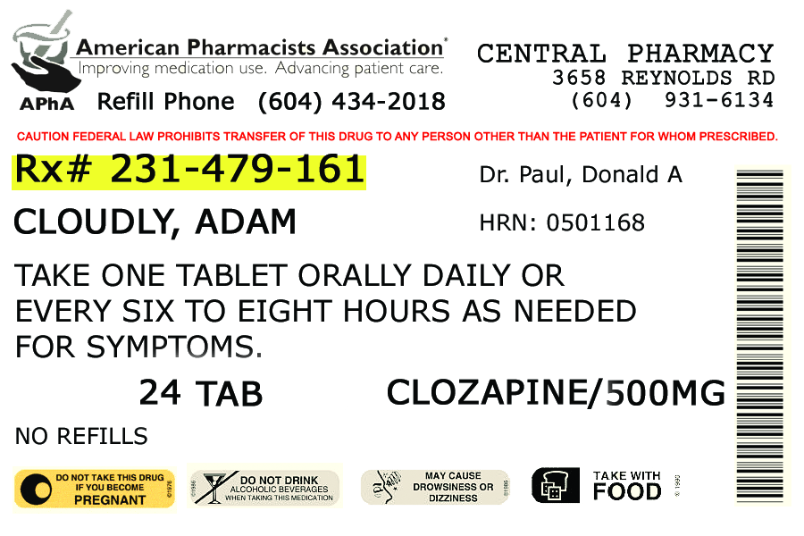

1. Which phone number do you call to order refills?
2. What is the prescription number?
3. What is the name of the drug?
4. What is the strength of the drug?
5. How many refills are left for this prescription?

*This page intentionally blank*TASK 2 - Handout #7

### ANSWER KEY: READING PRESCRIPTION LABELS

### PRACTICE: READING PRESCRIPTION LABELS

***Directions***: Read the prescription label and answer the questions.



1. Which phone number do you call to order refills? (604) 434-2018
2. What is the prescription number? Rx# 231-479-161
3. What is the name of the drug? Clozapine
4. What is the strength of the drug? 500MG
5. How many refills are left for this prescription? 0

*This page intentionally blank*TASK 2 - Handout #8

**COMMUNITY ACTIVITY—VISIT A LOCAL PHARMACY**

**Directions:**  Visit a local pharmacy. Research this information and report your findings to the class:

1. What is the name of the pharmacy? ___________________________
2. Where is the prescription counter? ____________________________
3. Write the names of three over-the-counter medications. List one instruction, one warning and one drug interaction precaution for each.

|  |  |  |  |
| --- | --- | --- | --- |
| **NAME** | **INSTRUCTION** | **WARNING** | **PRECAUTION** |
| 1. |  |  |  |
| 2. |  |  |  |
| 3. |  |  |  |

1. List three other items can you buy in a pharmacy: