Contents
Handout #1: Overview of Tasks 2
Handout #2: Speak to a Blank Employee (Task 1) 3
Handout #3: Speak to a Blank Employee Answer Key (Task 1) 4
Handout #4: Practice 1 – Make a Budget (Task 2) 5
Handout #5: Practice 1 – Make a Budget Answer Key (Task 2) 6
Handout #6: Bank Brochures (Task 3) 7
Handout #7: Practice 1: Comparison Chart & Writing (Task 3) 8
Handout #8: Practice 1: Comparison Chart & Writing Answer Key (Task 3) 9

Handout #1: Overview of Tasks
Banking
Intermediate High – Advanced
Task 1  Inquire at a Bank  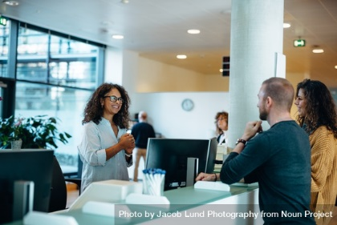  Oral | Task 2  Make a Budget  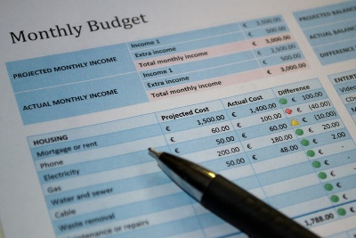  Written | Task 3  Find & Compare Information on Banking Institutions  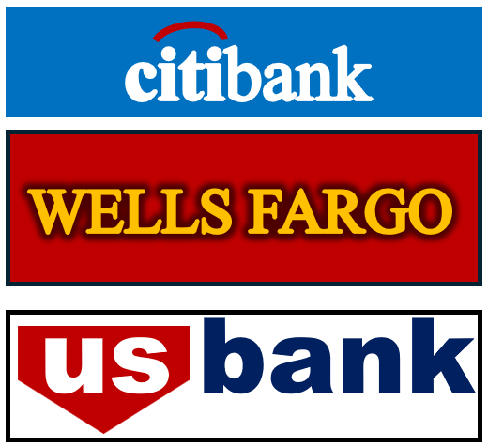  Written

Handout #2: Speak to a Blank Employee (Task 1)
Content A Directions: You want to open a checking account and would like to ask some questions about what is included with the account. You will have a conversation with a bank employee to get your answers. Begin the dialogue with a greeting and give a statement of reason for the meeting. Then, ask the bank employee 4 questions and end with an appropriate closing. Listen to the answers and take notes, if you need to, so that you can remember what the bank employee said. After the conversation, you will answer 3 comprehension questions.
Banker: Hello, welcome to California Bank. How are you doing today?
Customer: (1: Greet the banker and tell him/her how you are doing today.)
Banker: What can I help you with?
Customer: (2: Ask for help opening a checking account.)
Banker: Sure. Do you have any questions before we begin?
Customer: (3: Ask how much the monthly fee is.)
Banker: There is no monthly fee.
Customer: (4: Ask how much interest you will earn.)
Banker: None. We don’t pay interest on checking accounts.
Customer: (5: Ask how much the minimum balance is.)
Banker: There is no minimum balance.
Customer: (6: Ask if there is overdraft protection.)
Banker: Yes, there is.
Customer: (7: Close/finish the conversation.)
Content B Directions: Answer the following questions.
- How much is the monthly fee?
- What is the minimum balance?
- Is there overdraft protection?

Handout #3: Speak to a Blank Employee Answer Key (Task 1)
Content A: Example Role Play Script
Banker | Hello, welcome to California Bank. How are you doing today?
Customer | Fine, thanks. (1)
Banker | What can I help you with?
Customer | I’d like to open a checking account. (2)
Banker | Sure. Do you have any questions before we begin?
Customer | Yes, how much is the monthly fee? (3)
Banker | There is no monthly fee.
Customer | How much interest will I earn? (4)
Banker | None. We don’t pay interest on checking accounts.
Customer | What is the minimum balance? (5)
Banker | There is no minimum balance.
Customer | Is there overdraft protection? (6)
Banker | Yes, there is.
Customer | Good! Thank you. (7)

Content B: Comprehension Questions
- How much is the monthly fee? There is no monthly fee.
- What is the minimum balance? There is no minimum balance.
- Is there overdraft protection? Yes, there is.

Handout #4: Practice 1 – Make a Budget (Task 2)
Directions: Read the scenario below and complete the monthly budget. Write the amounts of the family’s income and expenses in the budget chart.
Greg Ruiz just got a raise at work. Now he makes $2,500 a month. His wife, Laura, makes $2,300 a month. Greg and Laura want to start saving money for their son’s education. They need to make a budget to show their monthly income and expenses, so they don’t spend too much money.
The Ruiz family spends $1,800 on rent. Their utilities (gas, electricity, and water) are $200. They pay $175 for their cell phones. They have two cars with a combined payment of $750 and a car insurance payment of $250. They spend $1,500 on food and clothing. This allows them to save $125 each month for their son’s education.

Monthly Income
Greg’s Income: (1) $
Laura’s Income: (2) $
Total Monthly Income: $4,800
Monthly Expenses
Rent: $1,800
Car Payments: (3) $
Car Insurance: (4) $
Cell Phones: (5) $
Utilities: (6) $
Food and Clothing: (7) $
Saving for Education: (8) $
Total Monthly Expenses: $4,800

Handout #5: Practice 1 – Make a Budget Answer Key (Task 2)

Monthly Income
Greg’s Income: (1) $ 2,500
Laura’s Income: (2) $ 2,300
Total Monthly Income: $4,800
Monthly Expenses
Rent: $1,800
Car Payments: (3)$750
Car Insurance: (4) $ 250
Cell Phones: (5) $ 175
Utilities: (6) $ 200
Food and Clothing: (7) $ 1,500
Saving for Education: (8) $ 125
Total Monthly Expenses: $4,800

Handout #6: Bank Brochures (Task 3)
Central California Bank |  |  | West Orange County  Credit Union |  |  | Hillside  Savings & Loan
12991 Beach Bl.  Garden Grove, CA 92841 |  |  | 13901 Seal Beach Bl.  Seal Beach, CA 90740 |  |  | 6929 W. Katella Ave.  Cypress, CA 90630
Services Offered | Fee/Rate |  | Services Offered | Fee/Rate |  | Services Offered | Fee/Rate
Basic Accounts |  |  | Basic Accounts |  |  | Basic Accounts
Checking Account  - Minimum opening balance $150 | - $25 per month  - Free with Direct Deposit $300 or more  - Free with $2,000 average daily balance |  | Checking Account  - Minimum opening balance $100 | - Free with $300 average daily balance |  | Checking Account  - Minimum opening balance $150 | - $20 per month  - Free with Direct Deposit $250 or more  - Free with $2,000 average daily balance
Savings Account  - Minimum opening balance $150 | 1.2% |  | Savings Account  - Minimum opening balance $25 | 2% |  | Savings Account  - Minimum opening balance $100 | 1.8%
ATM/Debit Card | Free  ($750 min. bal.) |  | ATM/Debit Card | Free |  | ATM/Debit Card | $2 per month
Loans |  |  | Loans |  |  | Loans
Home Loans | 9.25% for 30 years |  | Home Loans | 7% for 30 years |  | Home Loans | 8.5% for 30 years
Car Loans | 12% for 5 years |  | Car Loans | 8.5% for 7 years |  | Car Loans | 10.5% for 6 years
Personal Loans | 15% for 5 years |  | Personal Loans | 9.5% for 6 years |  | Personal Loans | 11% for 6 years
Other Services |  |  | Other Services |  |  | Other Services
Credit Card | 19% |  | Credit Card | 12.5% |  | Credit Card | 14%
Direct Deposit | Free |  | Direct Deposit | Free |  | Direct Deposit | Free
Overdraft Protection | $35 each occurrence |  | Overdraft Protection | $20 per year |  | Overdraft Protection | $25 each occurrence
Cashier Checks | $5 each |  | Cashier Checks | $2 each |  | Cashier Checks | n/a
Monday – Friday 9:00-5:00  Saturday 10:00-1:30, Closed Sunday |  |  | Monday – Friday 9:00-5:30  Saturday 9:00-2:30, Closed Sunday |  |  | Monday – Friday 9:30-6:00  Closed Saturday & Sunday

Handout #7: Practice 1: Comparison Chart & Writing (Task 3)
Directions: Using the brochures above, complete the chart to compare information about three banking institutions, including the names and addresses, hours, services, and fees/rates.
 | Banking Institution #1 | Banking Institution #2 | Banking Institution #3
Name | (1) | (2) | (3)
Address | (4) | (5) | (6)
Hours | (7) | (8) | (9)
2 Services* | (10) | (11) | (12)
Checking Fee | (13) | (14) | (15)
Savings Rate | (16) | (17) | (18)
Credit Card Rate | (19) | (20) | (21)
* Be sure to list two services available at each banking institution.
Directions: Using the comparison chart above, name the banking institution that you think is the best one for you and your family. Then, give two reasons to support your choice. (22-24)

Handout #8: Practice 1: Comparison Chart & Writing Answer Key (Task 3)
Directions: Using the brochures above, complete the chart to compare information about three banking institutions, including the names and addresses, hours, services, and fees/rates.
 | Banking Institution #1 | Banking Institution #2 | Banking Institution #3
Name | (1) Central California Bank | (2) West Orange County Credit Union | (3) Hillside Savings & Loan
Address | (4) 12991 Beach Bl.  Garden Grove, CA 92841 | (5) 13901 Seal Beach Bl.  Seal Beach, CA 90740 | (6) 6929 W. Katella Ave.  Cypress, CA 90630
Hours | (7) Monday – Friday 9:00-5:00  Saturday 10:00-1:30, Closed Sunday | (8) Monday – Friday 9:00-5:30  Saturday 9:00-2:30, Closed Sunday | (9) Monday – Friday 9:30-6:00  Closed Saturday & Sunday
2 Services* | (10) Checking Account, Savings Account, ATM/Devit Card, Home Loans, Car Loans, Personal Loans, Credit Card, Direct Deposit, Overdraft Protection, Cashier Checks | (11) Checking Account, Savings Account, ATM/Devit Card, Home Loans, Car Loans, Personal Loans, Credit Card, Direct Deposit, Overdraft Protection, Cashier Checks | (12) Checking Account, Savings Account, ATM/Devit Card, Home Loans, Car Loans, Personal Loans, Credit Card, Direct Deposit, Overdraft Protection, Cashier Checks
Checking Fee | (13) Free with Direct Deposit of $300 or more, or with $2,000 average daily balance | (14) Free with $300 average daily balance | (15) Free with Direct Deposit of $250 or more, or with $2,000 average daily balance
Savings Rate | (16) 1.2% | (17) 2% | (18) 1.8%
Credit Card Rate | (19) 19% | (20) 12.5% | (21) 14%
* You only need TWO of these possible answers for Services
Example Writing – Students can choose a different bank and give different reasons. This is only an example. (22-24)
West Orange County Credit Union is the best choice for me and my family. The first reason is because it has the lowest credit card rate. The second reason is because it is open the longest on Saturdays.

