Contents
Handout #1: Profile (Task 1) 2
Directions: Read the profile. Then fill out the bank application (next page). 2
Handout #2: Bank Application (Task 1) 3
Handout #3: Bank Application Answer Key (Task 1) 4
Handout #4: Introduction (Task 2A) 5
Handout #5: Practice 1 (Task 2A) 8
Handout #6: Practice 1 Answer Key (Task 2A) 9
Handout #7: Practice 2 (Task 2A) 10
Handout #8: Practice 2 Answer Key (Task 2A) 11
Handout #9: Practice 3 (Task 2A) 12
Handout #10: Practice 3 Answer Key (Task 2A) 13
Handout #11: Practice 4 (Task 2A) 14
Handout #12: Practice 4 Answer Key (Task 2A) 15
Handout #13: Introduction (Task 2B) 16
Handout #14: Practice 1 (Task 2B) 17
Handout #15: Practice 1 Answer Key (Task 2B) 18
Handout #16: Practice 2 (Task 2B) 19
Handout #17: Practice 2 Answer Key (Task 2B) 20

Profile (Task 1)
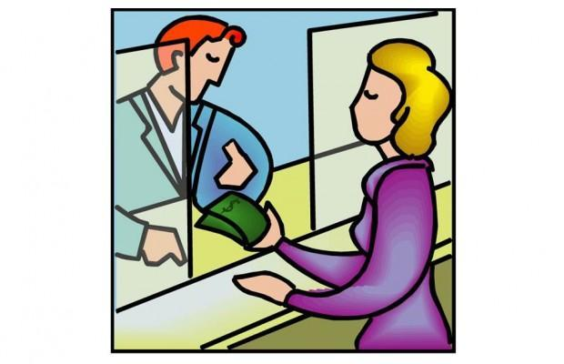

Directions: Read the profile. Then fill out the bank application (next page).
Profile:
Katrina Petrova wants to open a checking account at Contra Costa Bank.
Katrina Petrova is from Russia.
Her date of birth is September 20, 1990.
She is single.
She lives at 134 Apple Blossom Street.
The city is Pleasant Hill.
The state is California.
The zip code is 94523.
Her cell phone number is (925) 555-5729.
Her email address is kpetrova@gmail.com.
Katrina works full-time.
She works at FoodMax market.
She is the store manager at the market.
The address of the market is1756 Treat Street.
The city is Pleasant Hill.
The state is California.
The zip code is 94523.
The work telephone number is (925) 555-9290.
Katrina Petrova is a U.S. citizen.
Her social security number is 577-661-7564.
She has a driver’s license for identification.
The driver’s license ID number is CD9753112.
The expiration date for the driver’s license is February 17, 2019.
Katrina Petrova wants to deposit $1500.
Katrina Petrova signs her name.
Write today’s date.

Bank Application (Task 1)
Directions: Fill out the bank application.
CONTRA COSTA BANK ACCOUNT APPLICATION
Last name First name Middle name
Date of Birth:
Month Day Year
Address:
Street City State Zip Code
Phone Number:
Email Address:
Are you a U.S. citizen? Yes No
Do you have a Social Security Number (SSN)? Yes No
Or, do you have an Individual Taxpayer Identification Number (ITIN)? Yes No
Identification? Driver’s license State ID Card Passport
I agree this information is correct.
Signature Date

Bank Application Answer Key (Task 1)
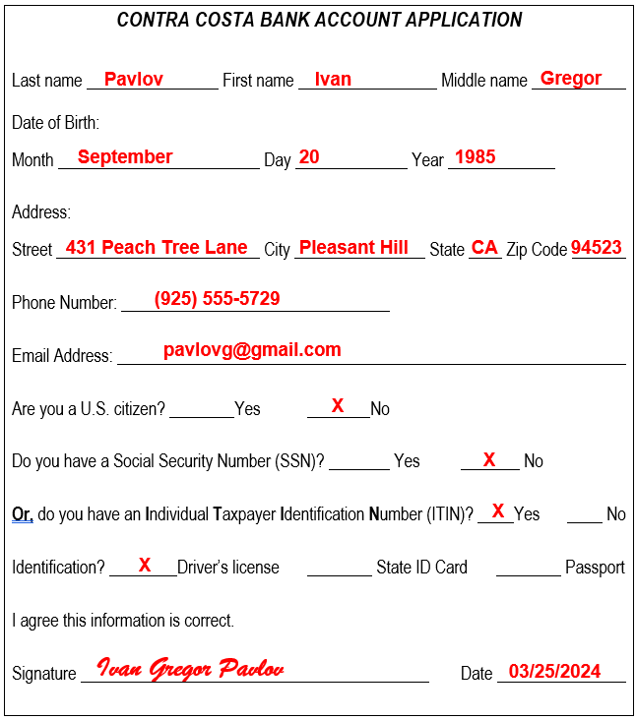
Note: Write today’s date.

Introduction (Task 2A)
How to write a check:
Step 1: Write the date:
Month, Day, Year
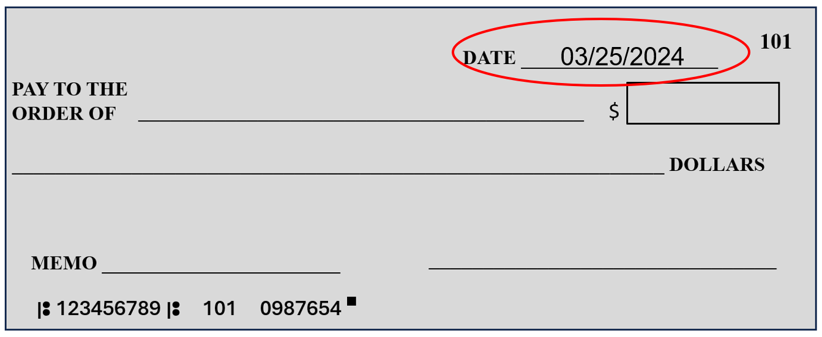
Step 2: Write the name of the person or company that gets the check.
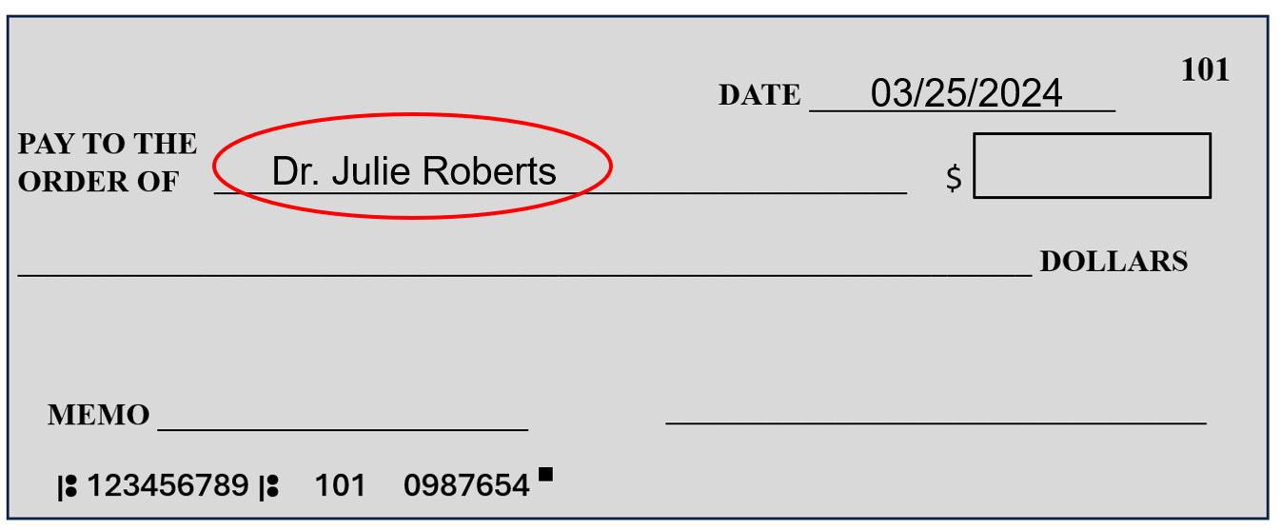

Handout #4 Introduction (cont.)
Step 3: Write the money in numbers.
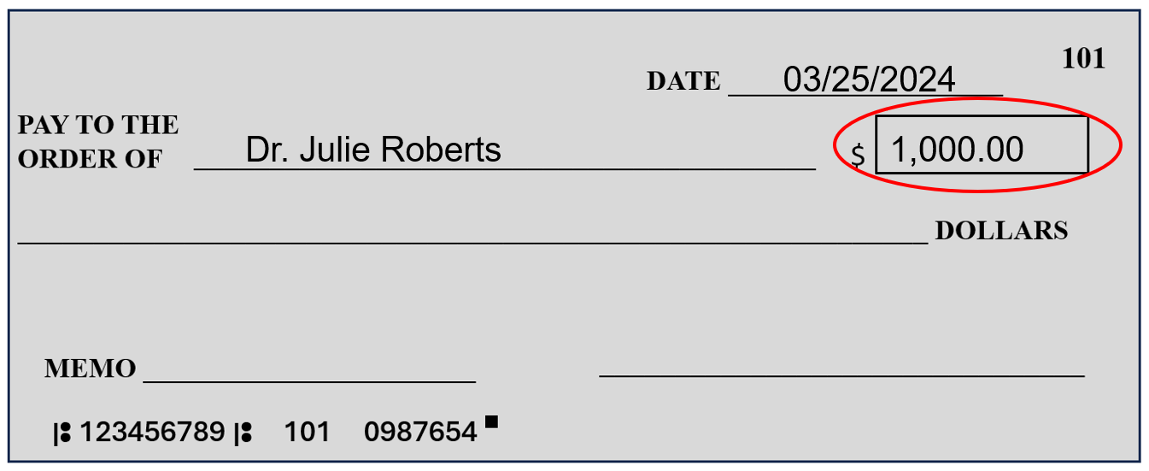
Step 4: Write the money in words.
Zero cents=00/100, 10 cents=10/100
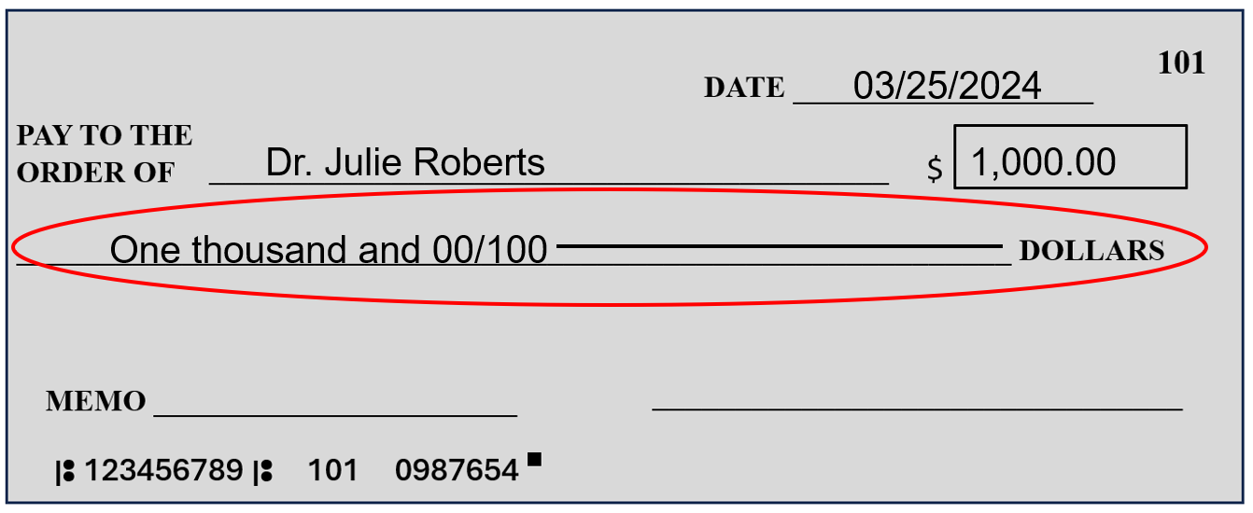

Handout #4 Introduction (cont.)
Step 5: (Optional) Write what the check is for.
Memo helps you remember what the money is for.
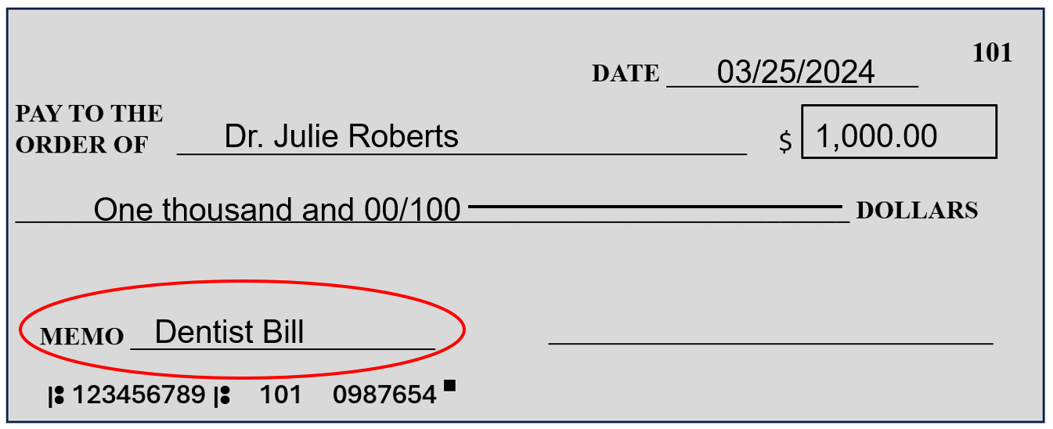
Step 6: Sign (write) your first and last name.
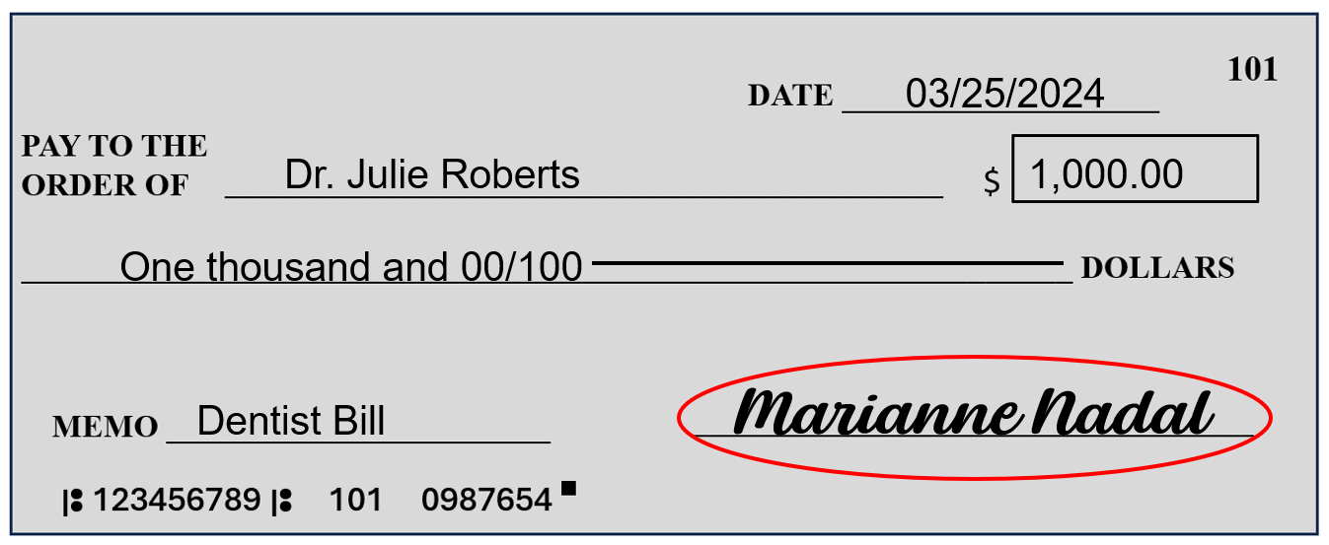

Practice 1 (Task 2A)
Directions: Read the check and answer the questions.
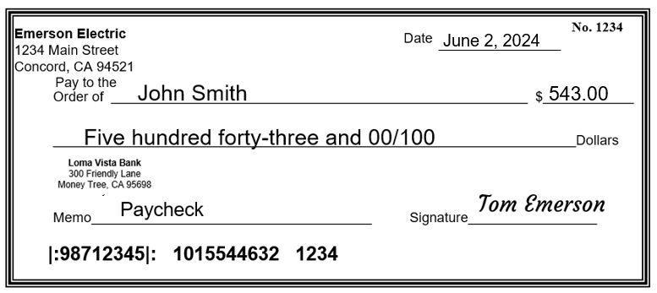
- How much money is the check?
- Who gets the check (Pay to the Order of)?
- Who writes the check (Signature)?
- What is the date of the check?

- (Optional) What is the memo?

Practice 1 Answer Key (Task 2A)
- $543
- John Smith
- Tom Emerson
- June 2, 2024
- Paycheck

Practice 2 (Task 2A)
Directions: Use the information in the bill to write a check.
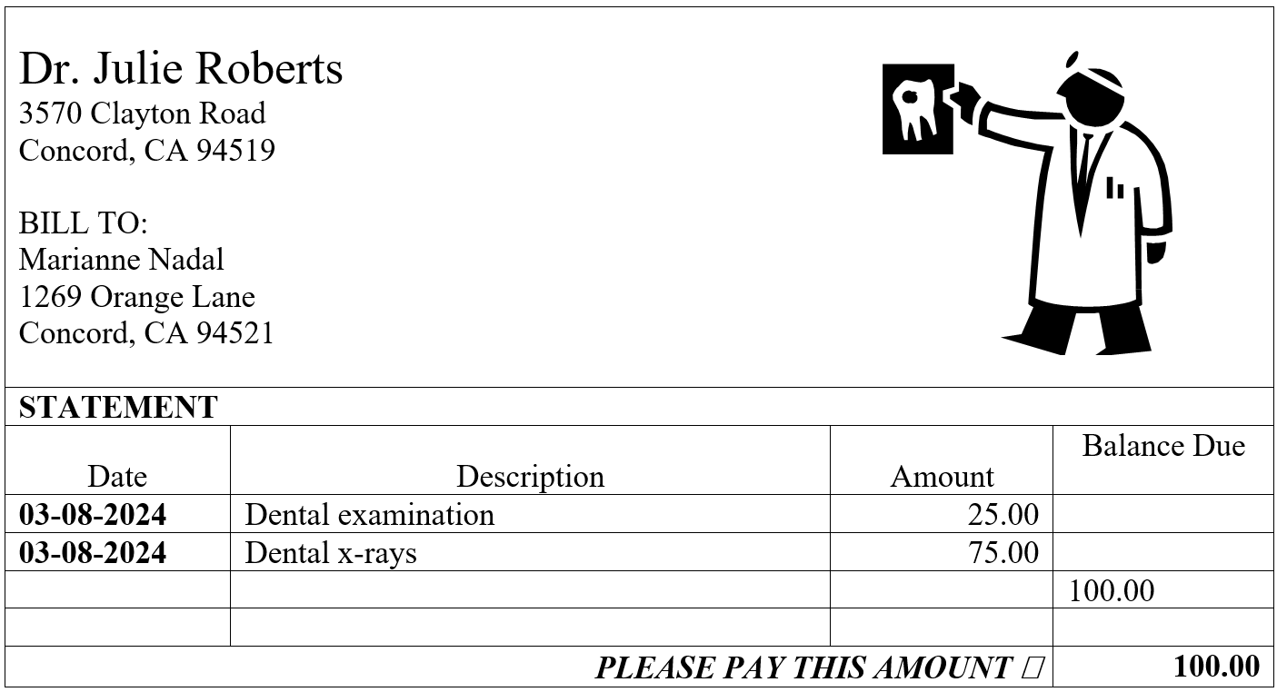
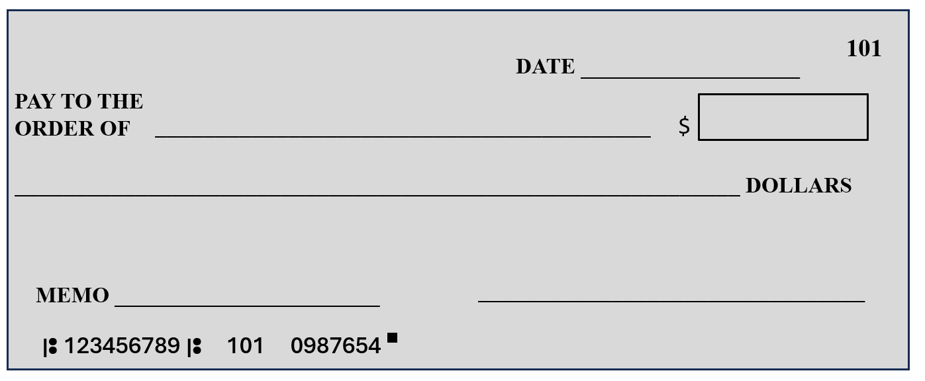

Practice 2 Answer Key (Task 2A)
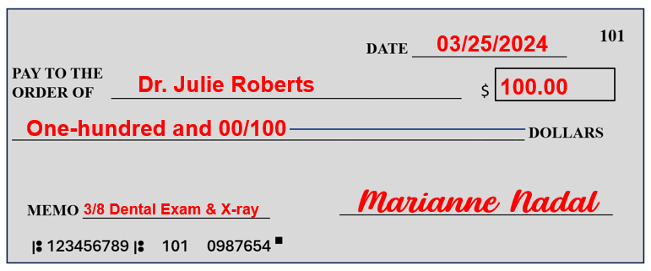
Notes:
- Write today’s date.
- Memo is optional.

Practice 3 (Task 2A)
Directions: Use the information in the bill to write a check.
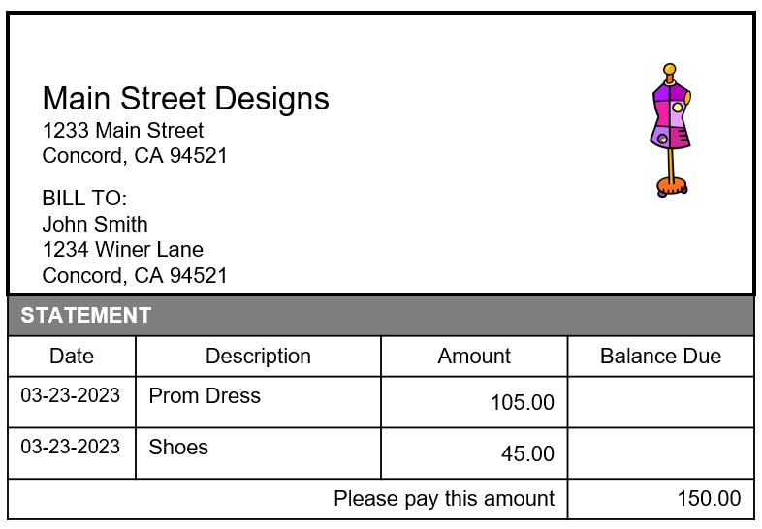

Practice 3 Answer Key (Task 2A)
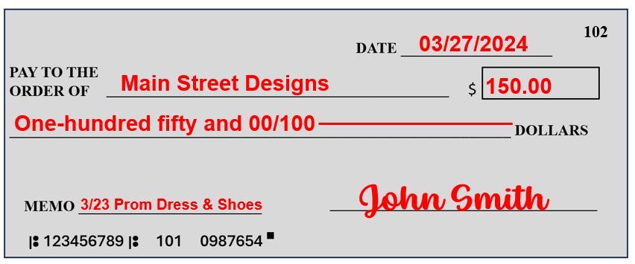
Notes:
- Write today’s date.
- Memo is optional.

Practice 4 (Task 2A)
Please write checks to pay for the bills.
- Write today’s date.
- Sign your name.
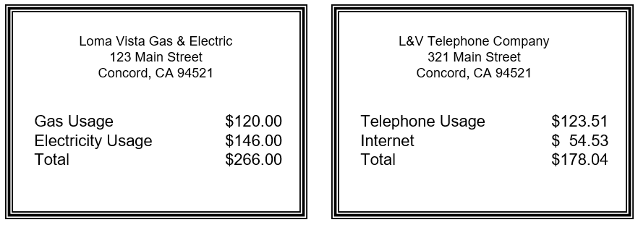
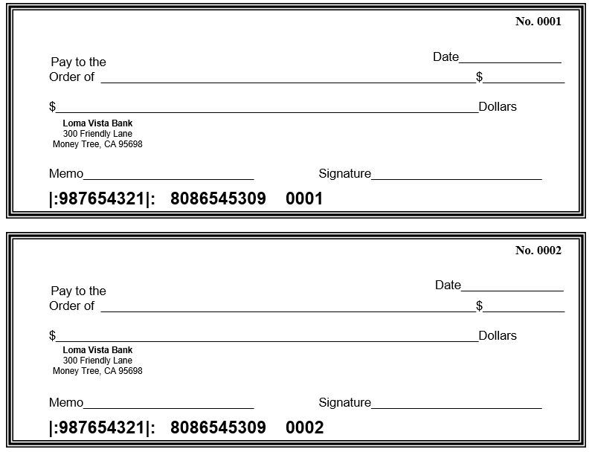

Practice 4 Answer Key (Task 2A)
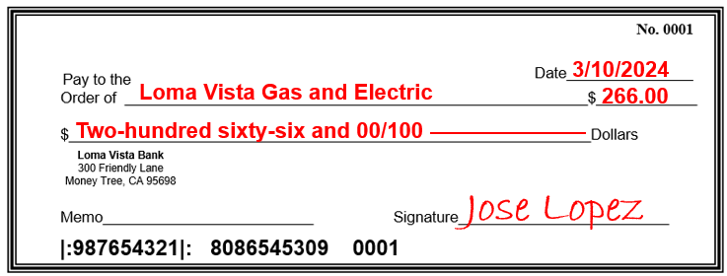
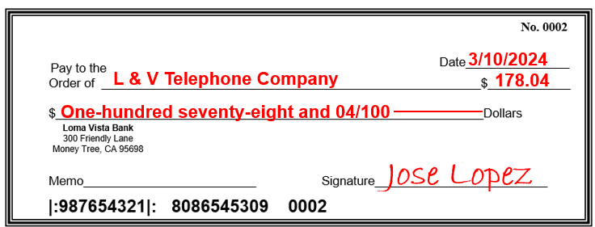
Notes:
- Write today’s date.
- Sign your name.

Introduction (Task 2B)
A Check Register helps you to know the total money in your account.
Deposit=money into bank account. Example: $0+$3,000=$3,000
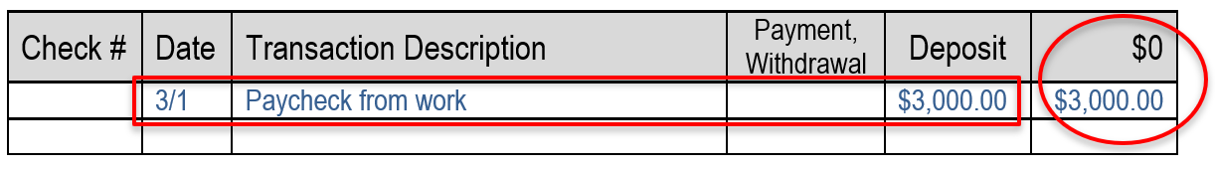
Payment=money out of bank account with a check.
Example: $3,000.00-$178.04=$2,821.96
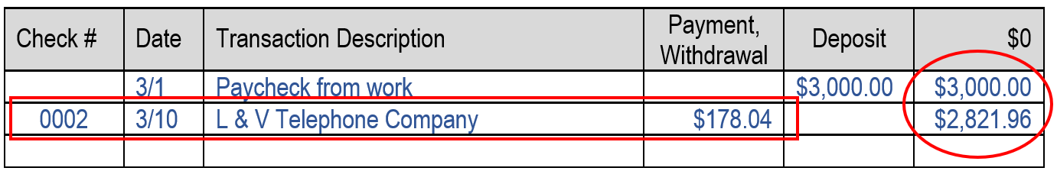
Withdrawal=money out of bank account from an ATM*.
Example: $2,821.96-$40.00=$2,781.96
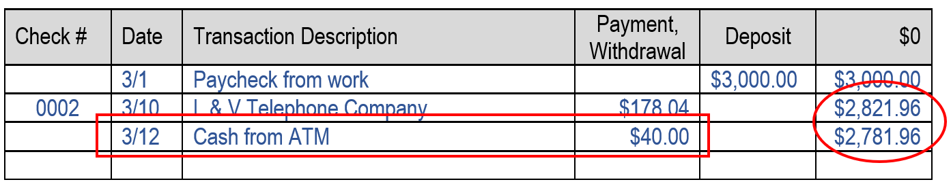
*ATM=Automated Teller Machine

Practice 1 (Task 2B)
Directions: Read the check and write the information on the check register.
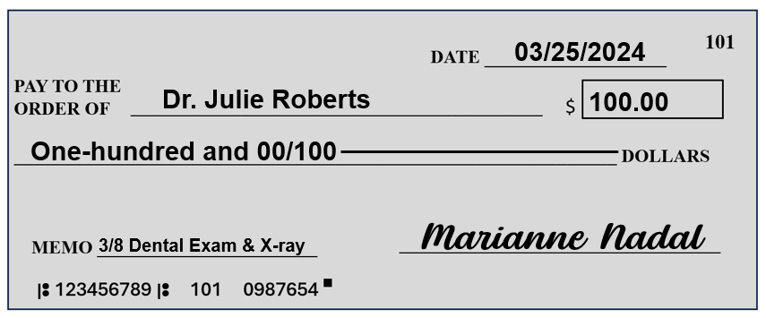
Check # | Date | Transaction Description | Payment, Withdrawal | Deposit | $0
 | 3/1 | Paycheck from work |  | $3,000.00 | $3,000.00
0002 | 3/10 | L & V Telephone Company | $178.04 |  | $2,821.96
 | 3/12 | Cash from ATM | $40.00 |  | $2,781.96

Practice 1 Answer Key (Task 2B)
Check # | Date | Transaction Description | Payment, Withdrawal | Deposit | $0
 | 3/1 | Paycheck from work |  | $3,000.00 | $3,000.00
0002 | 3/10 | L & V Telephone Company | $178.04 |  | $2,821.96
 | 3/12 | Cash from ATM | $40.00 |  | $2,781.96
101 | 3/25 | Dr. Julie Roberts (Dental Exam & X-ray) | $100.00 |  | $2,681.96

Practice 2 (Task 2B)
Directions: Read the check and write the information on the check register.
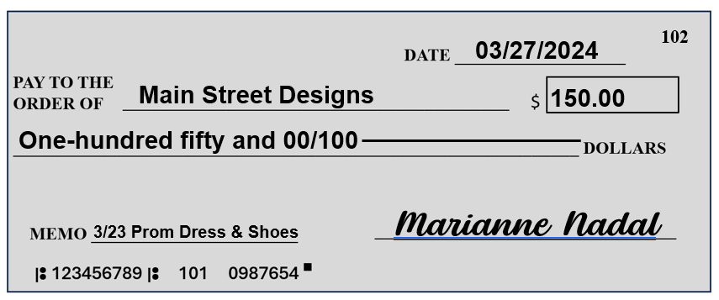
Check # | Date | Transaction Description | Payment, Withdrawal | Deposit | $0
 | 3/1 | Paycheck from work |  | $3,000.00 | $3,000.00
0002 | 3/10 | L & V Telephone Company | $178.04 |  | $2,821.96
 | 3/12 | Cash from ATM | $40.00 |  | $2,781.96
101 | 3/25 | Dr. Julie Roberts (Dental Exam & X-ray) | $100.00 |  | $2,681.96

Practice 2 Answer Key (Task 2B)
Check # | Date | Transaction Description | Payment, Withdrawal | Deposit | $0
 | 3/1 | Paycheck from work |  | $3,000.00 | $3,000.00
0002 | 3/10 | L & V Telephone Company | $178.04 |  | $2,821.96
 | 3/12 | Cash from ATM | $40.00 |  | $2,781.96
101 | 3/25 | Dr. Julie Roberts (Dental Exam & X-ray) | $100.00 |  | $2,681.96
102 | 3/27 | Main Street Designs (Prom Dress & Shoes) | $150.00 |  | $2,531.96

