EL Civics
COAAP #48.1 – Online Communication
Effectively use online tools to communicate and collaborate with others.

Student Activity Packet
Level: Beginning High

Name: _________________________

License: EL Civics Online Communication by SAC SCE and SCC SCE is licensed under Creative Commons

Permissions & Acknowledgments:
Zoom and Google Classroom images used for educational purposes with permission.
We would also like to thank Pixabay and Pixy.org for many of the images here.

To the Student:
EL Civics is a program that helps people who are new to the United States. You are going to study some EL Civics lessons. These lessons will help you connect learning English with your life, and the lessons will reflect your experiences as a community member, parent, and participant in the workforce. This student activity packet contains two tasks that you will learn about and practice:

- Task 1: Understand common uses of internet and conventions specific to online communication.
- Task 2: Identify parts of an email, and answer questions about it.

After you complete these lessons, you will take a test that will assess your understanding and application of the material.

The test date is: ______________________________.

Task 1: Understanding common uses of internet and online communication.
Assessment Task: (12 points possible) You will identify common ways the Internet is used for communication and learn abbreviations and features used in online communication.

Task 1 Handouts Provided
Handout 1: Vocabulary
Handout 2: Activity/Practice 1
Handout 3: Vocabulary
Handout 4: Discussion/Conversation Questions
Handout 5: Activity/Practice 2
Handout 6: Practice Evaluation

Task 1 – Handout 1

VOCABULARY: Internet Uses & Communication
Directions: Look at the pictures. Say the words out loud. Copy the words.
Image | Meaning | Copy
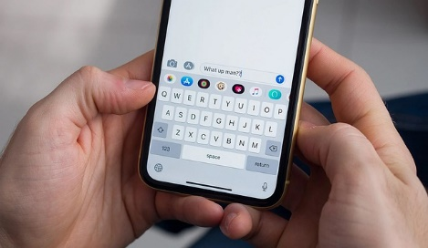 | text message
 | Zoom
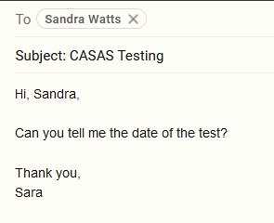 | email
 | social network

Task 1 – Handout 2

ACTIVITY/PRACTICE 1: Internet Uses & Communication
Directions: Write the letter of the definition next to the picture.
Vocabulary | Definition
- text message  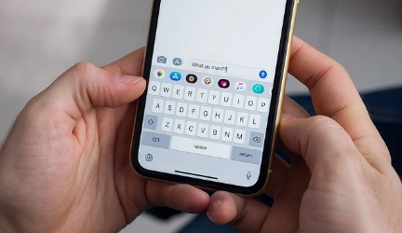 | - a website where people share information and photos
- Zoom | - message sent from one computer to another
- email | - a typed message from your phone to another phone
- social network | - video conference

Task 1 – Handout 3

VOCABULARY: Internet Uses & Communication
Abbreviation: a short way to say something (Thx = thanks)
Acronym: use the first letters only (BRB = Be Right Back)
Feature: a specific part of something (a casino is a feature of Las Vegas)

Directions: Look at the abbreviations, emoticons and features. Match them to the meaning.

Abbreviation, Acronym or Feature | Meaning
 | - before
- @ | - I don’t know
- LOL | - Zoom reactions
- OMG | - are
- b4 | - you
- u | - oh my goodness
- www.wikipedia.org | - laugh out loud
- IDK | - at
- r | - link (connect to a website)

Task 1 – Handout 4

DISCUSSION/CONVERSATION QUESTIONS: Internet Uses & Communication
Directions: Ask and answer the following questions with a partner
- Do you have a smartphone? What kind?
- Do you text? A lot?
- Who do you send text messages to?
- What is ?
- What are some text abbreviations in YOUR language?
- Do you video chat?
- Do you have email? What company (yahoo, gmail, aol)?
- Are you on Facebook? Are you on Instagram?
- Do you use the Internet? What for? (shopping, paying bills, learning English)

Task 1 – Handout 5

ACTIVITY/PRACTICE 2: Online Communication
Directions: Work with a partner. Ask “What is number 1?”, “What is number 2?”
After you practice all of them, then write the words on the lines.

- LOL

- @

- b4

- r

- u

Task 1 – Handout 5, cont.

- OMG

- www.wikipedia.org

- IDK

Task 1 – Handout 6

PRACTICE EVALUATION: Online Communication
A. Directions: write the words under the picture.

B. Directions: write the word or words next to the abbreviation or emoji.

- b4

- LOL

- @
- www.wikipedia.org
- r

- u
- OMG

Task 2: Interpret an online message

Assessment Task: (10 points possible)
Given an email, you will answer 5 questions about content, ideas, format, style, and tone.

Task 2 Handouts Provided
Handout 1: Vocabulary
Handout 2: Activity/Practice 1
Handout 3: Activity/Practice 2
Handout 4: Activity/Practice 3
Handout 5: Practice Evaluation

Task 2 – Handout 1

VOCABULARY: Internet Uses & Communication
Directions: Look at the pictures. Say the words out loud. Copy the words.
Word | Meaning | Image | Copy
- recipient | the person who  receives an email, letter or gift
- sender | the person who sends an email,  letter or gift
- subject | what the  email or letter is about | meeting  school  work
- contact information | how a person  can contact you, a phone number or email address
- tone | the feeling of the email (professional or personal?)

Task 2 – Handout 2

ACTIVITY/PRACTICE 1: Internet Uses & Communication
Directions: Look at the email. Discuss all the parts of the email with your teacher. Then answer the questions.
EMAIL
From: susieq@yahoo.com sender’s email
To: kgarcia@hotmail.com recipient’s email
Subject: Birthday Party subject
Hi Karen, recipient’s name

How are you? Our son’s birthday party is next week. Please let us know if you can come by Friday. See you soon!

Sincerely,
Susie Shaw sender’s name
(310) 555- 0010 contact information
tone: is it professional or personal?

Adapted with permission from LBSA, 2020

- What is the sender’s email address?
- What is the recipient’s email address?
- What is the subject?
- Who is the recipient?
- Who is the sender?
- What is the contact information?
- What is the tone?

Task 2 – Handout 3

ACTIVITY/PRACTICE 2: Internet Uses & Communication
Directions: Work with a partner. Student A, look at Email A and answer your partner’s questions. Student B, look at email B and answer your partner’s questions.

EMAIL A | EMAIL B
From: bertha@yahoo.com | From: bjames@aol.com
To: marco@gmail.com | To: lilysmith@att.com
Subject: Homework | Subject: Work hours
Dear Marco,  Can you tell me the homework for class tomorrow?  Sincerely,  Bertha  (714) 555-3008 | Dear Mr. James,  We need to talk about your work hours.  Can you come to my office tomorrow?  Sincerely,  Lily Smith  (714) 555-7623

Questions:
- What is the sender’s email address?
- What is the recipient’s email address?
- What is the subject?
- Who is the recipient?
- Who is the sender?
- What is the contact information?
- What is the tone?

Task 2 – Handout 4

ACTIVITY/PRACTICE 3: Internet Uses & Communication
Directions: Look at the email and label the parts. Then answer the questions.
EMAIL
From: marksmall@gmail.com
To: mayor@orange.gov
Subject: Trash on My Street
Dear Mr. Mayor,

We have a big problem in my neighborhood. My street has a lot of trash. Trash is ugly and makes my neighborhood look bad. Can you send someone to clean it up? Thank you for your help.

Best Regards,
Mark Small
(949) 555- 7070

Tone:

Adapted with permission from LBSA, 2020

- What is the sender’s email address?
- What is the recipient’s email address?
- What is the subject?
- Who is the recipient?
- Who is the sender?
- What is the contact information?
- What is the tone?

Task 2 – Handout 5

PRACTICE EVALUATION: Internet Uses & Communication
Directions: Look at the email and answer the questions.
EMAIL
From: tomhanks@gmail.com
To: ritaworth@aol.com
Subject: Movie Night
Dear Rita,

We are having a movie night at my house on Saturday. It starts at 7 p.m. Can you come? Please call and let me know.

Sincerely,
Tom
(714) 555-8443

- What is the sender’s email address?
- What is the recipient’s email address?
- What is the subject?
- Who is the recipient?
- Who is the sender?
- What is the contact information?
- What is the tone?

