COAAP # 73.2 – Workforce Training and Employment in Microcomputer Systems:

Computer Basics 1 Level: Beginning

Task 1: Respond to Instructions Related to Keyboarding  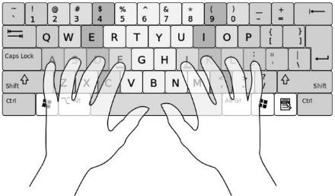 | Task 2: Identify Use of Common Office Software Applications

Task 1: The Keyboard

The Parts of a Keyboard
The computer keyboard is an important part of the computer system. There are many kinds of keyboards, but they all do two things. The keyboard is used to type and to send commands to the computer.
The keyboard has different parts. All keyboards have letters, numbers, and symbols for typing, and special keys for sending commands to the computer. We are going to learn about two of the parts of the keyboard: the letters we use for typing, and the modifier keys we use for special things.
These are the two parts of the keyboard we will study:
Alphanumeric - The alphanumeric part is the main part of the keyboard and has letters (alphabet) and numbers (numeric)
Modifier keys - The modifier keys are around the sides and bottom of the alphanumeric part
This picture shows the alphabet keys and the two modifier keys we will study. It also shows the space bar, used to add a space between words when we type.
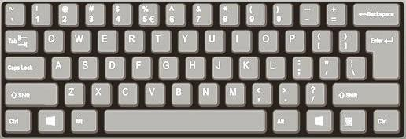
The ALPHABET keys (three rows)
MODIFIER keys (two keys)
MODIFIER keys (two keys)
The SPACE BAR

There are two modifier keys we will study. They are the Shift key and the Control (CTRL) key. These keys, if they are held down and another key is tapped, will change (modify) what other the keys do.

Vocabulary: Keyboard
keyboard the part of the computer that you use for typing and sending commands to the computer
alphanumeric the part of the keyboard used to type letters, numbers, and symbols
space bar the long key at the bottom of the keyboard used to type a space between letters
modifier keys special keys that change what other keys do
shift a modifier key used to type a capital letter
control a modifier key used to send commands to the computer

Vocabulary Practice: Keyboard
Directions: Fill in the blanks with the vocabulary words from the word bank below.

Word Bank

alphanumeric
keyboard
shift
control
modifier keys
space bar

- The _ change what other keys do.

- The is used for typing a space between letters.

- The part of the keyboard has letters and numbers.

- The is used for typing and sending commands to the computer.

- The key is used to type capital letters.

- The computer.
key is used to send commands to the

Modifier Keys
Some keys on the keyboard do not do anything by themselves. They only work when they are used with other keys. These keys are the MODIFIER keys. The word modify means change. Modifier keys change what other keys do. When these keys are held down and another key is pressed, it changes what the other key does.
There are two modifier keys that you need to remember: SHIFT and CTRL.

Control

The Control key (Ctrl) will send a command to the computer. Example:
If you tap on the p key you will type the letter “p”. Holding down the Control key and then tapping the p key will send the Print command to the computer.
The Control key is another modifier key and works the same way as the Shift key.
CORRECT: The correct way to use the Control key to send a command to the computer is to hold it down, tap the letter you want, then release the Control key.
INCORRECT: You should not press the Control key and let it go before tapping the letter. You will type a letter and not send a command to the computer.
INCORRECT: You should not try to tap the Control key and the letter key at the same time. You might send a command to the computer, but you might not.

Shift

The Shift key will let you type a capital letter. Example:
If you tap on the t key you will type the letter “t” – a lower case t (a small t).
If you hold down the Shift key and then tap the t key you will type the letter “T” – an upper case T (capital T).
CORRECT: The correct way to use the Shift key for a capital letter is to hold it down, tap the letter you want, then release the Shift key.
INCORRECT: You should not press the Shift key and let it go before tapping the letter. You will not get a capital letter.
INCORRECT: You should not try to tap the Shift key and the letter key at the same time. You might get a capital letter, but you might not.
INCORRECT: You should not use the Caps Lock key to type a capital letter.
REMEMBER: Hold down the Shift key, tap the letter you want, then release the Shift key.
All keyboards have two Shift keys, one on the right and one on the left. You should use the Shift key that is on the opposite side of the keyboard from the letter you want.
This picture shows typing a capital S: the right hand holds the Shift key down while the left hand taps the s key.
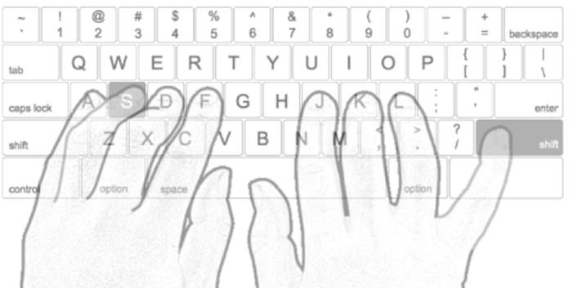

Modifier Keys Practice 1
Directions: On the picture below, follow these steps to practice using the Shift key to type a capital G the right way.
- Begin by holding down the right Shift key with your right pinkie finger.
- While holding it down, tap the G key with your left index finger.
- Release the Shift key.
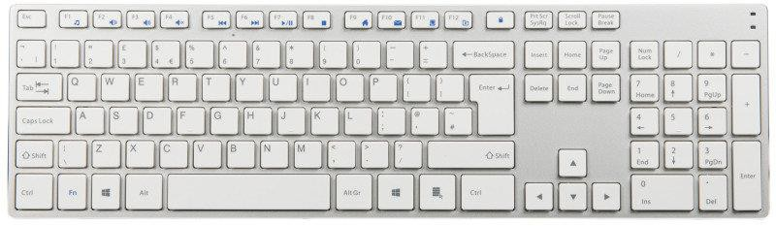

Modifier Keys Practice 2
Directions: On the picture below, follow these steps to practice using the Shift key to type a capital B the right way.
- Begin by holding down the left Shift key with your left pinkie finger.
- While holding it down, tap the B key with your right index finger.
- Release the Shift key.

Modifier Keys Practice 3
- Practice with a partner using this keyboard. Have your partner watch and tell you if you are using the Shift keys correctly.

Modifier Keys Practice 4
Directions: On the picture below, follow these steps to practice using the Shift key to type a capital T the right way.
- Begin by holding down the right Shift key with your right pinkie finger.
- While holding it down, tap the T key with your left index finger.
- Release the Shift key.

The Home Row
We use the keyboard mostly for typing. To type on the keyboard, you need to make sure your fingers are in the right place. When they are not typing a letter, each finger should be gently resting on a key in the HOME ROW. The home row is where the fingers return after each letter is typed.
The keys a s d f and j k l ; are the home row keys. The home row can always be found without looking by feeling the keys. The f key and the j key have a small bump on the key. This bump is where your index finger goes. The rest of the fingers go on the keys next to these.
This picture shows the home row.

Home Row Practice 1
On the picture above, place your fingers on the home row. Then remove your hands from the keyboard.
Repeat the above steps several times.

Home Row Practice 2
With a classmate, practice placing your fingers on the home row in the picture above. Have your classmate make sure you are doing it right.
Repeat several times.

Special Keys
The keyboard has many keys that are not letters or numbers. We already studied the modifier keys, Shift and Control. Here are the special keys we will study.
Enter Enter is used in forms to submit the form
Enter is used in a dialog box to confirm a choice such as OK or Save
Enter is used in text areas to make a new paragraph
Tab Tab is used in forms to move from one place (field) to another Tab is used in text areas to indent or move text to the right
Backspace Backspace is used to erase text you have typed – it erases backward
Delete (Del) Delete is used to erase text you have typed – it erases forward

Vocabulary: Special Keys
Home row the row of keys where your fingers rest when they are not typing
Space bar the long key at the bottom of the keyboard that puts a space between words
Enter key the key on the right side of the keyboard that enters information, confirms a dialog box, or creates a new paragraph
Tab key the key on the left side of the keyboard that moves the cursor from one place to another or moves text to the right
Modifier keys the keys on the keyboard that change what other keys do: the Shift and Control keys are modifier keys
Shift key the Shift key is used to type a capital letter Backspace key the key used to erase letters to the left Delete key the key used to erase letters to the right

Vocabulary Practice: Special Keys
Directions: Fill in the blanks with the vocabulary words from the word bank below.

Word Bank

Backspace key | Enter key | Modifier keys | Space bar
Delete key | Home row | Shift key | Tab key

- The are used to modify what other keys do.

- The is used to put a space between words.

- The is used to type a capital letter.

- The is used to erase letters to the left of the cursor.

- The is the place where your fingers rest when you are not typing.

- The is used to erase letters to the right of the cursor.

- The paragraph.
enters information or makes a new

- The moves the cursor from one field to another or moves text to the right.

Special Keys Practice 1
Directions: On the picture below, circle these keys: Enter, Backspace. Or show these keys on an actual computer keyboard.

Special Keys Practice 2
Directions: On the picture below, circle these keys: Tab, Space bar. Or show these keys on an actual computer keyboard.

Special Keys Practice 3
Directions: On the picture below, circle these modifier keys: Shift, Control. (You should draw four circles.) Or show these keys on an actual computer keyboard.

Home Row Practice
Directions: On the picture below, circle the home row. (You should draw two circles.) Or show these keys on an actual computer keyboard.

Letter Keys Practice
Directions: On the picture below, circle these keys: b, g, t. Or show these keys on an actual computer keyboard.

Task 1 Review
Directions: Using the keyboard on the back page of this booklet, answer these questions.

Can you do this? | YES NO
Point to the SHIFT key
Point to the ENTER key
Point to the SPACE BAR
Point to the BACKSPACE key
Point to the TAB key
Place your fingers on the HOME ROW

Directions: Repeat the practices on pages 13-15 until you can answer YES to all the questions.

Task 2: Office Apps

Microsoft Office
The Microsoft Office Suite is a group of apps used by companies, home users, and students. There are many apps that are part of Office The four main apps that are used most are: Word, Excel, Outlook, and PowerPoint. We will only study these four apps. You need to learn what each app does, and how to identify it.

What are the Office Apps?

Word

Microsoft Word is a word processor. It is an app that is made to let you work with words. A file you create in Word is called a document. You can type many kinds of documents, but we will only study about letters

Excel

Microsoft Excel is a spreadsheet app. A spreadsheet is a grid of rows and columns. The rows and columns form cells. There are many uses of a spreadsheet, but we will only study about numbers and lists.

Outlook

Microsoft Outlook is an app for email. Outlook can do many other tasks, including calendars and contacts, but we will only study email. Outlook lets you easily send and receive emails.

PowerPoint

Microsoft PowerPoint is a presentation app. With PowerPoint, you create and present a series of “slides” to share information in a “slideshow”.

Vocabulary: Office Apps
app (application) a program in the computer that is made to do a specific task
Word an app for writing letters, memos, notes, reports, etc.
Excel an app for working with numbers, calculations, budgets, lists, charts, etc.
PowerPoint an app for making or giving a presentation
Outlook an app for sending and receiving email; includes a calendar and contact list
Microsoft Office Suite a group of apps made by Microsoft that includes Word, Excel, PowerPoint, and Outlook
document a letter or other file created in Microsoft Word
spreadsheet a file created in Microsoft Excel presentation a file created in Microsoft PowerPoint email electronic mail
suite a group of apps that work together and are sold together
icon a small picture that represents something

Vocabulary Practice: Office Apps
Directions: Fill in the blanks with the vocabulary words from the word bank below.

Word Bank

app | email | presentation | Word
document | Outlook | spreadsheet
Excel | PowerPoint | suite

- is an app used to write letters.

- A is a group of apps sold together.

- is an app for working with numbers and lists.

- A is a PowerPoint file.

- An is a program made to do a specific task.

- A is a Word file.

- is an app used to give a presentation.

- is an app for sending email.

- is electronic mail.

- A is an Excel file.

Identifying Office Apps
It is important to be able to identify the app you need. Each app has a unique icon (picture) that represents it. The list of icons below will help you learn to identify the Office apps

Word: The icon used for Word is dark blue and has a big Won it. It also has a page with lines that look like a letter or report.

Excel: 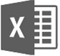 The icon used for Excel is green and has a big X on it. It also has a page with little boxes that look like a chart or table.

Outlook: The icon used for Outlook is light blue and has a big O on it. It also has an envelope that looks like one you use to mail a letter.

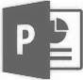
PowerPoint: The icon used for PowerPoint is brown and has a big P on it. It also has a page with a graphic and a few lines of text that represent a presentation.

Practice: Identifying Office Apps 1
Directions: Practice identifying the Microsoft Office app icon. Using the picture on page 19, identify the app icons here and write the app names below the icons.

1. 2.

_______________________________ __________________________

3.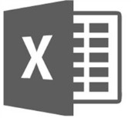 4.

________________________________________ __________________________________

Practice: Identifying Office Apps 2
Directions: Practice identifying the Microsoft Office app icon. Using the app names in the Word Bank, write the name under the icon. Note: you will not use all the names.

Word Bank:
Adobe Reader
Microsoft PowerPoint
Microsoft Excel
Microsoft WordPad
Microsoft Outlook
Microsoft Paint
Microsoft Edge

1. 2.

___________________________ _________________________

3. 4.

_____________________________________ _________________________________

Task 1

Study Guide

Review and study page 15 to prepare for your assessment.

Task 2
Review and study page 21 to prepare for your assessment.

Additional Information about Using the Keyboard
NOTE: This information (pages 21-22) is not necessary for the EL Civics assessment. It is included here only for students who wish to know more about using their keyboard correctly.

Proper Typing

Using the keyboard the right way will help you get better at typing. There are two rules you should follow to improve your typing skills.
Rule 1: NEVER look at the keyboard as you are typing. It is ok to look at the screen, or at something you are copying, but you should never look at the keyboard. This is very hard to do when you are first learning, but you will improve very quickly if you follow the rule.
Rule 2: ALWAYS use the correct fingers to type each letter. This is also very hard when you are first learning, but with practice it will become easier and you will type faster.

Fingering

Each finger should tap the keys that are close to it. You should not have to make your fingers move a lot to type correctly. The keys assigned to each finger can be seen on this fingering chart.

This fingering chart shows which letters should be typed by which fingers.
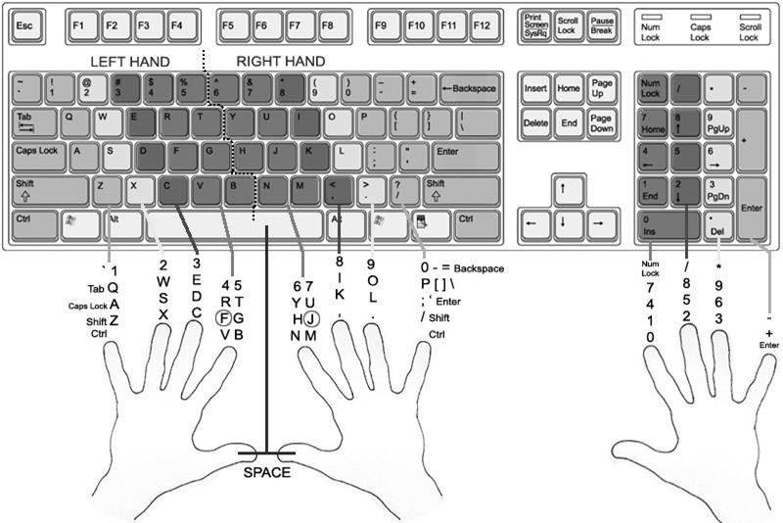

Use this keyboard picture (or an actual computer keyboard) to identify the parts and keys of the keyboard.
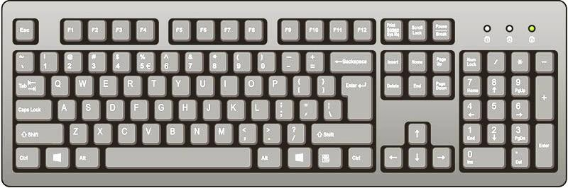

Use this picture of the keyboard (or an actual computer keyboard) to practice or demonstrate typing.

