EL Civics Objective #73.2 – Workforce training and employment in microcomputer systems:

Computer Basics 1

Levels: Intermediate - Advanced
Task 2: Identify and Demonstrate Use of Common Office Software Applications | Task 3: Write an Email to a Prospective Employer

Task 2: Office Apps

Microsoft Office
The Microsoft Office Suite is a group of apps that are commonly used by companies, users at home, and students. There are many apps that are part of Office, and many different combinations of how they can be purchased. There are three main apps that are usually included. They are Word, Excel, and PowerPoint. Some of the other apps that can be included in Office are PowerPoint, Outlook, Publisher, Edge, Access, and OneNote.
In this unit, we will only look at four of the Office apps: Word, Excel, PowerPoint, and Outlook. You need to learn what each app does, and how to identify it.

What are the Office Apps?

Word

Microsoft Word is a word processor. It is an app that is made to let you work with words. A file you create in Word is called a document. You can type lots of different kinds of documents: letters, memos, reports, books, scripts, press releases, advertisements, flyers, and many more. After typing a document in Word, you can format it in many ways to change how it looks. Word also lets you add pictures and other graphics to your document.

Excel

Microsoft Excel is a spreadsheet app. A spreadsheet is a grid of rows and columns. The intersection of a row and column is called a cell. The main use of a spreadsheet is to enter numbers and do calculations. There are several common uses of Excel. Some of them are: to make a budget, to keep financial information like loans or investments, to record sales or purchases.

Outlook

Microsoft Outlook is an app for email, as well as many other tasks. The app lets you easily send emails to others and see the emails that others have sent to you. Outlook also lets you keep a contact list of names, addresses, and phone numbers of people who are important to you. There is also a calendar for appointments and reminders. Outlook is very popular, and is used by many companies and organizations.

PowerPoint

Microsoft PowerPoint is a presentation app. Following the concept of a slide show, you create a series of slides with information you want to share with someone. The app makes it very easy to add colorful graphics and automated transitions. Giving a presentation using PowerPoint is very easy and looks great.

VOCABULARY: Office Apps
- app (application) a program in the computer that is made to do a specific task
- program also called an application or app; instructions for the computer to perform a task
- Word an app for writing letters, memos, notes, reports, etc.
- Excel an app for working with numbers, calculations, budgets, lists, charts, etc.
- PowerPoint an app for making or giving a presentation
- Outlook an app for sending and receiving email; includes a calendar and contact list
- Microsoft Office Suite a group of apps that are made to work together; the apps include Word, Excel, PowerPoint, Outlook, and others
- document a letter or other file created in Microsoft Word
- spreadsheet a file created in Microsoft Excel
- presentation a file created in Microsoft PowerPoint
- email electronic mail
- suite a group of apps that work together and are sold together
- icon a small picture that represents something

Vocabulary Practice: Office Apps
Directions: Fill in the blanks with the vocabulary words from the word bank below.

Word Bank
app | email | presentation | suite
document  Excel | Outlook  PowerPoint | program  spreadsheet | Word

- is an app used to write letters.

- A is a group of apps sold together.

- is an app for working with numbers and lists.

- A is a PowerPoint file.

- An is a program made to do a specific task.

- A is a Word file.

- is an app used to give a presentation.

- is an app for sending email.

- is electronic mail.

- A is an Excel file.

Part 1: Identifying Office Apps
It is important to be able to identify the app you need. Each app has a unique icon that represents it. The list of icons below will help you learn to identify the Office apps

Word: The icon used for Word is dark blue and has a big W on it. It also has a page with lines that look like a letter or report.

Excel: The icon used for Excel is green and has a big X on it. It also has a page with little boxes that look like a chart or table.

Outlook: The icon used for Outlook is light blue and has a big O on it. It also has an envelope that looks like one you use to mail a letter.

PowerPoint: The icon used for PowerPoint is brown and has a big P on it. It also has a page with a graphic and a few lines of text that represent a presentation.

Practice: Identifying Office Apps 1
Directions: Practice identifying the Microsoft Office app icon. Using the information on page 6, identify the app icons here and write the app names below the icons.

Practice: Identifying Office Apps 2
Directions: Practice identifying the Microsoft Office app icon. Using the app names in the Word Bank, write the name under the icon. Note: you will not use all the names.

Word Bank:

Adobe Reader | Microsoft Outlook | Microsoft WordPad
Microsoft Edge | Microsoft Paint | Microsoft Word
Microsoft Excel | Microsoft PowerPoint

Part 2: Explaining Office Apps
Each app in the Office Suite is used for a different purpose as explained above. For example, you would use Word to write a letter, not Excel, and you would use Outlook to send an email, not PowerPoint, etc.
You need to be able to explain what each Office app is used for.

Practice: Explaining Office Apps 1
Directions: Practice explaining what each Microsoft Office app is used for. On each line, use the names of the apps in the Word Bank to write the name of the app you would user for these tasks.

Word Bank:

Microsoft Excel Microsoft Power Point

Microsoft Outlook Microsoft Word

- Reading an email

- Working with numbers and calculations

- Sending an email

- Writing a letter

- Making a list

- Making a presentation

- Writing a report

- Giving a presentation

Practice: Explaining Office Apps 2
Directions: Practice explaining what each Microsoft Office app is used for. On each line write one or more key words to explain why you would use each app. Note: you will not use all the words in the keyword bank.

Keyword Bank:

browsing the Internet | editing photos | presentations
calculations | email | reading a book
contacts | letters | reports
drawing a picture | numbers | slide shows

- Microsoft Excel

- Microsoft Outlook

- Microsoft PowerPoint

- Microsoft Word

Part 3: Give an Example of Using Office Apps
When you are familiar with the Office apps and which one you use for different tasks, you will be able to recognize what app was used to create a document.
When you see a text document, you know it was made with Microsoft Word. When you see an email, you know Outlook would be the app used. When you see a presentation, you know you are seeing something from PowerPoint. When you see a spreadsheet, you know Excel was used.
Here are some examples of various documents created in the Office apps.

Word Documents:

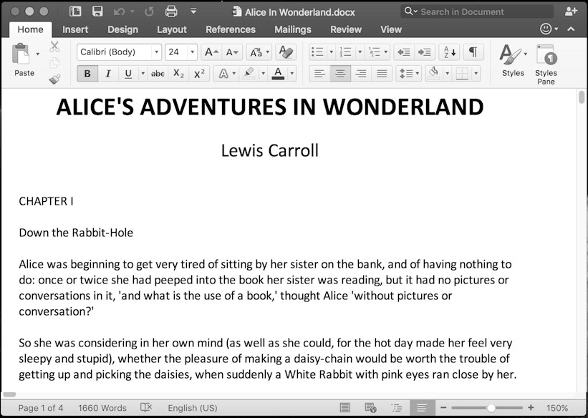

a book

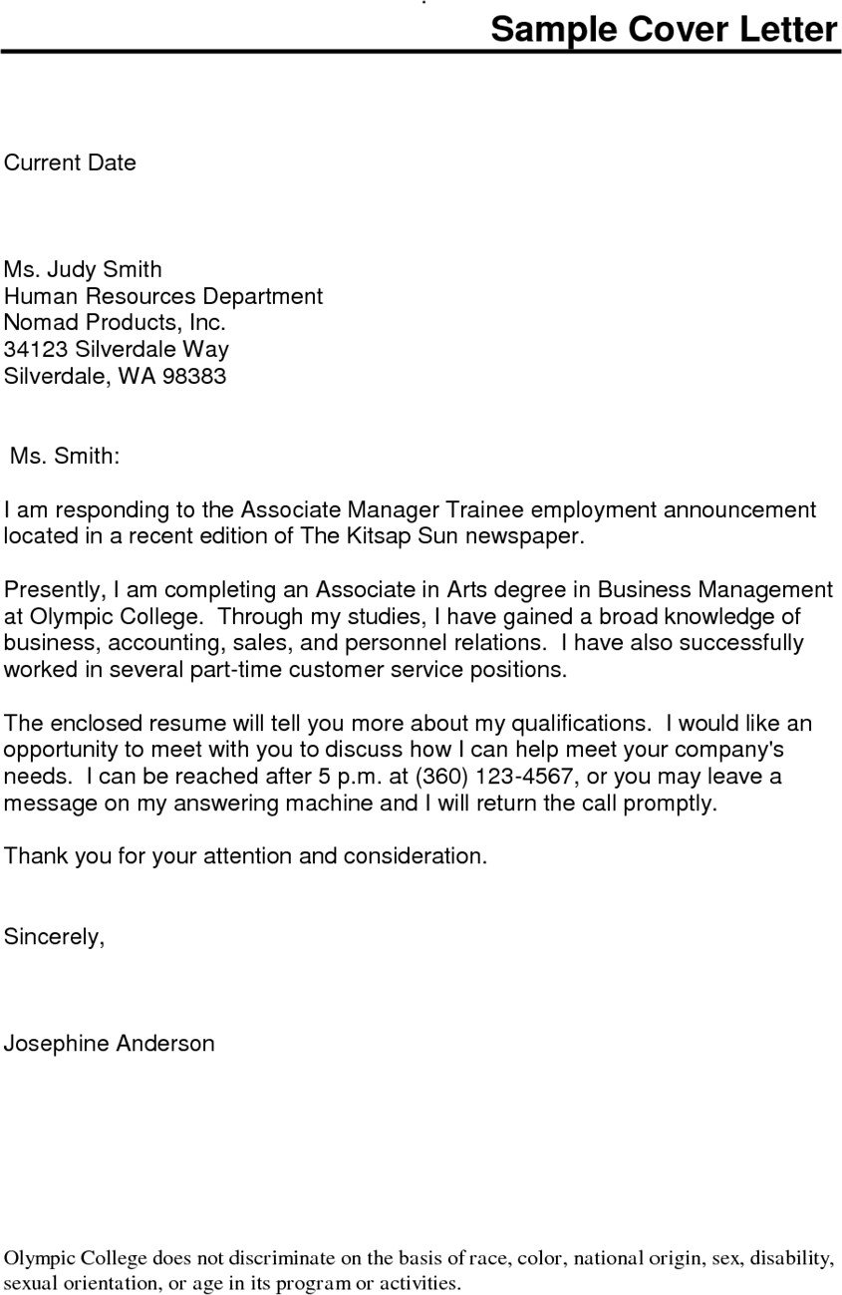

a letter

Excel Spreadsheets:
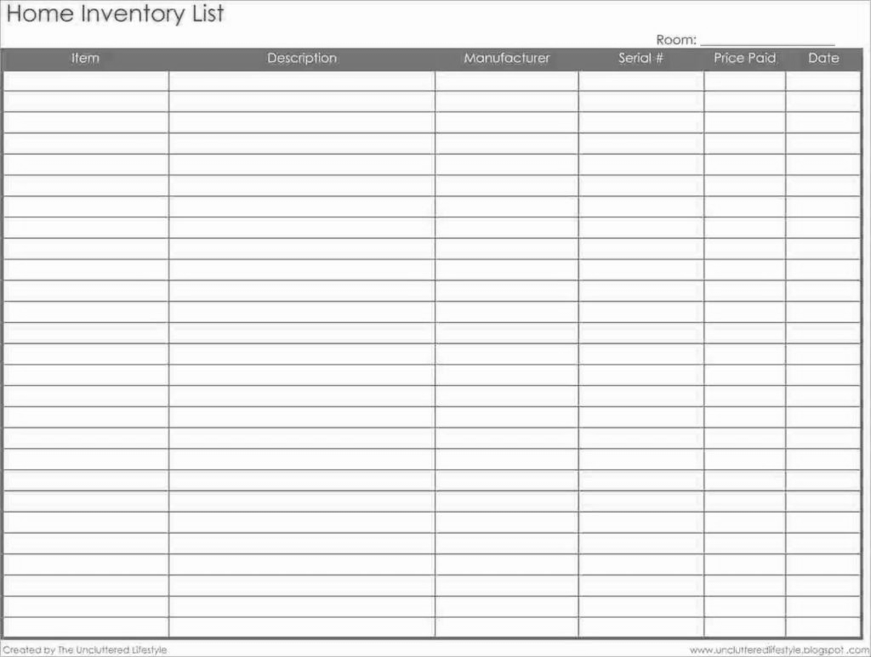

a list

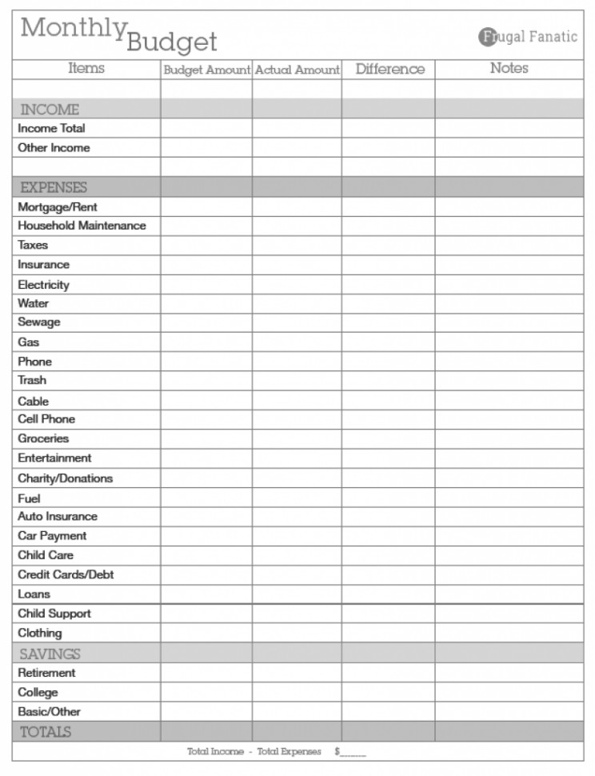

A budget

Outlook Emails

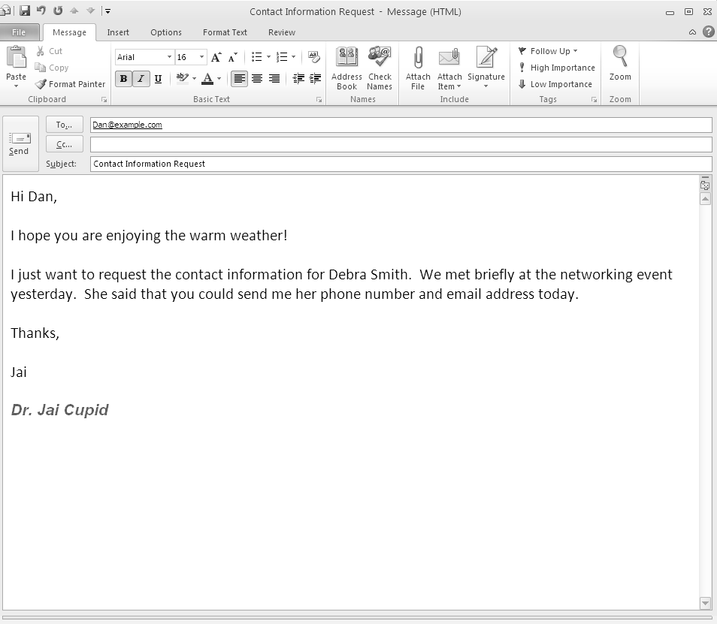

An email
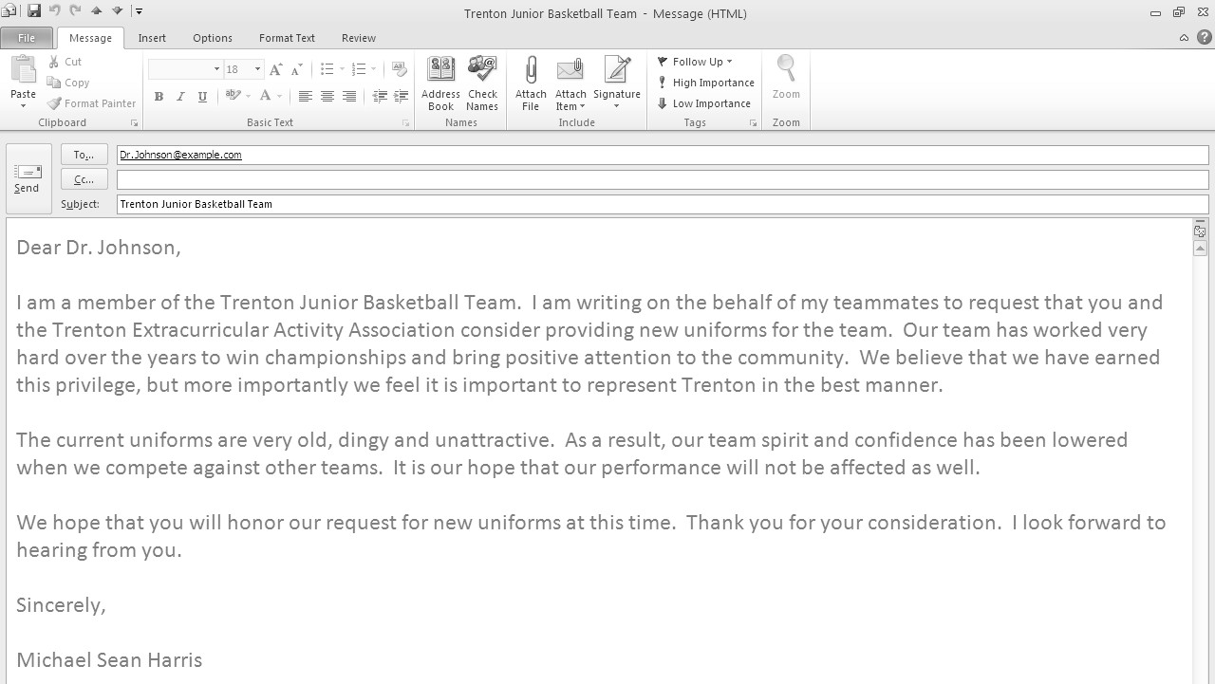

another email

PowerPoint Presentations:

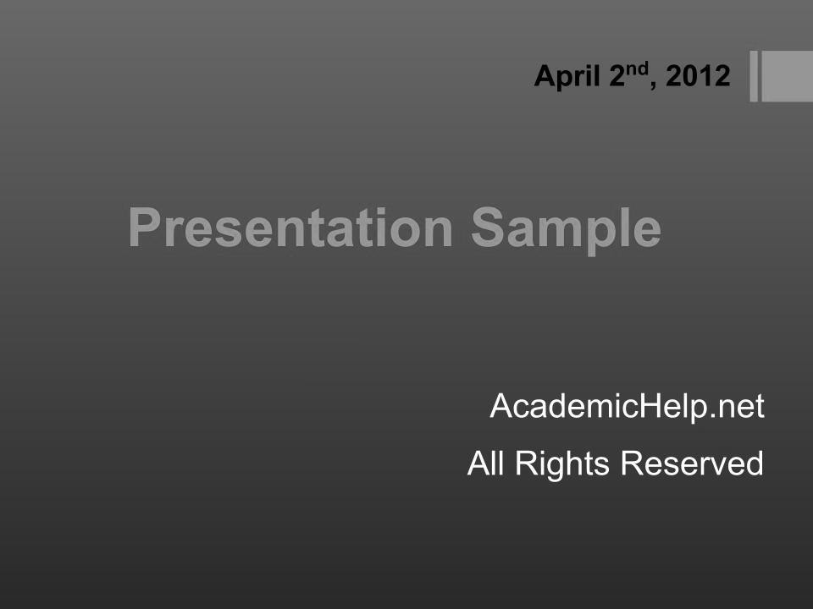

a presentation
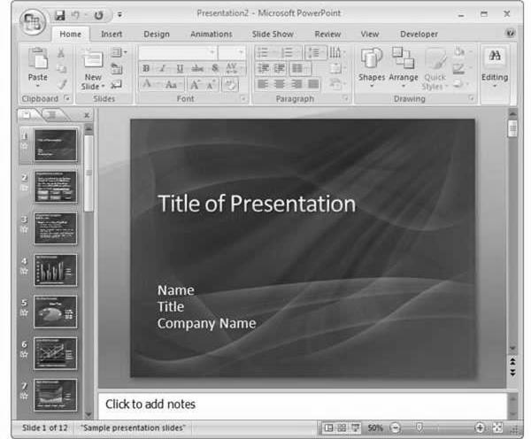

another presentation

Practice: Give an Example of Using an Office App 1
Directions: Give an example of how the Office apps are used. Below each picture, write the name of the app used to create what you see.
Note: not all the app names in the word bank are Office apps. You will use some app names more than one time.

Word Bank:

Adobe Reader | Microsoft Excel | Microsoft Word
Adobe Photoshop | Microsoft Outlook | Microsoft WordPad
Microsoft Edge | Microsoft Paint

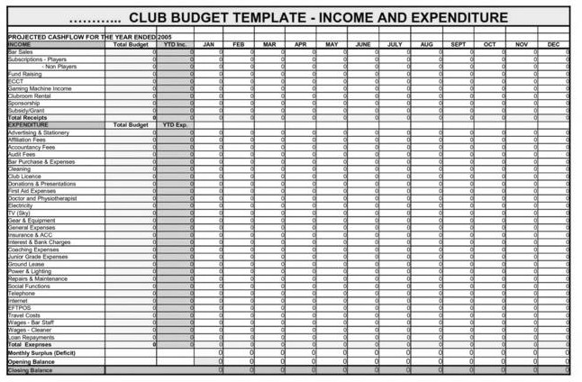  1. | 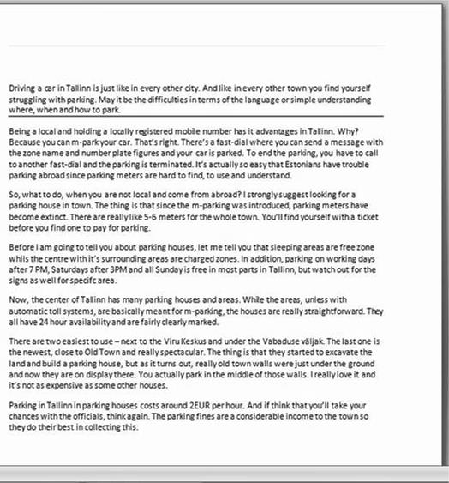  2.

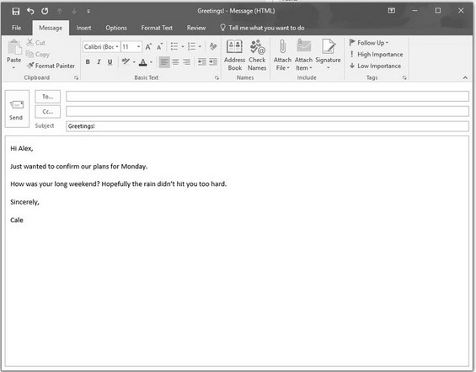  3. | 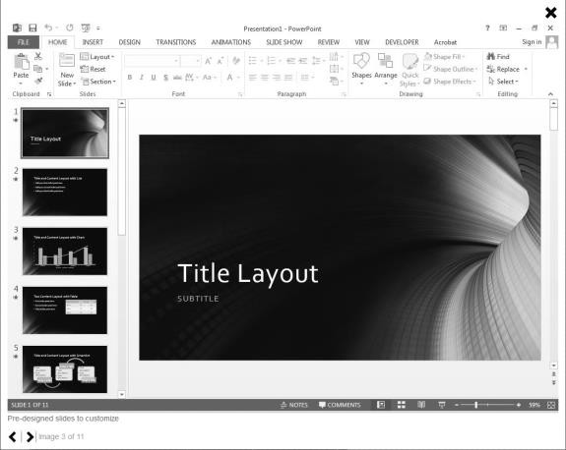  4.
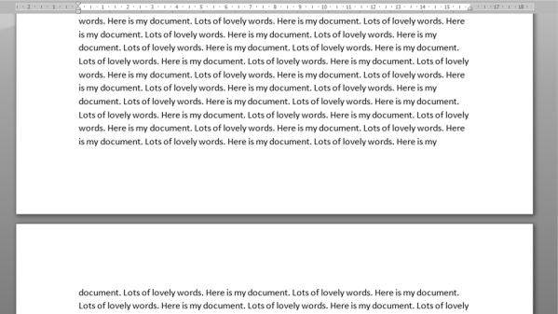  5. | 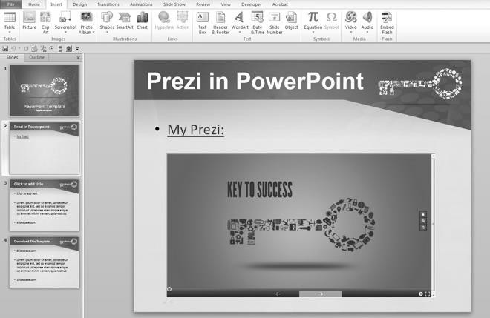  6.

Practice: Give an Example of Using an Office App 2
Directions: Give an example of how the Office apps are used. Below each picture, write the name of the app used to create what you see. Note: not all the app names in the word bank are Office apps.

Word Bank:

Microsoft Edge | Microsoft Paint | Microsoft Word
Microsoft Excel | Adobe Photoshop | Microsoft WordPad
Microsoft Outlook | Adobe Reader

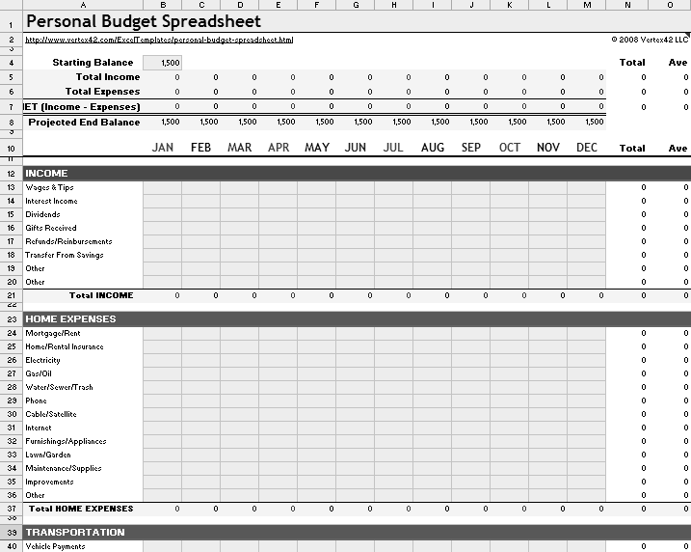 | 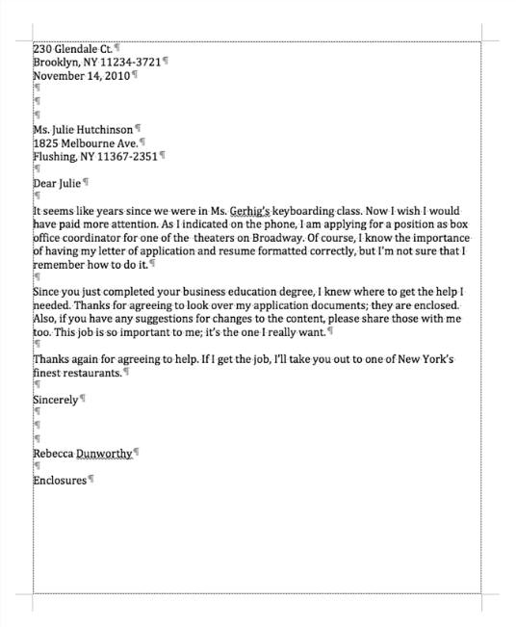

3. | 4.

Using Office Apps: Writing a Letter

The Parts of a Letter

There are many styles of letters. If you need to write a letter, you would need to decide what style of letter to write. There is a proper way to write each style, and you should always follow the correct format.
Below is a sample letter from an employee to his boss. Notice the format of the letter. It has six parts:
The DATE the date the letter was written
A GREETING a formal or polite way to address the person IDENTIFICATION saying who is writing the letter
The BODY the message the sender wants to tell the person A CLOSING a formal or polite way to end the letter
A SIGNATURE the name or signature of the person sending the letter

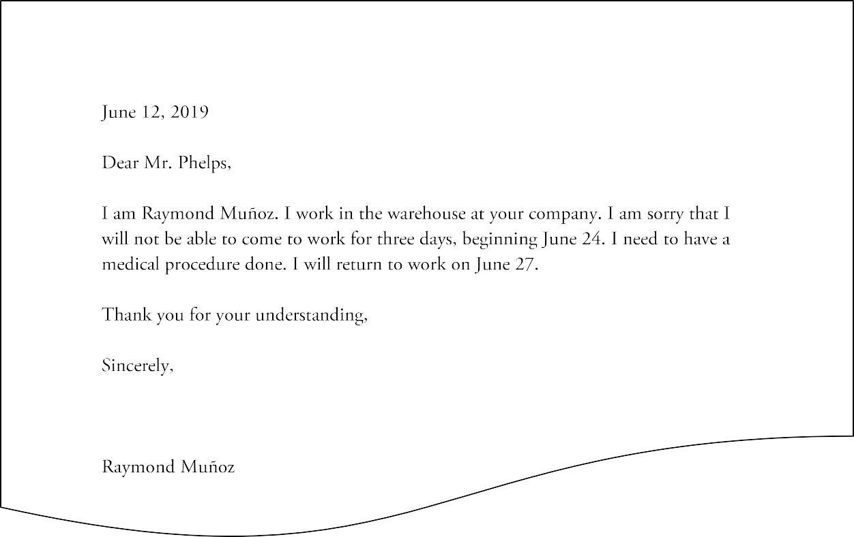

Identifying the Parts of a Letter

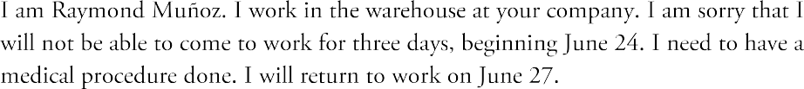The parts of the letter are identified here.
Date
Greeting
Identification
Body
Closing
Signature

Practice: Identifying the Parts of a Letter
Directions: On the picture below, identify each part of the letter. Write the name of the part and draw an arrow to the part.
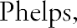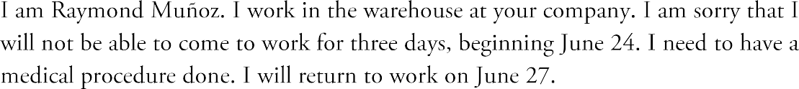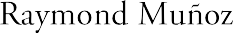

Writing a Letter

You will need to write a letter. When you write the letter, you will be given the scenario – the context for your letter. You will also be given a format to follow. You need to include all six of the parts we have just learned about.

Practice: Writing a Letter 1
Scenario: You are a student in an ESL class and you will be absent from school for one day because you have an appointment with the doctor.
Directions: Write a letter (note) to your teacher to tell him/her about missing school by filling in the blanks in this letter with your own information.
Date

Dear ,

This is . I am a student in your class. I am sorry that I won’t be able to attend class tomorrow. I have a doctor appointment.
Thank you. Sincerely,

Practice: Writing a Letter 2
Directions: Using the letter you just filled in on page 24, identify and label the six parts of the letter.

Writing a Letter Using Word

You will copy the letter you just wrote using Microsoft Word. If you are not familiar with Word, it’s ok. This lesson is not going to teach you Word, and you will not be assessed on how well you know Word. This lesson and the assessment are only about writing the letter.
However, here are a few tips for using Word that will be helpful.
- Tap the Enter key when you have finished a paragraph or a short line. Example: after you type the date, tap Enter to get a new paragraph before typing the greeting.
- Tap the Enter key twice to get a new paragraph with some extra space above it. Example: after you type the greeting, tap Enter key twice before typing the body of your letter.

Practice: Writing a Letter 3
Directions: Follow these steps to copy your letter using Microsoft Word. You need to follow the same format and include all six items. When you finish, show it to your teacher to see if everything is ok.
Begin by getting a computer and turning it on.
- Open Microsoft Word – if you see the icon for Word in the Taskbar at the bottom of the screen, click it once. If it is not there, click the Start button and type a W. Scroll if necessary, then click on Word in the apps list.
- Open a blank document.
- Type your letter from page 24.
- Be sure to begin each sentence and proper noun with a capital letter and use correct punctuation.

Email
Task 3: Email

Email is electronic mail. It is a way to send and receive messages over the Internet, instead of using the Post Office. Email is a type of letter and should follow a similar format. All six parts that are in a letter are in an email, but they are not all in the same places.
In an email, the date is automatically entered by the computer, so you don’t need to type it in. Also, the name of the sender is entered by the computer, so you MIGHT not need to put in identifying information. However, in some cases, your email should still have identification.
You, the sender, still need to start with an appropriate greeting. You also need to write the body of the letter. At the end, you need to use a closing, followed by your signature.
One thing every email needs that is not part of a letter is the subject. This tells the recipient (person receiving the email) what the message is about. A good subject will be very short, just one word or a few words.
This picture shows the top part of an email message. This part is called the header. It includes the name of the recipient (the person who will get the email) and the names of any other people who will get it. It also includes the subject.
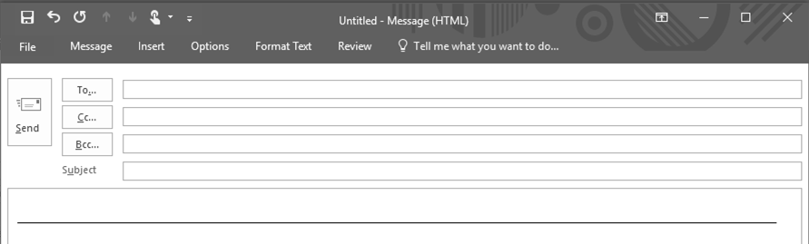
Below the header is where you will write the greeting, body, closing, and signature.

Vocabulary: Email
- Email a message sent or received electronically
- Sender the person sending an email
- Recipient the person receiving an email
- Subject what the email is about
- Greeting the first line of an email, such as “Dear ” or “To Whom It May Concern”
- Closing the last line of an email, such as “Sincerely” or “Thankfully”
- Body the message part of an email
- Signature your name at the end of the email

Vocabulary Practice: Email
Directions: Fill in the blanks with the vocabulary words from the word bank below.

Word Bank

body | email | recipient | signature
closing | greeting | sender | subject

- The is a polite way to address the recipient.

- The is a polite way to end the message.

- The is the main part of the email, the message.

- The is your name at the end of the email.

- The is the person writing the email.

- The is the person receiving the email.

- The is what the email is about.

- The is an electronic message.

Identifying the Parts of an Email
This picture shows the parts of the email identified and labeled as Recipient, Subject, Greeting, Body, Closing, and Signature. The Sender is not shown in this picture.

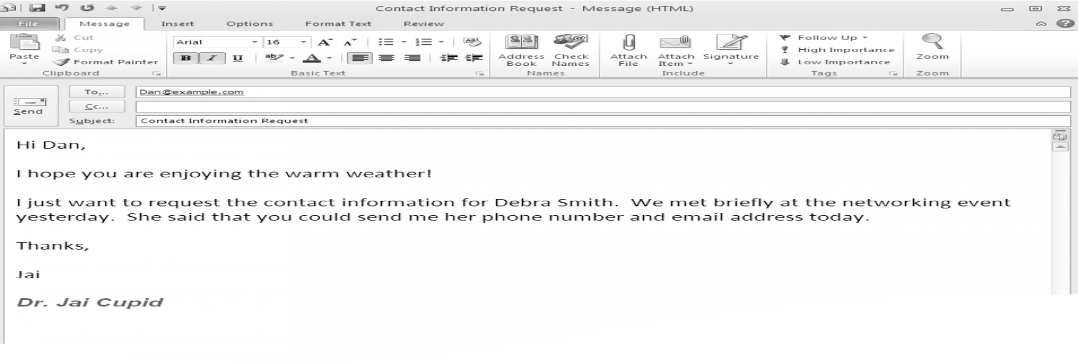
Recipient
Subject
Body
Greeting
Closing
Signature

Practice: Identifying the Parts of an Email
Directions: On the picture below, circle the parts of the email. Then write the name of the part.

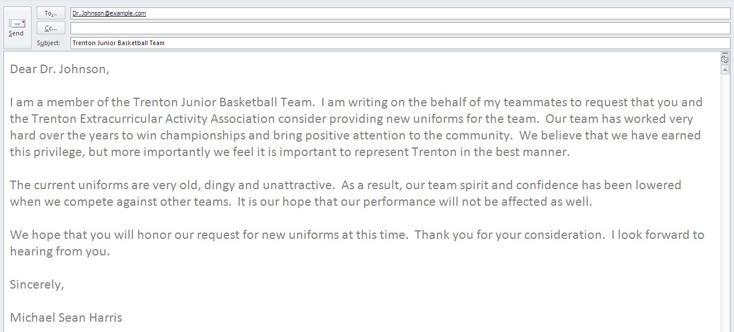

Writing an Email
You will write an email. However, for this lesson and the assessment, you will write the email on paper, not using a computer.
This is what you will do when you write the email:
- You will be given a scenario (context)
- You will be given a name to use for the recipient
- You will be the sender
- You will decide what to write for a subject
- You will need to write a greeting, body, closing, and signature for the email.
In this example, the places where you will write the parts of the email are identified.

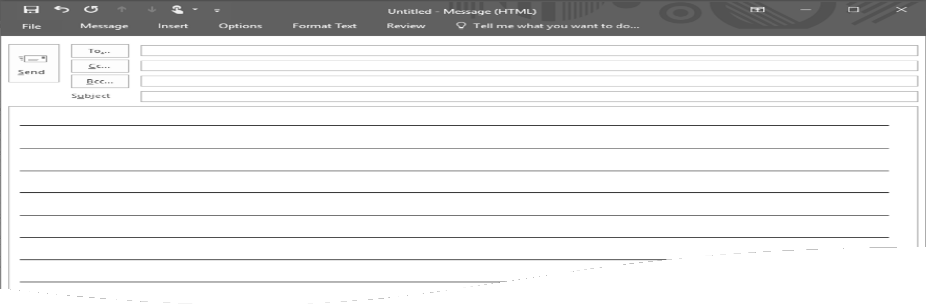
Recipient
Subject
Body
Greeting
Closing
Signature

For the following practice exercises, you will be given a scenario and directions. You need to write the email.

Example: Writing an Email 1
Here is an example:
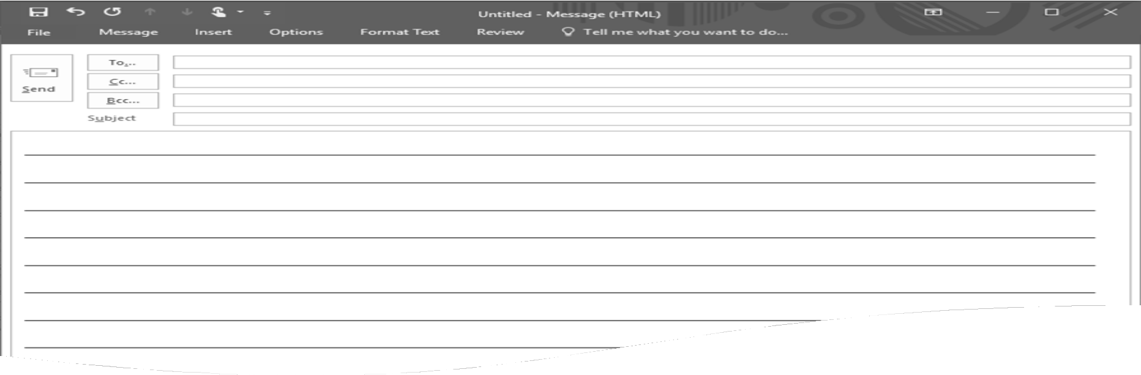

Scenario: Your son missed school because he was sick. The recipient will be:
washingtonelementary@bcsd.edu.

Directions: Write an email to the school to explain the absence.

Washingtonelementary@bcsd.edu

Absence Dear Staff,

I am sorry my son, Vince Ngo, missed school yesterday. He was sick.

Thank you.

Sincerely, Mr. Ngo

Practice: Writing an Email 1
Scenario: Your daughter will miss her appointment with the school counselor because she needs to take care of a family matter. The recipient will be: washingtonelementary@bcsd.edu.
Directions: Write an email to the school to explain missing the appointment. Some of the information has been entered for you.

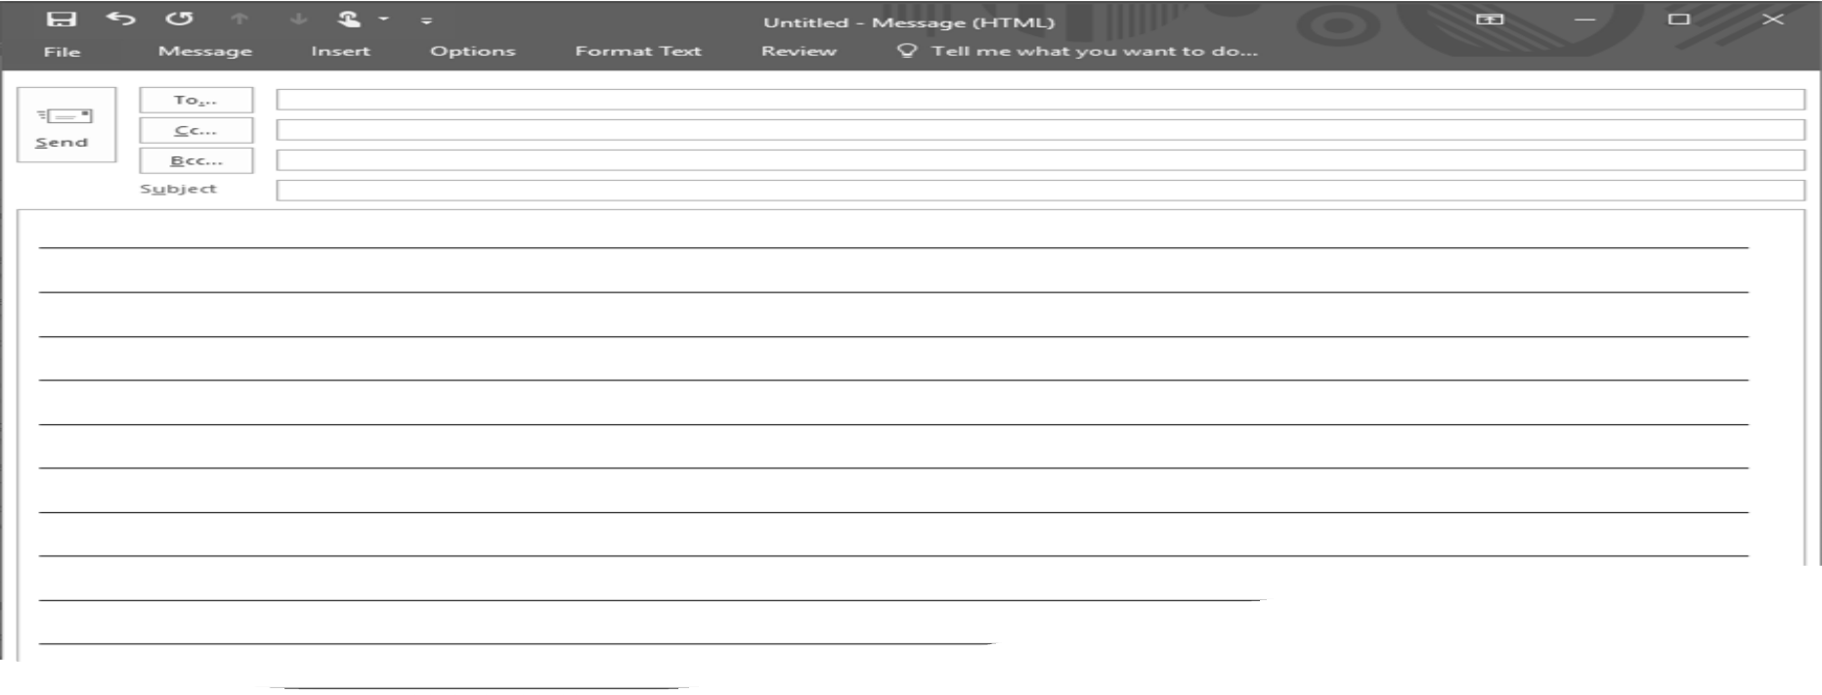
Washingtonelementary@bcsd.edu
You write the body of the letter.
Can’t Keep Appointment
Dear Counselor:
Thank you.
Sincerely,
You write your name as a signature.

Practice: Writing an Email 2
Scenario: You can’t keep your appointment at the dentist because your car broke down. The recipient will be: drvudentist@wd.com.
Directions: Write an email to the dentists’ office to explain why you will miss your appointment. Some of the information has been entered for you.
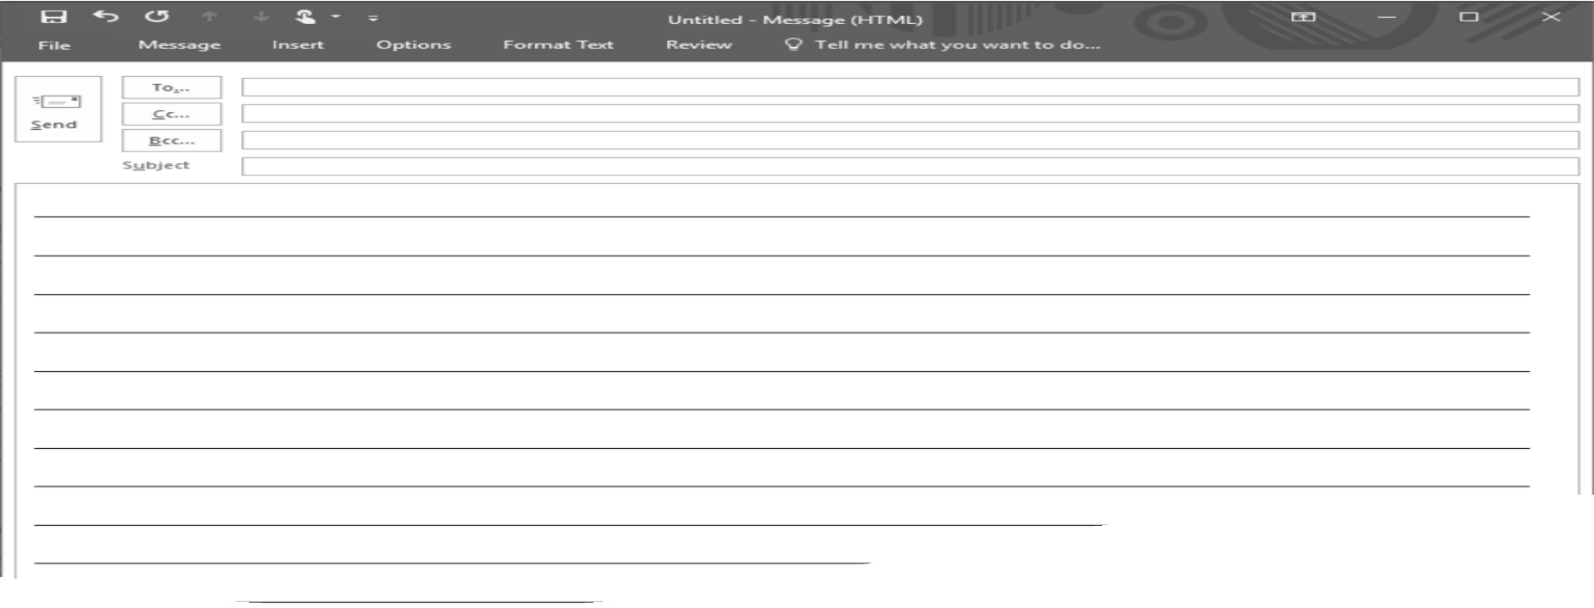
You write the subject of the letter.
drvudentist@wd.com
Dear Dr. Vu,
This is I have an appointment this afternoon,
but I will not be able to come. My car broke down and I don’t have any way to get there. I will reschedule soon.
Thank you for your understanding.
Sincerely,
You write your name as a signature.

Practice: Writing an Email 3
Scenario: You can’t meet your friend for lunch today because you don’t feel well. The recipient will be: janettran@outlook.com.
Directions: Write an email to your friend to explain why you can’t meet her for lunch. Some of the information has been entered for you.

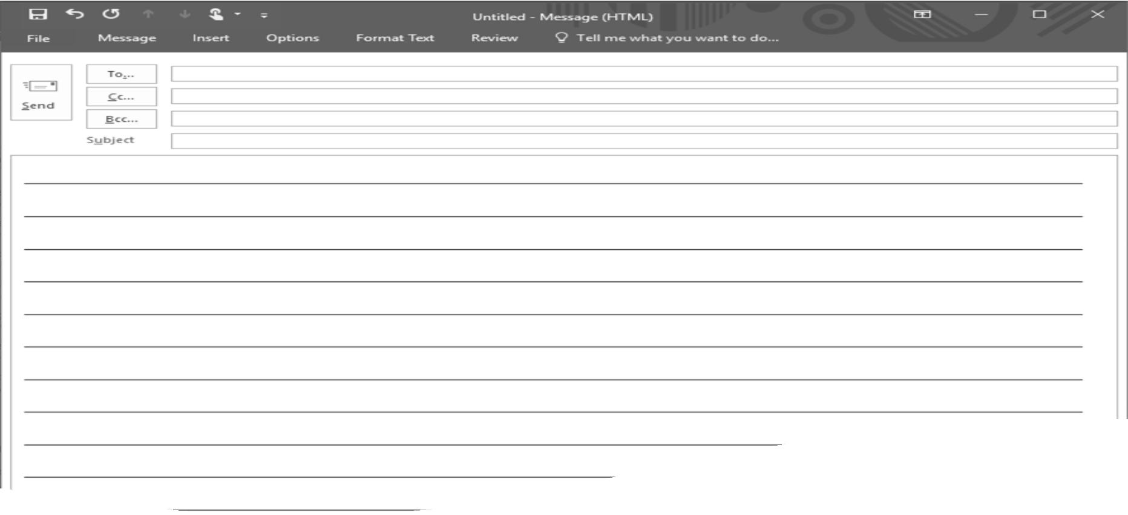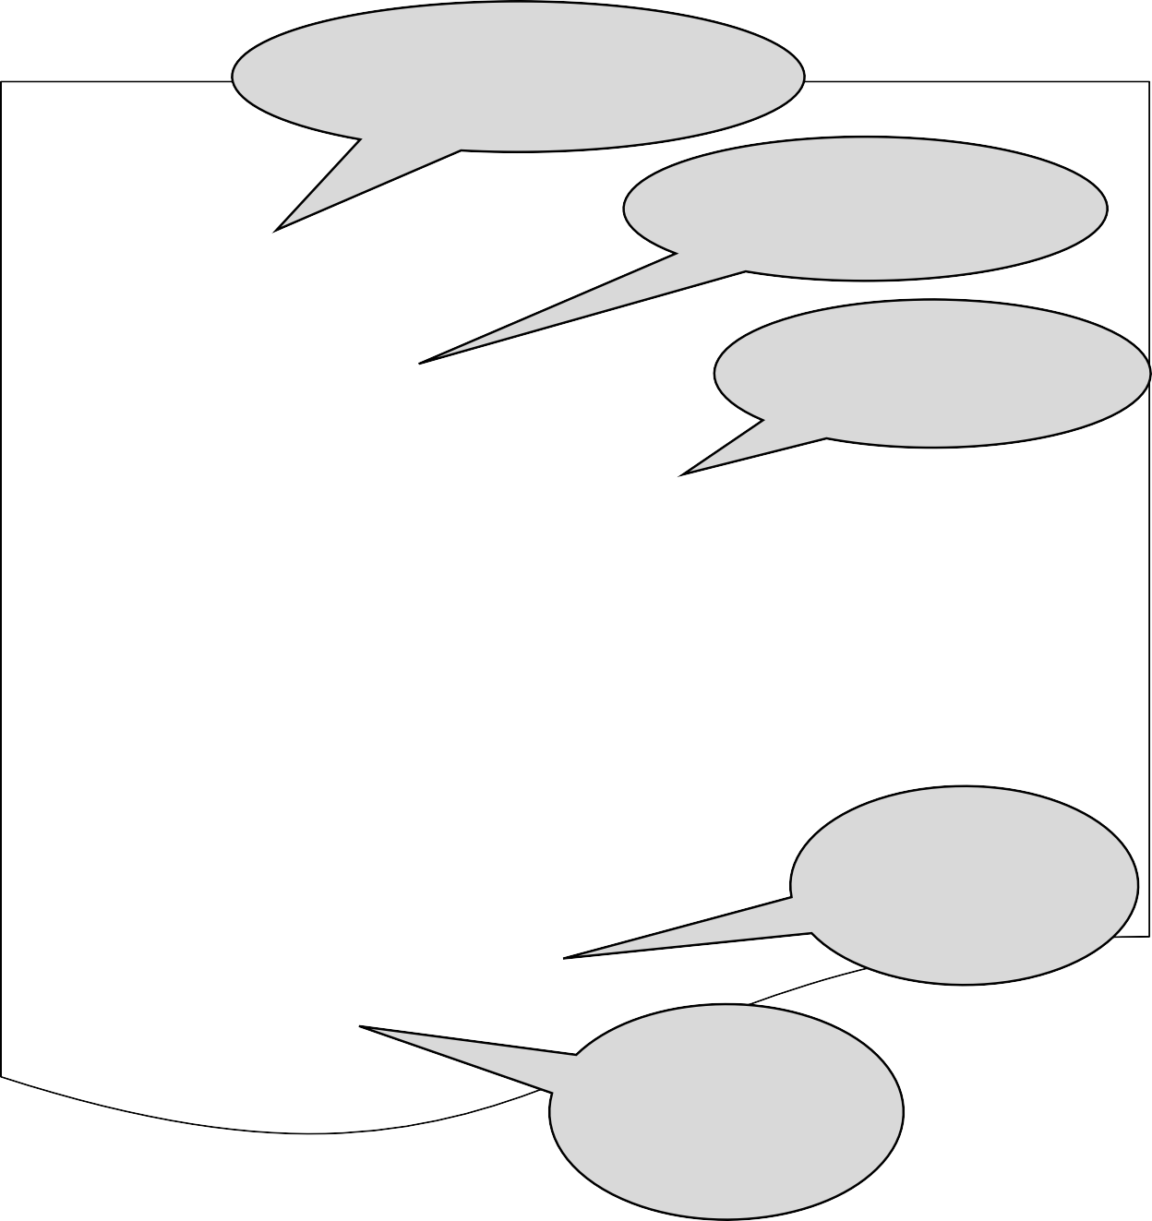
You write the recipient’s
email address.
You write the subject of the letter.
You write the body of the letter.
Dear Janet,
You write a closing for the letter.
You write your name as a signature.

Practice: Writing an Email 4
Scenario: You can’t meet your sister for dinner because you are too tired. The recipient will be: maribelsouza@outlook.com.
Directions: Write an email to your sister to explain why you can’t have dinner with her.

Practice: Writing an Email 5
Scenario: You applied for a job. The company where you applied has invited you to come for a job interview. The recipient will be: rayjones@goodco.com.
Directions: Write an email to accept the job interview. Review the information that has been entered for you.
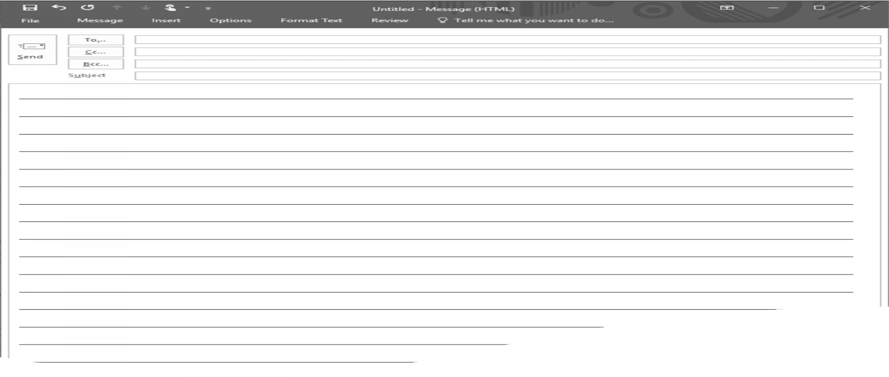
rayjones@goodco.com
Job Interview
Dear Mr. Jones,
Thank you for inviting me to a job interview. I am very grateful for this opportunity.
Wednesday at 9:00 will be just fine. I am looking forward to
meeting with you to discuss how my skills are a perfect fit for your company.
Thank you very much!
Sincerely
Viktor Romanof

In the next practice, the scenario is the same. You applied for the job and have been invited to a job interview. You will write to accept the job interview. Nothing has been written for you.

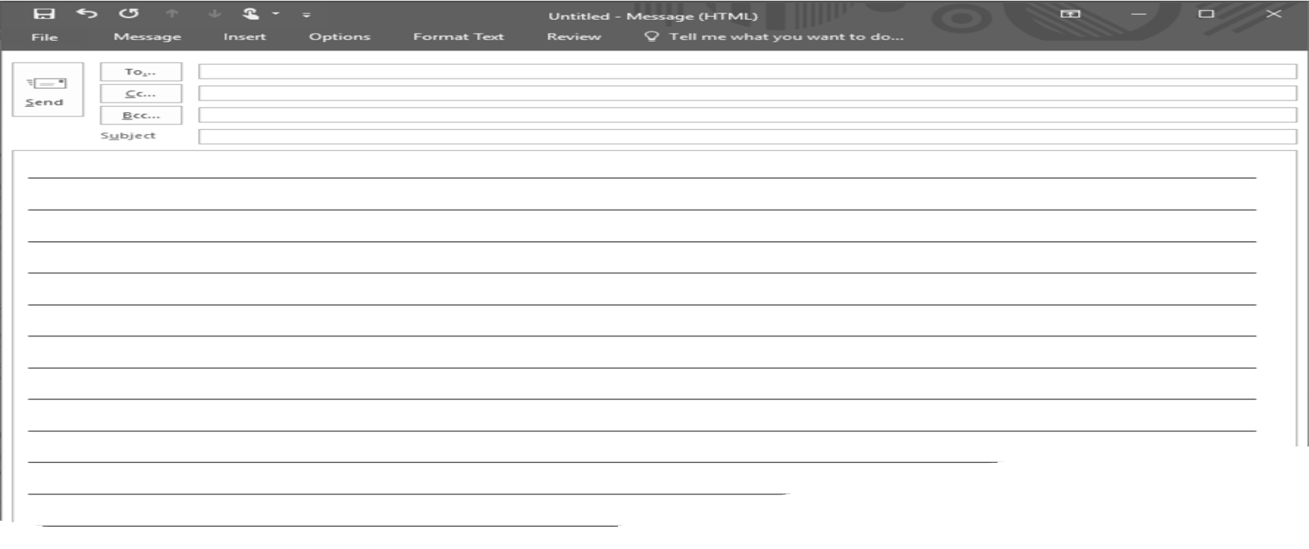
Dear Mr. Jones,
Job Interview
rayjones@goodco.com

You write the body of the letter.

You write a
closing for
the letter
You write your
name as a
signature.

Example: Writing an Email 2
Study the example below. Be sure to notice all the parts of the email.
Scenario: You applied for a job. The company’s hiring manager, Ray Jones, sent you an email inviting you to come for a job interview on Wednesday at 9:00. The recipient will be: rayjones@goodco.com.
Directions: On the form, write an email to accept the job interview. Tell the company that you are available to meet on Wednesday. Be sure to thank them for letting you have an interview. Use an appropriate greeting and closing in your email. Don’t forget to include a subject and your signature.

rayjones@goodco.com
Job Interview
Dear Mr. Jones,
Thank you for inviting me to a job interview. I am very grateful for this opportunity.
Wednesday at 9:00 will be just fine. I am looking forward to
meeting with you to discuss how my skills are a perfect fit for your company.
Thank you very much!
Sincerely
Viktor Romanof

Practice: Writing an Email 6
Scenario: You applied for a job. The company where you applied sent you an email inviting you to come for a job interview on Thursday at 10:00. The recipient will be: rayjones@goodco.com.
Directions: On the form, write an email to accept the job interview. Tell the company that you are available to meet on Thursday. Be sure to thank them for letting you have an interview. Use an appropriate greeting and closing in your email. Don’t forget to include a subject and your signature.
Look back at the example on page 38 if necessary.
When you have finished, ask a classmate to look at your email and tell you if you made any mistakes.
Then go to page 41 and write the email again, fixing any mistakes you or your classmate found.

Task 2

Study Guide

Review and study the practices on pages 8, 10, 19-20, 25 to prepare for your assessment.

Task 3
Review and study pages 39-40 to prepare for your assessment.

Supplemental Information

The information in this section is not part of this unit, and will not be included on your assessment. The information is here just to help you as you practice using the computer.

Proper Typing
Using the keyboard the right way will help you get better at typing. There are two rules you should follow to improve your typing skills.
Rule 1: NEVER look at the keyboard as you are typing. It is ok to look at the screen, or at something you are copying, but you should never look at the keyboard. This is very hard to do when you are first learning, but you will improve very quickly if you follow the rule.
Rule 2: ALWAYS use the correct fingers to type each letter. This is also very hard when you are first learning, but with practice it will become easier and you will type faster.

Modifier Keys
Some keys on the keyboard do not do anything by themselves. They only work when they are used with other keys. These keys are called MODIFIER keys. The word modify means change. Modifier keys change what other keys do. When these keys are held down and another key is tapped, the modifier keys change what the other key does.
There are two modifier keys that you need to remember: SHIFT and CTRL.
The Shift key will give you a capital letter or the second symbol on a key. For example: tapping on the t key will type the letter “t” – a lower case t (a small t). To type an upper case T (capital T), you need to hold down the Shift key and then tap the t key.
The Control key (Ctrl) will send a command to the computer. For example: tapping the p key will type the letter “p”. Holding down the Control key and then tapping the p key will send the Print command to the computer.

Using Control

The Control key (Ctrl) is used to send commands to the computer from the keyboard instead of using the mouse. Example: Control + p will send the Print command to the computer.
The Control key is also a modifier key and works the same way as the Shift key.
CORRECT: The correct way to use the Control key to send a command to the computer is to hold it down, tap the letter you want, then release the Control key.
INCORRECT: You should not press the Control key and let it go before tapping the letter. You will type a letter and not send a command to the computer.
INCORRECT: You should not try to tap the Control key and the letter key at the same time. You might send a command to the computer, but you might not.

Using Shift

The Shift key is used to type a capital letter. Example: Shift + t will type a T.
The Shift key is also used to type the special symbols that appear at the top of other keys. Example, Shift + 4 will type a $.
CORRECT: The correct way to use the Shift key for a capital letter is to hold it down, tap the letter you want, then release the Shift key.
INCORRECT: You should not press the Shift key and let it go before tapping the letter. You will not get a capital letter.
INCORRECT: You should not try to tap the Shift key and the letter key at the same time. You might get a capital letter, but you might not.
INCORRECT: You should not use the Caps Lock key to type a capital letter. Turning of the Caps Lock feature will give you a capital letter, but this is not the correct way. As your typing skills improve, and you begin to type more quickly Turning the Caps Lock key on and off every time you need a capital letter will slow you down. Also, many times people forget to turn Caps Lock off and then type with all capital letters. This is not correct typing.
REMEMBER: Hold down the Shift key, tap the letter you want, then release the Shift key.
All keyboards have two Shift keys, one on the right side and one on the left side. This is to make your typing easier and faster. If the letter you want is on the right side of the keyboard, typed by your right hand, then the left hand should hold down the Shift key on the left side of the keyboard. If the letter you want is on the left side of the keyboard, typed by your left hand, then the right hand should hold down the Shift key on the right side of the keyboard. This is shown in the picture below.
This picture shows typing a capital S: the right hand holds the Shift key down while the left hand taps the s key.

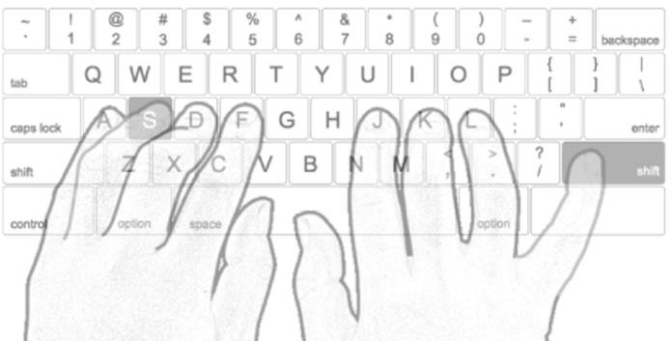

Using the Keyboard
There are rules for using the keyboard the right way. Many people don’t know the rules. Others know the rules, but don’t follow them.
Here are some things you should know to use the keyboard the right way.

The Home Row

We use the keyboard mostly for typing. To type on the keyboard, you need to make sure your fingers are in the right place. When they are not typing a letter, each finger should be gently resting on a key in the HOME ROW. The home row is where the fingers return after each letter is typed.
The keys a s d f and j k l ; are the home row keys. The home row can always be found without looking by feeling the keys. The f key and the j key have a small bump on the key. This bump is where your index finger goes. The rest of the fingers go on the keys next to these.
This picture below shows the home row in the middle of the keyboard.
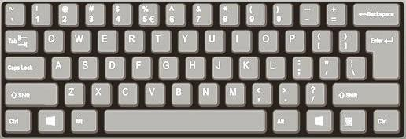

Fingering

Each finger should tap the keys that are close to it. You should not have to make your fingers move a lot to type correctly. The keys assigned to each finger can be seen on this fingering chart.

EL Civics COAAP 73.2 Supplemental Information
This fingering chart shows which letters should be typed by which fingers.
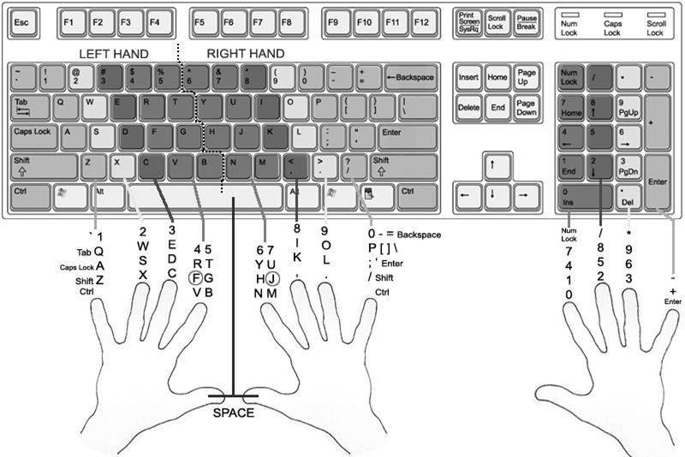

EL Civics Practice COAAP 73.2: Communication Technologies Tasks 2-3 © 2022 HBAS licensed as CC BY-NC-SA

