Elder Abuse Report Practice B

Directions: Read the following information and complete an Elder Abuse Report using all the information available for the practice B scenario.

You are a Personal Care Aide for Everyday Caregiving in Hollywood. You suspect elder abuse in the form of self neglect. Today, after speaking to your supervisor, you verbally reported your suspicion to Lisa Chen at Adult Protective Services (APS) 800-477-3646 at 1:30pm. Now you need to complete a written report. Your employer is:
Everyday Caregiving
1586 Santa Monica Blvd.
Hollywood, CA 90028
800-555-0125
everydaycaregiving@gmail.com

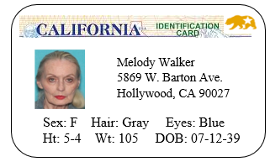
- lives alone
- drinking more heavily than usual
- Has passed out from alcohol before
- Drinks very heavily
- no children or family in California
- very frail
- doesn’t each much
- SSA Retirement Income
- SS# 258-54-8795
- Small pension from SAG (Screen Actors Guild)
- Irish-American ethnicity
- White race, speaks English
- 323-555-5643

Notes
What is the abusive situation?

When did it occur (date/time)?
Who is the abuser (if any)?
What is the danger?
How often has it occurred?
What is the consumer’s current health?

