Elder Abuse Report Practice A

Directions: Read the following information and complete an Elder Abuse Report (found online) using all the information available for the assessment scenario.
You are a Personal Care Aide for Angel Care in Los Angeles. You suspect elder abuse in the form of self neglect. Today, after speaking to your supervisor, you verbally reported your suspicion to Janet Bennett at Adult Protective Services (APS) 877-477-3646 at 2:15 pm. Now you need to complete a written report. Your employer is:
Angel Care
938 Sierra Blvd
Long Beach, CA 90802
800-345-6789
angelcare@gmail.com

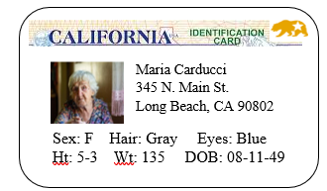
- lives alone
- no children or family in California
- no known family members
- In the past month you also noticed:
  - often forgets to take medication
  - does not drink enough water
  - cannot go up and down stairs without help
- SSA Retirement Income
- Italian
- 562-570-3600
- SS# 555-55-1111
- Speaks Italian and English

Notes
What is the abusive situation?

When did it occur (date/time)?
Who is the abuser (if any)?
What is the danger?
How often has it occurred?
What is the consumer’s current health?

