|  |
| --- |
| **EL Civics: Nutrition (Obj 46) • Int High/Adv Task 1: Interpret & Compare Food Labels** |
| **Language & Literacy Objectives:**   1. Identify a healthy diet as recommended by the USDA. 2. Identify the relationship between nutrition and good health.   7. Interpret food-packaging labels. |
| **INTRODUCTION** |
| In this lesson, students will learn how to read and interpret food nutrition fact labels. They will compare labels from similar products to determine the healthiest choice. |
| **ASSESSMENT TASK** |
| Given three food nutrition fact labels, student will compare the labels and respond to 5 questions/statements. 10 points possible. |
| **SUGGESTED ACTIVITIES** |
| * Teacher and/or students bring in actual food packaging. *[Class set available for checkout from Resource Office.]* Have students work in small groups to analyze the food labels to determine the healthiest choices. Use document reader to project to whole class. * Students work in small groups to write & perform a commercial for a product – compare to other similar products – use as opportunity to teach comparatives & superlatives (higher, lower, more, fewer). Students can perform in front of class, or can record using video camera & Windows Movie Maker. |

|  |
| --- |
| **HANDOUTS PROVIDED** |
| Handout 1: Related Vocabulary  Handout 2: Discussion Questions  Handout 3: Reading the Nutrition Label  Handout 4: How to Read a Food Label: Definitions  Handout 5: How to Read a Food Label: The 7 Main Parts  Handout 6: Nutritional Label: Comparison Example  Handout 7: Practice A: Interpret and Compare Food Labels (and Answer Key)  Handout 8: Practice B: Interpret and Compare Food Labels (and Answer Key)  Handout 9: Lab Lesson: Create Your Own Nutrition Facts Label |
| **COMPUTER LAB IDEAS** |
| * Conduct research on the healthiest product choices for people with different needs, e.g. pregnant or nursing mothers, children, seniors, people with chronic illnesses or food-related issues (diabetes, high blood pressure, allergies, etc.). Compare special needs to average recommended diet. Create and deliver a presentation to the class. * Students work on comparisons by analyzing charts on “Fast Food Restaurants and Nutrition Facts Compared:” <http://www.acaloriecounter.com/fast-food.php>. Also: “272 Fast-Food Items Highest in Calories:” <http://www.acaloriecounter.com/fast-food-calories.php> and “Fast Food Items Highest in Trans Fat: The 88 Least-Healthy Foods” http://www.acaloriecounter.com/fast-food-trans-fat.php * Have students make their own nutrition facts labels for family recipes or common foods. Go to [www.nutritiondata.com](http://www.nutritiondata.com). Students enter recipes, then generate their own nutrition labels*. (See Handout 9 for lab lesson.)* * Contribute to class EL Civics Cookbook Project |

Task 1 – Handout #1

**Related Vocabulary**

*adapted from* [*www.dictionary.com*](http://www.dictionary.com) *&* [*www.wikipedia.com*](http://www.wikipedia.com)

**% daily value:** Helps to determine if a serving of food is high or low in a nutrient. Based on a 2000-calorie diet. Use to compare similar products.

**5 and 20 rule**: If a food has 5% or less of a nutrient, it is considered low in that nutrient. If it has 20% or more, it’s considered high.

**allergens**: Foods that can cause allergic reactions.

**calories**: The amount of energy you get from a serving of food. Eating too many calories is related to overweight and obesity. Burning calories is a result of exercise and physical activity.

* *Consuming more calories than you burn =* ***weight gain***
* *Burning more calories than you consume =* ***weight loss***
* *Consuming and burning the same number of calories =* ***weight maintenance***

**ingredients**: Something that combines into a mixture.

**nutrients**: A source of nourishment.

**nutrition label**: Required on most pre-packaged food in many countries. In the U.S., it lists the percentage of human nutrients recommended, based on the average 2000 calorie a day diet.

**serving size**: On the nutrition label, the amount of a product typically eaten in one sitting. It is a confusing term, as it is found both on the Food Pyramid and on Nutrition Labels, and has two related--but differing--meanings.

**servings per container**: Total number of servings in a food package, based on the serving size.

**trans fat**: Ingredient that has no nutritional value. High levels in one’s diet contribute to many chronic health problems, including Coronary Heart Disease, Stroke and Diabetes.

**Food-related Comparatives:**

**healthy – healthier few - fewer**

**low – lower more than**

**high – higher less than**

*This page intentionally blank.*Task 1 – Handout #2

**Discussion Questions: Nutrition**

1. Have you ever read nutrition labels on food packaging? If not, why not? If so, were you able to understand what the information on the labels meant?
2. What kind of information appears on a nutrition label?

1. Are nutrition labels required in your home country? If so, is the information the same as or different from U.S. labels?
2. Have you ever changed your mind about buying a product after reading the nutrition label? If so, did you buy the product, or put it back on the shelf? Why?
3. Do you have any food allergies? Are they listed on nutrition labels?
4. Do you eat a special diet? If so, why? What changes have you made in your diet to improve your health?
5. How important do you think it is for children to eat nutritious foods? Adults? Seniors?
6. When you choosing what you eat, what factors are most important to you: Nutritional quality? Taste? or both?
7. Do you think you currently eat a healthy diet? Why or why not? If you don't, what could convince you to eat healthier foods?
8. How do Americanized versions of your culture's food differ from the comparable food you would find in your native country?

*This page intentionally blank.*

TASK 1 - Handout #3

##### Introduction: Reading the Nutrition Label

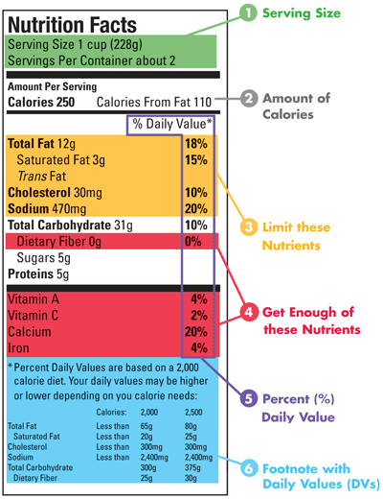

© October 2006, [www.fda.gov](http://www.fda.gov)

*This page intentionally blank.*

Task 1 – Handout #4

**How to Read a Food Label: Definitions**

*adapted from* [*www.latinonutrition.org*](http://www.latinonutrition.org)

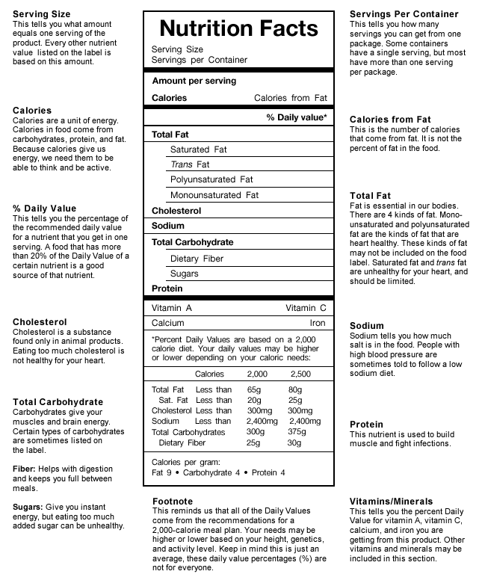

*This page intentionally blank.* Task 1 – Handout #5

**How to Read a Food Label: The 7 Main Parts**

*adapted from* [*www.latinonutrition.org*](http://www.latinonutrition.org)

**SERVING SIZE**  
The label describes the nutritional value for the stated serving size, not the whole package.

**CALORIES**  
The average person should consume about 2000 calories per day, less if you’re not active. It sounds like a lot but consider your average McDonald’s Big Mac meal (Big Mac, medium fries and coke) has about 1130 calories. Remember that the calories listed on the label will only be for the serving size, not the whole package. Spread out the calories you consume over the day

**TOTAL FAT (including Saturated Fat & Trans Fat)**  
Total fat tells you how much fat is in one serving of the product you are looking at. It includes healthy fats our bodies need (mono- and poly-unsaturated) and unhealthy fats we should limit (trans fats and saturated fats). Remember to ‘limit’ the saturated fats and ‘avoid’ ALL trans fats.

**CHOLESTEROL & SODIUM**  
Cholesterol and sodium should be limited.  The American Heart Association describes cholesterol as “a soft, waxy substance found among the lipids (fats) in the bloodstream and in all your body's cells”. It's an important part of a healthy body because it's used to form cell membranes and some hormones, and is needed for other functions. But a high level of cholesterol in the blood is a major risk factor for coronary heart disease, which leads to heart attack.  
  
Sodium is salt. Adults should aim for less than 2400 mg of sodium per day; this includes table salt as well as salt already present in foods.  If you have high blood pressure, it is recommended to consume even less salt.  Fresh foods are generally much lower in salt than packaged foods.

**TOTAL CARBOHYDRATES**   
The total carbohydrates listed include sugars, dietary fibers, and other carbohydrates. Carbohydrates are a part of a healthy and balanced diet. However, there are some carbohydrates that are better than others. Try to get the majority of your carbohydrates from fruits, vegetables, beans, and whole grain sources.

Sugars have no nutritional value, so make sure they are not listed as one of the first few ingredients. Names include: corn syrup, high-fructose corn syrup, fruit juice concentrate, maltose, dextrose, sucrose, honey, and maple syrup.

**PROTEIN**  
Helps build muscle. Foods like chicken, tofu, seafood, nuts and beans are high in protein.

**INGREDIENTS**  
As a rule of thumb, the fewer ingredients a product has, the healthier it is. Our bodies evolved for millions of years eating the bounty of nature, and that's what suits them best. Ingredients are listed in descending order, from the greatest amount to the least.

**BUZZ WORDS: REDUCED FAT, LOW FAT, & LIGHT**  
Don’t let these words fool you into thinking that the product is automatically healthy. These words are often used on packaging to describe products that might be low in fat but not necessarily nutritious. A low fat food can also be high is sugar or high in calories, while offering little that’s good for you.

*This page intentionally blank.*TASK 1 - Handout #6

**Nutrition Label: Comparison Example**

*adapted from www.fda.gov*

Below are two kinds of milk – one is “Reduced Fat” and the other is “Nonfat.” Each serving size is one cup. Compare the two products to determine which is the healthier choice:  
  
Which milk has more calories? ____________________________________  
Which milk has more saturated fat? ____________________________________  
Which milk has more calcium? ____________________________________

|  |  |
| --- | --- |
| REDUCED FAT MILK 2% Milkfat | NONFAT MILK |
|  |  |

|  |
| --- |
| ***Answer: They both have the same amount of calcium. The nonfat milk has no saturated fat. The nonfat milk has 40 calories less per serving than the reduced-fat milk.*** |

*This page intentionally blank.*TASK 1 - Handout #7

**Practice A: Interpret & Compare Food Labels**

**DIRECTIONS**: Compare the food labels and answer the questions below.

**flour tortilla**

**white rice, cooked**

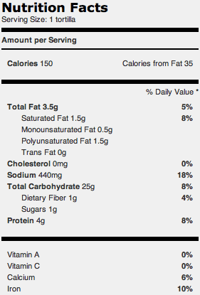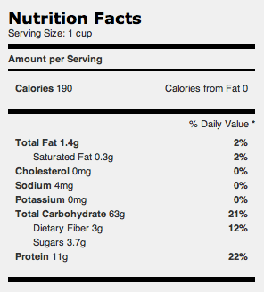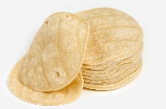

1. Compare the calories in the flour tortilla and white rice: ____________________  
     
   ________________________________________________________________
2. Compare the total fat in the flour tortilla and white rice: ____________________  
     
   ________________________________________________________________
3. Compare the sodium in the flour tortilla and white rice______________________  
     
   ________________________________________________________________
4. You have high blood pressure. Which food is the healthier choice? Why?  
      
   ________________________________________________________________  
     
   ________________________________________________________________

This page intentionally blank.TASK 1 - Handout #7 (Answer Key)

**Practice A: Interpret & Compare Food Labels (Answer Key)**

**DIRECTIONS**: Compare the food labels and answer the questions below.

**flour tortilla**

**white rice, cooked**



1. Compare the calories in the flour tortilla and white rice: *(any answer below …)*  
   **The white rice has more calories than the flour tortilla.   
   The white rice is higher in calories than the flour tortilla.  
   The flour tortilla has fewer calories than the white rice.  
   The flour tortilla is lower in calories than the white rice.**
2. Compare the total fat in the flour tortilla and white rice:   
   **The white rice has fewer calories than the flour tortilla.   
   The white rice is lower in calories than the flour tortilla.  
   The flour tortilla has more calories than the white rice.  
   The flour tortilla is higher in calories than the white rice.**
3. Compare the sodium in the flour tortilla and white rice  
   **The white rice has less sodium than the flour tortilla.   
   The white rice is lower in sodium than the flour tortilla.   
   The flour tortilla has more sodium than the white rice.  
   The flour tortilla is higher in sodium than the white rice.**
4. You have high blood pressure. Which food is the healthier choice? Why?  
   **The white rice is the healthier choice because it is lower in sodium.***This page intentionally blank.*TASK 1 - Handout #8

**Practice B: Understanding Food Labels**

Directions:Read the nutrition labels below to compare the beverages shown. Answer the questions on page 3.

|  |  |
| --- | --- |
| ½ Bottle Flavored Water  bottle of vitamin water nutrition facts for 1/2 bottle flavored water: serving size 8oz, calories 52, fat 0%, sodium 0, carbohydrate 12g or 4%, fiber 0, sugars 13g, protein 0g | 1 cup (8 oz.) Tomato/Vegetable Juice  Nutrition facts for V8 juice: calories 53 per cup, fiber 2g or 8%, sodium 169 mg or 7%, carbohydrate 11g or 4%, fiber 2g or 8%, sugars 9g, protein 1gbottle of V* juice |
| 1 “Tall” (12 oz.) Starbucks Frappuccino – no whipped cream  frappuccino12 inch "tall" frappuccino no whip cream nutrition facts: serving size 12oz, calories 225, total fat 2g or 3%, sodium 170mg or 7%, carbohydrate 48g or 16%, fiber 0, sugar 42g, protein 3g | 1 cup (8 oz.) Skim Milk  milk nutrition facts: calories per cup 90, fiber 0, sodium 125 mg or 5% DV, total carbohydrate 13g or 4%, sugars 12 g, protein 8gImage result for 1/2 gallon of milk container |

*This page intentionally blank.*TASK 1 - Handout #8 (cont.)

**Practice B: Understanding Food Labels (cont.)**

Directions:Compare the nutrition facts labels on the previous page, and then answer these questions:

1. Which beverage is lowest in calories? ________________________________   
     
   How many calories per serving? _____________
2. Which beverage is highest in sodium? ________________________________   
     
   How many milligrams per serving? _____________
3. How many grams of total fat are in each beverage?   
     
   Flavored Water: _______ Frappuccino: ______ Milk: _____ Vegetable Juice: ______
4. Of these beverages, which would be the best choice for someone with Diabetes? Why?   
     
   _______________________________________________________________________   
     
   _______________________________________________________________________
5. Which beverage would be the best choice for **you**? Explain why (give at least 2 reasons):   
     
   _______________________________________________________________________  
     
   _______________________________________________________________________

*This page intentionally blank.*

TASK 1 - Handout #8 (Answer Key)

**Practice B: Understanding Food Labels (Answer Key)**

Directions:Compare the nutrition facts labels on the previous page, and then answer these questions:

1. Which beverage is lowest in calories? **flavored water**   
     
   How many calories per serving? **52**
2. Which beverage is highest in sodium? **Frappucino**   
     
   How many milligrams per serving? **170mg**
3. How many grams of total fat are in each beverage?   
     
   Flavored Water: **0g** Frappuccino: **2g** Milk: **0g** Vegetable Juice: **0g**

1. Of these beverages, which would be the best choice for someone with Diabetes? Why?   
     
   **From these drinks, the best choice for someone with Diabetes would be the tomato/vegetable juice because it is the lowest in sugar. (Focus on fat/cholesterol or sugar, not sodium)**

1. Which beverage would be the best choice for **you**? Explain why (give at least 2 reasons):

**Answers will vary, but must include explanation specific to individual.   
Example: “I am overweight and have high blood pressure. The best choice for me would be the flavored water because it is the lowest in calories and sodium.”**

*This page intentionally blank.*

TASK 1 - Handout #9

**Lab Lesson: Create Your Own Nutrition Facts Label**

*adapted from ehow.com*

**ACTIVITY:** Bring in a family recipe, or a recipe that you use often. Enter it into the website to create a nutrition facts label. Analyze the label to determine if it is a healthy or unhealthy recipe. What changes can you make so the recipe is healthier?

**DIRECTIONS**:

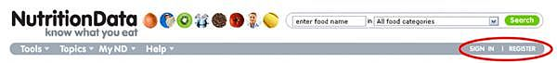

1. Go to [**www.nutritiondata.com**](http://www.nutritiondata.com) *(sign in, or register for a free account the first time).*
2. After you register, click on “**Go to our homepage**.”
3. Under “Nutrition Management Tools,” click “**Analyze Recipe**,” then “**Create Recipe**.”
4. 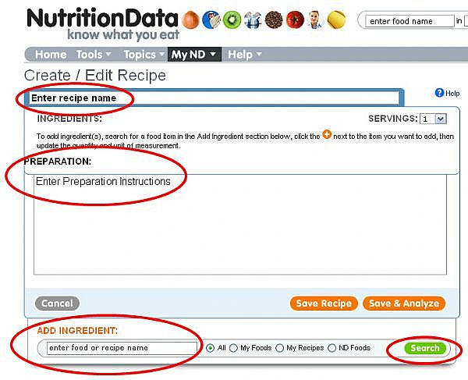Enter a **recipe name (e.g. Karla’s World-Famous Chili)**, the number of **servings** and **preparation instructions**.

1. Search for your first ingredient under “**Add Ingredient**” and click “**Search**.”
2. Find the best choice for your recipe. Click on the **orange plus sign** to the right. That item will now appear under “Ingredients.”
3. Now select the **quantity** and the **units** for the ingredient (e.g. 1 cup).
4. Continue this process for all the ingredients.
5. Once your recipe is complete, click "**Save & Analyze**."
6. Your nutritional label is now created. You can change the serving size by clicking on the drop-down menu next to "**Serving size**".
7. Download a printable label by clicking on "**Download Printable Label Image,**" under the label.