|  |
| --- |
| **EL Civics: Nutrition (Obj 46) • Int Low Task 1: Interpret & Compare Food Labels** |
| **Language & Literacy Objectives:**   1. Identify a healthy diet as recommended by the USDA. 2. Identify the relationship between nutrition and good health.   7. Interpret food-packaging labels. |
| **INTRODUCTION** |
| In this lesson, students will learn how to read and interpret food nutrition fact labels. They will compare labels from similar products to determine the healthiest choice. |
| **ASSESSMENT TASK** |
| Given two food nutrition fact labels, student will compare the labels and respond to 4 questions/statements. 8 points possible. |
| **SUGGESTED ACTIVITIES** |
| * Teacher and/or students bring in actual food packaging. *[Class set available for checkout from Resource Office.]* Have students work in small groups to analyze the food labels to determine the healthiest choices. Use document reader to project to whole class. * Students work in small groups to write & perform a commercial for a product – compare to other similar products – use as opportunity to teach comparatives & superlatives (higher, lower, more, fewer). Students can perform in front of class, or can record on video camera & make commercial using Windows Movie Maker. |

|  |
| --- |
| **HANDOUTS PROVIDED** |
| Handout 1: Related Vocabulary  Handout 2: Discussion Questions  Handout 3: Reading the Nutrition Label  Handout 4: How to Read a Food Label: Definitions  Handout 5: Nutritional Label: Comparison Example  Handout 6: Practice: Interpret and Compare Food Labels (and Answer Key)  Handout 7: Lab Lesson: Create Your Own Nutrition Facts Label |
| **COMPUTER LAB IDEAS** |
| * Conduct research on the healthiest product choices for people with different needs, e.g. pregnant or nursing mothers, children, seniors, people with chronic illnesses (diabetes, high blood pressure, etc.). Compare special needs to average recommended diet. * Students work on comparisons by analyzing charts on “Fast Food Restaurants and Nutrition Facts Compared:” <http://www.acaloriecounter.com/fast-food.php>. Also: “272 Fast-Food Items Highest in Calories:” <http://www.acaloriecounter.com/fast-food-calories.php> and “Fast Food Items Highest in Trans Fat: The 88 Least-Healthy Foods” <http://www.acaloriecounter.com/fast-food-trans-fat.php> * Have students make their own nutrition facts labels for family recipes or common foods. Go to [www.nutritiondata.com](http://www.nutritiondata.com). Students enter recipes, then generate their own nutrition labels*. (See Handout 7 for lab lesson.)* * Contribute to class EL Civics Cookbook Project |

Task 1 – Handout #1

**Related Vocabulary**

*adapted from* [*www.dictionary.com*](http://www.dictionary.com) *&* [*www.wikipedia.com*](http://www.wikipedia.com)

**% daily value:** Helps to determine if a serving of food is high or low in a nutrient. Based on a 2000-calorie diet. Use to compare similar products.

**5 and 20 rule**: If a food has 5% or less of a nutrient, it is considered low in that nutrient. If it has 20% or more, it’s considered high.

**allergens**: Foods that can cause allergic reactions.

**calories**: The amount of energy you get from a serving of food. Eating too many calories is related to overweight and obesity. Burning calories is a result of exercise and physical activity.

* *Consuming more calories than you burn =* ***weight gain***
* *Burning more calories than you consume =* ***weight loss***
* *Consuming and burning the same number of calories =* ***weight maintenance***

**ingredients**: Something that combines into a mixture.

**nutrients**: A source of nourishment.

**nutrition label**: Required on most pre-packaged food in many countries. In the U.S., it lists the percentage of human nutrients recommended, based on the average 2000 calorie a day diet.

**serving size**: On the nutrition label, the amount of a product typically eaten in one sitting. It is a confusing term, as it is found both on the Food Pyramid and on Nutrition Labels, and has two related--but differing--meanings.

**servings per container**: Total number of servings in a food package, based on the serving size.

**trans fat**: Ingredient that has no nutritional value. High levels in one’s diet contribute to many chronic health problems, including Coronary Heart Disease, Stroke and Diabetes.

**Food-related Comparatives:**

**healthy – healthier few - fewer**

**low – lower more than**

**high – higher less than**

*This page intentionally blank.*Task 1 – Handout #2

**Discussion Questions**

1. Do you eat healthy and nutritious food? If so, why? If not, why not?

1. Do you read the nutrition labels on packages? Why or why not?

1. What kind of information can you find on a nutrition label?

1. Are nutrition labels required in your home country? If so, is the information different from U.S. labels?
2. Have you ever changed your mind about buying a product after reading the nutrition label?
3. Do you have any food allergies? Are they listed on nutrition labels?

*This page intentionally blank.*

TASK 1 - Handout #3

##### Introduction: Reading the Nutrition Label

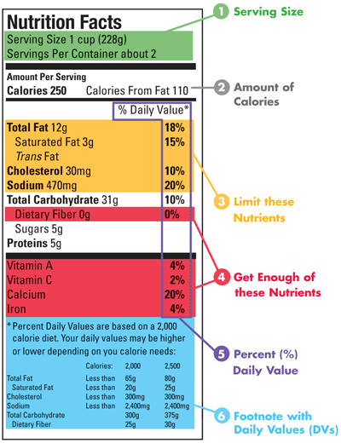

© October 2006, [www.fda.gov](http://www.fda.gov)

*This page intentionally blank.*

Task 1 – Handout #4

**How to Read a Food Label: Definitions**

*adapted from* [*www.latinonutrition.org*](http://www.latinonutrition.org)

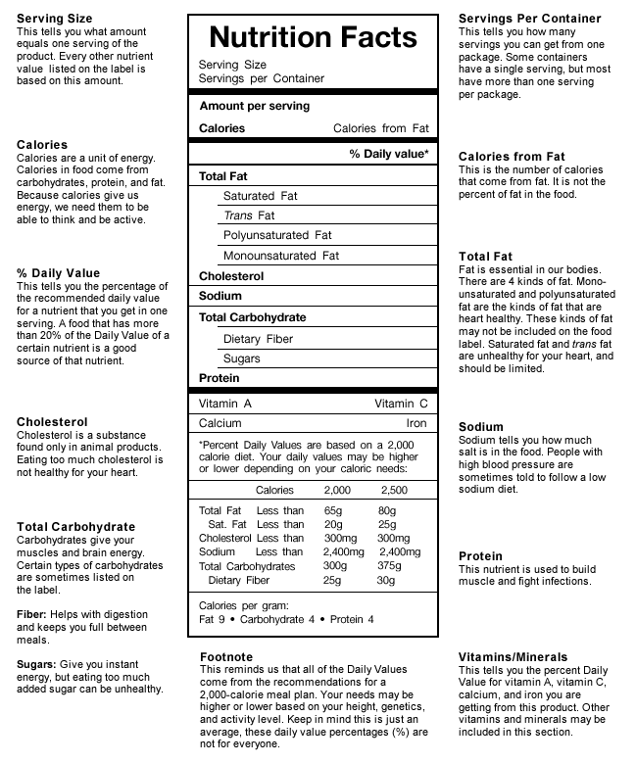

*This page intentionally blank.* TASK 1 - Handout #5

**Nutrition Label: Comparison Example**

*adapted from www.fda.gov*

Below are two kinds of milk – one is “Reduced Fat” and the other is “Nonfat.” Each serving size is one cup. Compare the two products to determine which is the healthier choice:  
  
Which milk has more calories? ____________________________________  
Which milk has more saturated fat? ____________________________________  
Which milk has more calcium? ____________________________________

|  |  |
| --- | --- |
| REDUCED FAT MILK 2% Milkfat | NONFAT MILK |
|  |  |

|  |
| --- |
| ***Answer: They both have the same amount of calcium. The nonfat milk has no saturated fat. The nonfat milk has 40 calories less per serving than the reduced-fat milk.*** |

*This page intentionally blank.*TASK 1 - Handout #6

**Practice: Interpret & Compare Food Labels**

DIRECTIONS: Compare the food labels and answer the questions below.

|  |  |
| --- | --- |
| 1 cup (8 oz.) Tomato/Vegetable Juice  **botte of V8 juice**Nutrition facts for V8 juice: calories 53 per cup, fiber 2g or 8%, sodium 169 mg or 7%, carbohydrate 11g or 4%, fiber 2g or 8%, sugars 9g, protein 1g | 1 cup (8 oz.) Fat Free Skim Milk  Image result for 1/2 gallon of milk containermilk nutrition facts: calories per cup 90, fiber 0, sodium 125 mg or 5% DV, total carbohydrate 13g or 4%, sugars 12 g, protein 8g |

***Example****: Compare the protein in the juice and milk.*

***The milk has more protein than the juice.***

1. **Compare the calories in the juice and milk**:   
     
   ___________________________________________________________________
2. **Compare the fiber in the juice and milk**:   
     
   ___________________________________________________________________
3. **Compare the sodium in the juice and milk**:   
     
   ___________________________________________________________________
4. **You have Diabetes. Which drink is the better choice? Why?**   
      
   ___________________________________________________________________

*This page intentionally blank.*TASK 1 - Handout #6 (Answer Key)

**Practice: Interpret & Compare Food Labels (Answer Key)**

DIRECTIONS: Compare the food labels and answer the questions below.

|  |  |
| --- | --- |
| **1 cup (8 oz.) Tomato/Vegetable Juice**  **V8 juice**Nutrition facts for V8 juice: calories 53 per cup, fiber 2g or 8%, sodium 169 mg or 7%, carbohydrate 11g or 4%, fiber 2g or 8%, sugars 9g, protein 1g | **1 cup (8 oz.) Fat Free Skim Milk**  Image result for 1/2 gallon of milk containermilk nutrition facts: calories per cup 90, fiber 0, sodium 125 mg or 5% DV, total carbohydrate 13g or 4%, sugars 12 g, protein 8g |

***Example****: Compare the protein in the juice and milk.*

***The milk has more protein than the juice.***

1. **Compare the calories in the juice and milk**:   
   The milk has more calories than the juice. OR The juice has fewer calories than the milk.

1. **Compare the fiber in the juice and milk**:   
   The juice has more fiber than the milk. OR The milk has less fiber than the milk.

1. **Compare the sodium in the juice and milk**:

The juice has more sodium than the milk. OR The milk has less sodium than the milk.

1. **You have Diabetes. Which drink is the better choice? Why?**

Juice is the better choice (for someone with Diabetes) because it has less sugar. **(Focus on fat/cholesterol or sugar, not sodium)**

*This page intentionally blank.*TASK 1 - Handout #7

**Lab Lesson: Create Your Own Nutrition Facts Label**

*adapted from ehow.com*

**ACTIVITY:** Bring in a family recipe, or a recipe that you use often. Enter it into the website to create a nutrition facts label. Analyze the label to determine if it is a healthy or unhealthy recipe.

**DIRECTIONS**:

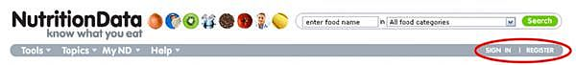

1. Go to [**www.nutritiondata.com**](http://www.nutritiondata.com) *(sign in, or register for a free account the first time).*
2. After you register, click on “**Go to our homepage**.”
3. Under “Nutrition Management Tools,” click “**Analyze Recipe**,” then “**Create Recipe**.”
4. 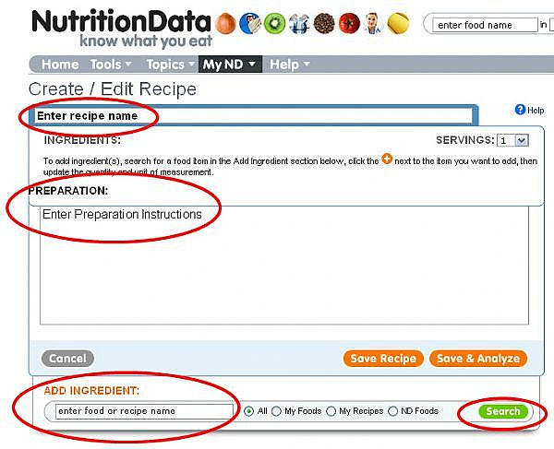Enter a **recipe name (e.g. Karla’s World-Famous Chili)**, the number of **servings** and **preparation instructions**.

1. Search for your first ingredient under “**Add Ingredient**” and click “**Search**.”
2. Find the best choice for your recipe. Click on the **orange plus sign** to the right. That item will now appear under “Ingredients.”
3. Now select the **quantity** and the **units** for the ingredient (e.g. 1 cup).
4. Continue this process for all the ingredients.
5. Once your recipe is complete, click "**Save & Analyze**."
6. Your nutritional label is now created. You can change the serving size by clicking on the drop-down menu next to "**Serving size**".
7. Download a printable label by clicking on "**Download Printable Label Image,**" under the label.