|  |
| --- |
| **EL Civics: Nutrition (Obj 46) • Beg High Task 1: Comparison Shopping** |
| **Language & Literacy Objectives:**   1. Identify a healthy diet as recommended by USDA. 2. Identify the relationship between nutrition and good health. |
| **INTRODUCTION** |
| In this lesson, students will compare prices for produce items at different food resources, and determine the most economical choice overall. Students will also learn vocabulary for fruits and vegetables commonly available in the U.S. |
| **ASSESSMENT TASK** |
| Students look at authentic ads from 3 different healthy food resources (supermarket, farmer’s market). Students compare prices for different fruits and vegetables, to select the food resource where they can buy the cheapest produce. 6 points possible. |
| **SUGGESTED ACTIVITIES** |
| Review “My Plate” for food groups   * Use LCD projector or handout to review My Plate & food groups   Bring in various produce items; Ss work in groups to sort into Fruits and Vegetables  Take a field trip to a grocery store and/or the Torrance Farmer’s Market  Bring in authentic ads from newspapers, stores, mailers & have students work in pairs or small groups to do a “produce hunt” (like a scavenger or treasure hunt, where you give them a list of items—and their prices—they must find in the advertisements). |

|  |
| --- |
| **HANDOUTS PROVIDED** |
| Handout 1: Related Vocabulary & Discussion Questions  Handout 2: Fruits  Handout 3: Vegetables  Handout 4: What Is It?  Handout 5: Comparison Shopping & Worksheet & KEY  Handout 6: Information Gap: Produce Ads (2 worksheets) & KEY  Handout 7: Practice/Review & Worksheet & KEY  Graphics courtesy of:  office.microsoft.com/clipart |
| **COMPUTER LAB IDEAS** |
| * Go to supermarket websites (e.g. vons.com, albertsons.com, 99ranch.com) and compare prices for the same items. * Students go shopping and bring in receipts. Work in groups to create graph showing different prices for similar items at different stores. * Watch video clips showing farmer’s markets (video.google.com), in lieu of (or in preparation for) visiting a farmer’s market in person. * Create a “picture dictionary” showing different fruits and vegetables. |

TASK 1 – Handout #1

**VOCABULARY**

*Adapted from* [*http://www.ldoceonline.com/*](http://www.ldoceonline.com/)

**$:** symbol for dollars

**¢:** symbol for cents

**advertisement (ad):** a picture, set of words, or a short film that persuades people to buy a product or use a service

**basket:** container to hold or carry things

**cheaper:** between two choices, the lower price (e.g. If avocados cost $1.99/each at Vons, and $1.50/each at Ralph’s, then Ralph’s is the cheaper store for avocados).

**cheapest/lowest:** of many choices, the least expensive price

**each:** one item, individually (e.g. Each avocado costs $1.50)

**farmer’s market:** public market at which farmers sell produce directly to consumers; usually outdoors.

**grocery store:** place to buy food and household supplies (e.g. paper towels, cleaners)

**head (hd):** flower of a plant (e.g. lettuce, cabbage, etc.)

**pound (lb):** measurement; unit of weight; 1 pound = 16 oz. = 4 cups

**produce:** fruits and vegetables

**price:** amount you pay; cost

**DISCUSSION QUESTIONS**

1. Who does the grocery shopping in your family?
2. Where do you shop for food?
3. How often do you go to the grocery store? Farmer’s Market?
4. What is typical produce available in your home country? Can you find the same items in the U.S.? If so, where?

*This page intentionally blank.*

TASK 1 - Handout #2

###### **FRUITS**

**Directions:** Study these fruits. Write the name of each fruit on the line under the picture.

|  |  |  |  |  |
| --- | --- | --- | --- | --- |
|  |  |  |  |  |
| strawberries  *strawberries* | bananas  ____________ | apple  ____________ | orange  ____________ | grapes  ____________ |
|  |  |  |  |  |
|  |  |  |  |  |
| pineapple  ____________ | watermelon  ____________ | pear  ____________ | cherries  ____________ | lemons  ____________ |

*This page intentionally blank.*TASK 1- Handout #3

**VEGETABLES**

**Directions:** Study these vegetables. Write the name of each vegetable on the line under the picture.

|  |  |  |  |  |
| --- | --- | --- | --- | --- |
|  |  |  |  |  |
| broccoli  *broccoli* | carrots  ____________ | corn  ____________ | tomatoes  ____________ | cucumber  ____________ |
|  |  |  |  |  |
|  |  |  |  |  |
| lettuce  ____________ | eggplant  ____________ | pepper  ____________ | mushrooms  ____________ | green beans  ____________ |

*This page intentionally blank.*

TASK 1- Handout #4

**WHAT IS IT?**

**Directions:** Read the words in the box. Match the name of the fruit or vegetable with the correct picture. Write the word on the line.

|  |  |  |  |  |
| --- | --- | --- | --- | --- |
| grapes | carrots | bananas | cucumber | cherries |
| lettuce | pineapple | pear | broccoli |  |

|  |  |
| --- | --- |
| lettuce | 1. ___________________________ |
| grapes | 2. ___________________________ |
| pears | 3. ___________________________ |
| cucumber | 4. ___________________________ |
| cherries | 5. ___________________________ |
| bananas | 6. ___________________________ |
| carrots | 7. ___________________________ |
| pineapple | 8. ___________________________ |
| broccoli | 9. ___________________________ |

*This page intentionally blank.*TASK 1 – Handout #5

**COMPARISON SHOPPING**

|  |
| --- |
| Henry’s Health Food Store    Corn 55¢ each strawberries $1.99 a basket    lemons 45¢ a pound green beans $1.19 a pound |
|  |
| Sally’s Supermart  The best prices in town!  corn grapes green beans lemons  45¢/each $1.99/lb 99¢/lb 50¢/lb |

*This page intentionally blank.*TASK 1 – Handout #5 (cont.)

**COMPARISON SHOPPING: WORKSHEET**

**Directions:** Look at the ads on page 7. Write the prices below.

1. green beans at Henry’s Health Food Store _________

2. strawberries at Henry’s Health Food Store _________

3. grapes at Sally’s Supermart _________

4. corn at Sally’s Supermart _________

5. corn at Henry’s Health Food Store _________

6. lemons at Sally’s Supermart _________

**Directions:** What is the **cheaper** place to buy these items? Circle the name of the store.

1. lemons

Henry’s Health Food Store Sally’s Supermart

2. green beans

Henry’s Health Food Store Sally’s Supermart

3. corn

Henry’s Health Food Store Sally’s Supermart

Write the prices. What is the **cheaper store to buy ALL your produce**?

**Henry’s Health Food Store**

corn

lemons

green beans

**TOTAL**

**Sally’s Supermart**

Corn

lemons

green beans

**TOTAL**

*This page intentionally blank*

TASK 1 - HANDOUT #5 (KEY)

**COMPARISON SHOPPING: WORKSHEET  
ANSWER KEY**

1. $1.19 a pound

2. $1.99 a basket

3. $1.99 a pound

4. .45 each

5. .55 each

6. .50 a pound

1. Henry’s Health Food Store

2. Sally’s Supermart

3. Sally’s Supermart

4.

**Henry’s Health Food Store**

corn .55

lemons .45

green beans 1.19

**Total** 2.19

**Sally’s Supermart**

corn .45

lemons .50

green beans .99

**Total** 1.94

*This page intentionally blank.*TASK 1 - HANDOUT #6

**INFORMATION GAP: PRODUCE ADS**

**Directions:** Talk to a partner. Ask for the prices. Fill in the blanks.

|  |  |  |
| --- | --- | --- |
| Grower’s Direct  Direct from the Farms!    avocados _______ /each    mushrooms _______ /lb    grapes _________/lb    peppers ______ /each    cherries _______ /lb    potatoes _______/lb |  | **The Produce Pantry** peppers  ___________ each    avocado  ___________ each  cherries  ___________ a pound  mushrooms  ___________ a pound  potatoes  ___________ lb  grapes  ___________ a pound |

**Directions:** Who has the **lowest price for** ……..? Write the name of the store.

1. *cherries* ________________________________________________

2. *peppers* ________________________________________________

3. *grapes* ________________________________________________

4. *eggplant* ________________________________________________

5. *mushrooms* ________________________________________________

6. What is the cheaper store to buy **ALL** your produce? ___________________

*This page intentionally blank.*TASK 1 – HANDOUT #6A

**Directions:** Talk to a partner. Ask for the prices. Fill in the blanks.

|  |  |  |
| --- | --- | --- |
| Grower’s Direct  Direct from the Farms!    avocados _______/each    mushrooms $3.49/lb    grapes _________/lb    peppers .99/each    cherries $2.99/lb    potatoes _______/lb |  | **The Produce Pantry**   peppers  $1.29 each    avocado  ___________ each  cherries  $4.99 a pound  mushrooms  $3.69 a pound  potatoes  ___________ lb  grapes  ___________ a pound |

**Directions:** Who has the **lowest price for** ……..? Write the name of the store.

1. *cherries* ________________________________________________

2. *peppers* ________________________________________________

3. *grapes* ________________________________________________

4. *eggplant* ________________________________________________

5. *mushrooms* ________________________________________________

6. What is the cheaper store to buy **ALL** your produce? ___________________

*This page intentionally blank.*TASK 1 – HANDOUT #6B

**Directions:** Talk to a partner. Ask for the prices. Fill in the blanks.

|  |  |  |
| --- | --- | --- |
| Grower’s Direct  Direct from the Farms!    avocados $1.89/each    mushrooms________/lb    grapes $1.99/lb    peppers ______/each    cherries __________/lb    potatoes 98¢/lb |  | **The Produce Pantry** peppers  ___________ each    avocado  $1.99 each    cherries  ___________ a pound  mushrooms  ___________ a pound  potatoes  89¢/lb  grapes  $2.99 a pound |

**Directions:** Who has the **lowest price for** ……..? Write the name of the store.

1. *cherries* ________________________________________________

2. *peppers* ________________________________________________

3. *grapes* ________________________________________________

4. *eggplant* ________________________________________________

5. *mushrooms* ________________________________________________

6. What is the cheaper store to buy **ALL** your produce? ___________________

*This page intentionally blank.*TASK 1 - HANDOUT #7

**PRACTICE/REVIEW**

**DIRECTIONS:** Compare the produce advertisements and answer the questions on p. 25.

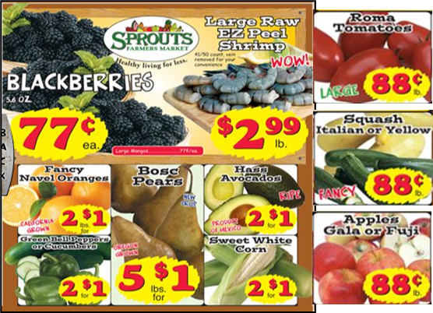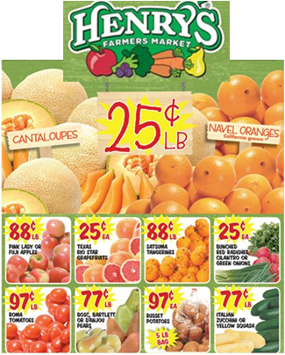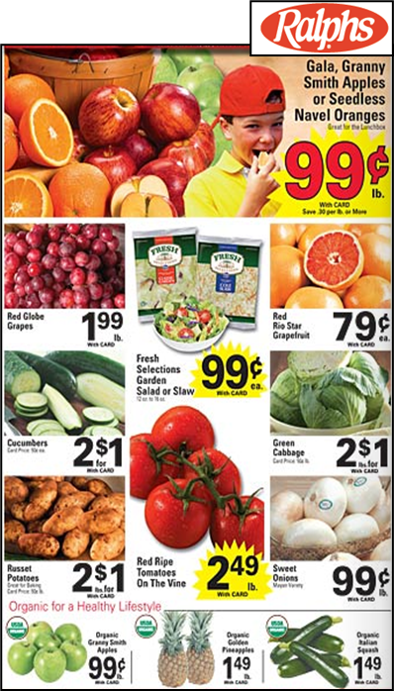

**PRACTICE/REVIEW: WORKSHEET**

**Directions:** Read the ads on page 23. Choose the cheapest place to buy each item listed below. Write the name of the store.

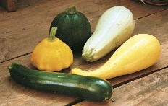

Example: **squash** _Sprouts Farmers Market_

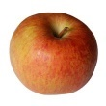  
1.  **gala** **apples** ___________________________________________  
  
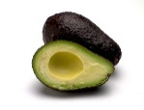

2. **avocados** ___________________________________________

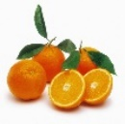

3. **navel oranges** ___________________________________________  
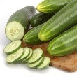

4. **cucumbers** ___________________________________________  
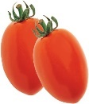

5. **roma tomatoes** ___________________________________________

6. **What is the cheapest store to buy ALL your produce?**  
  
 ______________________________________________________

*This page intentionally blank.*TASK 1 - HANDOUT #7 (KEY)

**PRACTICE/REVIEW: WORKSHEET (KEY)**

1. **gala apples** ***Sprouts Farmers Market***

2. **squash**  ***Henry’s Farmers Market***

3. **navel oranges** ***Henry’s Farmers Market***

4. **cucumbers** ***Ralphs OR Sprouts Farmers Market***

5. **roma tomatoes** ***Sprouts Farmers Market***

6. **What is the cheapest store to buy ALL your produce?**  
  
 ***Henry’s Farmers Market***