EL Civics Obj 11/Diversity
Level: Intermediate Low (4)
Task 2: Write About Culture

Language & Literacy Objectives:
1. Write and/or report personal information: name, place of birth, native language, etc.
3. Interview classmates about cultural information.
8. Report orally or in writing about one’s cultural background.
INTRODUCTION
In this lesson, students will explore typical customs and traditions in their own culture and those of their classmates. They will also look for similarities and differences between cultures, especially as they relate to the following topics: Education, Food, Medical Care, Money and Work.

ASSESSMENT TASK
For this task, the student will write about life in his native country and compare it to life in the U.S. 25 points possible.

SUGGESTED CLASSROOM ACTIVITIES
- Multicultural Fair @ TAS: Work with other classes at your site (or between sites) to plan and organize a Multicultural Fair that would highlight the similarities and differences between cultures. Students would determine theme & activities, plus be responsible for marketing and logistics.

HANDOUTS PROVIDED
Handout 1: Vocabulary - Culture
Handout 2: Conversation Questions - Culture
Handout 3: Introduction – Cultural Customs & Traditions
Handout 4: Worksheet – Holiday Traditions
Handout 5: Introduction – Technology Across Cultures
Handout 6: Activity – Technology Across Cultures
Handout 7: Worksheet – Customs & Traditions: Similarities
Handout 8: Worksheet – Customs & Traditions: Differences
Handout 9: Practice – Write About Culture

ADDITIONAL RESOURCES
- Related Websites - see list in “Additional Resources” section of this binder.
COMPUTER LAB IDEAS
- Class Newsletter: Students can write articles about customs and traditions in their native countries, or compare their native traditions to those in the U.S. (Publisher, Internet) Read-Write-Think.
- Class Blog: Students can post about customs and traditions in their native countries, or compare their native traditions to those in the U.S. (Internet). www.blogger.com

INDICATORS FOR INTERMEDIATE LOW
TASK 2
(W.4.3) write and expand upon simple, compound and a few complex sentences, applying basic capitalization, spelling, and punctuation rules when writing (ELPS 10.3)
(W.4.17) use an increasing number or general academic and content specific words and expressions in writing (ELPS 7.3)
(W.4.18) use common transition words and phrases to connect events, ideas, and opinions (ELPS 9.3)

(G.4.1) irregular verbs (SEE REGULAR AND IRREGULAR VERBS LIST)
(G.4.7) Mixed tenses: simple present, present progressive, and present perfect)

TASK 2– Handout #1

VOCABULARY: CULTURE
Adapted from Longman Dictionary of Contemporary English Online (www.ldoceonline.com)

activities: things people do either because they enjoy it or in order to achieve a
particular goal.

appropriate: correct or suitable for a particular time, situation, or purpose

celebrate: to show that an event or occasion is important by doing something
special or enjoyable.

compare: to examine or judge two or more things in order to show how they are
similar to or different from each other.

custom: something people do in a particular society because it is traditional.

differences: ways in which two or more people or things are not like each other. Also: “different from.”

holiday: time of rest from work, school, etc.

impolite: not polite; rude

inappropriate: not suitable or right for a particular purpose or in a particular situation

polite: behaving or speaking in a way that is correct for a social situation, and considering other people's needs and feelings

preparations: making arrangements for something that is going to happen.

similarities: ways in which two or more people or things are almost the same. Also: alike, “same as.”

tradition: a belief, custom, or way of doing something that has existed for a
long time.

typical: someone behaving or something happening in the usual way you expect.

value: the importance or usefulness of something.

with regard to: about a particular subject.
This page intentionally blank

TASK 2 – Handout #2

CONVERSATION QUESTIONS: CULTURE
adapted from The Internet TESL Journal (http://iteslj.org/questions/culture.html)

- Are there many people of different cultures in your country?

- Have you ever felt confused by the actions of someone from another culture?
  - If so, describe the situation.

- In your culture, is it polite to be straightforward and direct when you talk to someone?

- Would you ever consider marrying or dating someone from another culture?
- What is considered rude in your culture?
- How do young people in your culture behave differently from older people?
This page intentionally blank

TASK 2 –Handout #3
INTRODUCTION: CULTURAL CUSTOMS & TRADITIONS

One of the best ways to learn about people is to look at their customs and traditions. These illustrate the values most important to the people living there, and also show how they connect, relax and have fun.

What is a custom?
A custom is the usual way of behaving or acting. For example:

In the United States, most brides wear white on their wedding day. White is a symbol of purity.

The traditional wedding gown in China is bright red with gold. These colors symbolize luck for the new couple.

What is a tradition?
A tradition is a custom, opinion or belief handed down from one generation to another, often orally or by practice. For example:

In Spain on New Year’s Eve, it is traditional to eat twelve grapes, one for each month of the new year.

In Britain, it is traditional to drink tea with milk in the afternoon.

  - What customs do you practice?
  - What are your favorite customs?
This page intentionally blank.
TASK 2 –Handout #3 (cont.)

INTRODUCTION: CULTURAL CUSTOMS & TRADITIONS (cont.)

What is a holiday?
A holiday is a day that has special meaning for individuals, a government or a religious group. It is usually an official observance of religious, national or cultural significance, often accompanied by celebrations or festivities.

Examples (from http://www.earthcalendar.net):

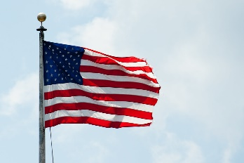
July 4 – Independence Day in United States
Celebration of America’s independence from England in 1776. Traditions include barbeques, parades, block parties and lighting/watching fireworks. Also known as “4th of July.”

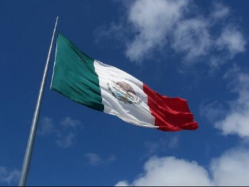
May 5 – Cinco de Mayo in Mexico
Commemorates the Mexican army's unpredicted victory over the French soldiers in the Battle of Puebla that occurred on May 5, 1862. Cinco de Mayo means "Fifth of May" in Spanish. It is not Mexican Independence Day, as some believe. (That is September 16.)

Think about some popular holidays in your native country and the U.S. …
Which ones are your favorites?
How are those holidays typically celebrated?
Which U.S. holidays do you enjoy the most?
This page intentionally blank.
TASK 2 –Handout #4

WORKSHEET – HOLIDAY TRADITIONS

Directions: Write about a holiday in your country. Interview another student and learn about a holiday in his or her native country.

 | My Country: _____________ | Classmate’s Country: _____________
Name & date of holiday:

Who we celebrate with:

Activities we plan:

Food we eat:

Customs we take part in:

This page intentionally blank.

Task 2 – Handout #5

INTRODUCTION: TECHNOLOGY ACROSS CULTURES

When it comes to using cell phones, what is considered polite? Are the “rules” different in your home country and the U.S.?

Directions: Work with a partner to answer the questions below.

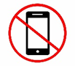
Cell Phone Etiquette

- With your partner, brainstorm 3 places it is appropriate (OK) to use a cell phone.

____________ _____________ _____________

Is it the same in your home countries and the U.S.?

- With your partner, brainstorm 3 places it is inappropriate (not OK) to use a cell phone.

____________ _____________ _____________

Is it the same in your home countries and the U.S.?

- Watch the video at http://www.youtube.com/watch?v=1TRDNdDWYDU
What are 3 places “Curt the Cyberguy” said it is not OK to use a cell phone?

____________ _____________ _____________

This page intentionally blank
Task 2 – Handout #6

ACTIVITY: TECHNOLOGY ACROSS CULTURES
Communicating Cliparts #63221

Polite or Impolite?

Is it polite/safe to use your cell phone_________?
Yes, it is.
No, it isn't.

Directions: Interview two partners. Ask them to compare customs in their home countries and the U.S. Share with the class & create a chart with all the results.

1) Is it polite to use your cell phone in the bathroom?

2) Is it polite to use your cell phone at the movies?

3) Is it polite to use your cell phone on the bus?

4) Is it polite to use your cell phone at a restaurant?

5) Is it polite to use your cell phone in English class?

6) Is it safe to use a cell phone while driving?

This page intentionally blank.

TASK 2 –Handout #7

WORKSHEET – CUSTOMS & TRADITIONS: SIMILARITIES

Think about life in your native country and life in the U.S. Fill in the chart below to compare the two cultures. Show how they are the same, or similar.

My native country:
___________________________

The United States

What are two ways these cultures are alike?

With regard to these topics … | Example 1: | Example 2:
EDUCATION:

FOOD/COOKING:

TECHNOLOGY:

HOLIDAYS & GIFT GIVING:

WORK:

This page intentionally blank.
TASK 2 –Handout #8

WORKSHEET – CUSTOMS & TRADITIONS: DIFFERENCES

Think about life in your native country and life in the U.S. Fill in the chart below to compare the two cultures. Show how they are different.

My native country:
___________________________

The United States

What are two ways these cultures are different?

In my native country … | With regard to … | In the U.S. …
 | EDUCATION
 | FOOD/COOKING
 | TECHNOLOGY
 | Holidays/Gift giving
 | WORK

This page intentionally blank.
TASK 2 –Handout #9

PRACTICE: WRITE ABOUT CULTURE

Directions: Answer the questions below about yourself and your native country. Fill in the blank spaces with your answers.

- Where were you born? __________________________________________
Where did you grow up? __________________________________________
What was your first language? __________________________________________

- What is your favorite holiday from your native country? Write about two (2) customs to celebrate it.

This page intentionally blank.
TASK 2 –Handout #9

PRACTICE: WRITE ABOUT CULTURE

Directions: To answer Questions #3 & #4, choose one of the topics below to write about.
CIRCLE  YOUR  CHOICE: | Technology | Holidays & Gift Giving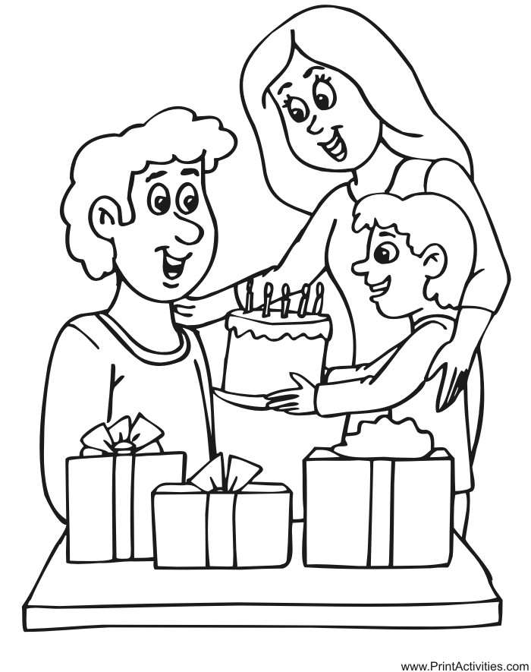
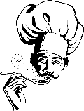  Food/Cooking | Work | Education
- Give one example (about this topic) that shows how life in your native country is THE SAME AS life in the U.S.:
Give one example (about this topic) that shows how life in your native country is DIFFERENT FROM life in the U.S.:

