EL Civics Obj 11/Diversity
Level: Beginning Low (2) & Beginning High (3)
Task 2: Report About Your Country
Language & Literacy Objectives:
1. Write and/or report personal information: name, place of birth, native language, etc.
3. Interview classmates about cultural information.
8. Report orally or in writing about one’s cultural background.
INTRODUCTION
In this lesson, students will explore typical customs and traditions in their own culture and those of their classmates. They will also look for similarities and differences between cultures, especially as they relate to the following topics: Education, Food, Medical Care, Money and Work.

ASSESSMENT TASK
For this task, each student will describe 5 customs from their native country that are the same as or different from customs in the U.S. 15 points possible.

SUGGESTED CLASSROOM ACTIVITIES
- Multicultural Fair @ TAS: Work with other classes at your site (or between sites) to plan and organize a Multicultural Fair that would highlight the similarities and differences between cultures. Students would determine theme & activities, plus be responsible for marketing and logistics.

INDICATORS FOR BEGINNING LOW
TASK 2
(R.2.4) follow simple written instructions and geographical directions that include pictures, diagrams or simple maps
(R.2.8) understand and respond to simple questions in print

(W.2.5) write short written exchanges about familiar topics in familiar contexts (including written lists and schedules) using basic punctuation
(e.g., capitalization, periods, commas, question marks) (ELPS 2.1,9.1, 10.1)
(W.2.7) present simple information in writing using a narrow range of vocabulary and syntactically simple sentences
(including a small number of frequently occurring nouns, noun phrases, verbs, conjunctions, and prepositions in writing) (ELPS 9.1, 10.1)
(W.2.13) write simple statements (affirmative and negative) (ELPS 9.1, 10.1)
(W.2.15) write compound sentences with “and,” “or,” and “but” (ELPS 9.1, 10.1)

(GS.2.3) subject pronouns
(GS.2.4) singular and plural of nouns
(GS.2.5) simple present of be
(GS.2.6) simple present of regular verbs (not be)

INDICATORS FOR BEGINNING HIGH
TASK 2
(R.3.2) follow simple written, multi-step instructions (ELPS 9.2)

(W.3.3) write simple sentences and compound sentences (with “and,” “or,” “but,” “because,” and “and…too/either”) related to familiar situations (ELPS 2.2. 10.2)
(W.3.6) use basic punctuation (e.g., capitalization, periods, commas, question marks) (ELPS 10.2)
(W.3.17) adapt written language choice to task and audience (ELPS 7.2)
(W.3.18) use frequently occurring academic and content specific words in writing (ELPS 7.2)
(W.3.21) use frequently occurring verbs, nouns, adjectives, adverbs, prepositions, and conjunctions in writing (ELPS 10.2)

(G.3.3) spelling and basic usage of definite/indefinite articles
(G.3.8) count and non-count nouns
(G.3.14) prepositions of location
(G.3.15) basic coordinating conjunctions: but, and, or

HANDOUTS PROVIDED
Handout 1: Vocabulary - Culture
Handout 2: Conversation Questions - Culture
Handout 3: Introduction – Cultural Customs & Traditions
Handout 4: Worksheet – Holiday Traditions
Handout 5: Introduction – Technology Across Cultures
Handout 6: Activity – Technology Across Cultures
Handout 7: Worksheet – Customs & Traditions: Similarities
Handout 8: Worksheet – Customs & Traditions: Differences
Handout 9: Practice – Write About Culture

ADDITIONAL RESOURCES
- Related Websites - see list in “Additional Resources” section of this binder.

COMPUTER LAB IDEAS
- Class Newsletter: Students can write articles about customs and traditions in their native countries, or compare their native traditions to those in the U.S. (Publisher, Internet) Read-Write-Think.
- Class Blog: Students can post about customs and traditions in their native countries, or compare their native traditions to those in the U.S. (Internet). www.weebly.com

TASK 2– Handout #1

VOCABULARY: CULTURE
Adapted from Longman Dictionary of Contemporary English Online (www.ldoceonline.com)

activities: things people do for fun, or to reach a goal.

celebrate: to show that an event or occasion is important by doing something
special or enjoyable.

custom: something that is done by people in a particular society because it is
traditional.

different: when people or things are not like each other.

holiday: time of rest from work, school, etc.

similar: alike; almost the same.
tradition: a belief, custom, or way of doing something that has existed for a
long time.

typical: someone behaving or something happening in the usual way you
expect.
value: the importance or usefulness of something.

This page intentionally blank

TASK 2 – Handout #2

CONVERSATION QUESTIONS: CULTURE
adapted from The Internet TESL Journal (http://iteslj.org/questions/culture.html)
- What is culture? (Music, language, sports ...)
- Why is culture important?
- What do you like about your native culture?
- Are there people of different cultures in your country?
- What American customs do you like?
- Are there any American customs you do not like?

This page intentionally blank

TASK 2 –Handout #3
INTRODUCTION: CULTURAL CUSTOMS & TRADITIONS

One way to learn about the people living in a country is to look at their customs and traditions. Many have been passed down for generations.

What is a custom?
A custom is the usual way of behaving or acting. For example:

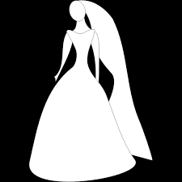 | In the United States, most brides wear white on their wedding day. White is a symbol of purity.
 | The traditional wedding gown in China is bright red with gold. These colors symbolize luck for the new couple.

What is a tradition?
A tradition is a custom passed from one generation to another. For example:
In Spain on New Year’s Eve, it is traditional to eat twelve grapes, one for each month of the new year.

In Britain, it is traditional to drink tea with milk in the afternoon.

  - What customs do you practice?
  - What are your favorite customs?
This page intentionally blank.

TASK 2 –Handout #3 (cont.)

INTRODUCTION: CULTURAL CUSTOMS & TRADITIONS (cont.)

What is a holiday?
A holiday is a day set aside to honor a person or remember an event. It usually involves rest from work. Holidays often include culture-wide activities and rituals.

Examples (from http://www.earthcalendar.net):

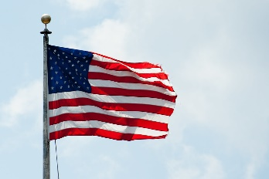

July 4 – Independence Day in United States
Celebration of America’s independence from England in 1776. Traditions include picnics and fireworks.

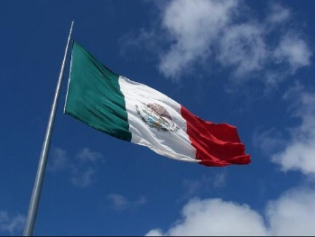

May 5 – Cinco de Mayo in Mexico
Commemorates the Mexican army's surprise victory during a battle with French soldiers in 1862. Cinco de Mayo means
"Fifth of May" in Spanish.

Think about some popular holidays in your native country and the U.S. …
Which ones are your favorites?
How are those holidays typically celebrated?
Which U.S. holidays do you enjoy the most?

This page intentionally blank.

TASK 2 –Handout #4

WORKSHEET – HOLIDAY TRADITIONS

Directions: Write about a holiday in your country. Interview another student and learn about a holiday in his or her native country.

 | My Country: _____________ | Classmate’s Country: _____________
Name & date of holiday:

Who celebrates:

Food:

Customs:

This page intentionally blank.

Task 2 – Handout #5

INTRODUCTION: TECHNOLOGY ACROSS CULTURES
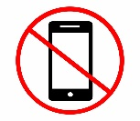

Many people have cell phones. Some people are polite when the use their phone. Others are rude. Are you a polite cell phone user?

Directions: Work with a partner to answer the questions below.

Cell Phone Etiquette

- With your partner, think of 2 places it is OK to use a cell phone.

_________________ __________________

Is it the same in your home countries and the U.S.?

_________________
- With your partner, think of 3 places it is not OK to use a cell phone.

________________ _________________ __________________

Is it the same in your home countries and the U.S.?

_________________

This page intentionally blank
Task 2 – Handout #6

ACTIVITY: TECHNOLOGY ACROSS CULTURES

Polite or Impolite?

Is it polite/safe to use your cell phone_________?
Yes, it is.
No, it isn't.

Directions: Interview a partner. Ask him to compare customs in his home country and the U.S. Share with the class & create a chart with all the results.

1) Is it polite to use your cell phone at the movies?

2) Is it polite to use your cell phone on the bus?

3) Is it polite to use your cell phone in English class?

4) Is it safe to use a cell phone while driving?

This page intentionally blank.

TASK 2 –Handout #7

WORKSHEET – CUSTOMS & TRADITIONS: SIMILARITIES

Think about life in your native country and life in the U.S. How are they similar? Fill in the chart below.

My native country:
___________________________

The United States

How are these cultures alike?

With regard to …

EDUCATION:

FOOD/COOKING:

TECHNOLOGY:

HOLIDAYS & GIFT GIVING:

WORK:

This page intentionally blank.
TASK 2 –Handout #8

WORKSHEET – CUSTOMS & TRADITIONS: DIFFERENCES

Think about life in your native country and life in the U.S. How are they different? Fill in the chart below.
In my native country:
___________________________

In the United States

How are these cultures different?

With regard to …

EDUCATION

FOOD

TECHNOLOGY

HOLIDAYS & GIFT GIVING

WORK

This page intentionally blank.

TASK 2 –Handout #9

PRACTICE: REPORT ABOUT YOUR COUNTRY

Directions: Describe 5 customs from your home country that are different from customs in the United States.

EDUCATION | In my home country, ____________________________________________________________  In the U.S., _____________________________________________________________________
FOOD/COOKING 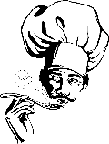 | In my home country, ____________________________________________________________  In the U.S., _____________________________________________________________________
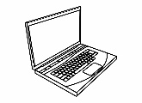  TECHNOLOGY | In my home country, ____________________________________________________________  In the U.S., _____________________________________________________________________
HOLIDAYS  & GIFT GIVING  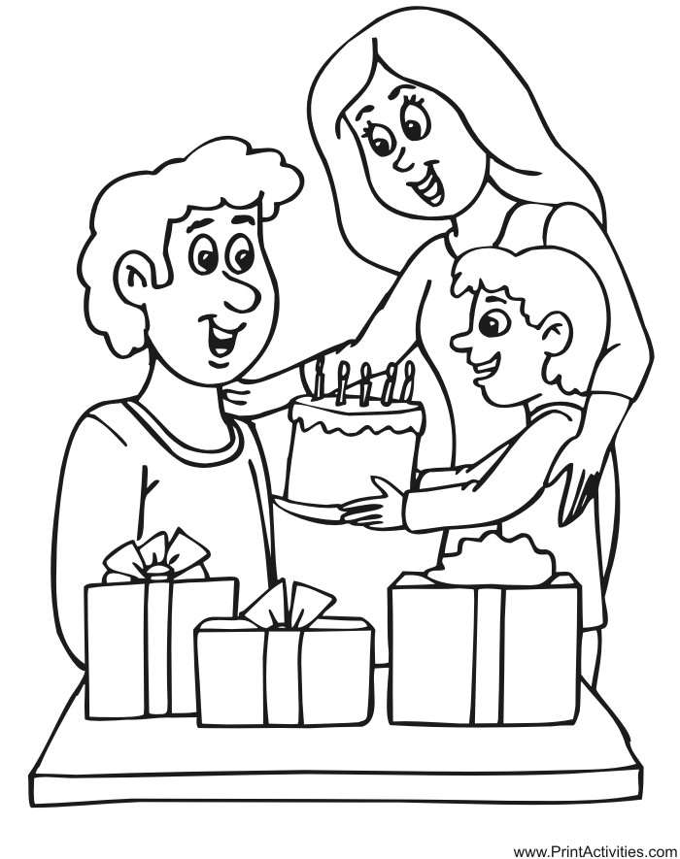 | In my home country, ____________________________________________________________  In the U.S., _____________________________________________________________________
WORK | In my home country, ____________________________________________________________  In the U.S., _____________________________________________________________________

