EL Civics Objective 11.6/Diversity
Level: Int. Low-Advanced Levels 4, 5, 6
Task 1: Identify and Describe a
Classmate’s Culture

Language & Literacy Objectives:
1. Write and/or report personal information: name, place of birth, native language, etc.
3. Interview classmates about cultural information.
4. Identify classmates’ countries of origin on a map.

INTRODUCTION
In this lesson, students will learn conversational techniques to find out where their classmates are originally from. They will get practice reading world maps, identifying the location of their home country & continent, identifying the location of their classmates’ home countries, and asking questions about their classmates’ cultures.

ASSESSMENT TASK
Use a map to locate and name home country and continent of origin, and one other classmate’s as well. Will then interview the classmate using 5 (IL4) or 6 (IH5/A6) level-appropriate questions about culture developed by the class. 12-14 points possible.

SUGGESTED CLASSROOM ACTIVITIES
- Survey the class to find out how many students were born in each continent. Write on board or type & project. Sort further by country, region, native language, etc. Can be done on board, typed & projected, or with students physically moving around the room to sort themselves.
- Create Your Own Country: Students work in groups to create a map and “plan” for a brand-new country. What are typical jobs? Where do people meet up to have fun? What is the schooling like? Where do people live?

- Students organize and host “International Day” in the classroom. They can bring in typical mementos, food, photographs, clothing, etc. from their native countries. Students can work in groups based on region, native language, etc.

This page intentionally blank

INDICATORS FOR INTERMEDIATE LOW
TASK 2
(W.4.3) write and expand upon simple, compound and a few complex sentences, applying basic capitalization, spelling, and punctuation rules when writing (ELPS 10.3)
(W.4.17) use an increasing number or general academic and content specific words and expressions in writing (ELPS 7.3)
(W.4.18) use common transition words and phrases to connect events, ideas, and opinions (ELPS 9.3)

(G.4.1) irregular verbs (SEE REGULAR AND IRREGULAR VERBS LIST)
(G.4.7) Mixed tenses: simple present, present progressive, and present perfect)

INDICATORS FOR INTERMEDIATE HIGH A
TASK 2
(R.5.3) follow simply written directions and narratives on authentic topics

(W.5.2) draft, organize, write, and edit short paragraphs using topic sentence, supporting details, concluding sentence, and transitions (ELPS 2.4, 3.4)
(W.5.4) use complex phrases and clauses (ELPS 10.4)
(W.5.5) produce and expand simple, compound, and complex sentences (ELPS 10.4)

INDICATORS FOR INTERMEDIATE HIGH B
TASK 2
(W.5.17) adapt written language choice to task and audience (including the adoption and maintenance of a formal and informal style and tone) (ELPS 7.4)
(W.5.18) use a wide range of complex general academic and content specific words and expressions using connecting words for coordination (yet-contrast, so-result, for-reason) (ELPS 7.4)

INDICATORS FOR ADVANCED
TASK 2
(W.6.1) demonstrate and use correct use of capitalization, punctuation, and spelling (e.g.), using reference materials to edit and revise)
(W.6.11) produce and expand simple, compound, and complex phrases/clauses/sentences (ELPS 10.5)

(G.6.3) Prepositions of location

HANDOUTS PROVIDED
Handout 1: Vocabulary — Identify and Describe Culture
Handout 2: Introduction – Where are you from?
Handout 3: Introduction – Conversation Questions about Culture
Handout 4: Practice – Interview Classmates about Culture
Handout 5: Practice – Identify & Describe Culture

ADDITIONAL RESOURCES
- Graphics, PowerPoint presentations & activity worksheets available for download in “Additional Resources” section of EL Civics folder (see desktop of classroom computer or teacher’s workstation in labs).
- Related Websites - see list in “Additional Resources” section.

COMPUTER LAB IDEAS
- http://maps.google.com (Google Maps). Show students a demonstration of how to enter your name, native country (town?), and continent where you were born. Have each student enter his/her information on the map. Display map each day as students walk into the class, or during the break, adding updates. See instructions/activity in Additional Resources.
- www.esl-lab.com/intro2/intro2.htm (Randall’s ESL Listening Lab).
Play this sound clip for the class & have the class work together to answer the follow-up/comprehension questions. Replay clip. Ask students to use the conversation model to ask two other students in the class where they are from.
- Create a “Culture Scavenger Hunt” using a site(s) provided on the “Related Websites” page or in the EL Civics folder on your computer desktop. Send students on the Internet in search of unusual and interesting customs and traditions. Would probably be most interesting to do with cultures not represented already in the classroom, and/or have students confirm or challenge the information they find about their own countries.
Task 1– Handout #1

VOCABULARY: IDENTIFY & DESCRIBE CULTURE
Adapted from Longman Dictionary of Contemporary English Online (www.ldoceonline.com)

belief: what you feel is true or right.
Example: My belief is that family should always come first.
culture: system of beliefs, values, rules and customs that is shared by a group. It is used to interpret experiences and direct patterns of behavior.
custom: something that is done by people in a particular culture because it is traditional.
Example: It's the custom for the bride's family to pay for the wedding.

direct communication: saying exactly what you mean in an honest, clear way. Goal is to get things done, particularly if there is a deadline or a law that must be followed.

habit: usual and repeated behavior or custom.
Example: My family has dinner together every Sunday.

indirect communication: not saying or showing something in a clear, definite way. Goal is to create an environment of collaboration and involvement of others, especially if there is more than one possible way to do something.

polite: behaving or speaking in a way that is correct for the social situation you are in, and showing that you are careful to consider other people's needs and feelings.

stereotype: a belief or idea of what a particular type of person or thing is like. May be unfair or untrue, or partially true. Example: All Californians have blond hair, blue eyes and tanned skin.

rude: speaking or behaving in a way that is not polite and is likely to offend or annoy people.

success: when you achieve what you want or intend.

taboo: a custom that says you must avoid a particular activity or subject, either because it is considered offensive or because your religion does not allow it.

typical behavior: common or usual among many, but not necessarily all, people in a culture.
Example: Many Americans leave home when they are 18 years old.
value: belief or idea that you consider important or desirable.
Example: Relationships with family are most important to me.

Helpful Phrases
My name is... What is your name? Where are you from? I'm from...

This page intentionally blank

TASK 1 –Handout #2
INTRODUCTION: WHERE ARE YOU FROM?

Many people who live in the U.S. come from countries all over the world. Where were you born? Ask three of your classmates where they are from and fill in all your answers below.
- Your native country: ______________________________________________
- Classmate 1 - native country: ______________________________________________
- Classmate 2 - native country: ______________________________________________
- Classmate 3 – native country: ______________________________________________
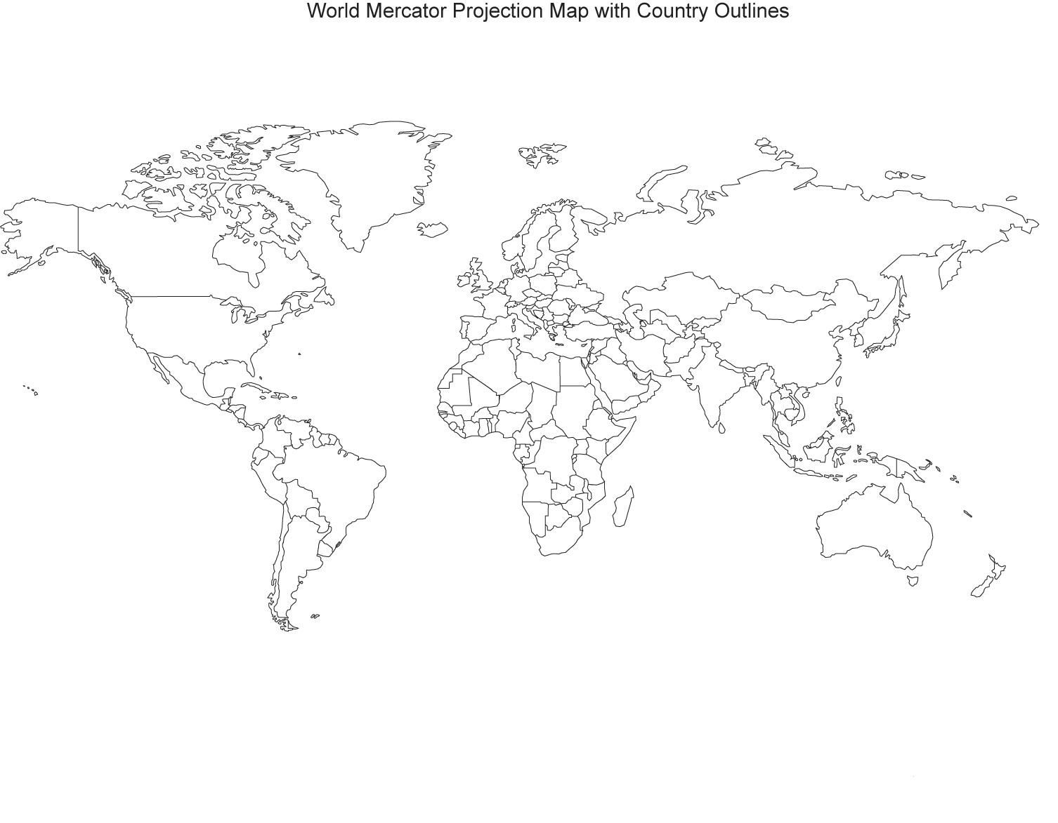

This page intentionally blank

TASK 1 – Handout #3

INTRODUCTION: CONVERSATION QUESTIONS ABOUT CULTURE
Adapted from: © 1997-2015, The Internet TESL Journal (http://iteslj.org/questions/culture.html)
Directions: Work with your teacher and class to develop a list of questions that can help you better understand your classmates and their native cultures. Then, interview your classmates, write down their responses, and share what you learned with your whole class (see Handout #4 to collect answers).
When you meet someone from another culture, you may notice that you have different customs or ways of doing things. What would you like to know about people from other cultures? Some questions might include:
- What are some things that define a culture? For example, music, language ...
- What do you think is interesting about your native culture?
- What would you change about your native culture?
- What does it mean to be polite in your culture?
- What behavior is considered rude in your culture?
- What are the most important values of your culture? (For example, family)
- What defines success in your culture?
- In your culture, do most people have a healthy balance of work and home life?
- In your culture, is it more polite to be direct or indirect when you talk to someone?
- How do young people in your culture behave differently from young Americans?
- How are older people treated in your culture? Is it different from American culture?
- In your culture, is it acceptable to date or marry someone from another culture?
- Is it OK to discuss religion or politics in your culture? Are any topics taboo?
This page intentionally blank

TASK 1 –Handout #4
PRACTICE: INTERVIEW CLASSMATES ABOUT CULTURE

Directions: Find 2 classmates to work with. They should be people you don’t know very well, preferably from different native countries than your own. Ask the questions selected by your class (write them down first), then write your classmates’ answers below.

Question 1:

Classmate’s Response (1):

Classmate’s Response (2):

Question 2:

Classmate’s Response (1):

Classmate’s Response (2):

Question 3:

Classmate’s Response (1):

Classmate’s Response (2):

This page intentionally blank

TASK 1 –Handout #4
PRACTICE: INTERVIEWING CLASSMATES ABOUT CULTURE (cont.)
Question 4:

Classmate’s Response (1):

Classmate’s Response (2):

Question 5:

Classmate’s Response (1):

Classmate’s Response (2):

Question 6:

Classmate’s Response (1):

Classmate’s Response (2):

This page intentionally blank

TASK 1 –Handout #5
PRACTICE: IDENTIFY AND DESCRIBE CULTURE
Directions: Write the names of the countries, then circle each one on the map below:
- Your native country: ______________________________________________
- One classmate’s native country: ______________________________________________
Directions: Follow your teacher’s instructions and interview another student. Ask your classmate 6 questions about his or her native county. Write the answers here:
- ________________________________________________________________
- ________________________________________________________________
- ________________________________________________________________
- ________________________________________________________________
- ________________________________________________________________
- ________________________________________________________________

