EL Civics Obj 11.6/Diversity
Level: Beginning (Levels 2-3)
Task 1: Identify & Describe a Classmate’s Culture

Language & Literacy Objectives:
1. Write and/or report personal information: name, place of birth, native language, etc.
3. Interview classmates about cultural information.
4. Identify classmates’ countries of origin on a map.

INTRODUCTION
In this lesson, students will learn conversational techniques to find out where their classmates are originally from. They will get practice reading world maps, identifying the location of their home country & continent, and identifying the location of their classmates’ home countries.

ASSESSMENT TASK
Student will use a map to locate and name his/her country and continent of origin, and one other classmate’s country of origin. BL(2) = 8 points possible. BH(3) = 10 points.

SUGGESTED CLASSROOM ACTIVITIES
- http://maps.google.com (Google Maps)
Show students a demonstration of how to enter your native country (and town?) and your name. Have each student enter his/her information on the map. Display map each day as students walk into the class, or during the break.
See directions in Additional Resources.

INDICATORS FOR BEGINNING LOW
TASK 1
(L.2.3) identify/respond to simple questions/statements in familiar contexts (e.g., weather, family, employment, personal information)
(L.2.5) follow one-step spoken directions in a familiar context to complete a simple task

(S.2.3) produce syntactically simple statements using a narrow range of vocabulary and a small number of frequently occurring nouns, noun phrases, verbs, conjunctions, and prepositions to communicate information, feelings, and opinions about routine and familiar topics and situations (ELPS 3.1, 4.1, 9.1, 10.1)
(S.2.4) understand and respond to simple questions in a familiar situation demonstrating a developing control of grammar (including asking for repetition or help when there is lack of understanding) (ELPS 2.1)
(S.2.5) communicate simple information or feelings about familiar topics, events, or experiences and provide support by producing simple statements (including responding to common greetings, introductions and polite expressions) (ELPS 3.1, 9.1, 10.1)
(S.2.6) use simple formal and informal language depending on audience (ELPS 7.1)

(R.2.4) follow simple written instructions and geographical directions that include pictures, diagrams or simple maps
(R.2.8) understand and respond to simple questions in print

(W.2.7) present simple information in writing using a narrow range of vocabulary and syntactically simple sentences (including a small number of frequently occurring nouns, noun phrases, verbs, conjunctions, and prepositions in writing) (ELPS 9.1, 10.1)
(W.2.10) understand and respond to simple written questions (ELPS 9.1, 10.1)

INDICATORS FOR BEGINNING HIGH
TASK 1
(L.3.3) follow multiple-step directions and instructions (ELPS 9.2)
(L.3.5) take turns appropriately in interactions with others (ELPS 2.2, 7.2)

(S.3.6) use informal and formal language appropriately (such as colloquial and academic expressions) (ELPS 2.2,3.2, 5.2, 7.2)
(S.3.10) use some frequently occurring content-specific words/academic words (ELPS 3.2, 4.2, 5.2, 7.2)
(S.3.14) use frequently occurring verbs, nouns, adjectives, adverbs, and prepositions (ELPS 9.2) (SEE S.3.11 & S.3.14 LIST)

(R.3.2) follow simple written, multi-step instructions (ELPS 9.2)

(W.3.6) use basic punctuation (e.g., capitalization, periods, commas, question marks) (ELPS 10.2)

HANDOUTS PROVIDED
Handout 1: Vocabulary — Identify and Describe Culture
Handout 2: Conversation Questions - Culture
Handout 3: Introduction – Where are you from?
Handout 4: Practice – Where are you from?
Handout 5: Practice – Identify & Describe Culture

ADDITIONAL RESOURCES
- Graphics, presentations & activity worksheets available for download in “Additional Resources” section of EL Civics shared folder (see desktop of classroom computer or teacher’s workstation in labs).
- Related Websites - see list in “Additional Resources” section of this binder. Live links to all sites listed available in “Related Websites” section of EL Civics shared folder.

COMPUTER LAB IDEAS
- www.esl-lab.com/intro2/intro2.htm (Randall’s ESL Listening Lab).
Play this sound clip for the class & have the class work together to answer the follow-up/comprehension questions. Replay clip. Ask students to use the conversation model to ask two other students in the class where they are from.

Task 1 – Handout #1

VOCABULARY: IDENTIFY & DESCRIBE CULTURE
Adapted from Longman Dictionary of Contemporary English Online (www.ldoceonline.com)

belief: what you feel is true or right.
Example: My belief is that family should always come first.

culture: system of beliefs, values, rules and customs that is shared by a group.

custom: something that is done by people in a particular culture because it is traditional.
Example: It's the custom for the bride's family to pay for the wedding.

habit: usual and repeated behavior or custom.
Example: My family has dinner together every Sunday.

home (native) country: where you were born and/or grew up.

stereotype: a belief or idea of what a particular type of person or thing is like. May be unfair or untrue, or partially true. Example: All Californians have blond hair, blue eyes and tanned skin.

typical behavior: common or usual among many, but not necessarily all, people in a culture.
Example: Many Americans leave home when they are 18 years old.

value: belief or idea that you consider important or desirable.
Example: Relationships with family are most important to me.

Helpful Phrases
My name is...
What is your name?
Where are you from?
I'm from...

TASK 1 – Handout #2

CONVERSATION QUESTIONS: CULTURE
Adapted from: © 1997-2010, The Internet TESL Journal (http://iteslj.org/questions/culture.html)
- What defines a culture? For example, music, language, ...

- Why is culture important?
- What do you like about your native culture?
- What would you change about your native culture?
- Are there many people of different cultures in your home country?
- What parts of American culture do you like?

- What parts of American culture confuse you?
This page intentionally blank

TASK 1 –Handout #3
INTRODUCTION: WHERE ARE YOU FROM?
Using the world map in your classroom, or a handout from your teacher, find your home country and circle it. What is the name of your native country? On which continent is your country is located?

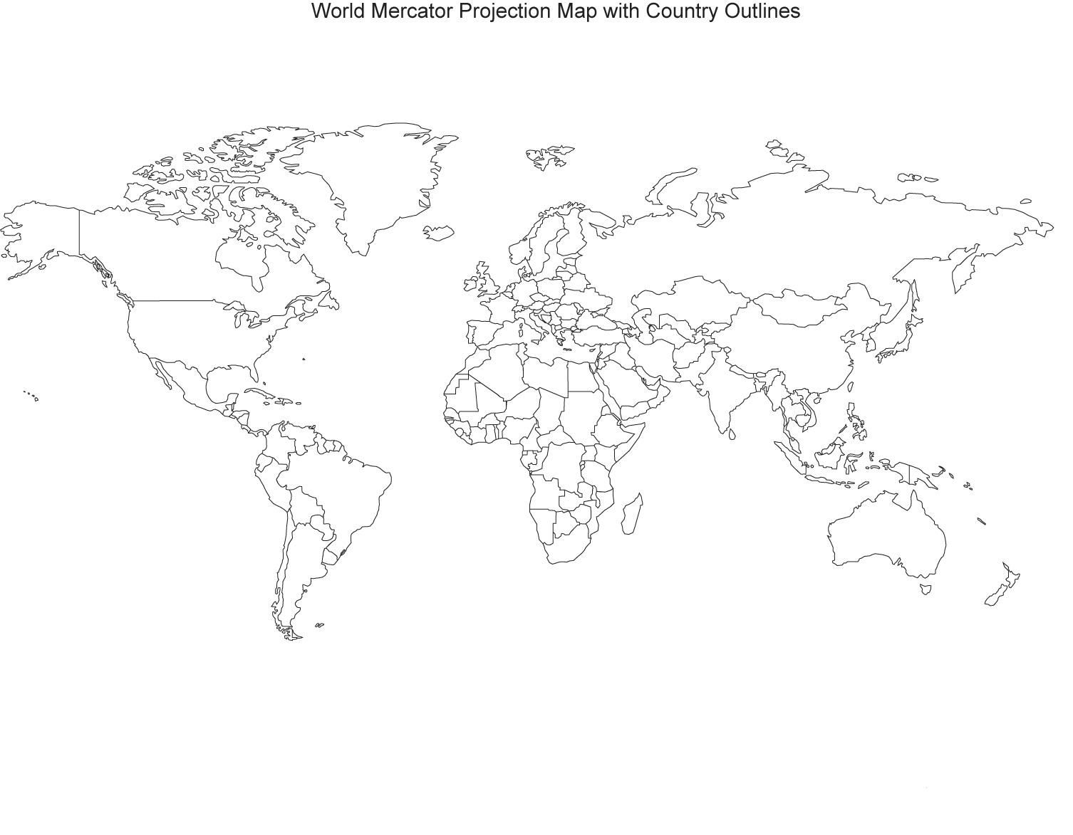

The name of my native country is _____________________________________.

It is on the continent of _____________________________________________.

This page intentionally blank

TASK 1 –Handout #4
PRACTICE: WHERE ARE YOU FROM?

In the U.S., we have people who are from many different native cultures. Think about meeting someone for the first time. We cannot assume we know where they are from based simply on the way they look, dress or speak. To find out where someone is from, we must ask them. Below is a sample dialog:

ENRIQUE: Hello. My name's Enrique. What's your name?
JANET: Janet.

ENRIQUE: Where are you from, Janet?
JANET: I'm from Seattle. Where are you from?

ENRIQUE: I'm from Madrid, Spain.
JANET: Is that in Europe?

ENRIQUE: Yes, it is. Are you American?
JANET: Yes, I am.
ENRIQUE: Nice to meet you, Janet.
JANET: Nice to meet you, too, Enrique.

Now, write your own dialog here. Use the model above for ideas:

SPEAKER1: ______________________________________________________
SPEAKER2: ______________________________________________________

SPEAKER1: ______________________________________________________
SPEAKER2: ______________________________________________________

SPEAKER1: ______________________________________________________
SPEAKER2: ______________________________________________________

SPEAKER1: ______________________________________________________
SPEAKER2: ______________________________________________________

SPEAKER1: ______________________________________________________
SPEAKER2: ______________________________________________________

TASK 1 –Handout #5a
PRACTICE – BEG LOW: IDENTIFY & DESCRIBE CULTURE

Directions: On this map, circle your native country (where you were born). Circle the native country of one classmate.

- Write the name of your native country & continent:
__________________________ __________________
your native country continent
- Write the name of the native country of your classmate:
___________________________
classmate’s native country

This page intentionally blank

TASK 1 –Handout #5b
PRACTICE – BEG HIGH: IDENTIFY & DESCRIBE CULTURE
Directions: On this map, circle your native country (where you were born). Circle the native country of one classmate.

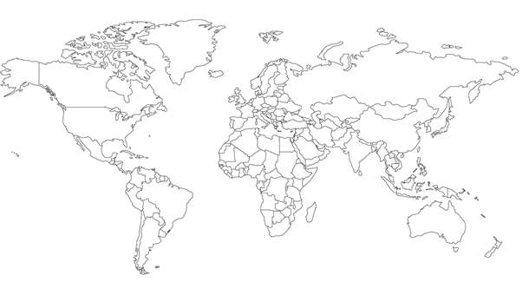

Directions:
Write the name of your native country & continent:
1) ___________________________ 2) ___________________
country continent
Write your classmate’s native country & continent:

3) ___________________________ 4) ___________________
country continent

