INTRODUCTION
EL CIVICS GOVERNMENT AND LAW UNIT

Beginning Level
This guide will take you through the Government and Law 40.4 Objective. The objective is to: “Respond to questions about the History and Government of the United States in order to be successful in the naturalization process.”

There are three tasks for this assessment. Note: Beginning level students will only complete Tasks 1 and 2.

In Task 1, students will participate in a mock oral USCIS interview.

There are several teaching activities to achieve the objective. These are suggestions only and can be adapted to meet your students’ specific needs.

Page 3: The first page of Task 1 contains a suggested list of activities and materials.

Pages 4-5: Government and Law Visuals. Visuals of key symbols and historic information are included to aid in instruction.

Pages 6-7: Government and Law Study Guide. Students preview the Government and Law questions to become familiar with the information being asked in the interview.

Pages 8-10: Our Leaders. Students work with partners to learn the names of government leaders.

Pages 11: Getting to Know You Activity. To reinforce personal information, students will ask each other the questions and write down the answers.

Pages 12-13: Government and Law Practice 1: Cloze Activity. Students fill in the blanks to reinforce vocabulary and sentence structure.

Pages 14-17: Government and Law Sentence Cards. Students match practice interview questions to the correct answer and then practice giving and answering the questions.

Pages 18-19: Practice Interviews. Students practice asking and answering questions.
REMINDER - The activities in this packet are meant to be suggestions for your use on completing the objectives. These additional assessments are not meant to be “additional work for you and your students.” They are to be incorporated into your regular classroom activities.

In Task 2, students write two dictated sentences about
Government and Law.

Page 20: The first page of Task 2 contains a suggested list of activities and materials.

Page 21: Government and Law Dictation Study Guide. Students preview 6 Government and Law dictation sentences.

Page 22: Government and Law Dictation Cards. With partners, students
use cards to practice dictating and then correcting each other’s sentences

GOVERNMENT AND LAW OBJECTIVE: TASK 1
Respond to questions about the Government and Law of the United States in order to be successful in the naturalization process.

Level: Beginning
Task 1 | Materials | Suggested Activities
tudents will participate in a mock oral USCIS interview.  Examiner will take the part of the USCIS Agent.  Student will answer up to 12 USCIS interview questions. | - Government and Law Visuals  - Government and Law Study Guide  - Getting to Know You Worksheet  - Government and Law Practice 1: Cloze Activity  - Government and Law Practice 2: Cloze Activity  - Government and Law Practice 3: Jigsaw Activity  - Government and Law Sentence Cards  - Government and Law Assessment Practice | - Begin discussion about the American flag and other important patriotic symbols. Use the Government and Law Visuals to aid in the discussion.  - Review the Government and Law Study Guide. Teach Government and Law facts using visuals.  - Reinforce personal information by using the Getting to Know You Worksheet.  - Practice facts using Practice Sheets 1-3. Optional activities: Create a timeline, play bingo.  - Give Ss copies of the Government and Law Sentence Cards. Have Ss match the questions to the answers in pairs (this could also be done as a whole group competition). Practice asking and answering questions.  - Practice Mock Interview using  Practice Interview Sheets.
Patriotic Symbols
(from Ben’s Guide to Government)

The Flag
The United States flag has 13 stripes. Seven are red and 6 are white. It also has 50 white stars on a blue background. The stripes represent the 13 original colonies. The 50 stars represent the 50 states in the U.S.

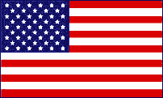

Royalty-free images and illustrations are taken from Wikimedia Commons

The White House
The White House is the home of the President of the United States. The address is 1600 Pennsylvania Avenue in Washington, D.C. Every President except George Washington has lived there. The President’s office is called the Oval Office. Here the President signs bills and visits with important guests.

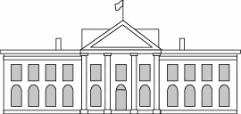

Three Branches of Government
(Adapted from Ben’s Guide to Government)
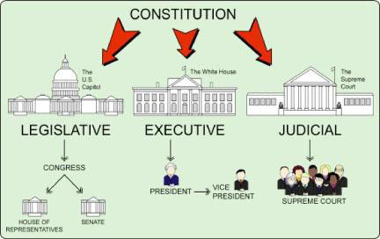

- The Legislative Branch makes the laws. Congress is part of this branch.

The Senate and the House of Representatives are in Congress.

- The Executive Branch makes sure people follow the laws. The President and Vice President are in charge of the Executive Branch. The President asks for advice from a group called the Cabinet.

- The Judicial Branch makes decisions about the laws. It is made up of courts such as the Supreme Court.

Government and Law Study Guide

 | Questions | Possible Answers
1. | What is your full name? | My name is _____________.
2. | What is your age? | I am ____________ years old.
3. | What is your current address? | My address is ______________.
4. | Are you married? | Yes, I am.  No, I’m single/divorced/widowed.
5. | What is the highest court in the United States? | Supreme Court
6. | Where is the capitol of the United States? | Washington, D.C.
7. | Why does the flag have 13 stripes? | They represent the original 13 colonies
8. | Why does the flag have 50 stars? | One for each state
9. | What do we call the first 10 amendments to the Constitution? | Bill of Rights
10. | What are two rights guaranteed to everyone living in the United States? | Answers may include: freedom of speech, religion, press
11. | What is the supreme law of the land? | The Constitution
12 | Name two U.S. national holidays. | Answers may include: New Year’s, Martin Luther King Day, Memorial Day, Independence Day, Thanksgiving, Christmas

13. | When was the Declaration of Independence signed? | July 4, 1776
14. | Who is the governor of California? | Gavin Newsom
15. | Who is the mayor of your city? | [Go to www.google.com and type “who is the mayor of ?") Oceanside: Vista: Carlsbad: Other:
16. | Name one branch of government. | Legislative, Executive, or Judicial
17. | Who is the President of the United States? | Joe Biden
18. | What did Martin Luther King, Jr. do? | Fought for civil rights
19. | Who makes federal laws in the United States? | Congress
20. | What ocean is on the West Coast? | Pacific Ocean
21. | What do you like best about living in the U.S.? | Answers may include: better job, more opportunities, be with family
22. | How is a person eligible for citizenship? | Must be 18 years of age.  Permanent resident for at least 5 years (3 years if married to a US citizen)

Our Leaders

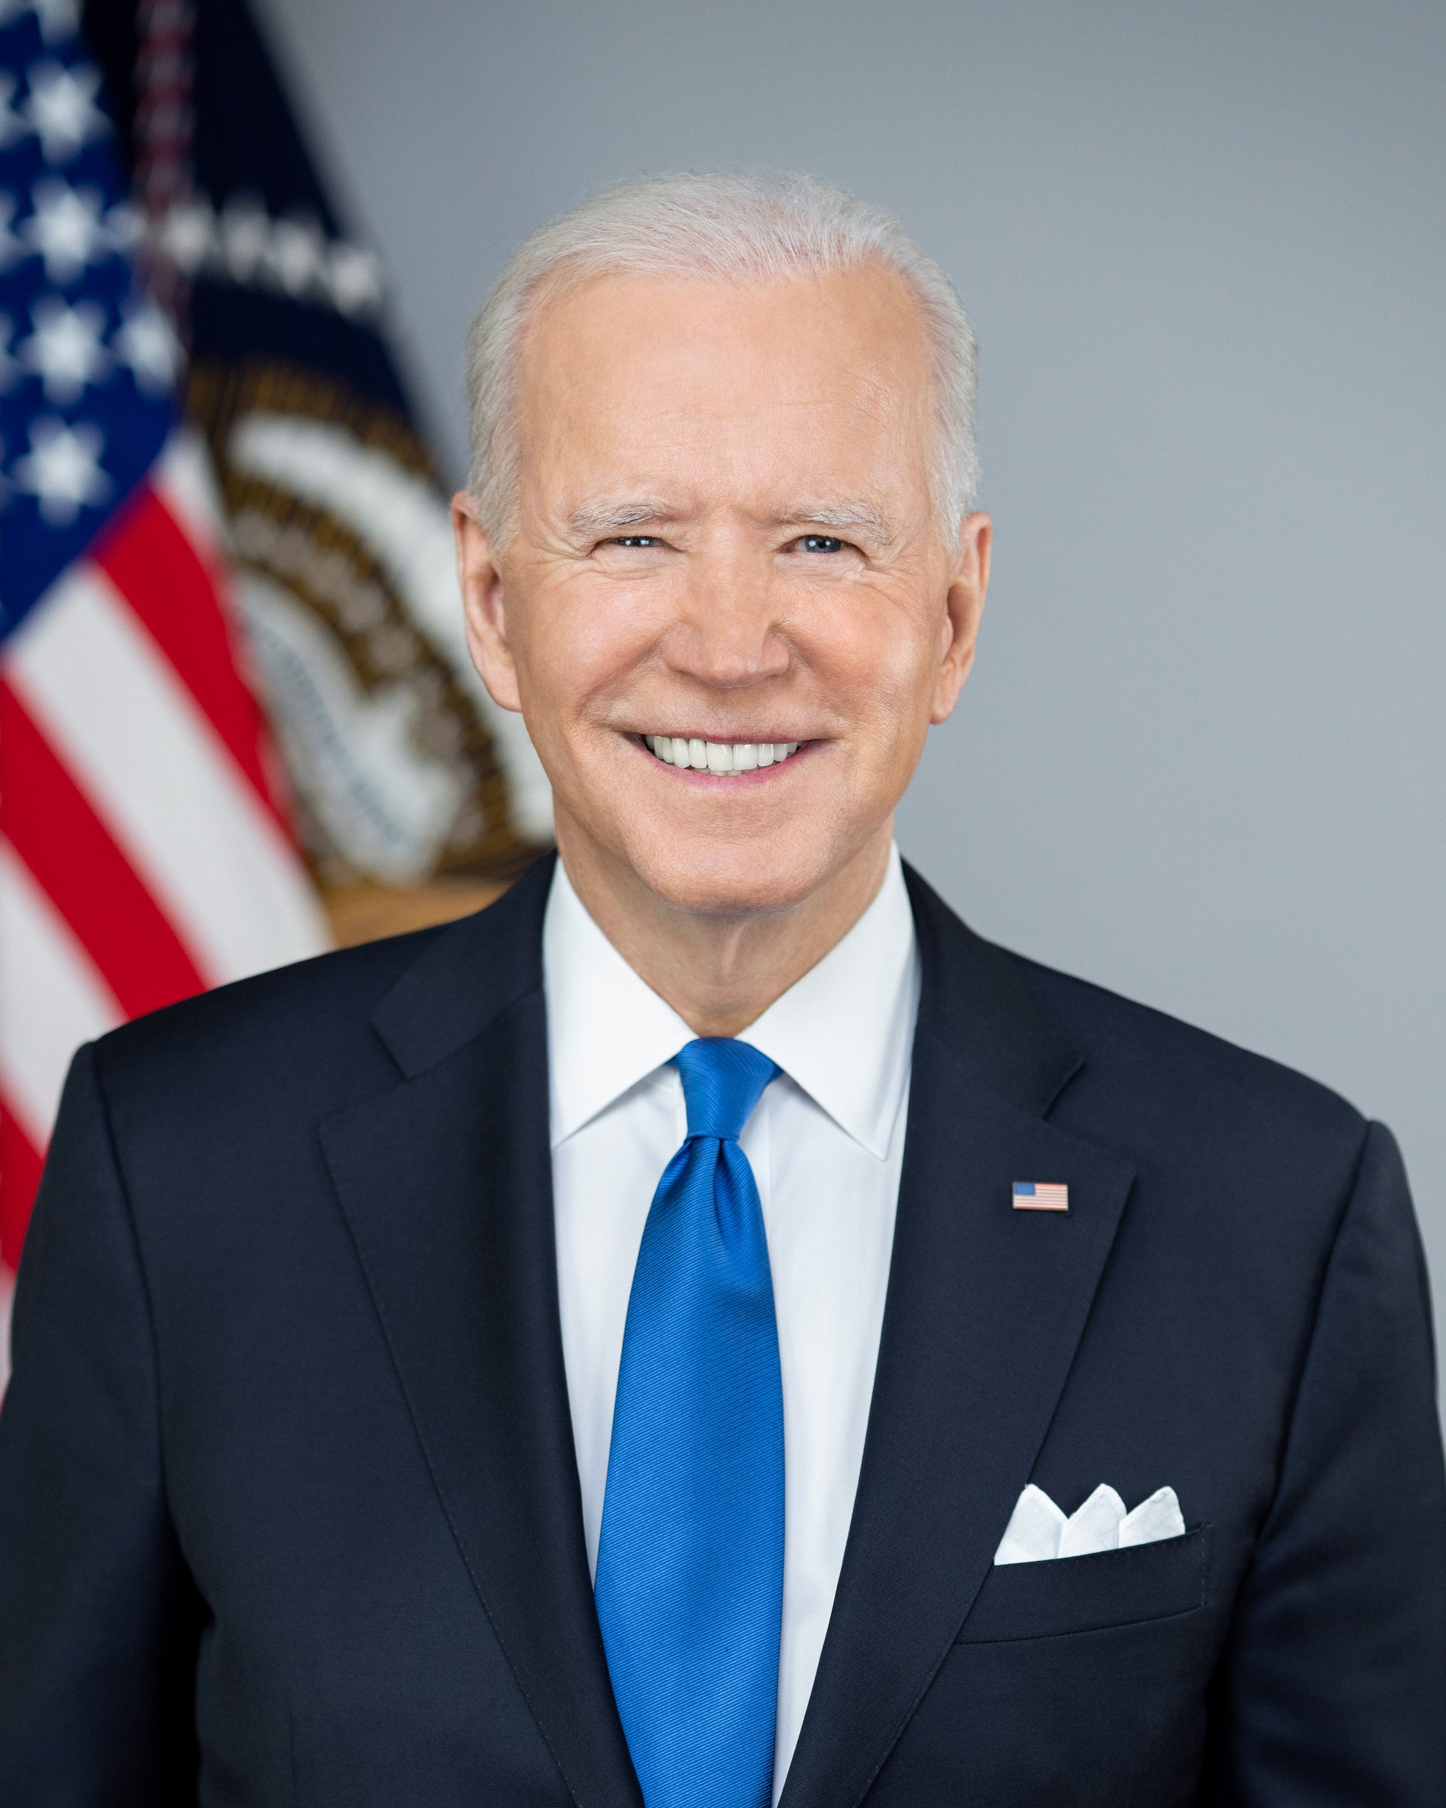  President  Joe Biden | 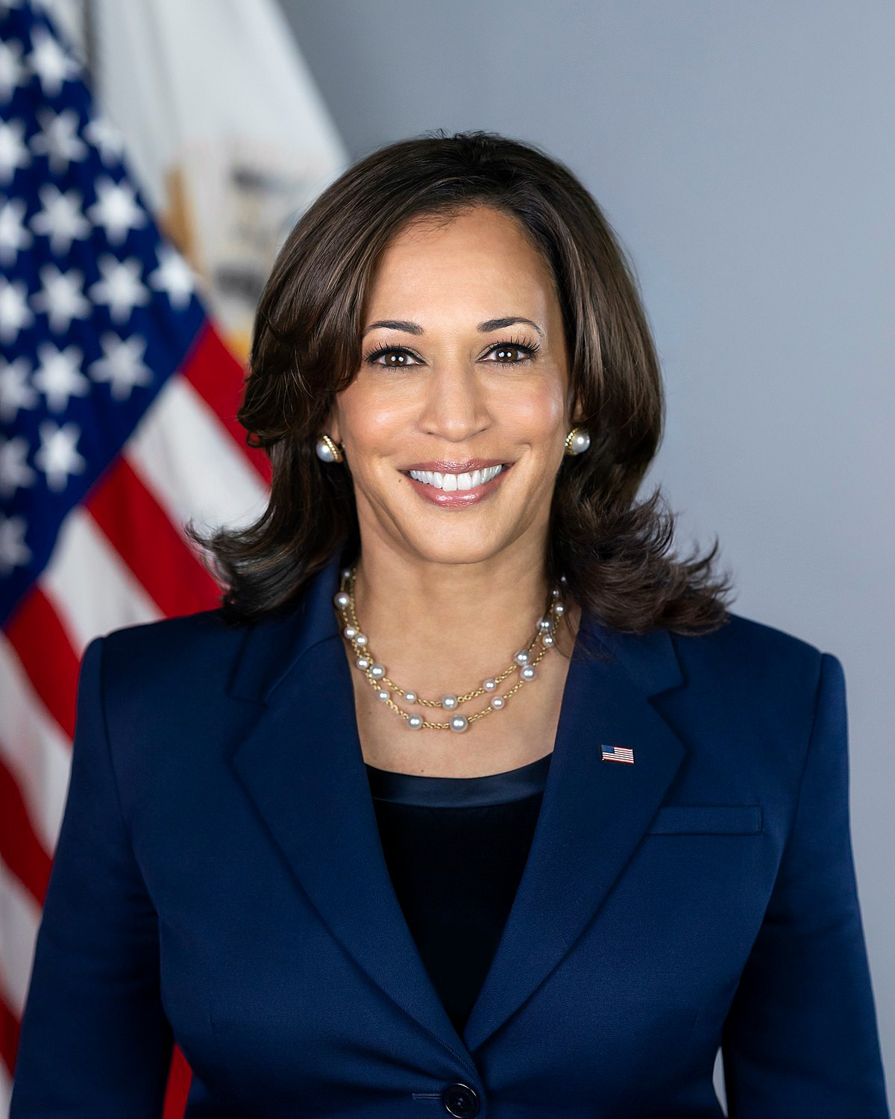  Vice-President  Kamala Harris | 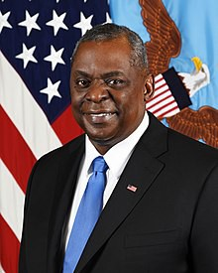  Secretary of Defense  Lloyd Austin
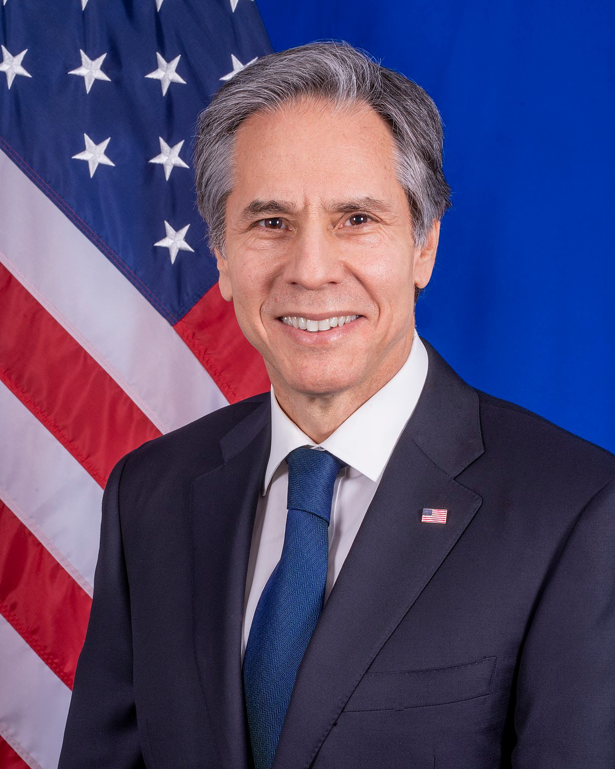  Secretary of State  Antony Blinken | California Governor Gavin Newsom | Your City's Mayor

Which leaders are members of the Executive Branch?

Our Leaders: Jigsaw Activity
Partner A: Ask your partner for the missing names. Write the name of the leader beneath each picture.

California Governor Gavin Newsom | Your City's Mayor | Secretary of State  Antony Blinken

Secretary of Defense
Lloyd Austin

Our Leaders: Jigsaw Activity
_____________
Partner B: Ask your partner for the missing names. Write the name of the leader beneath each picture.

 | Your City's Mayor
 | President  Joe Biden | Vice-President  Kamala Harris

Getting to Know You

Directions:

Ask each person a different question. Write their answer and name for each question.
What is your name? __________________

What is your address?
__________________

What is your zip code? __________________

Are you married?
__________________

Why do you like living in the US? __________________

What is your age? __________________

Government and Law Practice 1: Cloze Activity
Complete the sentences below. Use the words in the Word Choices list to help you.

Word Choices

executive Supreme Federal
18 President Star
Thanksgiving Colonies Washington

- is an American holiday.

- Congress makes the laws.

- The stripes on the flag are for the first 13 .

- There is one on the flag for each state.
- The U.S. Capitol is in , D.C.

- The three branches of the government are legislative, judicial, and
.

- The is a member of the executive branch.

- The Constitution is the land.
law of the

- To be a citizen, you must be years old.

Government and Law Practice 1: Cloze Activity
Complete the sentences below. Use the words in the Word Choices list to help you.

Word Choices

executive Supreme Federal
18 President Star
Thanksgiving Colonies Washington

Answer Key

- Thanksgiving is an American holiday.

- Congress makes the federal laws.

- The stripes on the flag are for the first 13 colonies.

- There is one star on the flag for each state.

- The U.S. Capitol is in Washington, D.C.

- The three branches of the government are Legislative, Judicial, and
Executive.

- The President is a member of the executive branch.

- The Constitution is the supreme law of the land.

- To be a citizen, you must be 18 years old.

Government and Law Sentence Cards

What is your full name? | My name is .
What is your age? | I am years old.
What is your current address? | My address is .
Are you married? | Yes, I am.  No, I’m single/divorced/widowed.
What is the highest court in the United States? | Supreme Court
Where is the capitol of the United States? | Washington, D.C.
Why does the flag have 13 stripes? | They represent the original 13 colonies

Why does the flag have 50 stars? | One for each state
What do we call the first 10 amendments to the Constitution? | Bill of Rights
What are two rights guaranteed to everyone living in the United States? | Answers may include: freedom of speech, religion, press
What is the supreme law of the land? | The Constitution
Name two U.S. national holidays. | Examples include: New Year’s, Martin Luther King Day, Memorial Day, Independence Day, Thanksgiving, Christmas
When was the Declaration of Independence signed? | July 4, 1776
Who is the governor of California? | Gavin Newsom

Who is the mayor of your city? | Oceanside: Esther Sanchez  Vista: Judy Ritter Carlsbad: Matt Hall
Name one branch of government. | Legislative, Executive, or Judicial
Who is the President of the United States? | Joe Biden
What did Martin Luther King, Jr. do? | Fought for civil rights
Who makes federal laws in the United States? | Congress
What ocean is on the West Coast? | Pacific Ocean
What do you like best about living in the U.S.? | Answers may include: better job, more opportunities, be with family
How is a person eligible for citizenship? | Must be 18 years of age. Permanent resident for at least 5 years (3 years if married to a US citizen).

Government and Law: Practice Interview 1

Questions |  | Possible Answers | Score
1. | What is your full name? | Answers may vary but must include first and last name
2. | Are you married? | Yes I am. No, I’m  single/divorced/widowed.
3. | What is your current address? | Street number, street name, city, state, zip code
4. | Why does the flag have 13 stripes | They represent the 13 original colonies
5. | Where is the capitol of the United States? | Washington, D.C.
6. | What are two rights guaranteed to everyone living in the United States? | Answers may include: freedom of speech, religion, press
7. | Who makes federal laws in the United States? | Congress
8. | Who is mayor of your city? | Oceanside: Esther Sanchez Vista: Judy Ritter Carlsbad: Matt Hall
9. | Name one branch of the government. | Legislative, Executive, or Judicial
10. | Who is the President of the United States? | Joe Biden
11. | What do you like best about living in the U.S.? | Answers may include: better job, more opportunities, be with family
12. | What is the supreme law of the land? | The Constitution

Government and Law: Practice Interview 2

Questions |  | Possible Answers | Score
1. | What is your full name? | Answers may vary but must include first and last name
2. | What is your age? | I am years old.
3. | What is your current address? | Street number, street name, city, state, zip code
4. | Why does the flag have 50 stars? | One for each state
5. | What is the highest court in the United States? | Supreme Court
6. | What do we call the first 10 amendments to the Constitution? | Bill of Rights
7. | Who is the governor of California? | Gavin Newsom
8. | Who is mayor of your city? | Oceanside: Esther Sanchez Vista: Judy Ritter Carlsbad: Matt Hall
9. | When was the Declaration of Independence signed? | July 4, 1776
10. | What ocean is on the West Coast? | Pacific Ocean
11. | What did Martin Luther King, Jr. do? | Fought for civil rights
12. | How is a person eligible for citizenship? | Must be 18 years of age. Permanent resident for at least 5 years (3 years if married to a  US citizen).

GOVERNMENT AND LAW OBJECTIVE: TASK 2
Respond to questions about the Government and Law of the United States in order to be successful in the naturalization process.

Level: Beginning

Task 2 | Materials | Suggested Activities
Students will write two level appropriate sentences dictated by the USCIS agent (examiner) as in Task 1. The sentences cover the same topics at all levels. | - Government and Law Dictation Study Guide  - Dictation Practice Cards  - Government and Law Dictation Practice Sheets | - Explain to Ss that they will learn 6 sentences and be ready to write two of them when asked to do so by the examiner.  - Read the Government and Law Dictation Study Guide. Have Ss repeat the sentences. Explain any necessary vocabulary.  - Optional activity: Write one sentence at a time on the board. Repeat words out loud. Erase one word at a time until SS can say entire sentence from memory. Repeat with other sentences.  - Put Ss in pairs. Give each pair a set of Dictation Practice Cards. Practice dictating and writing down sentences. Have partners correct sentences.  - Dictate sentences to Ss using Dictation Practice Sheet. Correct as a group.

Government and Law Dictation Study Guide

- The United States of America has 50 states.

- The United States flag is red, white, and blue.

- Thanksgiving is in November.

- There are 100 Senators.

- There are three branches in the government.

- The White House is in Washington, D.C.

Government and Law Dictation Cards
The United States of America has 50 states.
The United States flag is red, white, and blue.
There are three branches of government.
Thanksgiving is in November.
There are 100 senators.
The White House is in Washington, D.C.

Government and Law Dictation Practice
Directions: Listen to the dictation. Write the two sentences you hear.

1.

2.

Government and Law Dictation Practice

Directions: Listen to the dictation. Write the two sentences you hear.

1.

2.

