Government and Law Unit

Beginning Level

This guide will take you through the Government and Law 40.4 Objective. The objective is to “Respond to questions about the History and Government of the United States in order to be successful in the naturalization process.”

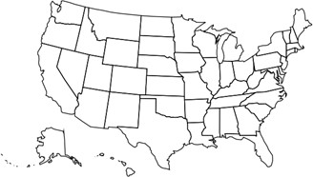

Royalty-free images and illustrations are taken from Wikimedia Commons

Patriotic Symbols
(from Ben’s Guide to Government)

The Flag
The United States flag has 13 stripes. Seven are red and 6 are white. It also has 50 white stars on a blue background. The stripes represent the 13 original colonies. The 50 stars represent the 50 states in the U.S
.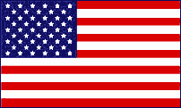

The White House
The White House is the home of the President of the United States. The address is 1600 Pennsylvania Avenue in Washington, D.C. Every President except George Washington has
lived there.

The President’s office is called the Oval Office. Here the President signs bills and visits with important guests.

Three Branches of Government
(Adapted from Ben’s Guide to Government)

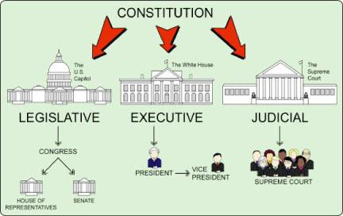

- The Legislative Branch makes the laws. Congress is part of this branch.

The Senate and the House of Representatives are in Congress.

- The Executive Branch makes sure people follow the laws. The President and Vice President are in charge of the Executive Branch. The President asks for advice from a group called the Cabinet.

- The Judicial Branch makes decisions about the laws. It is made up of courts such as the Supreme Court.

Government and Law Study Guide

 | Questions | Possible Answers
1. | What is your full name? | My name is .
2. | What is your age? | I am years old.
3. | What is your current address? | My address is
4. | Are you married? | Yes, I am.  No, I’m single/divorced/widowed.
5. | What is the highest court in the United States? | Supreme Court
6. | Where is the capitol of the United States? | Washington, D.C.
7. | Why does the flag have 13 stripes? | They represent the original 13 colonies
8. | Why does the flag have 50 stars? | One for each state
9. | What do we call the first 10 amendments to the Constitution? | Bill of Rights
10. | What are two rights guaranteed to everyone living in the United States? | Answers may include: freedom of speech, religion, press
11. | What is the supreme law of the land? | The Constitution
12 | Name two U.S. national holidays. | Answers may include: New Year’s, Martin Luther King Day, Memorial Day, Independence Day, Thanksgiving, Christmas

 | Questions | Possible Answers
13. | When was the Declaration of Independence signed? | July 4, 1776
14. | Who is the governor of California? | Gavin Newsom
15. | Who is the mayor of your city? | [Go to www.google.com and type “who is the mayor of ?") Oceanside: Vista: Carlsbad: Other:
16. | Name one branch of government. | Legislative, Executive, or Judicial
17. | Who is the President of the United States? | Joe Biden
18. | What did Martin Luther King, Jr. do? | Fought for civil rights
19. | Who makes federal laws in the United States? | Congress
20. | What ocean is on the West Coast? | Pacific Ocean
21. | What do you like best about living in the U.S.? | Answers may include: better job, more opportunities, be with family
22. | How is a person eligible for citizenship? | Must be 18 years of age.  Permanent resident for at least 5 years (3 years if married to a US citizen)

Our Leaders

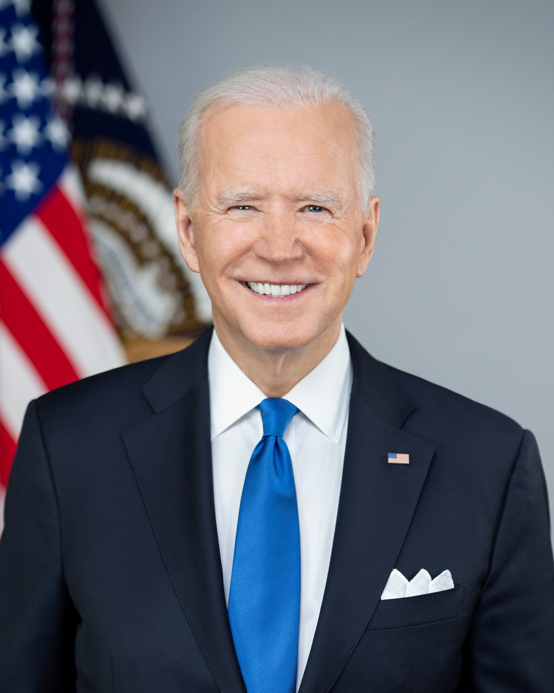  President  Joe Biden | 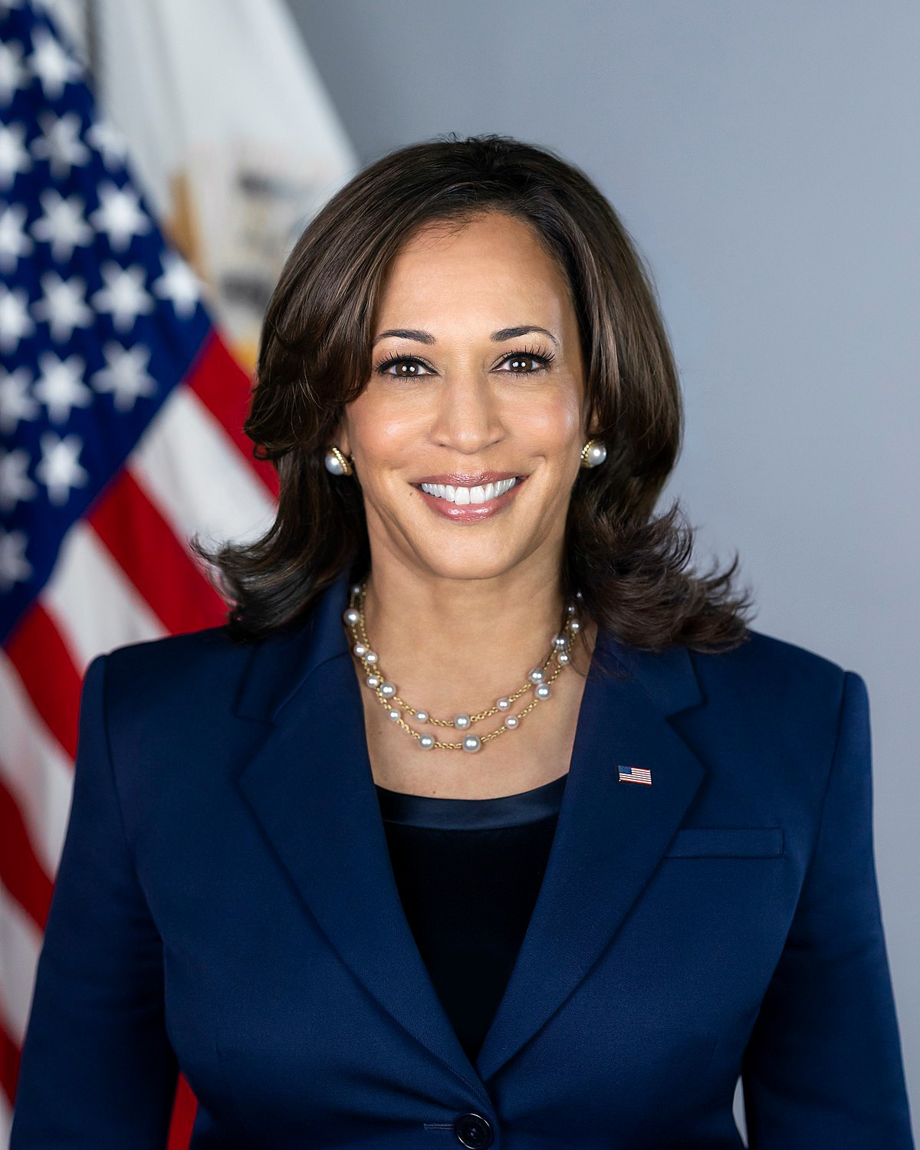  Vice-President  Kamala Harris | 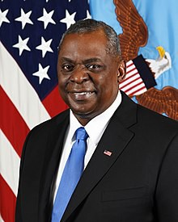  Secretary of Defense  Lloyd Austin
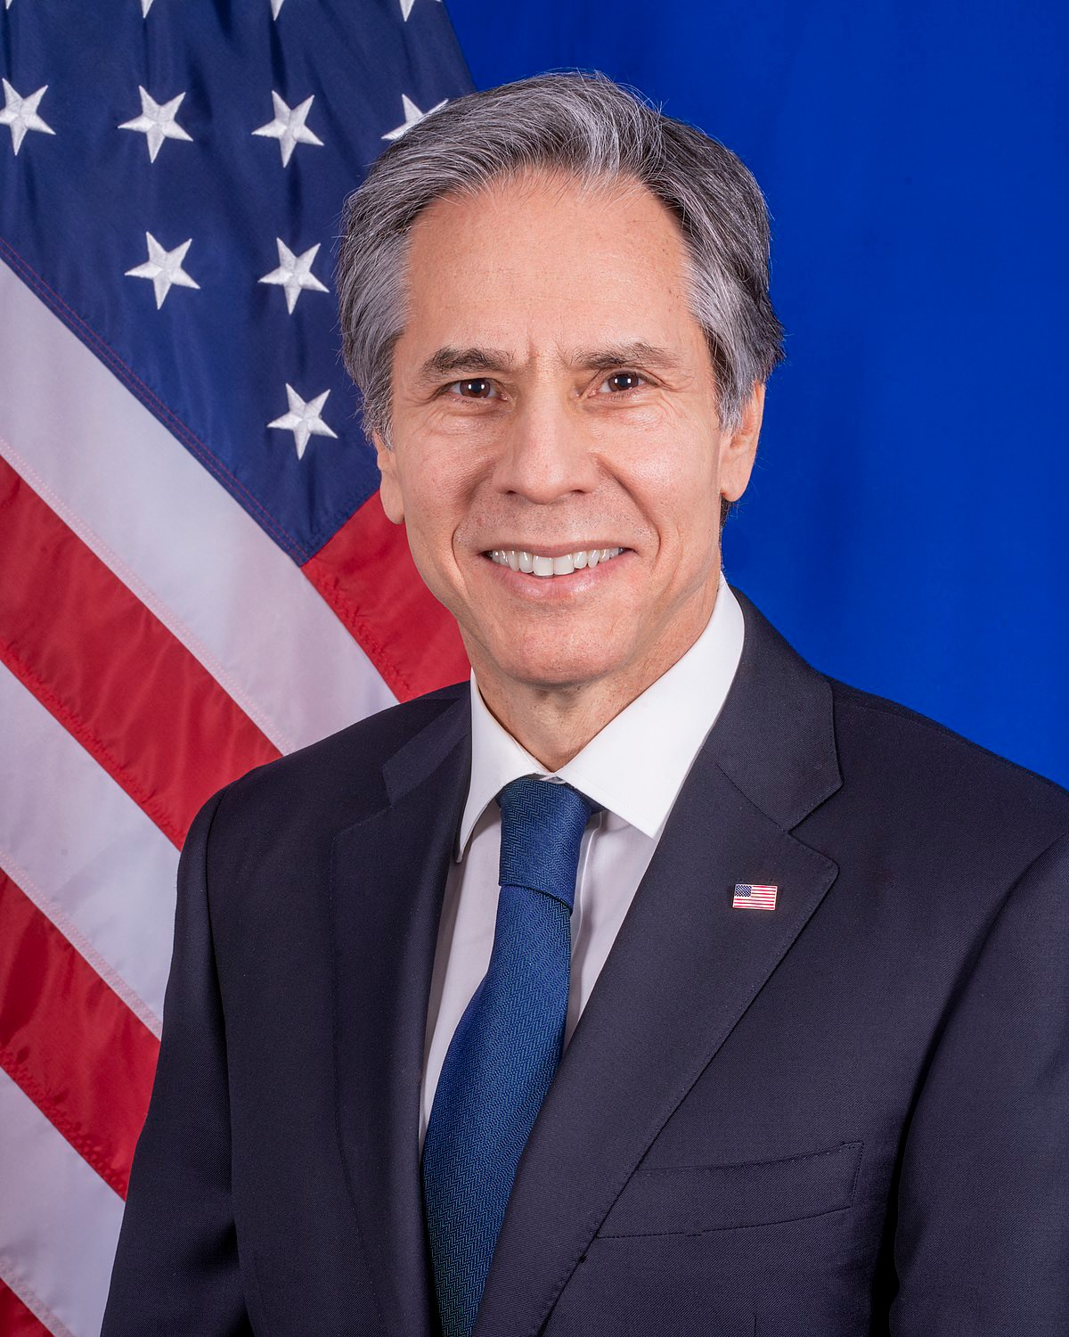  Secretary of State  Antony Blinken | California Governor Gavin Newsom | Your City's Mayor

Which leaders are members of the Executive Branch?

Our Leaders

Jigsaw Activity Partner A

Partner A: Ask your partner for the missing names. Write the name of the leader beneath each picture.

California Governor  Gavin Newsom | Your City's Mayor | Secretary of State  Antony Blinken

Secretary of Defense
Lloyd Austin

Our Leaders

Jigsaw Activity Partner B
Partner B: Ask your partner for the missing names. Write the name of the leader beneath each picture.

 | Your City’s Mayor | 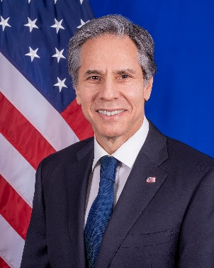
 | President  Joe Biden | Vice-President  Kamala Harris

Getting to Know You

Directions:

Ask each person a different question. Write their answer and name for each question.

What is your name? __________________

What is your address?
__________________

What is your zip code? __________________

Are you married?
__________________

Why do you like living in the US? __________________

What is your age? __________________

Government and Law

Practice 1: Cloze Activity
Complete the sentences below. Use the words in the Word Choices list to help you.

Word Choices

executive Supreme Federal
18 President Star
Thanksgiving Colonies Washington

- ________________ is an American holiday.

- Congress makes the laws.

- The stripes on the flag are for the first 13 .

- There is one on the flag for each state.
- The U.S. Capitol is in , D.C.

- The three branches of the government are legislative, judicial, and _________________________.

- The is a member of the executive branch.
- The Constitution is the land.
- To be a citizen, you must be years old.

Government and Law

Sentence Cards

Question | Answer
What is your full name? | My name is .
What is your age? | I am years old.
What is your current address? | My address is .
Are you married? | Yes, I am.  No, I’m single/divorced/widowed.
What is the highest court in the United States? | Supreme Court
Where is the capitol of the United States? | Washington, D.C.
Why does the flag have 13 stripes? | They represent the original 13 colonies

Question | Answer
Why does the flag have 50 stars? | One for each state
What do we call the first 10 amendments to the Constitution? | Bill of Rights
What are two rights guaranteed to everyone living in the United States? | Answers may include: freedom of speech, religion, press
What is the supreme law of the land? | The Constitution
Name two U.S. national holidays. | Examples include: New Year’s, Martin Luther King Day, Memorial Day, Independence Day, Thanksgiving, Christmas
When was the Declaration of Independence signed? | July 4, 1776
Who is the governor of California? | Gavin Newsom

Question | Answer
Who is the mayor of your city? | Oceanside: Esther Sanchez  Vista: Judy Ritter Carlsbad: Matt Hall
Name one branch of government. | Legislative, Executive, or Judicial
Who is the President of the United States? | Joe Biden
What did Martin Luther King, Jr. do? | Fought for civil rights
Who makes federal laws in the United States? | Congress
What ocean is on the West Coast? | Pacific Ocean
What do you like best about living in the U.S.? | Answers may include: better job, more opportunities, be with family
How is a person eligible for citizenship? | Must be 18 years of age. Permanent resident for at least 5 years (3 years if married to a US citizen).

Government and Law

Assessment: Practice Interview 1

 | Questions | Possible Answers | Score
1. | What is your full name? | Answers may vary but must include first and last name
2. | Are you married? | Yes I am. No, I’m  single/divorced/widowed.
3. | What is your current address? | Street number, street name, city, state, zip code
4. | Why does the flag have 13 stripes? | They represent the 13 original colonies
5. | Where is the capitol of the United States? | Washington, D.C.
6. | What are two rights guaranteed to everyone living in the United States? | Answers may include: freedom of speech, religion, press
7. | Who makes federal laws in the United States? | Congress
8. | Who is mayor of your city? | Oceanside: Esther Sanchez Vista: Judy Ritter Carlsbad: Matt Hall
9. | Name one branch of the government. | Legislative, Executive, or Judicial
10. | Who is the President of the United States? | Joe Biden
11. | What do you like best about living in the U.S.? | Answers may include: better job, more opportunities, be with family
12. | What is the supreme law of the land? | The Constitution

Government and Law

Assessment: Practice Interview 2

Questions |  | Possible Answers | Score
1. | What is your full name? | Answers may vary but must include first and last name
2. | What is your age? | I am years old.
3. | What is your current address? | Street number, street name, city, state, zip code
4. | Why does the flag have 50 stars? | One for each state
5. | What is the highest court in the United States? | Supreme Court
6. | What do we call the first 10 amendments to the Constitution? | Bill of Rights
7. | Who is the governor of California? | Gavin Newsom
8. | Who is mayor of your city? | Oceanside: Esther Sanchez Vista: Judy Ritter Carlsbad: Matt Hall
9. | When was the Declaration of Independence signed? | July 4, 1776
10. | What ocean is on the West Coast? | Pacific Ocean
11. | What did Martin Luther King, Jr. do? | Fought for civil rights
12. | How is a person eligible for citizenship? | Must be 18 years of age. Permanent resident for at least 5 years (3 years if married to a  US citizen).

Government and Law

Dictation Study Guide

- The United States of America has 50 states.

- The United States flag is red, white, and blue.

- Thanksgiving is in November.

- There are 100 Senators.

- There are three branches in the government.

- The White House is in Washington, D.C.

Government and Law

Dictation Cards

The United States of America has 50 states.
The United States flag is red, white, and blue.
There are three branches of government.
Thanksgiving is in November.
There are 100 senators.
The White House is in Washington, D.C.

Government and Law

Dictation Practice
Directions: Listen to the dictation. Write the two sentences you hear.

1.

2.

Government and Law

Dictation Practice

Directions: Listen to the dictation. Write the two sentences you hear.

1.

2.

Name Teacher
Date

Government and Law

Dictation Assessment
Directions: Listen to the dictation. Write the two sentences you hear.

1.

2.

