Government and Law Unit

Advanced Level

This guide will take you through the Government and Law Objective 40.4. The objective is to “Respond to questions about the History and Government of the United States in order to be successful in the naturalization process.”

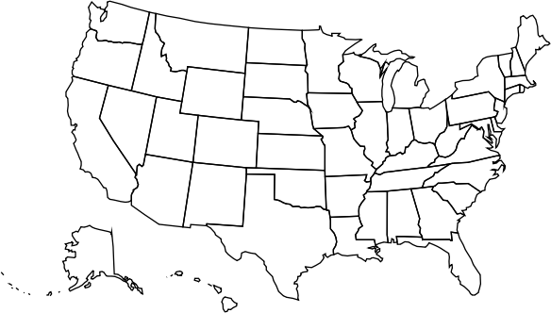
Royalty-free images and illustrations are taken from Wikimedia Commons

Before we begin:

Land Acknowledgement
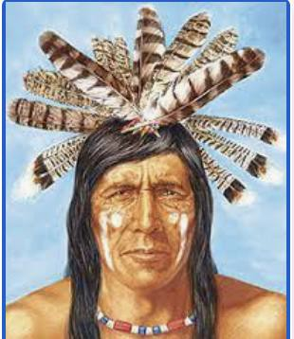
Land Acknowledgement Toolkit

Before there was a United States, this was the land of the American Indians. Let’s take a moment to honor the ancestral grounds where you are learning and support the resilience and strength that all Indigenous people have shown worldwide. Please repeat with me:
“We acknowledge that we are on the traditional territory and homelands of the Luiseno/Payomkawichum people.”
For more information, please go to California Indian Culture and Sovereignty Center. Image: Luiseno Nation from Indigenous Peoples’ Literature.

Introduction to Citizenship

Watch the video:
A Promise of Freedom: An Introduction to U.S. History and Civics for Immigrants
Created by the Department of Homeland Security, U.S. Citizenship and Immigration Services

Before you watch the video:
- What do you know about becoming a US citizen?
- What do you know about American history?
- What do you know about the government of the United States?
- What makes “Americans” and why do people want to come to the United States?
- Why did you want to come to the United States?

Part 1: Introduction

- What is the US Constitution?
- What is the New World?
- What are ‘settlers’? Are they the same thing as ‘colonists’?
- When did they first come to the United States?
- Where did the settlers come from?
- What is the Declaration of Independence? What did it say?
- What is the name of the war that settlers fought to become free from Britain?
- What did George Washington do?

Part 2: After independence: Creation and changes to the US Constitution

- What did the people want to do in the meeting in Philadelphia?
- What did the Constitution do that had never been done before?
- What are the first 10 Amendments called?
- Name 3 rights in the Bill of Rights

Part 3: Responsibilities and rights of citizens

- What are some responsibilities of being a citizen?
- Taking the naturalization test

Symbols of U.S. Government:
From Ben’s Guide to the Government. For more symbols, go to:
Ben’s Guide to Government

The Flag

The United States flag has 13 stripes. Seven are red and 6 are white. It also has 50 white stars on a blue background. The stripes represent the 13 original colonies. The 50 stars represent the 50 states in the U.S. The first U.S. flag was designed in 1777. The flag has been changed many times since then. New stars are added each time new states join the union.

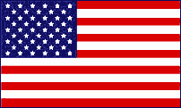

The White House

The White House is the home of the President of the United States. It is located at 1600 Pennsylvania Avenue in Washington, D.C. Every President except George Washington has lived there. The President’s office is called the Oval Office. Here the President does the business of the country. He signs bills and Executive Orders, and he meets with staff, visitors, and guests.

The Statue of Liberty
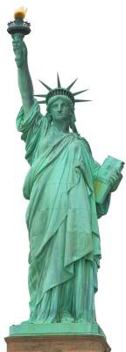
Located in New York, at 151 feet (46 meters) tall (305 feet including base and pedestal), the Statue of Liberty symbolizes freedom throughout the world. The Statue was actually a gift from the people of France.

The statue, made of copper sheets with an iron framework, depicts a woman escaping the chains of tyranny, which lie at her feet. Her right hand holds aloft a burning torch that represents liberty. Her left hand holds a tablet inscribed with the date "July 4, 1776" (in Roman numerals), the day the United States declared its independence from England. She is wearing flowing robes and the seven rays of her spiked crown symbolize the seven seas and continents.

Near the Statue of Liberty in New York Harbor is Ellis Island. This island served as an immigrant station and a temporary shelter for people coming to the U.S. from other countries. Between 1892 and 1954, approximately 12 million people passed through Ellis Island seeking refuge, freedom and opportunity. The main building on Ellis Island is now a museum dedicated to the history of the Ellis Island Immigration Station.

Bill of Rights
(Courtesy of Escondido Adult School)

The Bill of Rights is the name given to the first ten amendments to the Constitution that were added as a group in 1791. These amendments guarantee rights to everyone living in the United States. These rights are considered basic to all individuals and cannot be taken away, not even by Congress. Though Congress makes new laws, it cannot make laws that go against the Bill of Rights. Here is a brief summary of these amendments:

AMENDMENT | SUMMARY
1st Amendment | Freedom of speech, religion, press, assembly, and petition
2nd Amendment | Freedom to bear arms
3rd Amendment | Freedom from the quartering of troops without letting you know first
4th Amendment | Freedom from unreasonable searches without a search warrant
5th Amendment | Freedom from self-incrimination, double jeopardy (being tried for the same crime twice), and  eminent domain (government can’t take your property without compensation)
6th Amendment | The right to a speedy public trial and an attorney
7th Amendment | The right to a have a jury hear your case
8th Amendment | Freedom from cruel and unusual punishment
9th Amendment | People have other rights besides those listed in the Constitution that can’t be violated.
10th Amendment | States have powers that the Constitution does not give to the federal government. They can make their own decisions about certain laws.

Three Branches of Government
(from Ben’s Guide to Government)
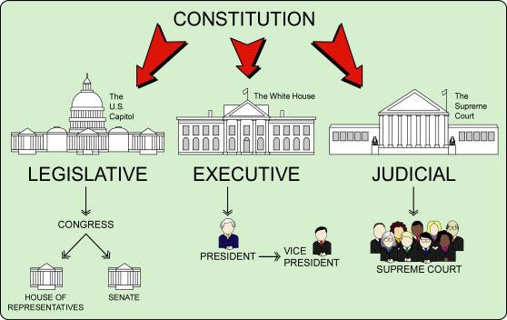

Legislative Branch
The legislative branch of government is made up Congress and government agencies. Congress has two parts, the House of Representatives and the Senate. Congress meets at the U.S. Capitol in Washington, D.C. Its primary duty is to write, debate, and pass bills, which are then passed on to the President for approval.

Executive Branch
The executive branch of Government makes sure that the laws of the United States are obeyed. The President of the United States is the head of the executive branch of government. This branch is very large so the President gets help from the Vice President, department heads (Cabinet members), and heads of independent agencies.

Judicial Branch
The judicial branch of government is made up of the court system. The Supreme Court is the highest court in the land. Courts decide arguments about the meaning of laws, how they are applied, and whether they break the rules of the Constitution.

Branches of Government Practice
From Entry into Citizenship by Aliza Becker p. 153
Instructions: Fill in the chart with the correct information.
Branch | Legislative | Executive | Judicial
What do they do?
Who is the leader?
How many members?
How many terms?

What does Congress Do?
Entry into Citizenship by Aliza Becker p. 124

Representatives
How many are there?
Who elects them?
How often are they elected?
How many terms do the serve?
Who is the leader?
Senators
How many are there?
Who elects them?
How often are they elected?
How many terms do the serve?
Who is the leader?

Who Represents Me?

National
Go to usagov for current leaders

President of the United States
Vice President of the United States .
Secretary of State
Secretary of Defense

State Level: (name of state)
Go to usagov for current leaders

Governor
State Representative (optional)
State Senator (optional)

City Level: (name of your city)
Go to www.google.com “Who is the mayor of
City Mayor
- Which leaders are members of the Executive Branch?
- Who is a state leader?
- Who is a local leader?

The Naturalization Interview
The naturalization interview will be testing for three things:
- Your ability to understand small talk and your ability to answer questions about your personal information: name, address, family, and work.
- The INS officer is testing your ability to ask for clarification if you do not understand something.
- The final part of the interview is the civics test. You will be asked 10 questions about the history and government of the United States.
Watch a short video of a sample interview; see The Naturalization Interview and Test on YouTube for an example.

During the Interview: Asking for clarification and expressing understanding

Asking for clarification/repetition
- Pardon me?
- Excuse me?
- What did you say?
- Can you repeat that, please?
- Would you repeat that, please? (polite/ formal)
- Would you please say it again?
- I didn’t catch that.
- Did you say or ?
Expressing understanding
- Ok, thank you.
- I understand now, thank you.
- Got it!
- Gotcha!
- Thanks for your patience.

Giving thanks
- Thanks.
- Thank you.
- Thank you very much.
- That’s very kind of you.
- I appreciate it.
- I appreciate it very much.

Study Guide
 | Questions | Possible Answers
1. | What is your full name? | My name is .
2. | What is your age? | I am years old.
3. | What is your current address? | My address is .
4. | Are you married? | Yes, I am.  No, I’m single/ divorced/widowed.
5. | Name two U.S. national holidays. | Answers may include: New Year’s, Memorial Day, Independence Day, Thanksgiving, Christmas
6. | What is one reason colonists came to America? | Religious freedom, escape persecution
7. | Why does the flag have 13 stripes? | They represent the original 13 colonies
8. | Why does the flag have 50 stars? | There is one star for every state
9. | When was the Declaration of Independence signed? | July 4, 1776
10. | What was one important thing Abraham Lincoln did? | Freed the slaves, preserved the Union
11. | What is the supreme law of the land? | The Constitution
12. | What do we call the first 10 amendments to the Constitution? | The Bill of Rights
13. | What are two rights guaranteed to everyone living in the United States? | Answers may include: freedom of speech, religion, press, freedom to petition, right to bear arms, double jeopardy, right to speedy trial by jury, can’t search property without a warrant
14. | Who is the governor of California? | Gavin Newsom
15. | Who is the mayor of your city? | Oceanside: Esther Sanchez Vista: Judy Ritter  Carlsbad: Matt Hall  Other:
16. | Name one branch of the government. | Legislative, Executive, or Judicial

 | Questions | Possible Answers
17. | Who is the President of the United States? | Joe Biden
18. | Who is Vice-President? | Kamala Harris
19. | When is a person eligible for citizenship? | Must be 18 years of age Permanent resident for at least 5 years (3 years if married to a US citizen).
20. | What do you like best about living in the U.S.? | I like .
21. | Who was the first president of the United States? | George Washington
22. | We elect a President for how many years? | Four years
23. | What does the President’s Cabinet do? | Advises the president
24. | What are names of two Cabinet-level positions? | Secretary of State (Anthony Blinken) Secretary of Defense (Lloyd Austin)
25. | What is an amendment? | A change to the Constitution
26. | How many amendments does the Constitution have? | 27
27. | What did Martin Luther King, Jr. do? | Fought for civil rights
28. | Who makes federal laws? | Congress
29. | What are the two parts of Congress? | The Senate and the House of Representatives
30. | How many U.S. senators are there? | 100
31. | How many U.S. representatives are there? | 435
32. | What is the highest court in the United States? | The Supreme Court
33. | What does the judicial branch do? | Decides if a law goes against the constitution
34. | Which ocean is on the West Coast? | Pacific Ocean
35. | What is the capitol of the United States? | Washington, D.C.

Our Leaders
Directions: Write the branch or level of government under each name.
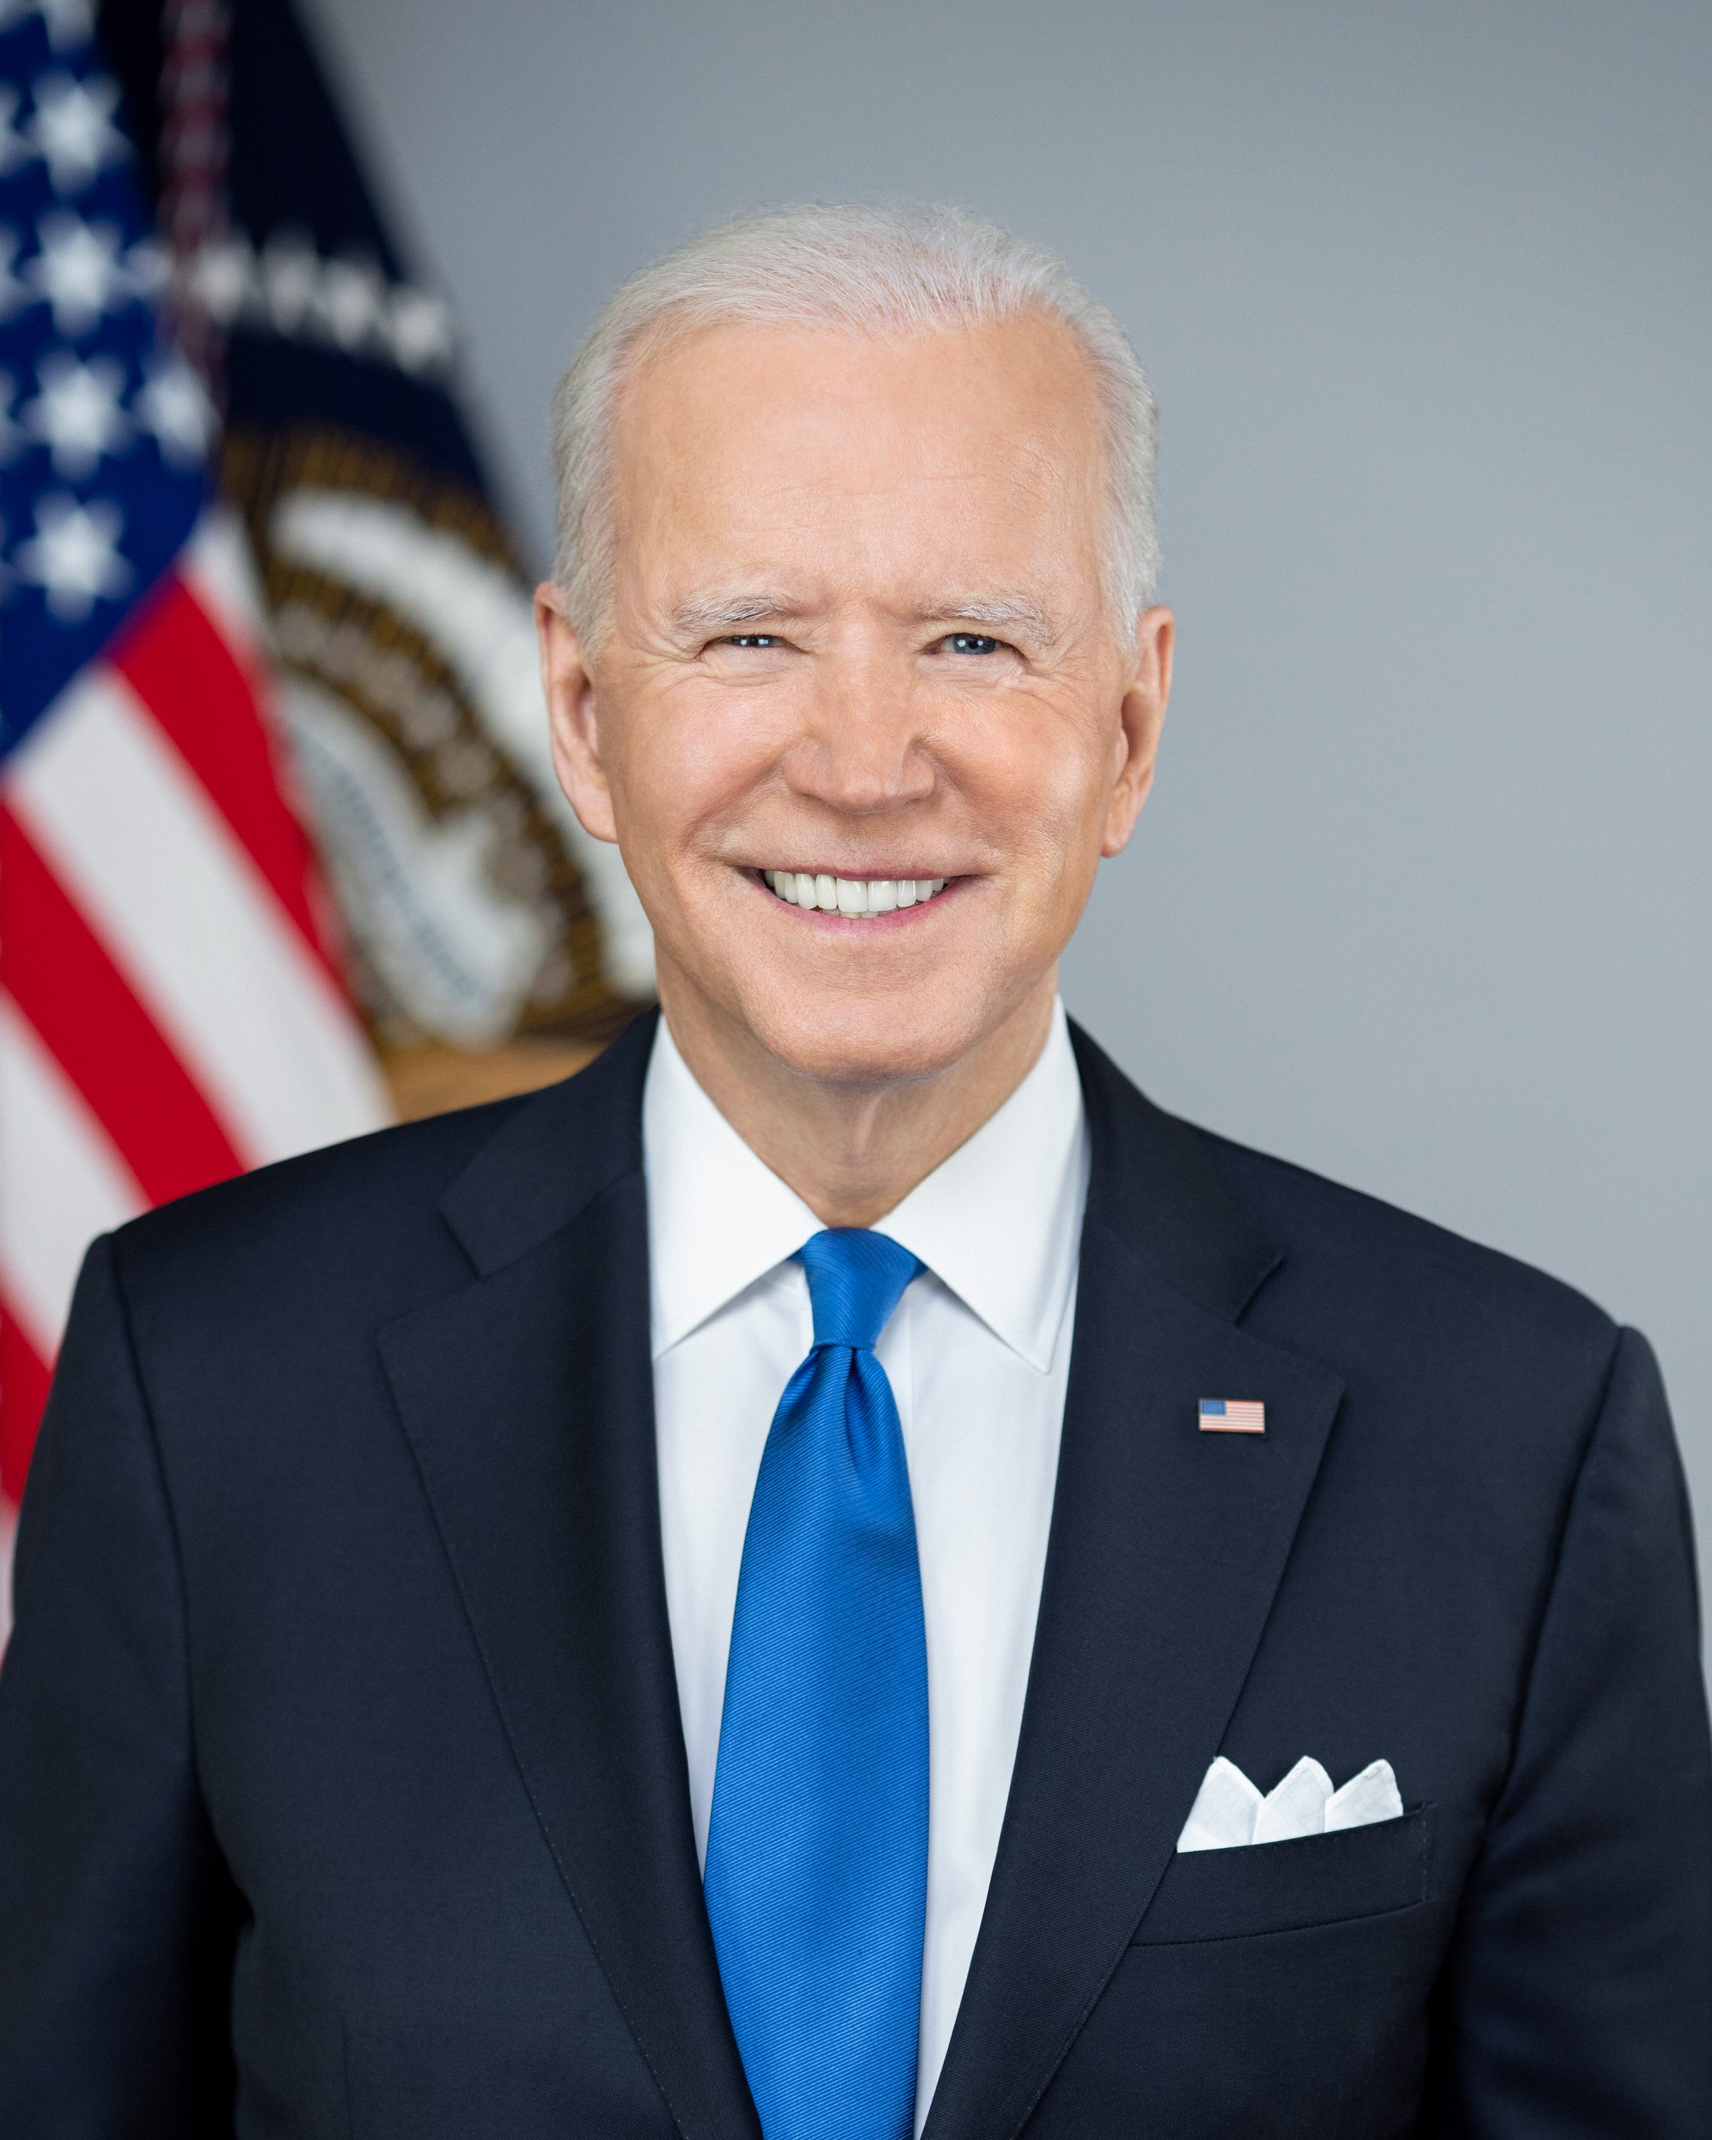  President Joe Bide | 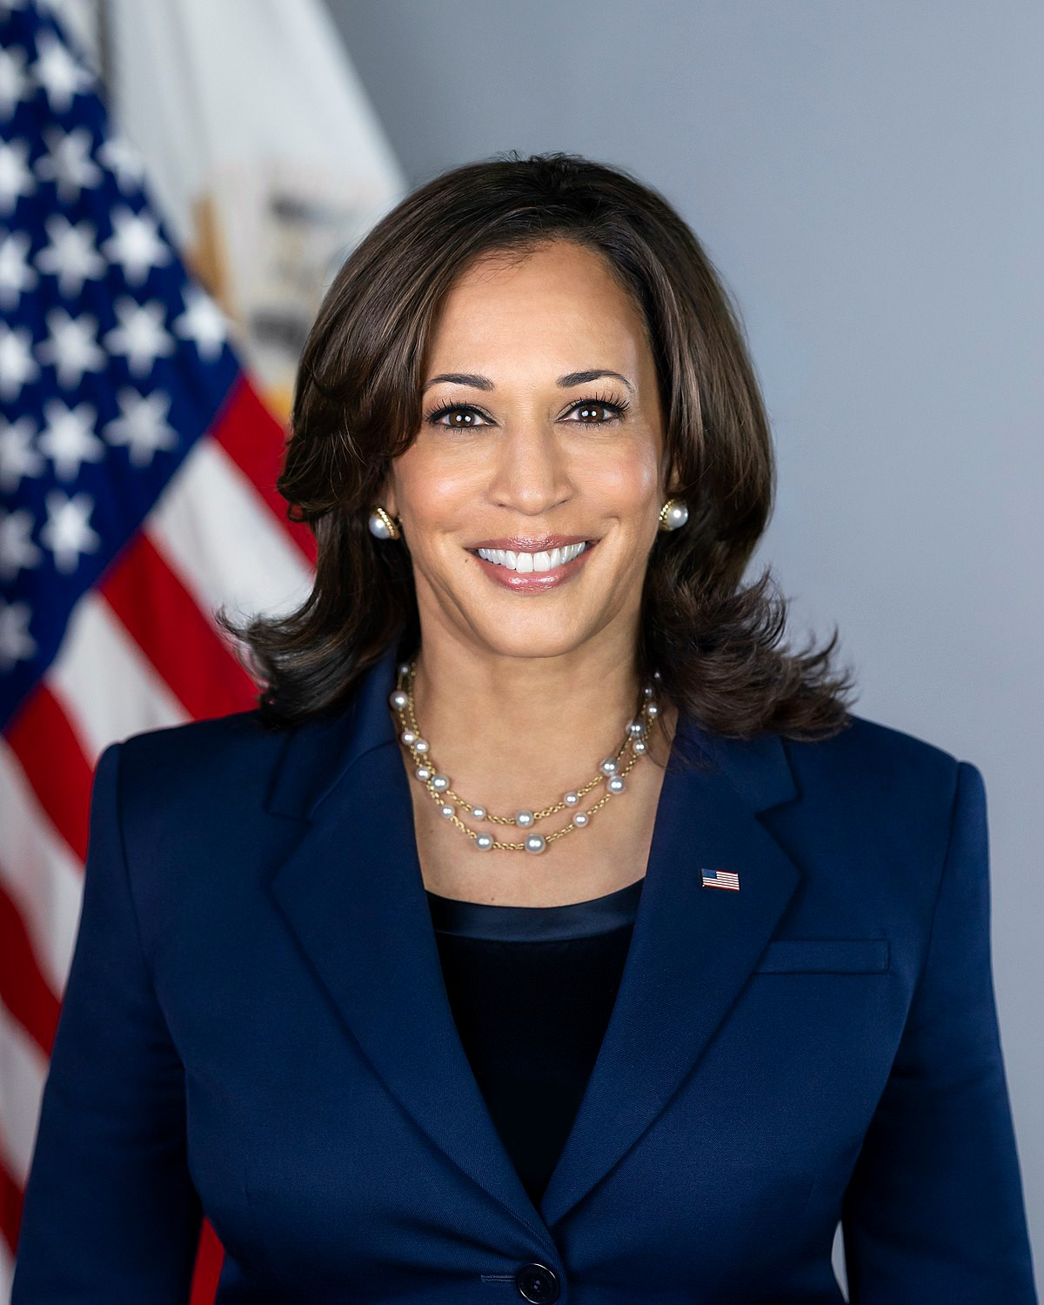  Vice President Kamala Harris | 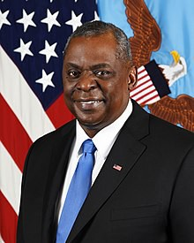  Secretary of Defense  Lloyd Austin
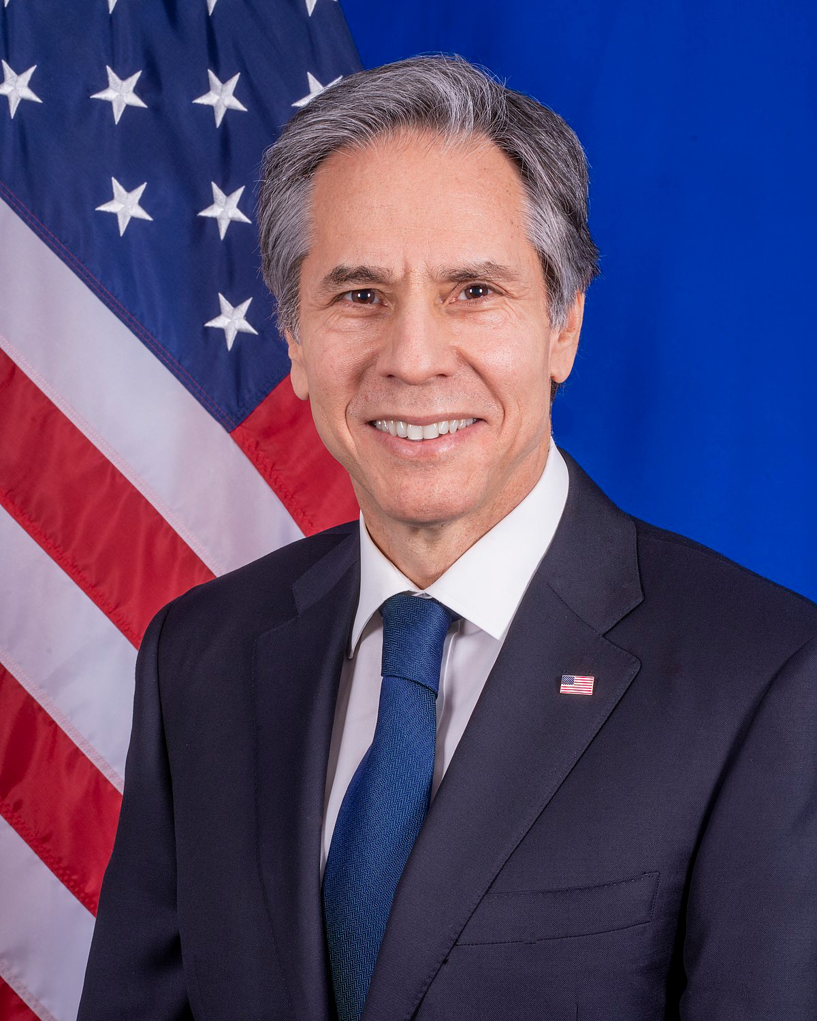  Secretary of State Anthony Blinken | California Governor Gavin Newsom | Your city's mayor:
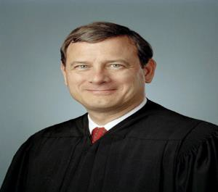  Chief Justice John G. Roberts | 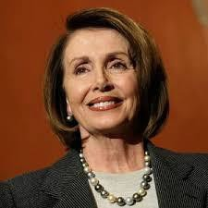  Speaker of the House Nancy Pelosi | 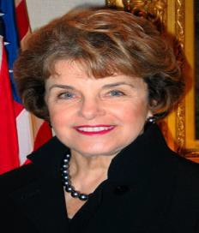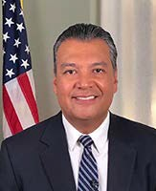  U.S. Senators for California  Dianne Feinstein and Alex Padilla

Cloze Activity
Complete the sentences below. Use the words in the Word Box to help you.
Word Box
supreme | Court | U.S. Capitol
Washington | Congress | Representatives
Thanksgiving | colonies | Independence
Legislative | amendment | Star

1. is an American holiday.
2. The Supreme decides if a law goes against the constitution.
3. The stripes on the flag represent the first 13
4. There is one on the flag for each state.
5. Day is July 4.
6. The three branches of the government are , Judicial and Executive.
7. makes federal laws.
8. The Constitution is the law of the land.
9. The is in Washington, D.C.
10. Senators and the House of are in Congress.
11. George was the first U.S. president.
12. A change to the Constitution is called an .

Bill of Rights Activity
Directions: Get in groups of 4. Each person reads an example. Decide as a group which Amendment is being referred to in each example and if you agree or disagree with the statement.

    - A person can enter a room and scream "Bomb!" just to see the reaction of the people in the room.
Agree/Disagree:
Amendment:
    - Members of Congress can learn many different things -- such as what you like and dislike about the area where you live -- from letters you send to them.
Agree/Disagree:
Amendment:
    - A police officer comes to your door and asks to search your home without a reason.
Agree/Disagree:
Amendment:
    - Violence is getting to the point in our society where they should stop letting civilians own guns.
Agree/Disagree:
Amendment:
    - The Death Penalty is a good way to punish those who murder another human being.
Agree/Disagree:
Amendment:
    - Your parents own a house. They invest hours of time and many thousands of dollars into it. The government can make your parents sell the house to them so a highway can be built on the land.
Agree/Disagree: Amendment:

    - If a power is not expressed in the Constitution, then it is the responsibility of the individual states to protect citizens' rights. Agree/Disagree:
Amendment:
    - Even after September 11th, people are still free to practice the Islamic religion in the United States.
Agree/Disagree:
Amendment:
    - The government is allowed to call you at home and tell you that you must let soldiers stay in your home.
Agree/Disagree:
Amendment:
    - If someone is dangerous, the government should be able to hold them in jail for as long as they want to before having a trial.
Agree/Disagree: Amendment:
Education World®
Copyright © 2004 Education World

Three Branches of Government
Adapted from Teacher Created Resources, Inc.

President
House of Representatives
Senate
Both House and Senate
Supreme Court

Congress | Chosen by the Electoral College
Elected by the people | Appointed by the president
Decides what the laws say and if they agree with the U.S. Constitution | Commander-in-Chief of all U.S. military forces
Makes laws for the entire country | Can sign bills so they can become laws
Heads the Executive Branch | Legislative Branch
John Roberts | Nancy Pelosi

Kamala Harris | Lloyd Austin
Anthony Blinken | Joe Biden
Meets in the U.S. Capitol building | Members serve in this office for life unless they resign or are removed
Must be re-elected every two years | Must be re-elected every six years
Must be re-elected every four years | Can serve unlimited terms if re-elected
Can serve only two terms | Has two members from each state
Has members based on each state’s population | Can declare war

Appoints a cabinet to help run the country | Has 435 members
Has 100 members | Must be a native-born citizen to hold this office

Government and Law Assessment:

Practice Interview 1

Questions |  | Possible Answers | Score
1. | What is your full name? | Answers may vary but must include first and last name
2. | Are you married? | Yes, I am. No, I’m single/divorced/widowed.
3. | What is your current address? | Street number, street name, city, state, zip code
4. | Why does the flag have 13 stripes? | They represent the 13 original colonies
5. | Where is the capitol of the United States? | Washington, D.C.
6. | What are two rights guaranteed to everyone living in the United States? | Answers may include: freedom of speech, religion, press, freedom to petition, right to bear arms, double jeopardy, right to speedy trial by  jury, can’t search property without a warrant
7. | Who makes federal laws in the United States? | Congress
8. | Who is mayor of your city? | Oceanside: Esther Sanchez Vista: Judy Ritter  Carlsbad: Matt Hall  Other:
9. | Name one branch of the government. | Legislative, Executive, or Judicial
10. | Who is the President of the United States? | Joe Biden
11. | What do you like best about living in the U.S.? | Answers may include: better job, more opportunities, be with family
12. | What is the supreme law of the land? | Constitution

Government and Law Assessment: Practice Interview 2

Questions |  | Possible Answers | Score
1. | What is your full name? | Answers may vary but must include first and last name
2. | What is your age? | I am years old
3. | What is your current address? | Street number, street name, city, state, zip code
4. | Why does the flag have 50 stars? | One for each state
5. | What is the highest court in the United States? | Supreme Court
6. | What do we call the first 10 amendments to the Constitution? | Bill of Rights
7. | Who is the governor of California? | Gavin Newsom
8. | Who is mayor of your city? | Oceanside: Esther Sanchez Vista: Judy Ritter  Carlsbad: Matt Hall  Other:
9. | When was the Declaration of Independence signed? | July 4, 1776
10. | What ocean is on the West Coast? | Pacific Ocean
11. | What did Martin Luther King, Jr. do? | Fought for civil rights
12. | How is a person eligible for citizenship? | Must be 18 years of age.  Permanent resident for at least 5 years (3 years if married to a US citizen)

Government and Law Dictation Study Guide

- The United States of America has 50 states.
- The United States flag is red, white, and blue.
- Thanksgiving is in November.
- Mexico is the country south of the United States.
- The Statue of Liberty is in New York.
- There are 100 Senators.
- There are three branches in the government.
- George Washington is on the dollar bill.
- The White House is in Washington, D.C.
- Congress meets in the U.S. Capitol building.

Government and Law Dictation Practice
Directions: Listen to the dictation. Write the three sentences you hear.

1.
2.
3.

Government and Law Dictation Practice

Directions: Listen to the dictation. Write the three sentences you hear.

1.
2.
3.

Government and Law Dictation Assessment
Directions: Listen to the dictation. Write the three sentences you hear.

1.
2.
3.

Write a paragraph about a freedom or right from the Bill of Rights.

Discuss what you learned about the Bill of Rights in Task 1

Watch the video:
A 3-minute guide to the Bill of Rights
Brainstorm with your teacher and classmates about modern examples of freedoms and rights. Write them in the box marked “Examples”:
Brainstorm / notes modern examples of the Bill of Rights

The 5 First Amendment Freedoms

Civil liberty |  | Examples:
Speech | The First Amendment says that people have the right to speak freely without government interference. | Examples: I can criticize my government and not be thrown in jail;  I can wear clothing that I like; I can give my opinions
Press | The First Amendment gives the press the right to publish news, information and opinions without government interference.  This also means people have the right to publish their own newspapers, newsletters, magazines, Web sites, radio programs, and other types of media. | Examples:
Religion | The First Amendment prohibits the government from establishing a religion and protects each person's right to practice (or not practice) any faith without government interference. | Examples:
Petition | The First Amendment says that people have the right to appeal to the government in favor of or against policies that affect them or that they feel strongly about. This freedom includes the right to gather signatures in support of a cause and to | Examples:

Civil liberty |  | Examples:
 | lobby legislative bodies for or against legislation.
Assembly | The First Amendment says that people have the right to gather in public to march, protest, demonstrate, carry signs, and otherwise express their views in a nonviolent way. It also means people can join and associate with groups and organizations without interference. | Examples:

Choose 2 or 3 rights that are interesting to you.
  - Write down reasons why you think they interesting.
  - What are those reasons?
  - Write down anything that comes to your mind. You will use these thoughts later when you write a paragraph.

Rights/Freedom interesting to me (choose 1-3) | Why are these interesting to you?

Prepare to write a paragraph. Read the information below.

What’s in a paragraph?
A paragraph is a group of sentences that tell about a single idea or thought.
Each paragraph has a topic sentence, which tells you what the paragraph is about. The middle of the paragraph tells more about the idea. These are called supporting sentences. The last sentence is the conclusion, which tells you about the idea in different words than the topic sentence.

1. Topic Sentence: What the paragraph is about.
2. Supporting Sentence-details with examples: Examples, facts, and descriptions about the topic
3. Conclusion Sentence: restate the topic sentence (the main idea) in different words.
Read the example paragraph below:

Freedom of Speech
Freedom of speech is important to me. In my country if someone said they didn’t like the government they could go to jail. In the United States everyone is free to say what they think. For example, in my town some people think that bilingual education is a bad idea. Others think it is a good idea. It’s nice that both groups of people can talk about their opinions. I like freedom of speech because I like to listen to everyone and then choose what I believe.

Fill in the table with sentences from the paragraph above

Topic sentence
Supporting sentences
Conclusion sentence

Step 5 Now you will write your paragraph:
  - The topic sentence
A topic sentence tells about the main idea of a paragraph.
A good topic sentence includes a topic (the subject of the paragraph) and a controlling idea (what you want to say about the subject).
Topic:  (The subject of the paragraph) | Freedom of speech
Controlling idea:  (what you want to say about the subject/topic) | It is important to me
Topic Sentence | Topic + controlling idea =  Freedom of speech is important to me.
Your turn. Write a topic sentence for your paragraph.
Choose the freedom or right you want to write about. This is your TOPIC.

TOPIC ___________________________________________
+
CONTROLLING IDEA_______________________________
=
TOPIC SENTENCE__________________________________
__________________________________________________
  - Supporting sentences/ details
Supporting sentences give information that explains and describes the topic sentence of the paragraph.
Supporting sentences can do the following:
    - Answer the questions - who? What? Where? Why? And How?
    - Give examples
    - Explain
    - Describe
    - Give facts
    - Definitions
Your turn: Choose three details you want to support your topic sentence. You can choose from the list above.
Example:
Supporting sentence | I prefer to make my own decision about what church I want to attend.
Explanation
I like to follow my religious beliefs, and not have the government tell me what church to attend.
 | Description
 | Example

Write 3 supporting sentences. Choose how you want to give more information.
Supporting sentence 1:
Explanation
Description
Example

Supporting sentence 2:
Explanation
Description
Example

Supporting sentence 3:
Explanation
Description
Example

Write a concluding sentence.
  - A concluding sentence is the last sentence in your paragraph. It restates, or retells, what you said in the topic sentence, but in different words.
  - Example:
Concluding sentence: In short, freedom of religion is important to me because I can make the decision about what church to attend, practice my religion in my own way, and celebrate the religious holidays of my faith.

Your turn:
Concluding sentence:

Sample Civil Liberty Paragraph

Name
Teacher's Name
Class
Date

Freedom of Religion
Freedom of religion is important to me for several reasons. First of all, I prefer to make my own decision about what church I want to attend. I like to follow my religious beliefs, and not have the government tell me what church to attend. Second, I want to practice my religion in my own way. If I choose to practice my religion in my living room with my family and friends, I can do that. Third, I like to celebrate the religious holidays of my faith. I want to have the freedom to put my religious holiday decorations on display. In short, freedom of religion is important to me because I can make the decision about what church to attend, practice my religion in my own way, and celebrate the religious holidays of my faith.

Civil Liberty Paragraph Worksheet
- What is the civil liberty you want to write about?
- Why is it important to you?

- What are three details or examples you want to use to support, or explain about this topic? What are examples of each idea?
Detail 1
Example
Example
Example
Detail 2
Example
Example
Example
Detail 3
Example
Example
Example

- A concluding sentence is the last sentence in your paragraph. It restates, or retells, what you said in the topic sentence, but in different words. Write your concluding sentence here.

Freedom of Religion Sentence Strips

Freedom of religion is important to me for several reasons.
First of all, I prefer to make my own decision about what church I want to attend.
I like to follow my religious beliefs, and not have the government tell me what church to attend.
Second, I want to practice my religion in my own way.
If I choose to practice my religion in my living room with my family and friends, I can do that.
Third, I like to celebrate the religious holidays of my faith.
I want to have the freedom to put my religious holiday decorations on display.
In short, freedom of religion is important to me because I can make the decision about what church to attend, practice my religion in my own way, and celebrate the religious holidays of my faith.

What’s in a Letter to the Editor?
A letter to the editor is sent to a newspaper to explain a person’s opinion.
The letter should have the following:

- The date
- Address
- A salutation (Dear )
- Body of the letter
- Closing statement (Thank you, Sincerely)
- Your signature
- Your address (optional) January 12, (year)
Editor
North County Times
1722 South Coast Highway Oceanside, CA 92054

Dear Editor,
I agree with your recent article about bilingual education. A free education is a right guaranteed by the constitution, and I think that bilingual education should be available to anyone coming to the United States for the first two years. I was 14 years old when my family moved here. I didn’t know any English and felt nervous about going to school. I liked learning about math in my country and was afraid I wouldn’t understand anything. When I walked into my first class and I heard my language, I felt so happy. For the first year most of my classes were in my first language, but as I learned more English, I took more and more classes in English until all of my classes were in English. I graduated from high school and am now studying math in college. I wouldn’t be in college now if my high school hadn’t had a bilingual education program. Bilingual education helped me to be successful and I think it’s an important program.

Thank you,

Sarina Maldonado 141 Mission Blvd.
Oceanside, CA 92054

Letter to the Editor Worksheet
- What is the civil liberty you want to write about?
- Why is it important to you?

- What are three details or examples you want to use to support, or explain your opinion? What are examples of each idea?
Detail 1 Fact or Example Fact or Example Fact or Example
Detail 2 Fact or Example Fact or Example Fact or Example
Detail 3 Fact or Example Fact or Example Fact or Example

- A concluding sentence is the last sentence in your letter. It restates, or retells, what you the most important details of the argument, but in different words. Write your concluding sentence here.

Civil Liberty Letter to the Editor

Practice Sheet
Date
Name
Address

Dear :

Closing ,
Your Name Address

Civil Liberty Writing Checklist

Directions: Check Yes/No |  | Self | Self | Peer | Peer
 |  | Yes | No | Yes | No
Content
1. | Does the letter or paragraph state which civil liberty is going to be discussed?
2. | Does the letter or paragraph have at least three supporting details?
3. | Does the letter or paragraph have a concluding sentence?
4. | Is the meaning of each sentence clear?
Format
1. | Does the letter have a salutation or paragraph have a title?
2. | Is the letter or paragraph indented?
4. | Is the letter or paragraph within margins?
Grammar and Punctuation
1. | Does each sentence begin with a capital letter?
2. | Does each sentence end with punctuation?
3. | Do the verbs agree with their subjects?

Appendix 1

Citizenship Resources at MiraCosta College

Are you interested in becoming a U.S. Citizen? Follow the steps below to find out about what is available at MiraCosta to help you.
Go to www.miracosta.edu. Click on each of these links: Class Info
Community Education
Noncredit English as a Second Language (ESL) ESL Program

Scroll down to Citizenship. Answer the questions.
- Which link shows pictures of people receiving their citizenship?

- Which link has questions and tests to help you decide if you are eligible for citizenship?
- Look at the citizenship flyer. When do classes begin?
- When can you register?
- When can you take classes?
- What phone number can you call for more information?

Appendix 2

Revised USCIS History and Government Questions
1. What is the supreme law of the land? | The Constitution
2. What does the Constitution do? | Defines the government  Protects the basic rights of Americans
3. The idea of self-government is in the first three words of the Constitution. What are these words? | We the People
4. What is an amendment? | A change or addition to the Constitution
5. What do we call the first ten amendments to the Constitution? | The Bill of Rights
6. What is one right or freedom from the First Amendment? | Freedom of speech, religion, assembly, press, petition the government
7. How many amendments does the Constitution have? | 27
8. What did the Declaration of Independence do? | Said that the United States is free from Great Britain
9. What are two rights in the Declaration of Independence? | Life, liberty, and the pursuit of happiness
10. What is freedom of religion? | You can practice any religion or not practice a religion
11. What is the economic system in the United States? | Capitalist or market economy
12. What is the “rule of law”? | Everyone must follow the law Leaders must obey the law Government must obey the law
13. Name one branch or part of the government. | Legislative, Executive, or Judicial
14. What stops one branch of government from becoming too powerful? | Checks and balances Separation of powers
15. Who is in charge of the executive branch? | The President
16. Who makes federal laws? | Congress
17. What are the two parts of the U.S. Congress? | The Senate  House of Representatives

18. How many U.S. Senators are there? | 100
19. We elect a U.S. Senator for how many years? | 6
20. Who is one of your state’s U.S. Senators? | Dianne Feinstein, Kamala Harris
21. The House of Representatives has how many voting members? | 435
22. We elect a U.S. Representative for how many years? | 2
23. Name your U.S. Representative. | Mike Levin
24. Who does a U.S. Senator represent? | All people of the state
25. Why do some states have more Representatives than other states? | Some states have more people
26. We elect a President for how many years? | 4
27. In what month do we vote for President? | November
28. What is the name of the President of the United States now? | Joe Biden
29. What is the name of the Vice President of the United States now? | Kamala Harris
30. If the President can no longer serve, who becomes President? | The Vice President
31. If both the President and Vice President can no longer serve, who becomes President? | The Speaker of the House
32. Who is the Commander in Chief of the Military? | The President
33. Who signs bills to become laws? | The President
34. Who vetoes bills? | The President
35. What does the President’s Cabinet do? | Advises the President
36. What are two Cabinet-level positions? | Positions include: Secretary of Defense (Lloyd Austin), Secretary of State (Anthony Blinken)
37. What does the judicial branch do? | Reviews laws, decides if law goes against the Constitution
38. What is the highest court in the U. S.? | Supreme Court

39. How many justices are on the Supreme Court? | 9
40. Who is the Chief Justice of the United States? | John Roberts
41. Under our Constitution, some powers belong to the federal government. What is one power of the federal government? | Print money, declare war, create an army, make treaties
42. Under our Constitution, some powers belong to the states. What is one power of the states? | Provide education, protection (police), safety (fire departments), give driver’s license, approving zoning and land use
43. Who is the Governor of your state? | Gavin Newsom
44. What is the capital of your state? | Sacramento
45. What are the two major political parties in the United States? | Democratic and Republican
46. What is the political party of the President now? | Republican
47. What is the name of the Speaker of the House of Representatives now? | Nancy Pelosi
48. There are four amendments to the Constitution about who can vote. Describe one of them. | Must be 18 to vote, you don’t have to pay (a poll tax) to vote, any citizen can vote (men and women), a male citizen of any race can vote
49. What is one responsibility that is only for United States citizens? | Vote in a federal election, serve on a jury
50. Name one right only for United States citizens. | Vote in a federal election, run for federal office
51. What are two rights of everyone living in the United States? | Freedom of expression, speech, assembly, petition the government, worship, right to bear arms
52. What do we show loyalty to when we say the Pledge of Allegiance? | The United States, the Flag
53. What is one promise you make when you become a United States citizen. | Give up loyalty to other countries, defend the Constitution and laws of the United States, serve in the military or serve the nation if needed

54.-How old do citizens have to be to vote for the President? | 18
55.-What are two ways that Americans can participate in their democracy? | Vote, join a political party, join a civic or community group, give an elected official your opinion on an issue, run for office
56.-When is the last day you can send in federal income tax forms? | April 15
57.-When must all men register for the Selective Service? | Between ages 18-26
58.-What is one reason colonists came to America? | Religious freedom, escape persecution, economic opportunity
59.-Who lived in America before the Europeans arrived? | Native Americans
60.-What group of people was taken to America and sold as slaves? | Africans
61.-Why did the colonists fight the British? | Because of high taxes, no self government
62.-Who wrote the Declaration of Independence? | Thomas Jefferson
63.-When was the Declaration of Independence adopted? | July 4, 1776
64.-There were 13 original states. Name  three. | New Hampshire, Massachusetts, Rhode Island, Connecticut, New York, New Jersey, Pennsylvania, Delaware, Maryland, Virginia, North Carolina, South Carolina, Georgia
65.-What happened at the Constitutional Convention? | The Constitution was written
66.-When was the Constitution written? | 1787
67.-The Federalist papers supported the passage of the U.S. Constitution. Name one of the writers. | James Madison, Alexander Hamilton, John Jay, Publius
68.-What is one thing Benjamin Franklin is famous for? | Items include: U.S. diplomat, oldest member of the Constitutional Convention, started first free libraries
69.-Who is the “Father of Our Country”? | George Washington
70.-Who was the first President? | George Washington
71.-What territory did the United States | Louisiana

buy from France in 1803?
72.-Name one war fought by the United States in the 1800s. | War of 1812, Mexican-American War, Civil War, Spanish-American War
73.-Name the U.S. war between the North and the South. | Civil War
74.-Name one problem that led to the Civil War. | Slavery, states’ rights
75.-What was one important thing Abraham Lincoln did? | Freed the slaves, saved the Union, led the United States during the Civil War
76.-What did the Emancipation Proclamation do? | Freed the slaves
77.-What did Susan B. Anthony do? | Fought for women’s rights
78.-Name one war fought by the United States in the 1900s. | World War !, World War II, Korean War, Vietnam War, Persian Gulf War
79.-Who was President during World War I? | Woodrow Wilson
80.-Who was President during the Great Depression and World War II? | Franklin Roosevelt
81.-Who did the United States fight in World War II? | Japan, Germany, Italy
82.-Before he was president, Eisenhower was a general. What war was he in? | World War II
83.-During the Cold War, what was the main concern of the United States? | Communism
84.-What movement tried to end racial discrimination? | Civil rights movement
85.-What did Martin Luther King Jr. do? | Fought for civil rights (equality for all Americans)
86.-What major event happened on September 11, 2001, in the United States? | Terrorists attacked the United State
87.-Name one American Indian tribe in the United States. | Some tribes include: Cherokee, Navajo, Sioux, Apache, Cheyenne, Crow, Hopi, Inuit
88.-Name one of the two longest rivers in the United States. | Missouri River, Mississippi River

89.-What ocean is on the West Coast of the United States? | Pacific Ocean
90.-What ocean is on the East Coast of the United States? | Atlantic Ocean
91.-Name one U.S. territory. | Puerto Rico, U.S. Virgin Islands, American Samoa, Northern Mariana Islands, Guam
92.-Name one state that borders Canada. | States include: Main, New Hampshire, Vermont, New York, Ohio, Michigan, Idaho, Washington, Alaska
93.-Name one state that borders Mexico. | California, Arizona, New Mexico, Texas
94.-What is the capital of the United States? | Washington, D.C.
95.-Where is the Statue of Liberty? | New York Harbor
96.-Why does the flag have 13 stripes? | The stripes represent the 13 original colonies
97.-Why does the flag have 50 stars? | There is one star for each state
98.-What is the name of the national anthem? | The Star-Spangled Banner
99.-When do we celebrate Independence Day? | July 4th
100.-Name two national U.S. holidays. | Holidays include: New Year’s, Martin Luther King Day, Memorial Day, Independence Day, Thanksgiving, Christmas

